FAST-API
GitHub Link: https://github.com/laibaafreen/To-Do-API
GET /todos
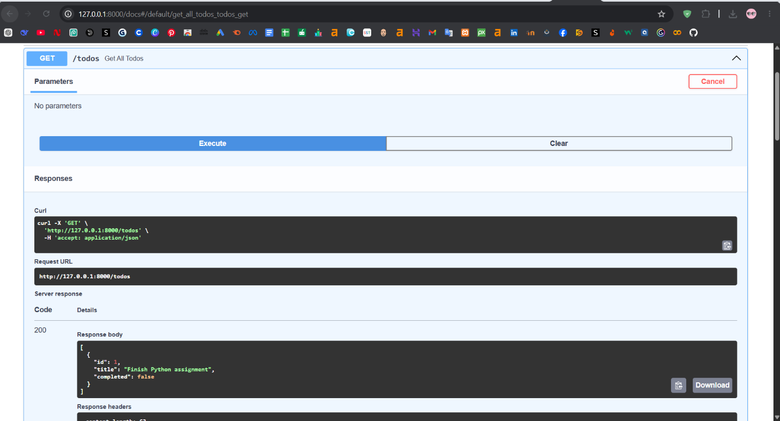
POST /todos 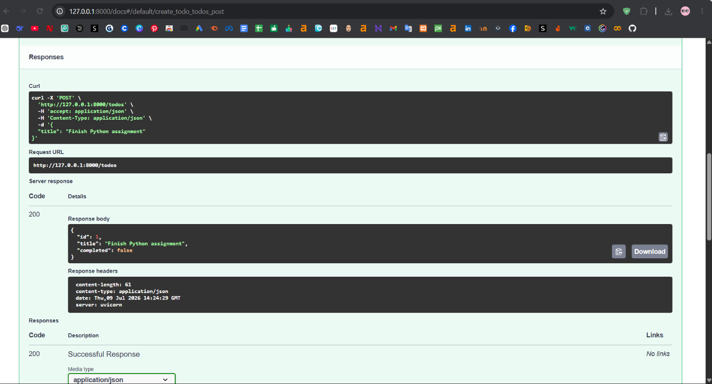
Test GET /todos (see all tasks)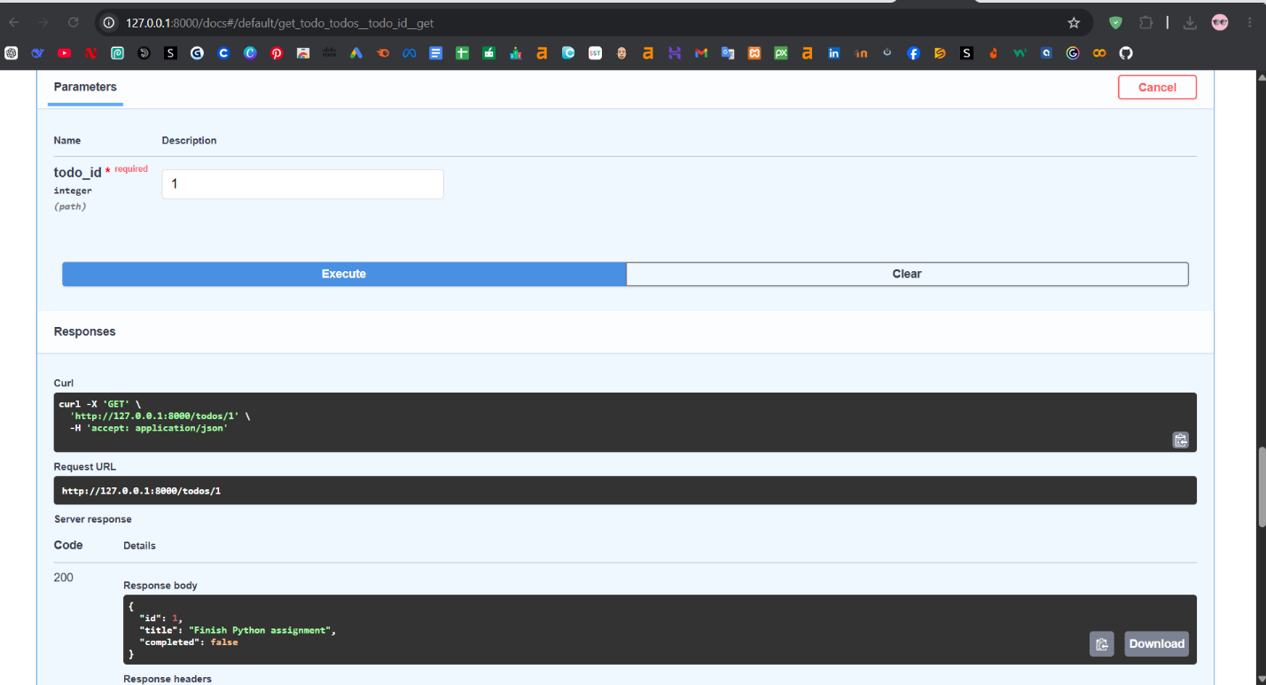

Test GET /todos/{todo_id} (get one specific task)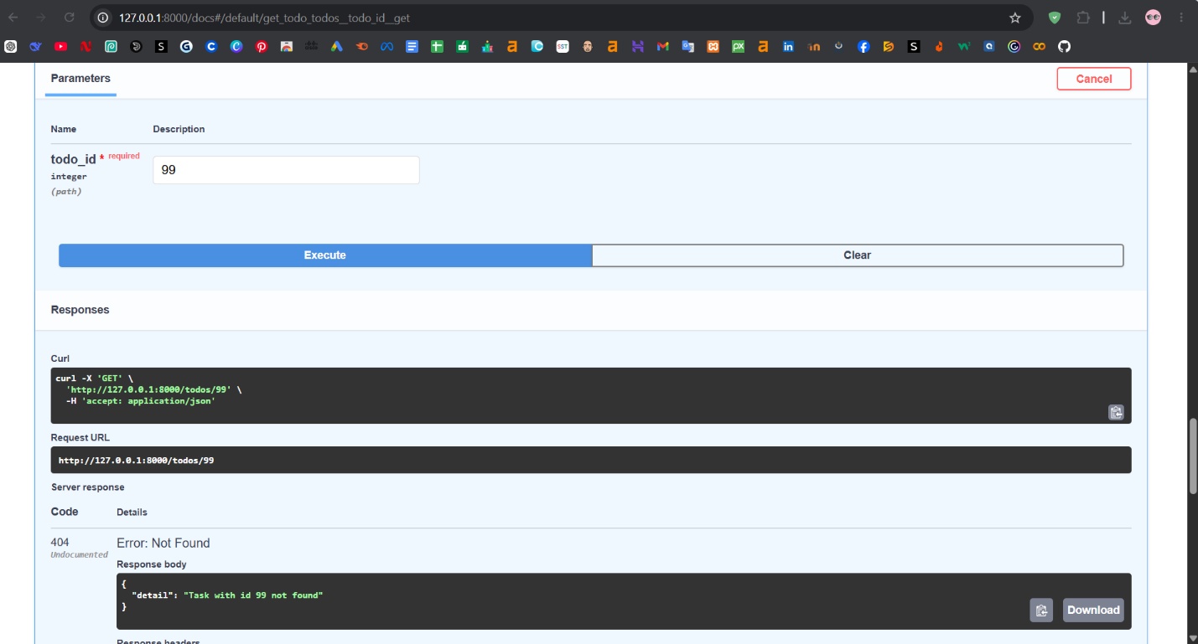

Test PUT /todos/{todo_id} (update a task)
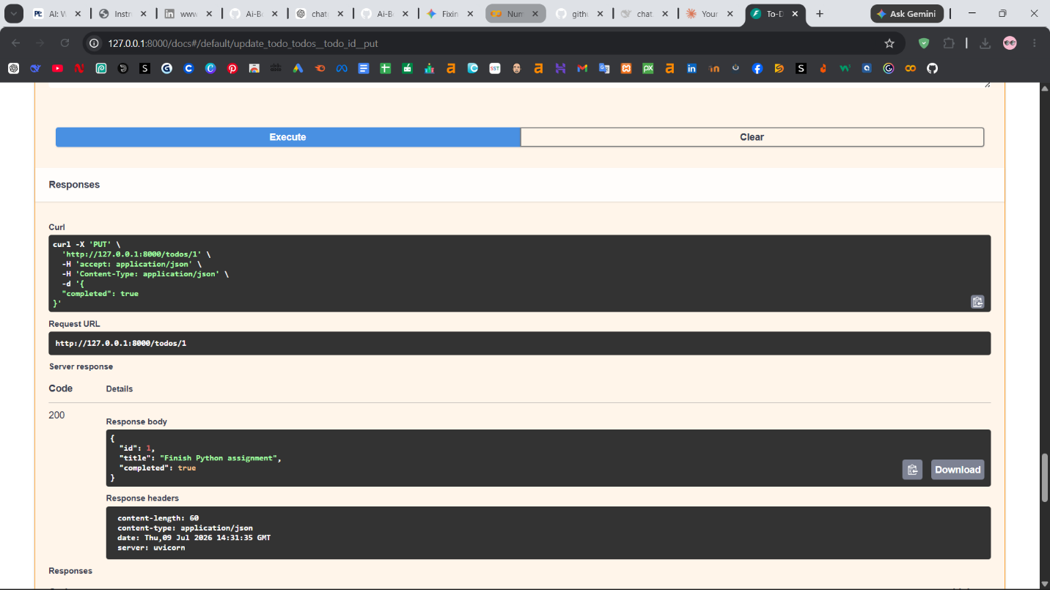

Test DELETE /todos/{todo_id} (delete a task)
