24F-0040

Laiba

Lab02

Problem 01:

#include<iostream>

#include<cstdlib>

using namespace std;

int add(int\* a, int size) { //add array elements

int sum = 0;

cout << "This function is int type function"<< endl;

for (int i = 0; i < size; i++) { //add all values of array

sum += a[i];

}cout << "Sum of array is: " << sum << endl;

return sum;

}

double add(double\* a, int size) { //function polymorphism (add array elements)---------1

double sum = 0;

cout << "This is double type function" << endl;

for (int i = 0; i < size; i++) { //add all values of array

sum += a[i];

}cout << "Sum of array is: " << sum<<endl;

return sum;

}

int main() {

//memory allocation

double \*ptra = (double \*)malloc(3\*sizeof(double)); //use of malloc-------------------2

int \*ptrb = (int \*)calloc(5,sizeof(int)); //use of calloc----------------------------3

cout << "Enter 3 values for first array(double type)";

for (int i = 0; i < 3; i++) {

cin >> ptra[i];

}

cout << "Enter 5 values for second array(int type)";

for (int i = 0; i < 5; i++) {

cin >> ptrb[i];

}

//use of functions

double sum = 0;

sum+=add(ptra, 3);

sum+=add(ptrb, 5);

cout << "Sum of ptra and ptrb is: " << sum<<endl;

//free memory--------------------------------------------------------------------------4

free(ptra);

free(ptrb);

system("Pause");

return 0;

}

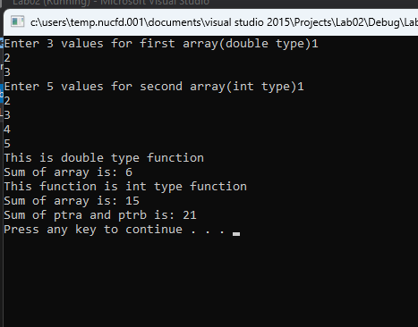

End------------------