ASSIGNMENT 01
GIT, GITEA, GITHUB, GIT LFS & GITHUB PAGES
BS(SE)-V Cloud Computing (BSE-410)
Name | Laiba Amjad
Roll No. | FA24B1-SE-021
Section | BSE-VA
Submission Date | 10 October 2026

TASK 1 — Install Gitea and Push a Repository

1.1 Install and Run Gitea

Step 1.1: Install and Run Gitea
Installed Docker Engine and Docker Compose on the Ubuntu server. Cloned the official Gitea Docker repository, configured the compose.yaml file, initialized PostgreSQL along with the Gitea container service, and verified local connectivity via HTTP status code 200 on port 3000.
.
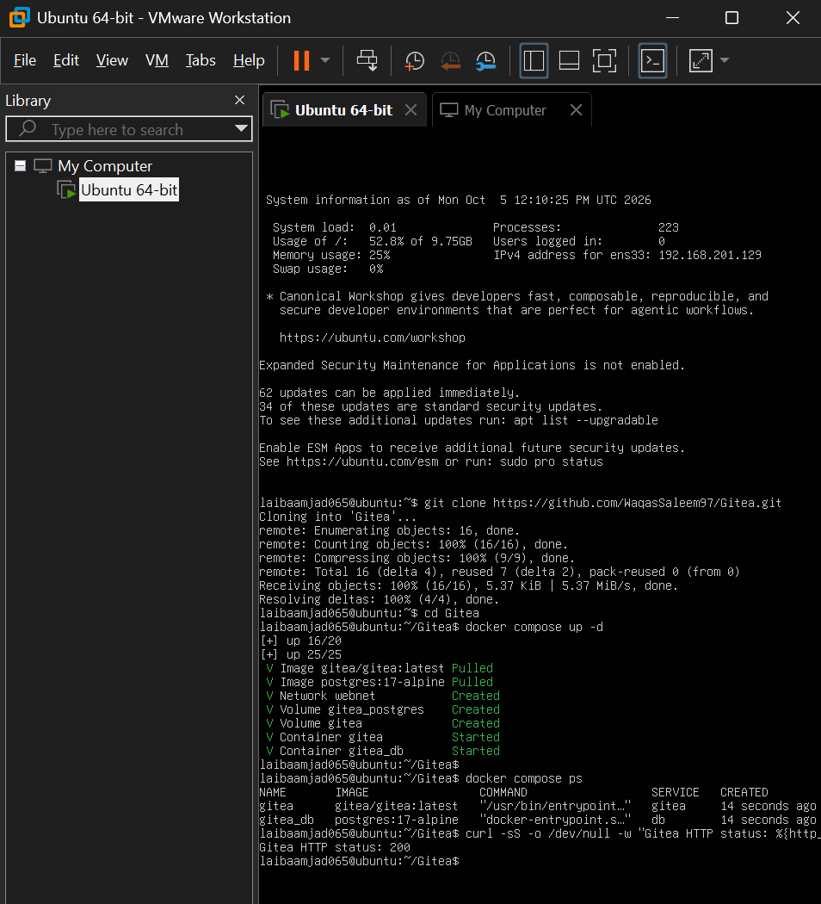.

1.2 Create and Push Assignment 01 to Gitea
Created a local repository named Assignment01 on the Ubuntu server containing a README.md file with student registration details. Generated a Gitea Personal Access Token (ubuntu-server-token), added the local Gitea remote URL without embedding credentials, and successfully pushed the main branch over HTTP using token authentication.

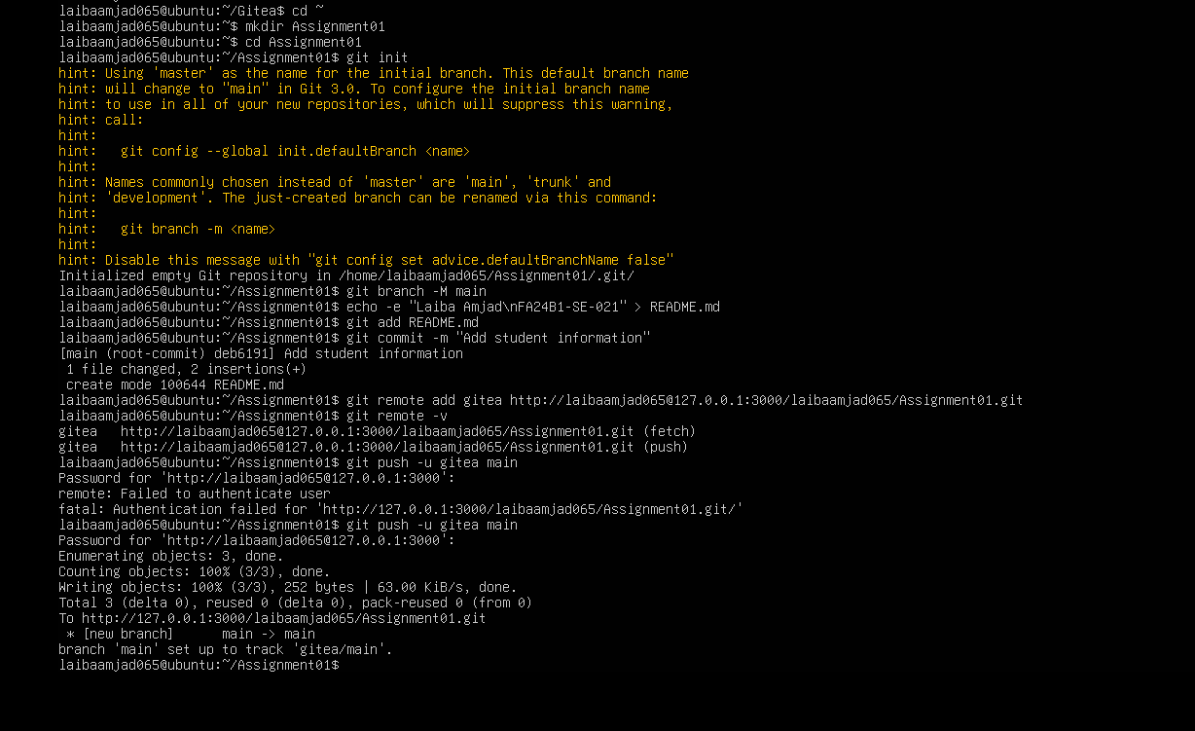

1.3 Verify Gitea Repository
Verified the public Assignment01 repository in the Gitea web interface. Confirmed that the repository ownership, visibility status (Public), and rendered README.md content displaying student identification details are accurate.
.
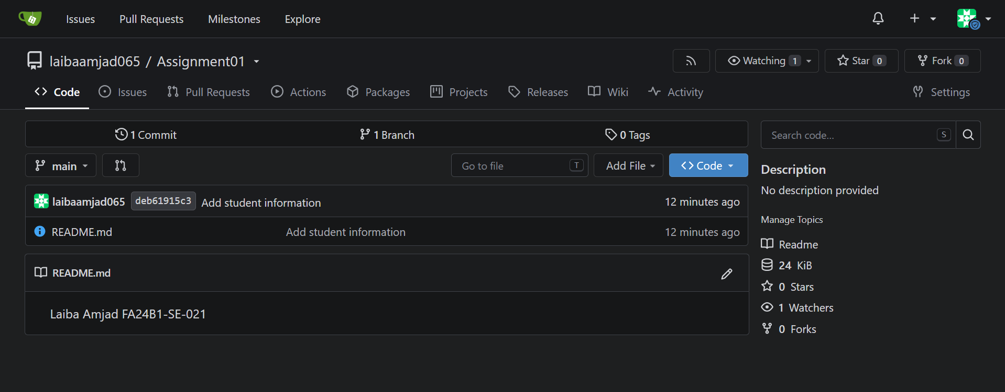

TASK 2 — Push the Same Repository to GitHub

2.1 Add GitHub Remote
Created a public GitHub repository named Assignment01. Added the GitHub remote URL to the existing local repository on the Ubuntu server and verified that both gitea and github remotes are configured correctly without exposed passwords or access tokens.
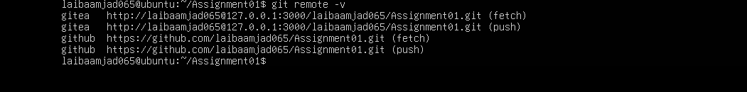

2.2 Push to GitHub
Pushed the local main branch to the GitHub remote repository using SSH/HTTPS authentication.
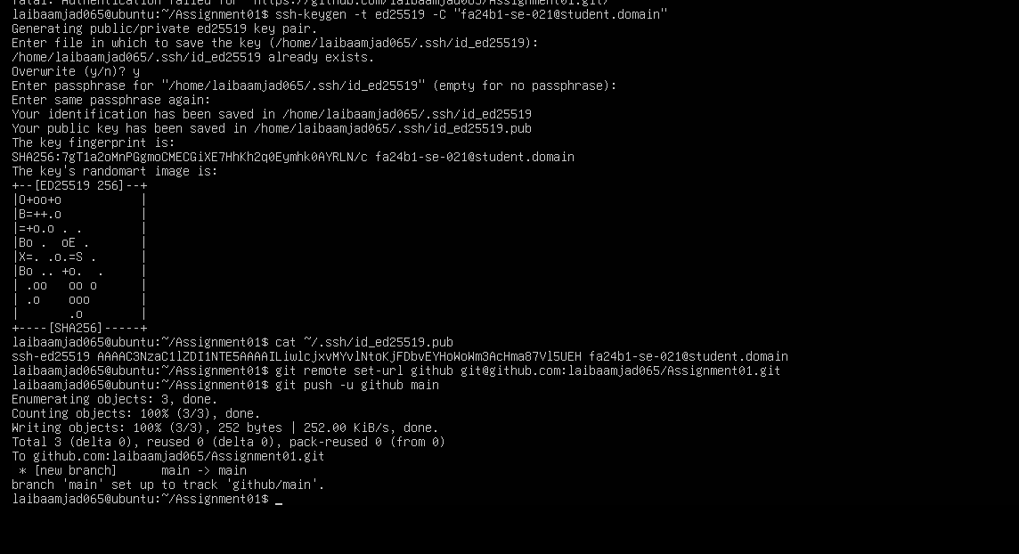

2.3 Verify GitHub Repository
Navigated to [https://github.com/laibaamjad065/Assignment01](https://github.com/laibaamjad065/Assignment01) in the web browser to verify that the public repository, owner username, repository name, and rendered README.md file are correctly reflected on GitHub.
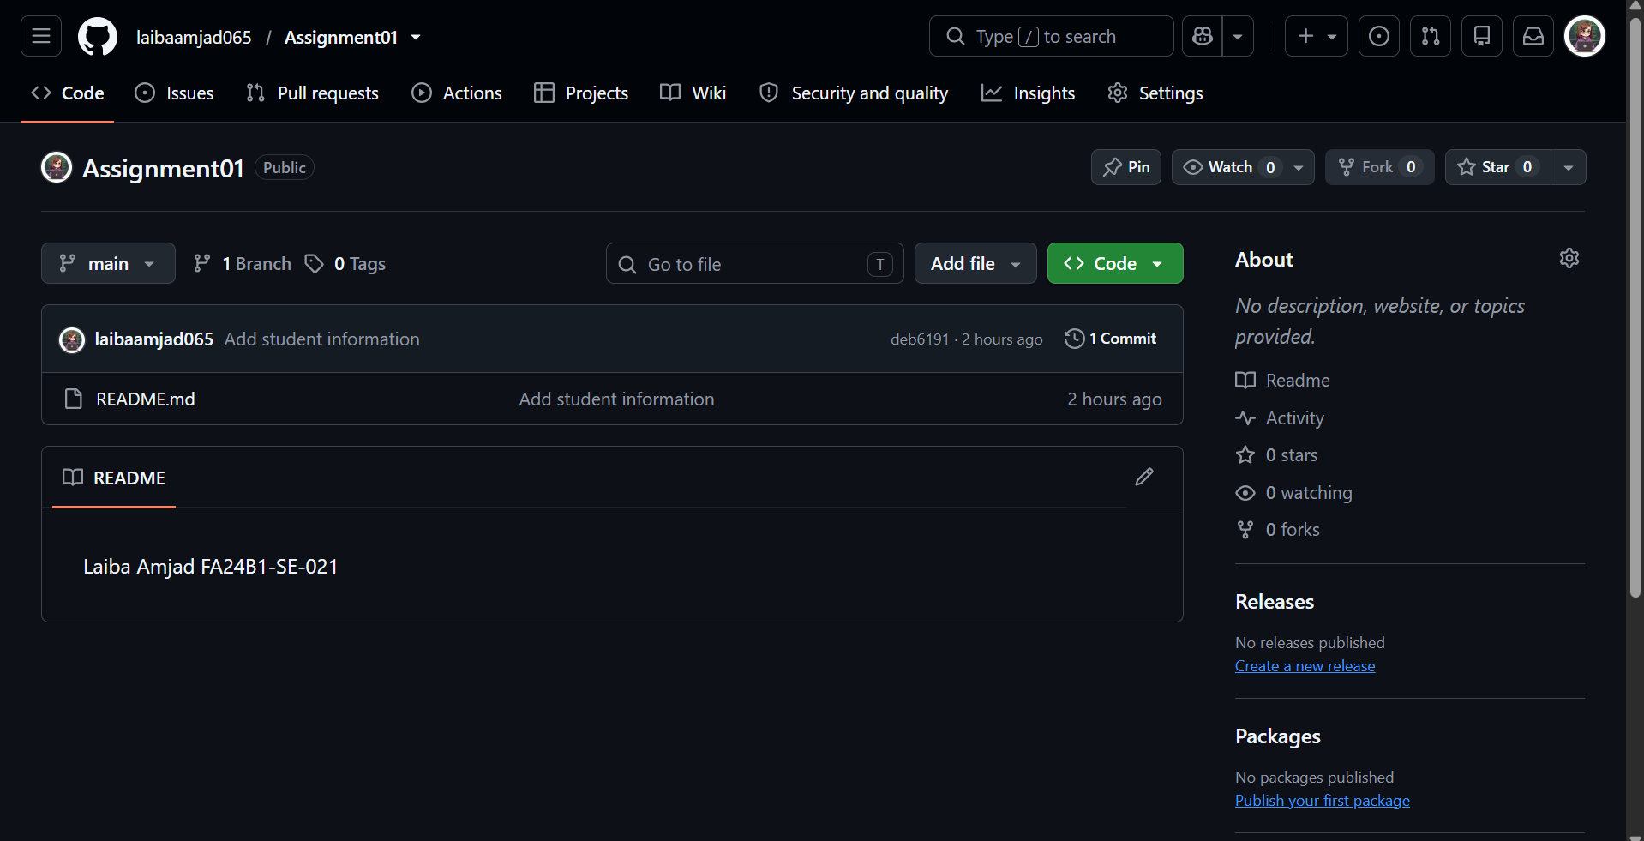

TASK 3 — Track Three Large Files with Git LFS

3.1 Configure Git LFS
Initialized Git Large File Storage (Git LFS) inside the Assignment01 repository and configured tracking for binary (*.bin) files, verifying the generated .gitattributes configuration file.

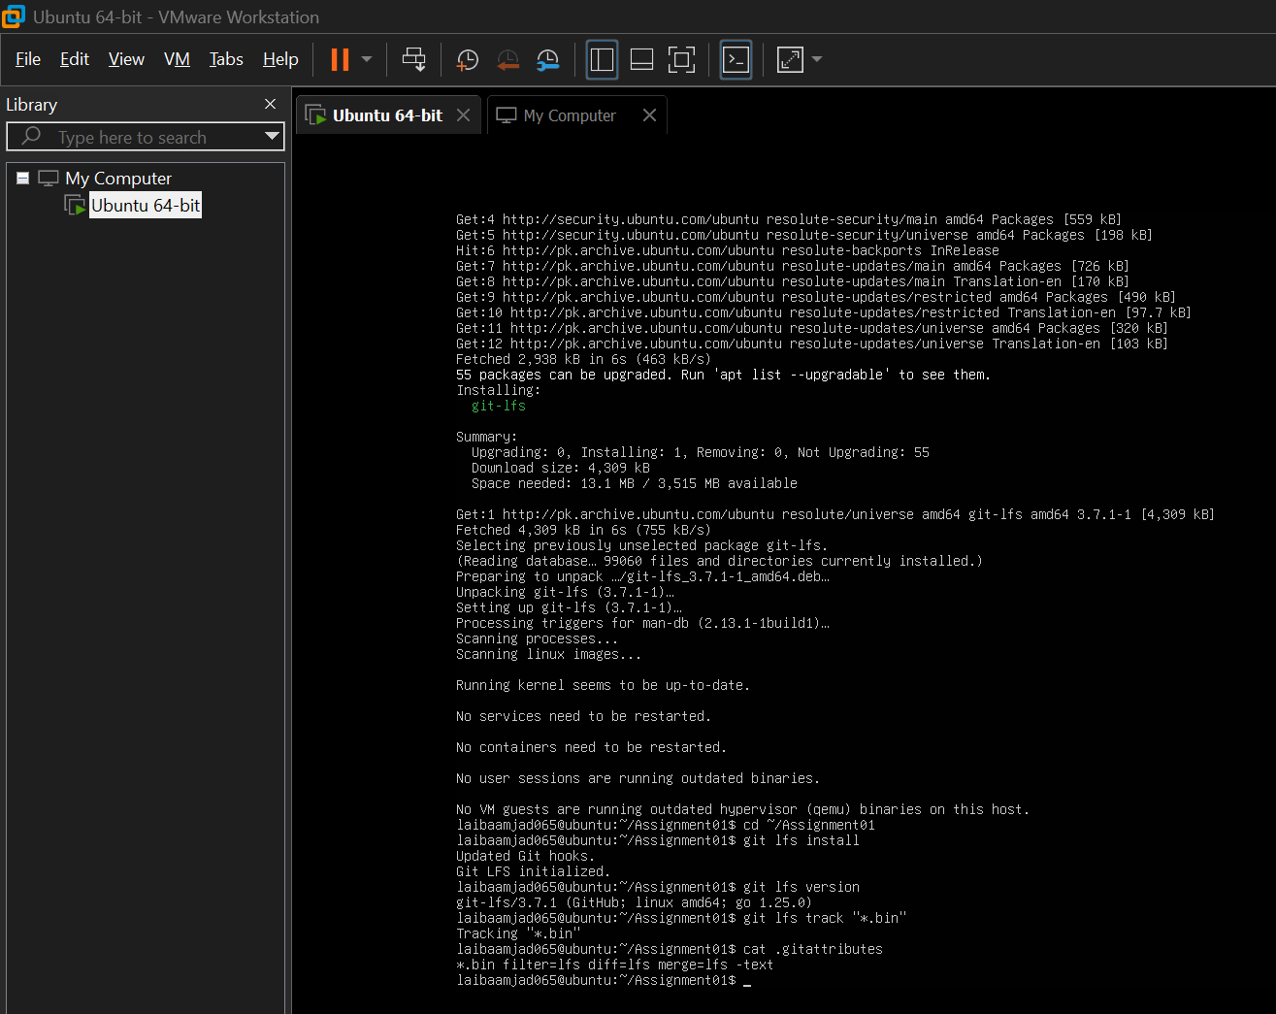

3.2 Create and Verify Three LFS Files
Generated three dummy binary files exceeding 100 MiB each (large-file-1.bin, large-file-2.bin, large-file-3.bin) using the truncate utility. Staged the files and verified that Git LFS accurately tracks them along with their designated file sizes.
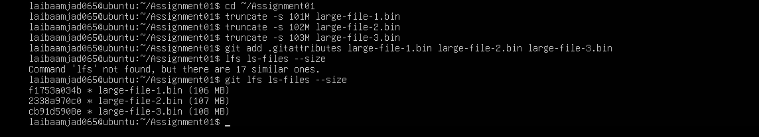

3.3 Commit and Push
Committed the Git LFS tracking rules and large binary files to the repository, followed by pushing the entire payload to GitHub. Verified that all three LFS objects (total size ~507 MB) uploaded successfully at 100% completion.
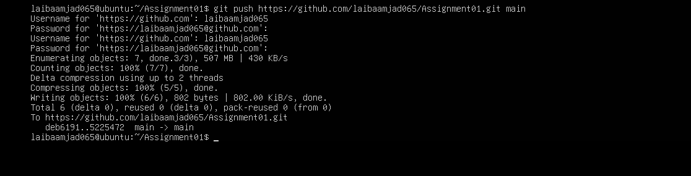

TASK 4—Create a Portfolio/CV with GitHub Pages

4.1 Portfolio Repository
Configured a dedicated public repository named laibaamjad065.github.io containing the necessary web assets (index.html and styles.css). Ensured the HTML file incorporates all required sections: About Me, Education, Skills, and Projects. Pushed the source code to the main branch.
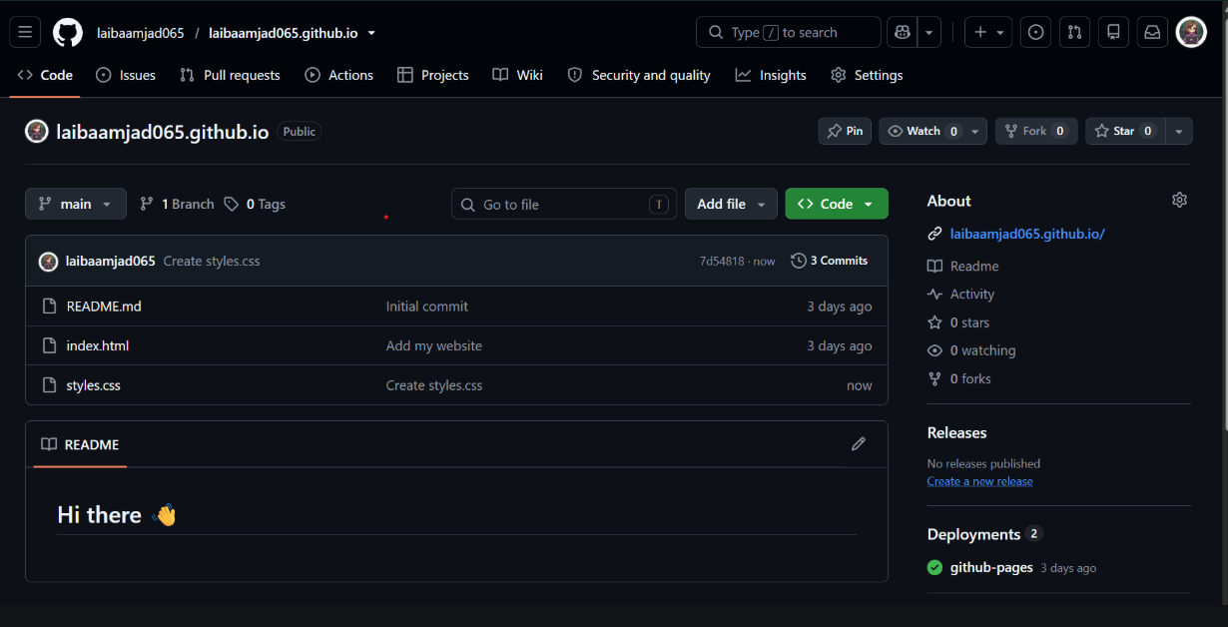

4.2 Publish with GitHub Pages
Configured GitHub Pages deployment under Settings → Pages by assigning the deployment source to the main branch and / (root) folder. Confirmed successful build execution indicated by the active status banner: "Your site is live at https://laibaamjad065.github.io/".

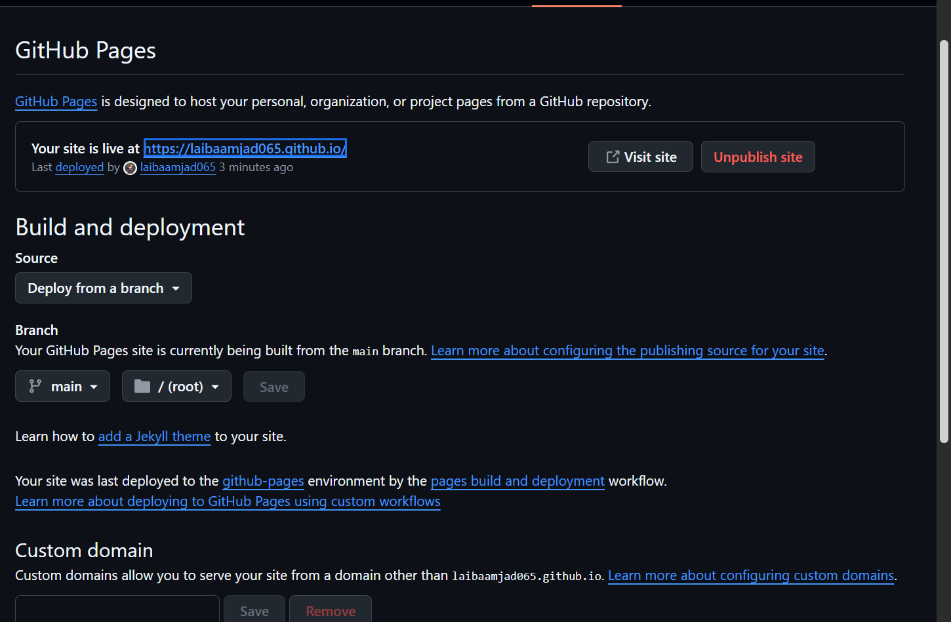

4.3 Verify Live Portfolio
Accessed [https://laibaamjad065.github.io/](https://laibaamjad065.github.io/) via a web browser to confirm live deployment accessibility. Verified that the website renders properly, displaying the complete URL along with the mandatory sections (About Me, Education, Skills, and Projects).
