Implementation Points:

1. Architecture & Design
- Service-Oriented Architecture: Uses interface segregation with ILabService, ISectionService, IReportService, etc.
- Role-Based Access Control: Different menus for different user roles
- Modular Design: Separate services for labs, sections, users, timesheets, and makeup requests
- Data Persistence: File-based storage system with FileManager class

2. User Management System
- Multiple User Roles:
  - System Administrator
  - Academic Officer
  - HOD (Head of Department)
  - Instructor
  - Attendant
- Login Authentication: Secure login system with session management
- Account Creation: Ability to create new user accounts
- Role-Based Permissions: Each role has specific accessible functions

3. Core Data Entities
- Labs: Lab ID, name, course code, credit hours
- Sections: Section ID, lab association, instructor, TAs, venue, schedule
- Users: Instructors, TAs, Attendants, Academic Officers, HODs
- Venues & Buildings: Room management with capacity tracking
- Timesheets: Actual lab timing records
- Makeup Requests: Lab rescheduling system

Working:

Login.
I chose option 2 here you can choose option 1 as well if there is any already present attendant or officer. If you choose option 1 add password and username. I entered as administrator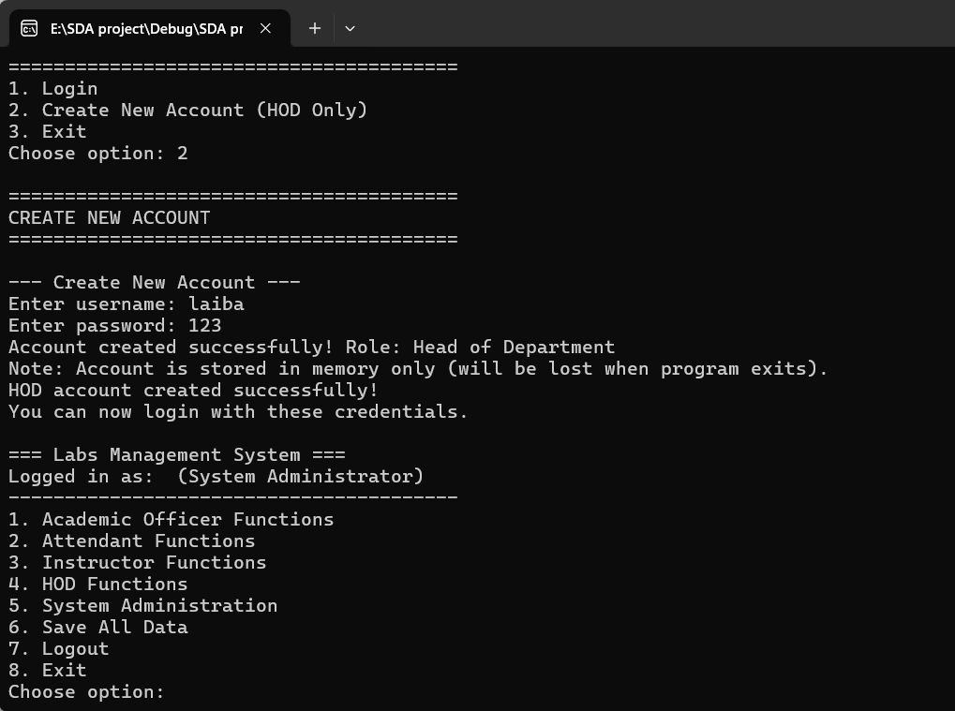

ACADEMEIC OFFICER FUNCTIONS

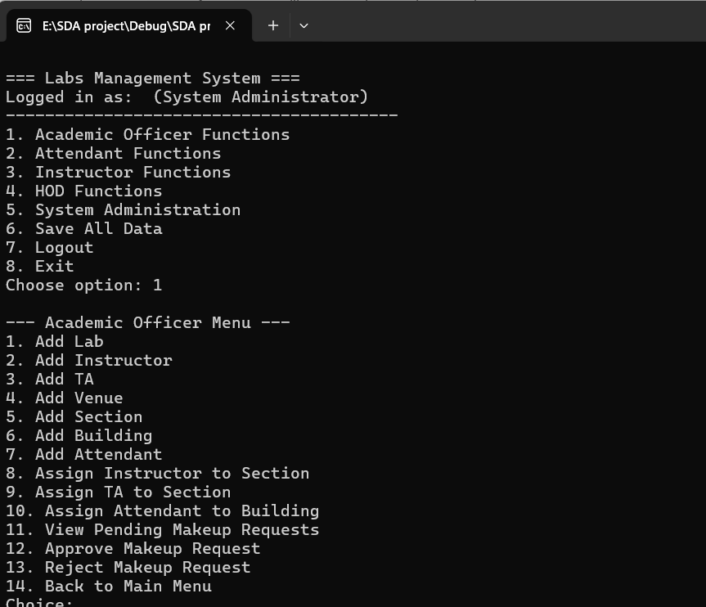

1.added lab
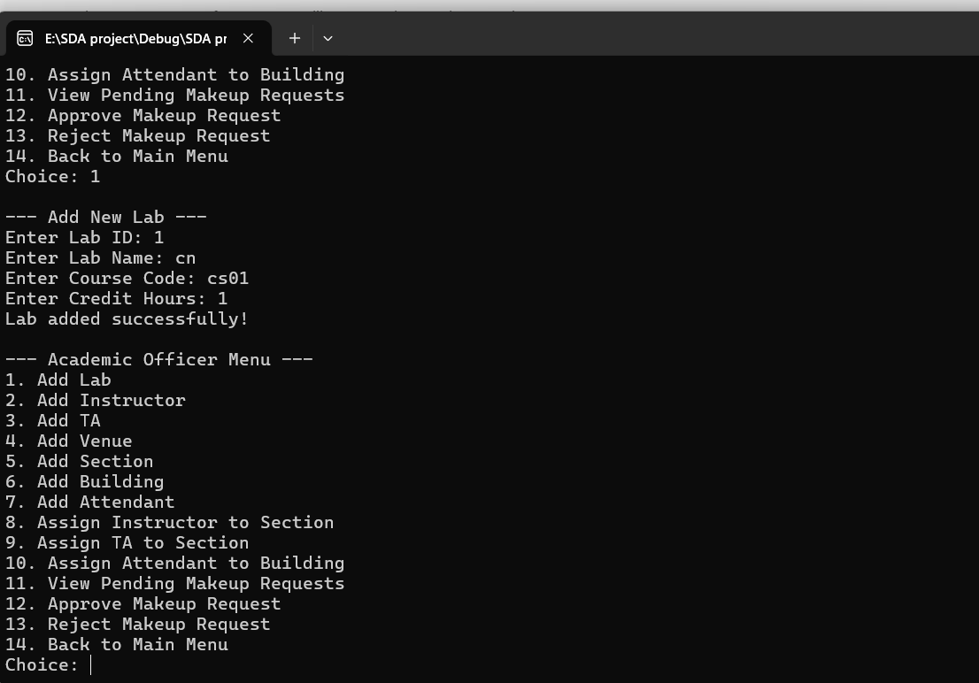

2.added instructor
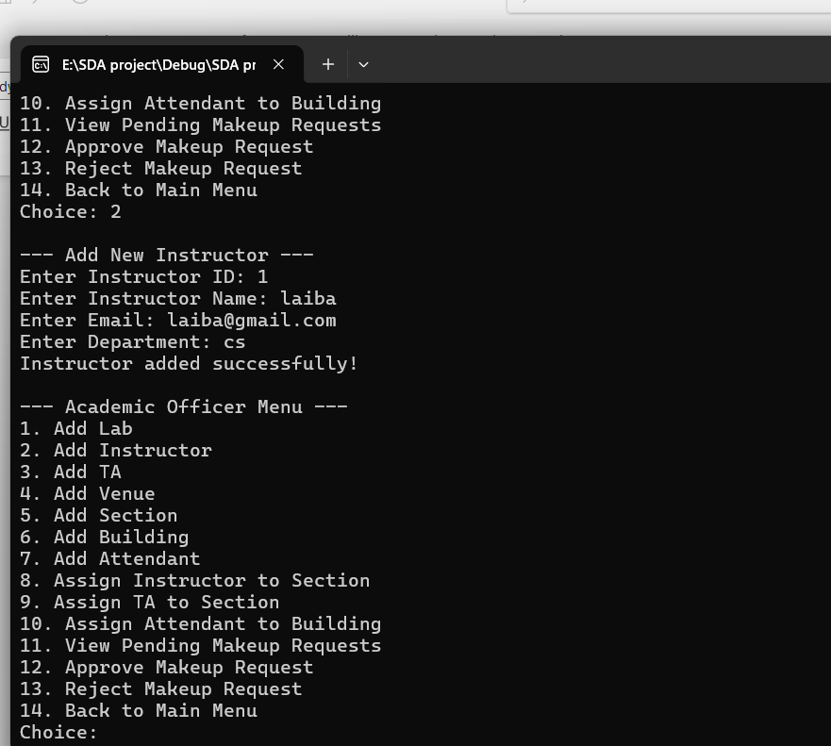
3.added TA 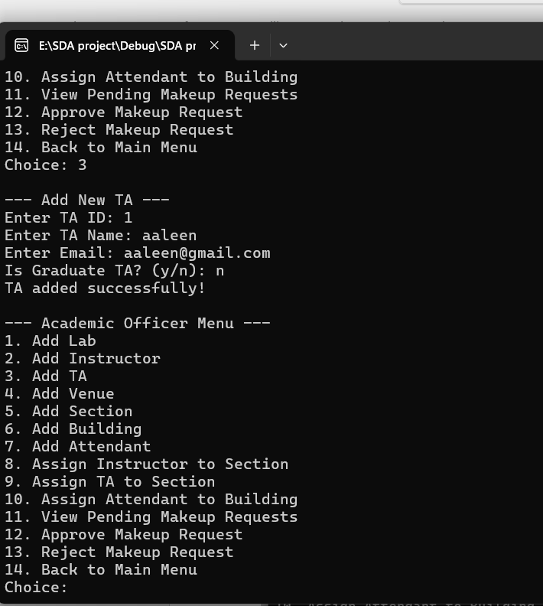

4.added venue

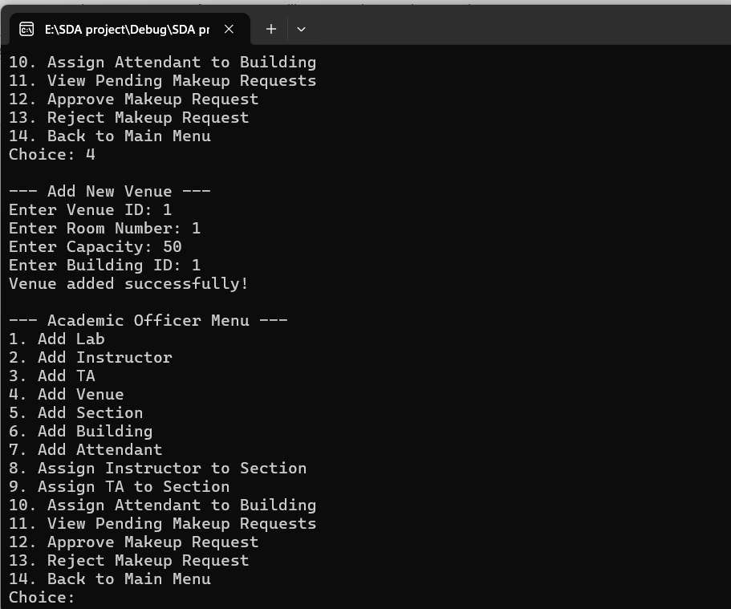

5.added section

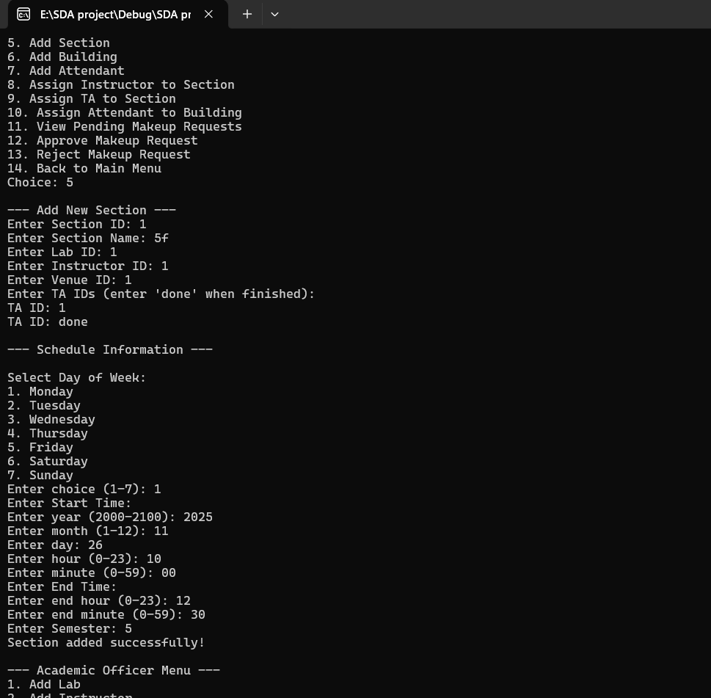

6.added building

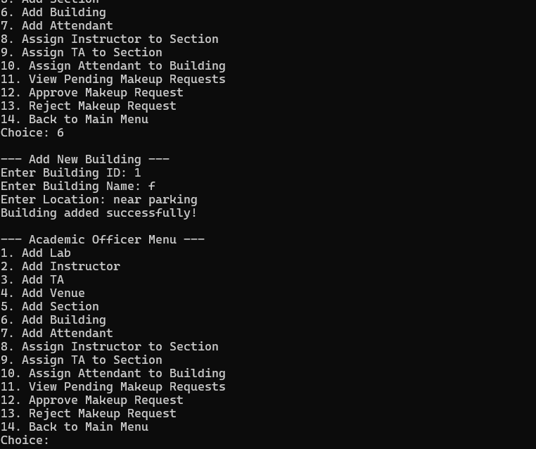
7.Added attendant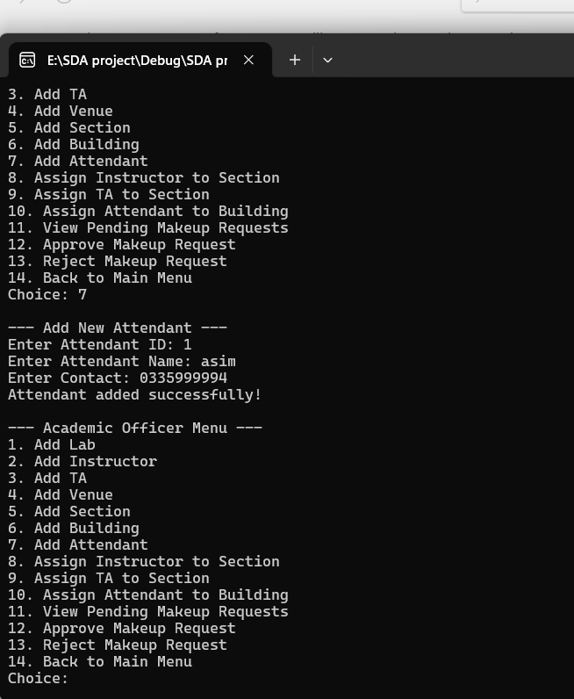
8.assigned added instructor to added TA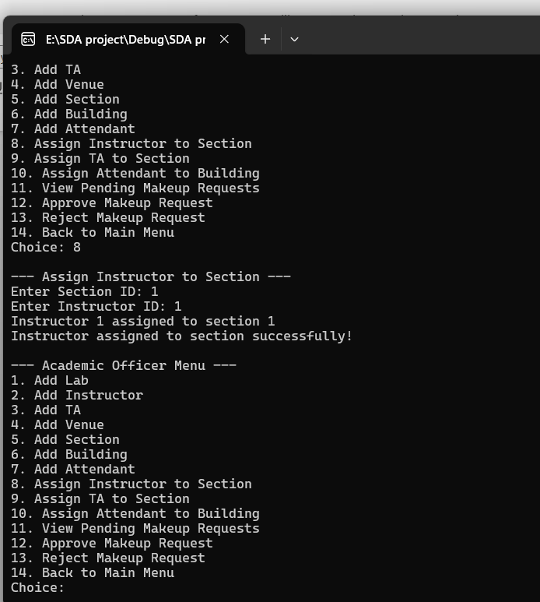
9.assigned added TA to section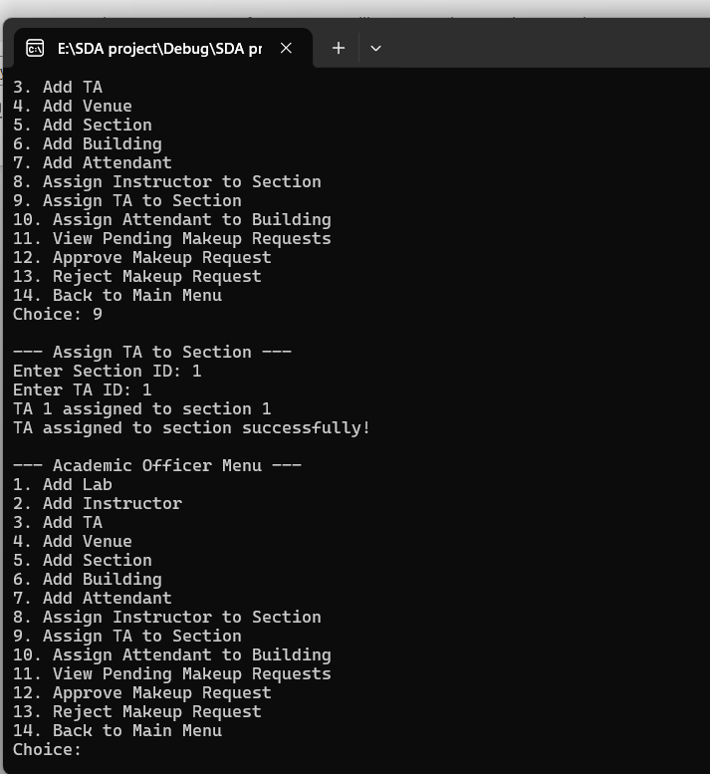

10.assigned added attendant to added building

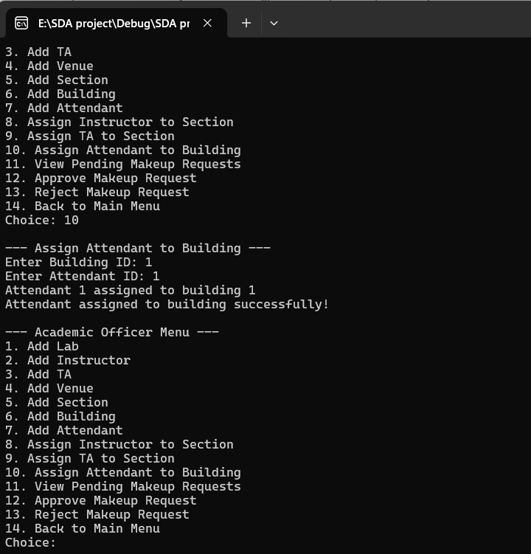

there is no makeup request yet so we cannot view approve or reject it
next we choose option 2
ATTENDANT FUNCTIONS
1.fill timesheet
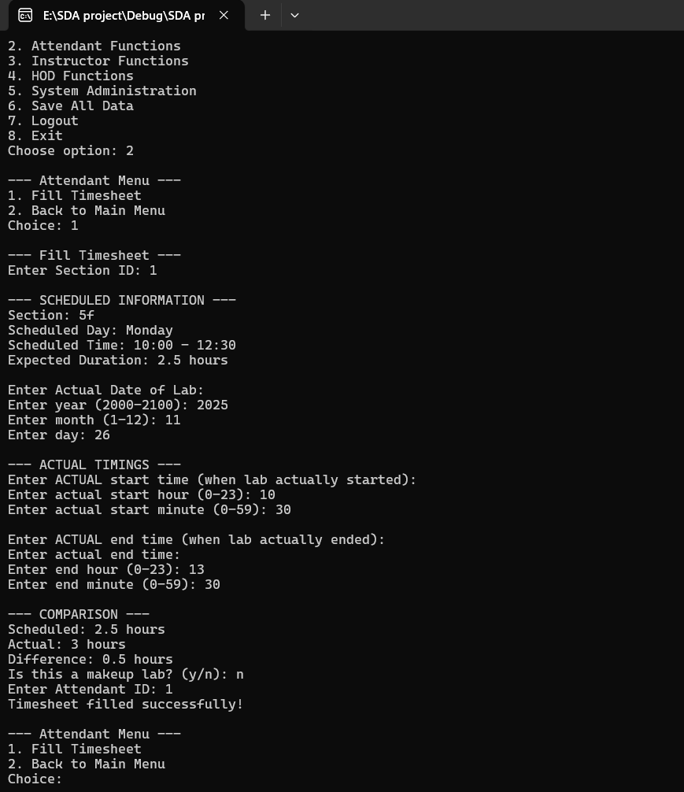

INSTRUCTOR FUNCTIONS
1.request makeup lab
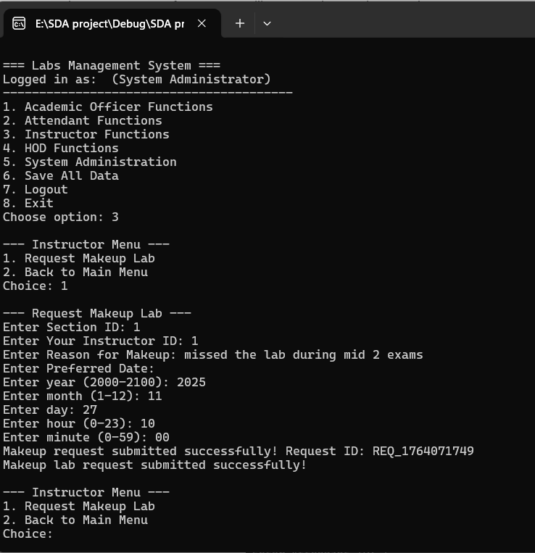
Now we see pending requests as we added a request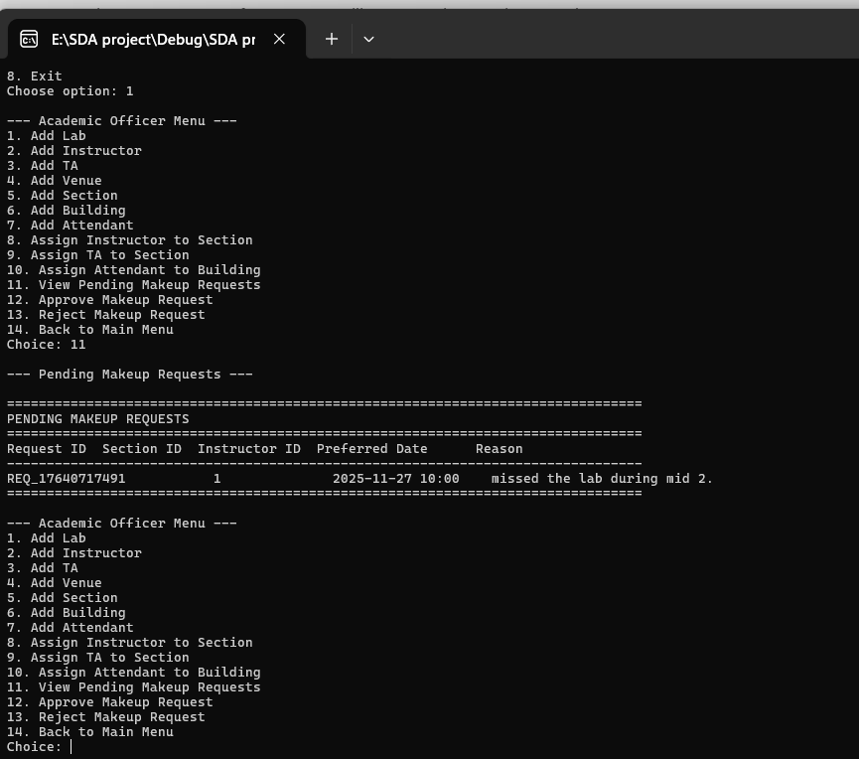

Makeup request is approved upon entering the request ID from .dat file or the makeup request ID given when we add the makeup request. It can also be rejected in the same way. 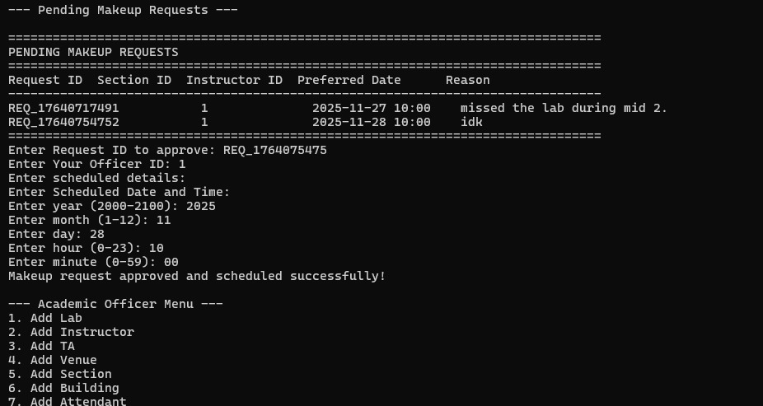

HOD FUNCTIONS
1.generate weekly schedule report
And you can save it in a separate file of your choice.You can enter the name and a file will be created
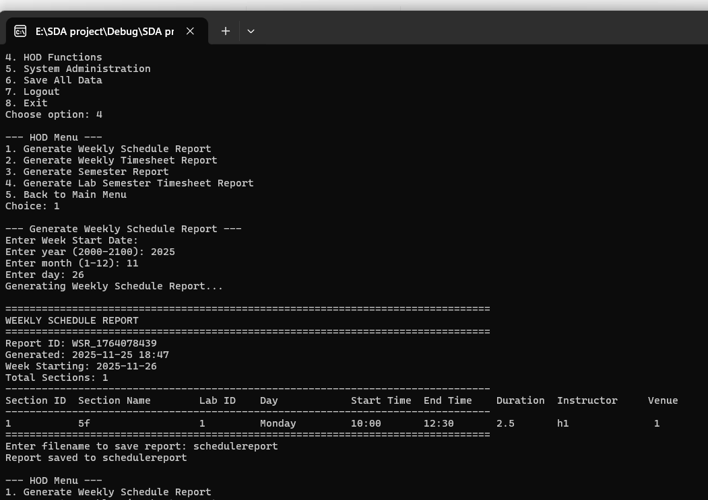

2.generate weekly timesheet report
And you can save it in a separate file of your choice.You can enter the name and a file will be created
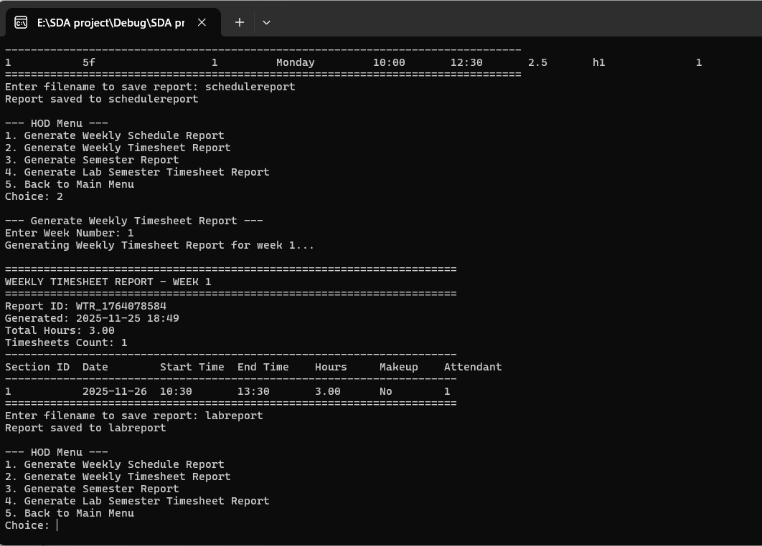

3.generate semester report
And you can save it in a separate file of your choice.You can enter the name and a file will be created
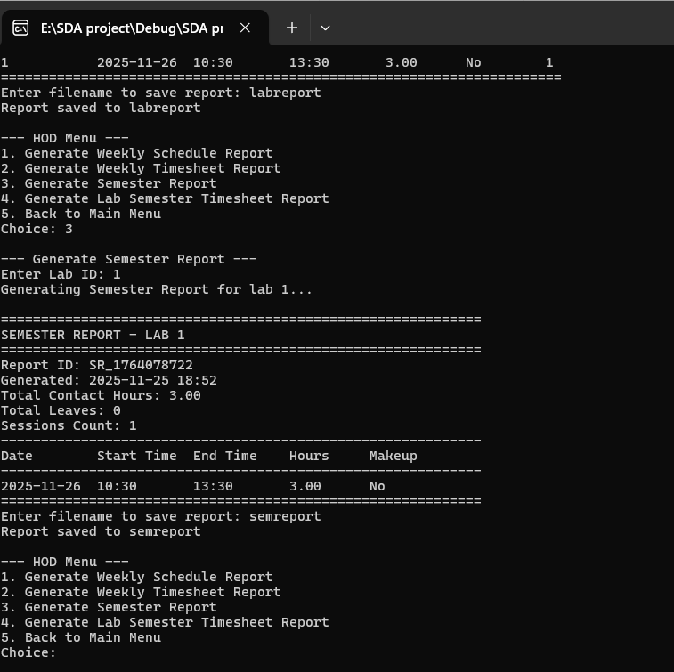

4.generate lab semester timesheet report
And you can save it in a separate file of your choice.You can enter the name and a file will be created
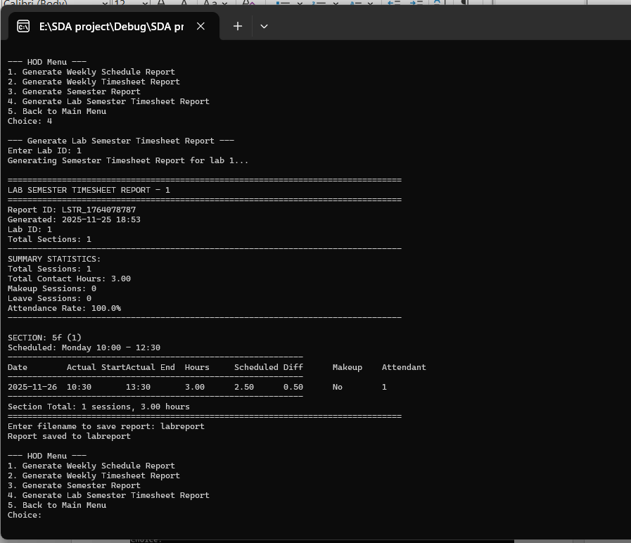

SYSTEM ADMINISTRATION FUNCTIONS
You can add HOD and academic officer in this
I have added academic officer
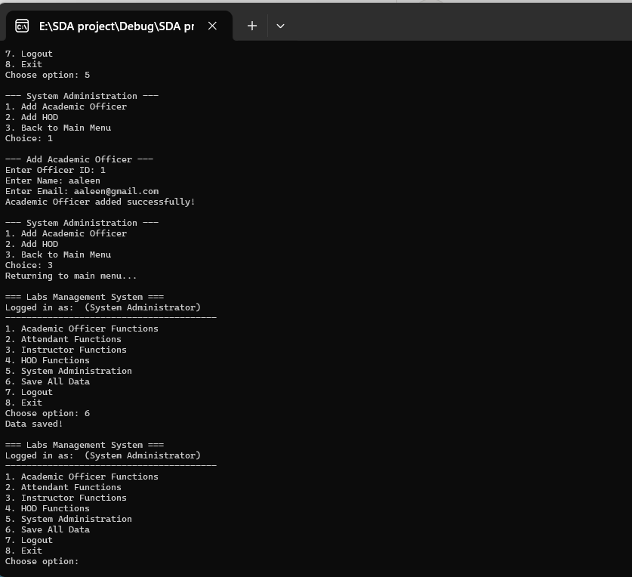
In the end save all the data so that it is saved in binary files
Solid Principles applied:
1. SRP - Single Responsibility Principle:
Service Interfaces
class ILabService { // Only handles lab operations
class ISectionService { // Only handles section operations
class IUserService { // Only handles user management
class ITimesheetService { // Only handles timesheet operations
class IReportService { // Only handles report generation

2. OCP - Open/Closed Principle:
The service interfaces are stable - you can create new implementations without changing the existing interface contracts.
3.LSP - Liskov Substitution Principle:
Polymorphic Service Usage
class LabManagementSystem {
private:
ILabService* labService; // Can use any ILabService implementation
ISectionService* sectionService; // Can use any ISectionService implementation
// ...
};
// In implementation:
labService = new LabServiceImpl(); // Concrete implementation
// Could substitute with: new MockLabServiceImpl(), new DatabaseLabServiceImpl()
4.ISP - Interface Segregation Principle:
Focused Interfaces
// Instead of one giant "ILabManagement" interface:
class ILabService { // Only lab methods
virtual void addLab(...) = 0;
virtual Lab* findLab(...) = 0;
};
class ISectionService { // Only section methods
virtual void addSection(...) = 0;
virtual void assignInstructor(...) = 0;
};
class IUserService { // Only user methods
virtual void addInstructor(...) = 0;
virtual void addTA(...) = 0;
};

5.DIP - Dependency Inversion Principle:
Abstractions Over Implementations
class LabManagementSystem {
private:
ILabService* labService; // Depends on abstraction
ISectionService* sectionService; // Depends on abstraction
IUserService* userService; // Depends on abstraction
// NOT: LabServiceImpl* labService (concrete dependency)
};
// High-level modules depend on abstractions
void academicOfficerMenu(ILabManagementSystem& system); // Abstraction
void fillTimesheetInteractive(ILabManagementSystem& system); // Abstraction

