

COMSATS UNIVERSITY ISLAMABAD, ABBOTTABAD CAMPUS

Assignment 1

**Mobile Application Development**

**Laiba Binta Tahir FA21-BSE-019-5A**

**Arfah Ali FA21-BSE-080-5A**

Submitted To:

**Sir Jawad Khan**

Date: 20 October-2023

**Mobile Application Development**

**Task 1:** Create a login and a registration page, with proper react native styling. Here is a sample, but your work can be different and better than this.

**App.js**

**Login.js**

**Register.js**

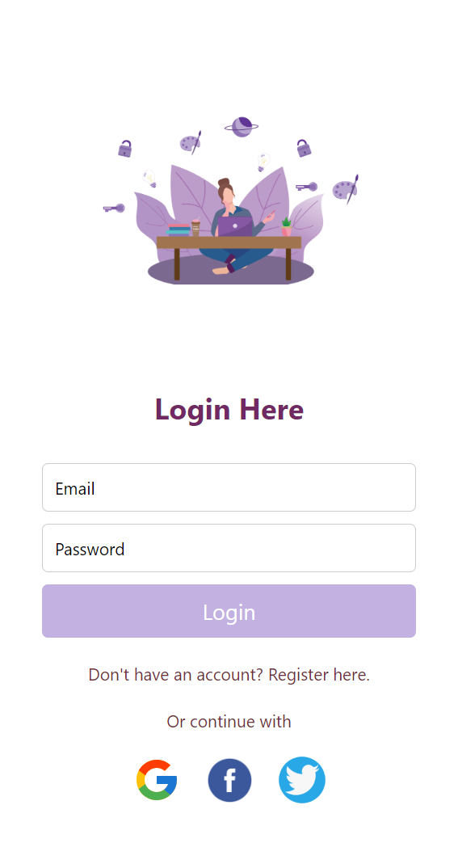**Output**

**Screen 1**

**Screen 2**

**Task 2:** You need to create a mobile phone portrait layout:

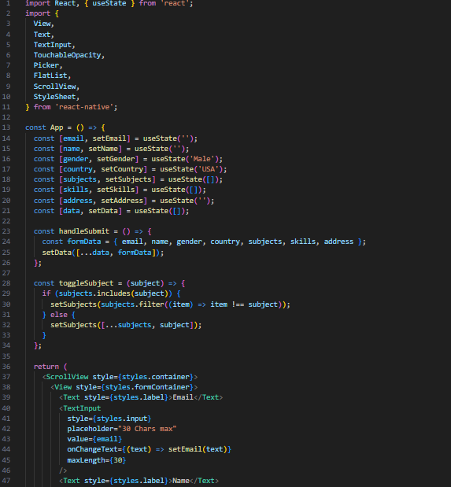

**Output**

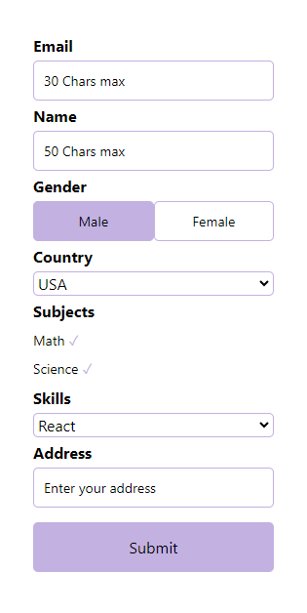

**Task 3:** Using Flex design and calculate logic for CALCULATOR**.**

**App.js**

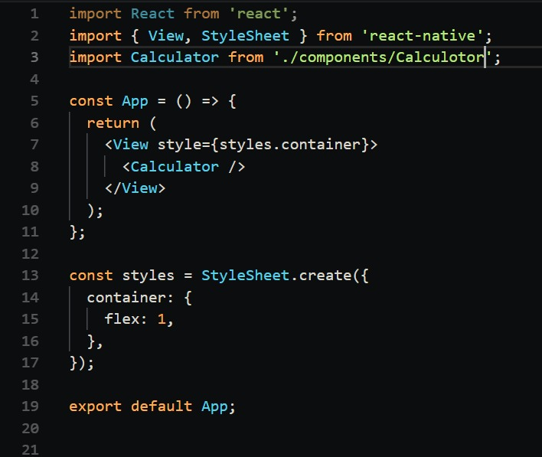

**Calculator.js**

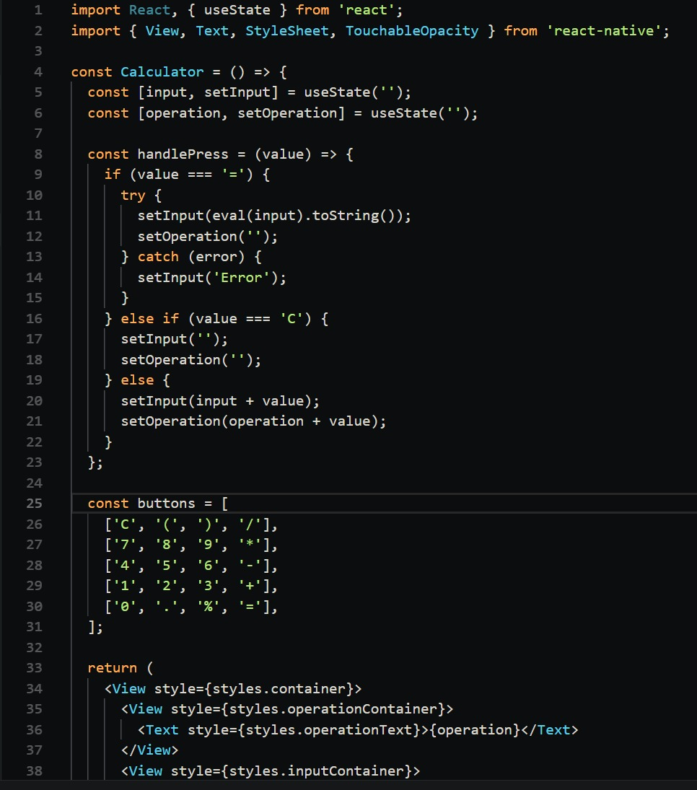

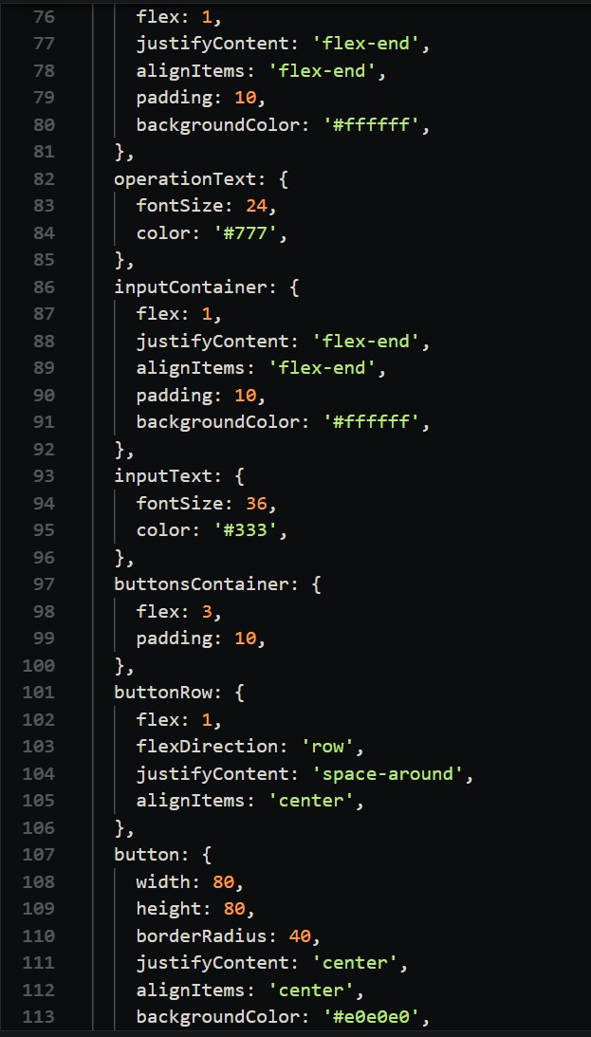

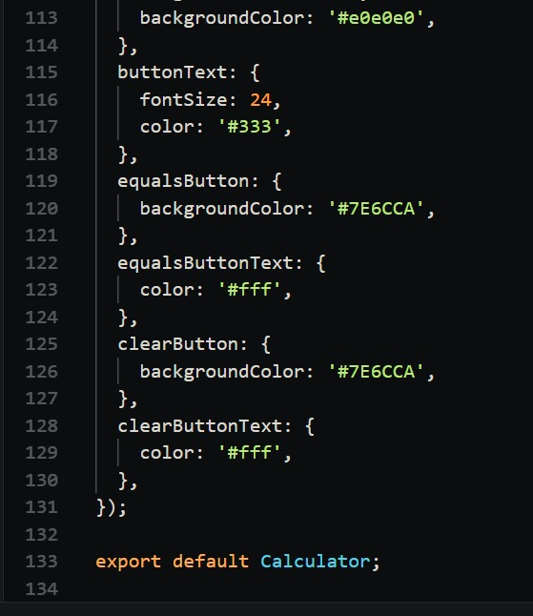

**Output**

