

COMSATS UNIVERSITY ISLAMABAD, ABBOTTABAD CAMPUS

DATABASE-I ASSINGEMENT # 04

**Submitted By:**

Laiba binta tahir. FA21-BSE-019-4A

Arfah Ali FA21-BSE-080-4A

Hanzala Nouman FA21-BSE-015-4A

Muhammad Irfan Khan FA21-BSE-027-4A

**Submitted To:** Dr. Rab Nawaz Jadoon

Date: 6 July-2023

**Problem statement**

Developing a hospital management system in order to effectively manage most aspects of hospitals such as booking appointments, managing patient records and keeping medical history.

**ER-Diagram**

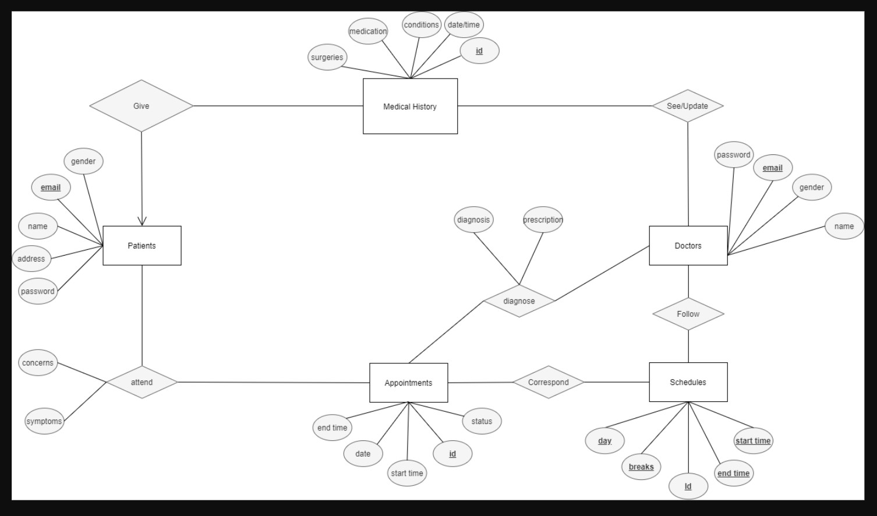

**Schema**

**Relational Schemas**

1. Patient

|  |  |  |  |
| --- | --- | --- | --- |
| **Email** | Password | Name | Address |

1. Doctor

|  |  |  |  |  |
| --- | --- | --- | --- | --- |
| **Email** | Gender | Password | Id | Name |

1. Medical History

|  |  |  |  |  |
| --- | --- | --- | --- | --- |
| Surgery | Medication | Condition | Date/Time | **Email** |

1. Appointment

|  |  |  |  |  |
| --- | --- | --- | --- | --- |
| **Id** | Date | Start | End | Status |

1. Schedules

|  |  |  |  |  |
| --- | --- | --- | --- | --- |
| **Id** | Start | End | Holidays | Breaks |

1. Diagnose

|  |  |  |  |
| --- | --- | --- | --- |
| **Appt Id** | Doctor | Diagnosis | Prescription |