**COMSATS UNIVERSITY ISLAMABAD, ABBOTTABAD**

Design patterns lab Assignment # 02

***Submitted by:***

Laiba binte tahir FA21-BSE-019

Contents

**Implementation of Facade pattern** 3

Task -01 Home Theater System 3

Code 3

Class diagram 7

Task-02 Flight booking 8

Code 8

Class diagram 10

**Implementation of proxy design pattern:** 11

Task 1: Caching Proxy in Web Applications 11

Code 11

Class diagram 12

Task 2: Protection Proxy in Online Banking Systems 13

Code 13

Class Diagram 15

**Implementation of observer pattern** 16

Task -01 Weather application 16

Code 16

Class diagram 19

Task -02 Chat application 20

Code 20

Class diagram: 23

**Implementation of prototype design pattern:** 24

Task 1: Cloning Shapes 24

Code 24

Class Diagram 26

Task 2: Cloning Employee Records 27

Code 27

Class diagram 29

# **Implementation of Facade pattern**

## Task -01 Home Theater System

### Code

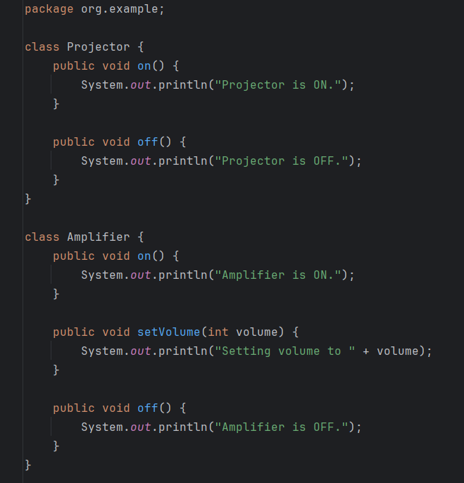

### Class diagram

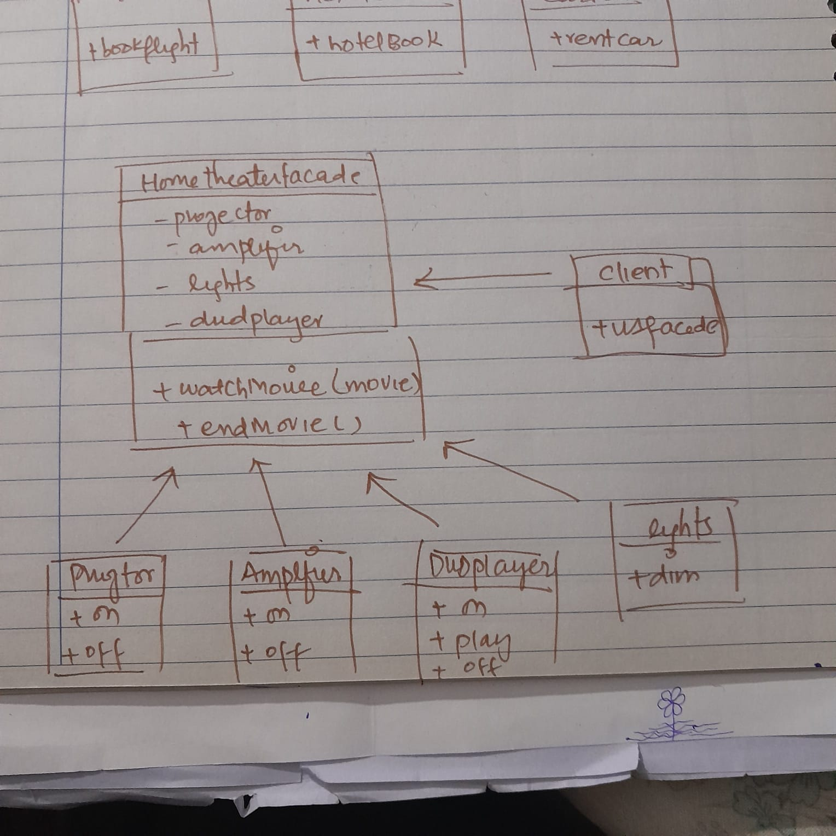

## Task-02 Flight booking

### Code

### Class diagram

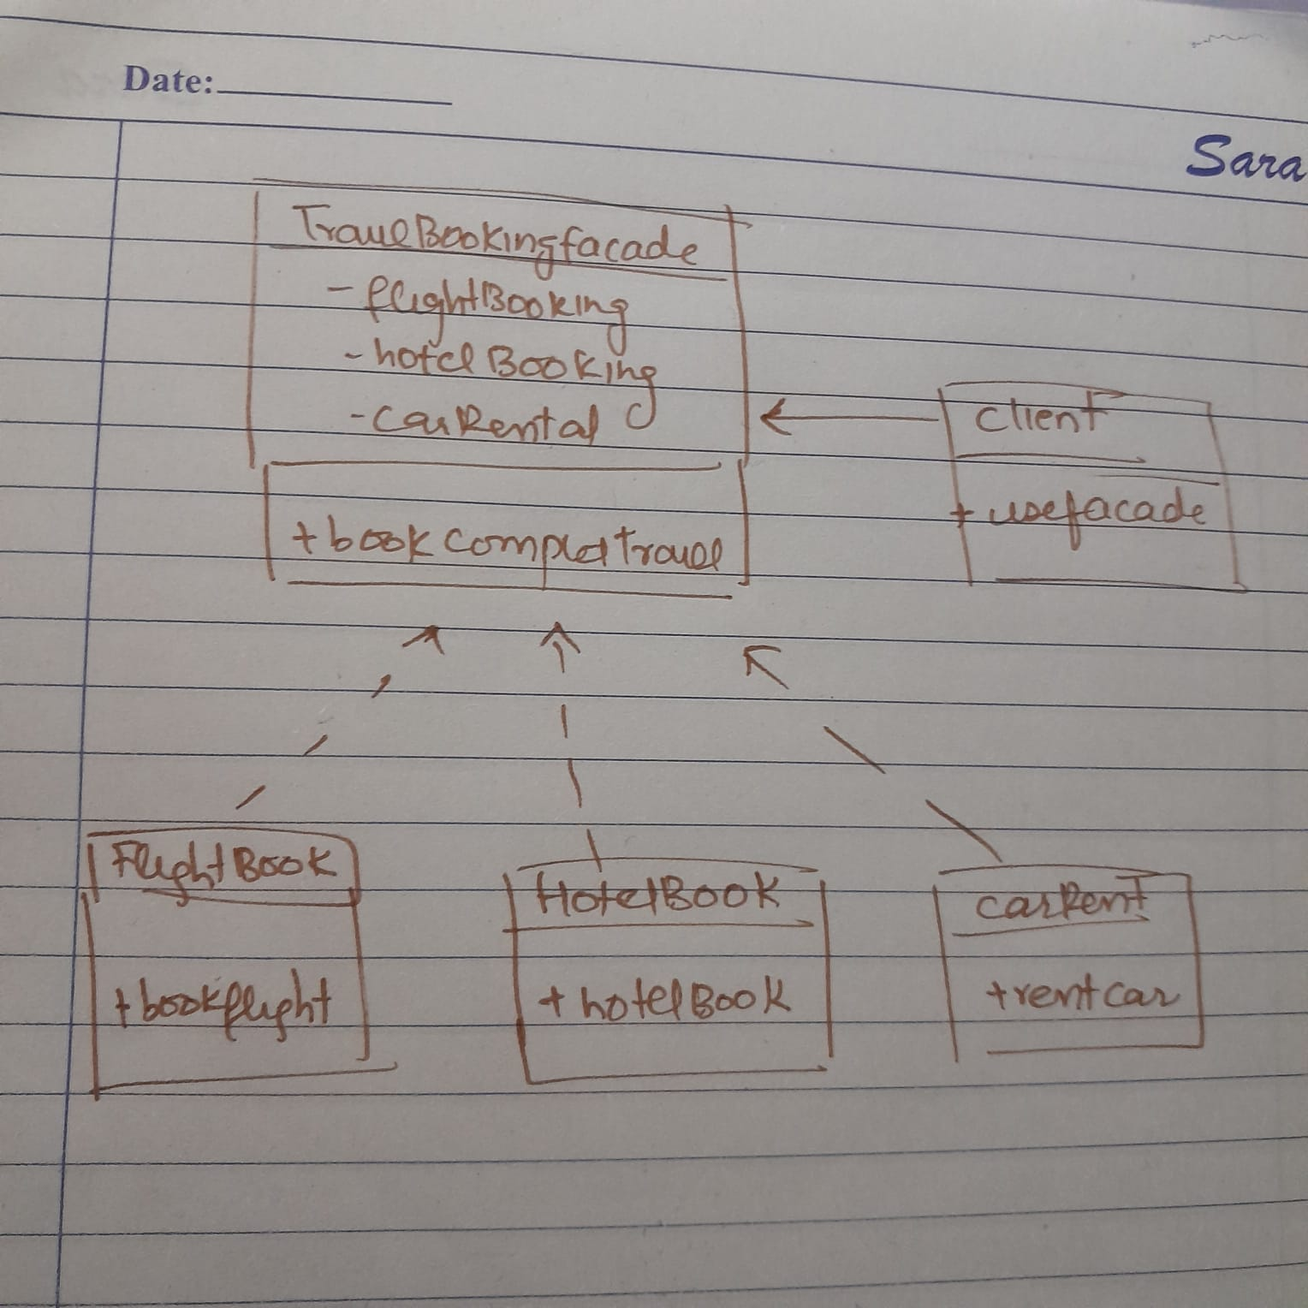

# **Implementation of proxy design pattern:**

## Task 1: Caching Proxy in Web Applications

### Code

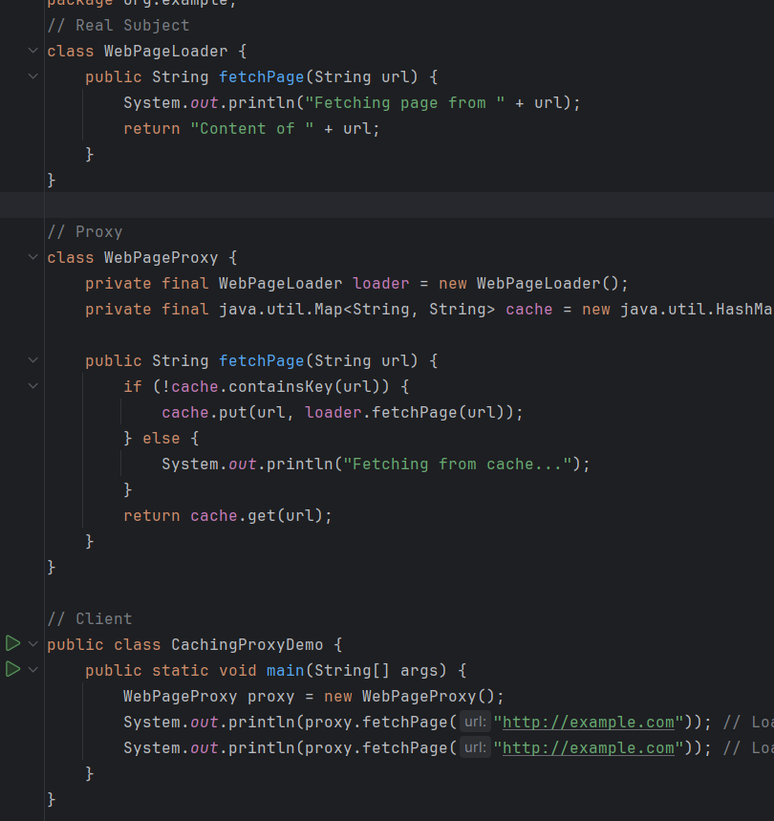

### Class diagram

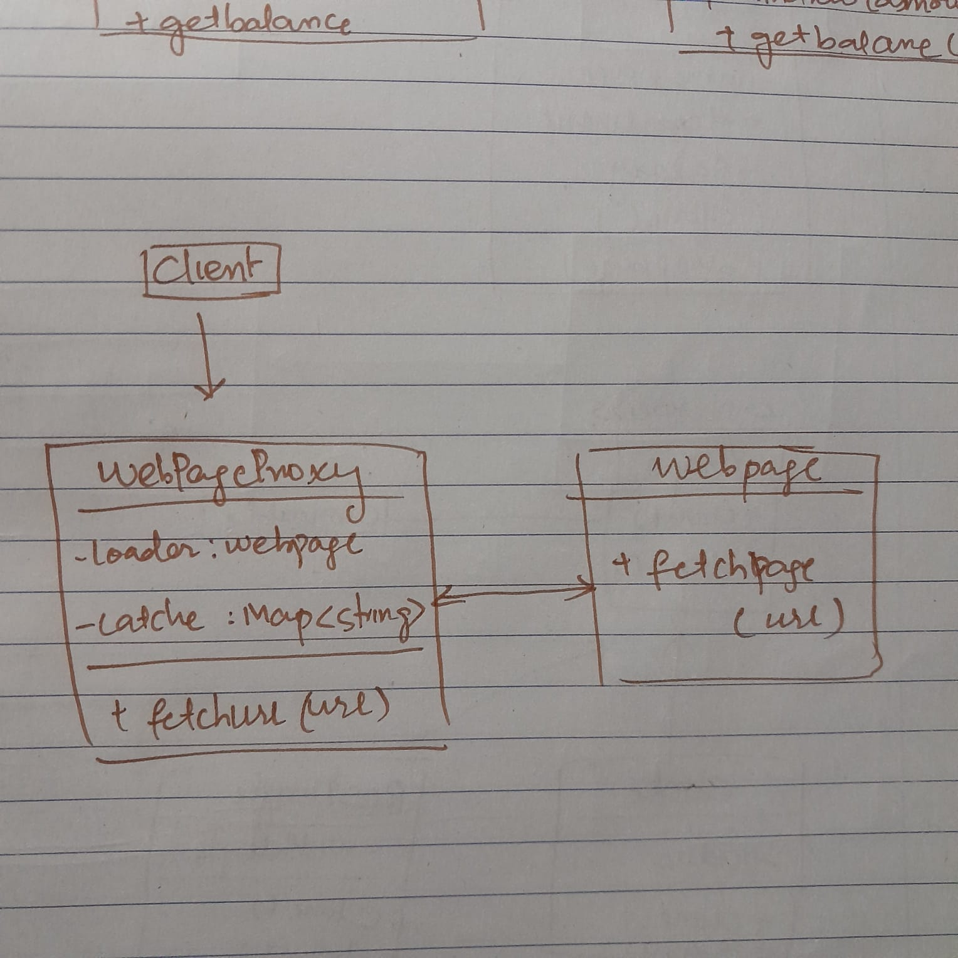

## Task 2: Protection Proxy in Online Banking Systems

### Code

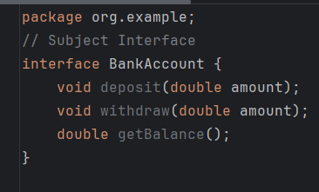

### Class Diagram

# **Implementation of observer pattern**

## Task -01 Weather application

### Code

### Class diagram

## Task -02 Chat application

### Code

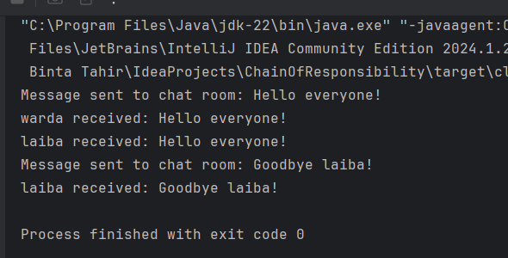

### Class diagram:

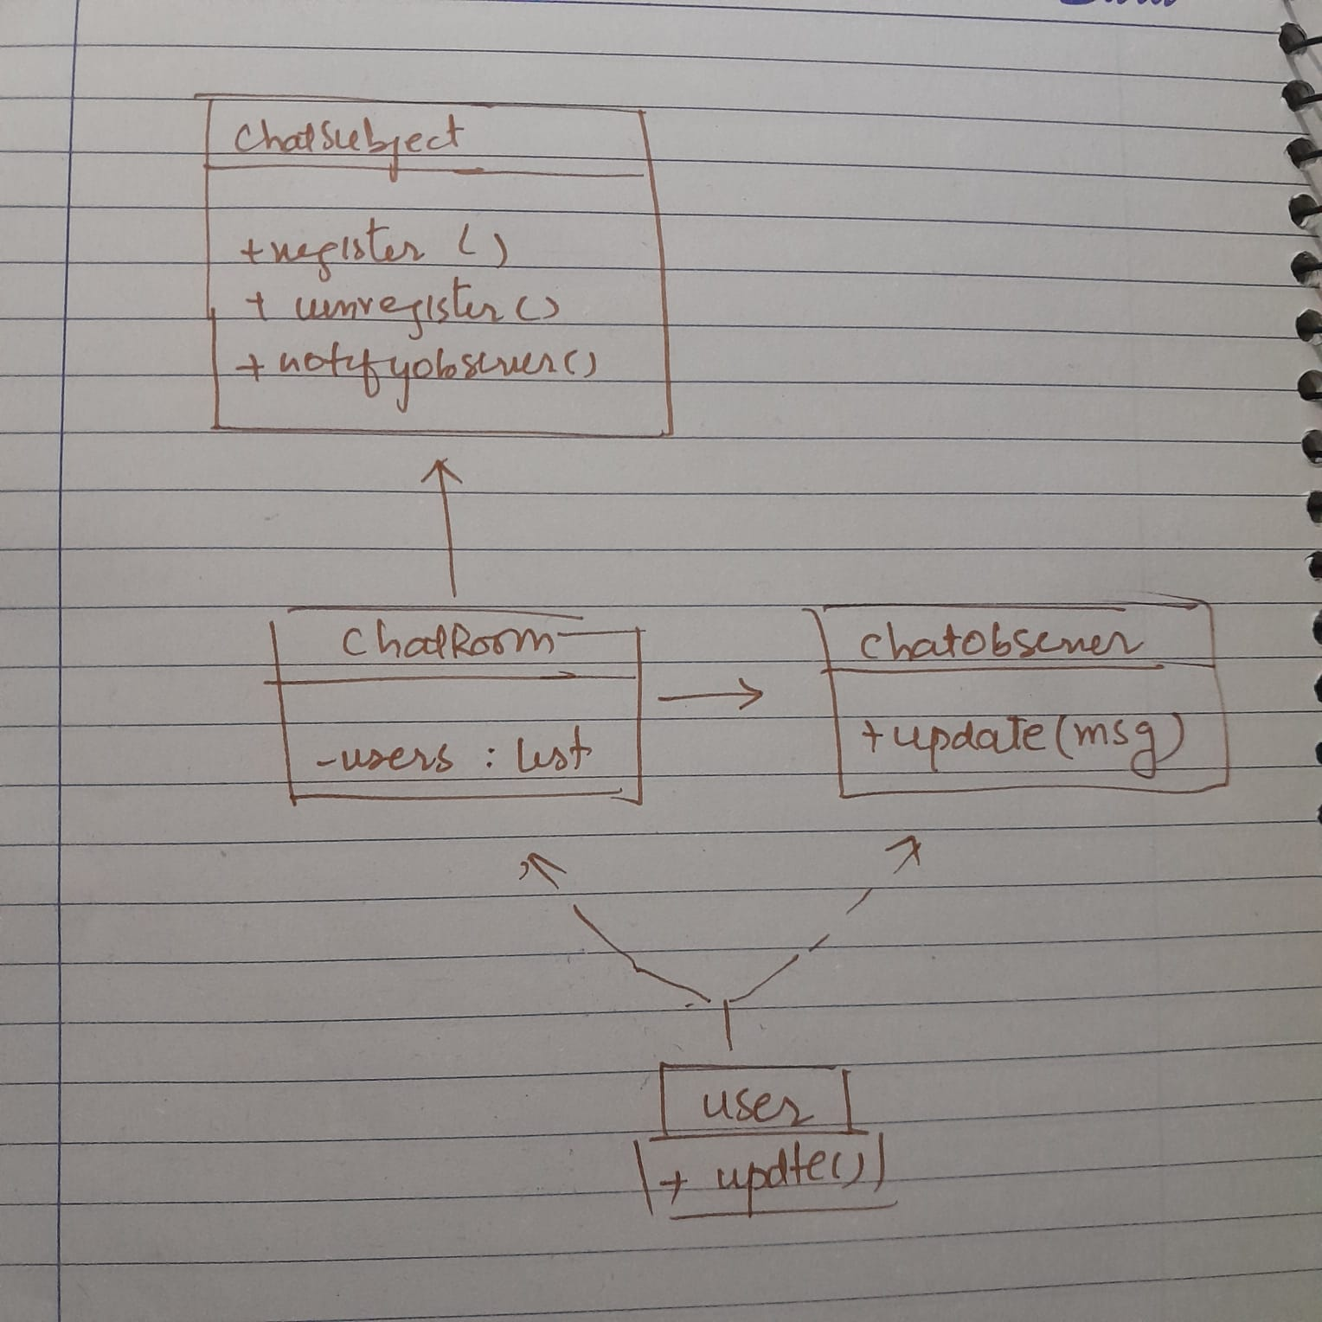

# **Implementation of prototype design pattern:**

## Task 1: Cloning Shapes

### Code

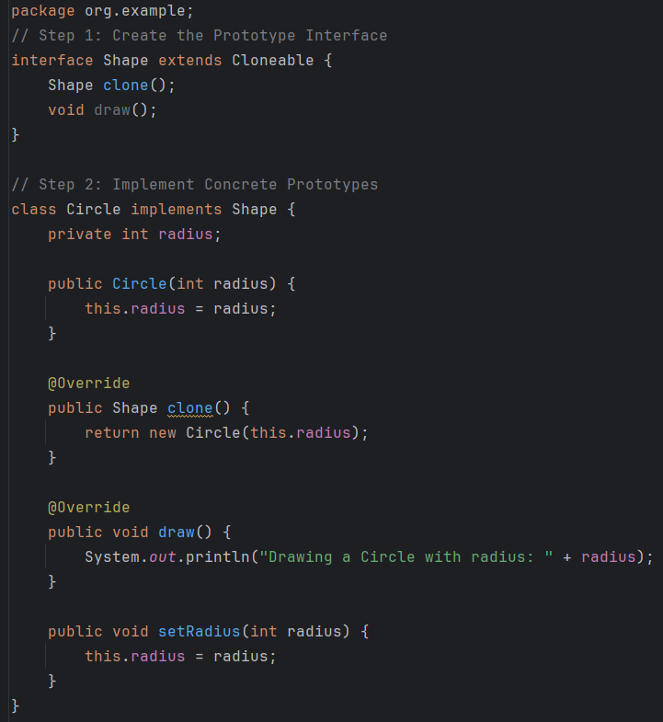

### Class Diagram

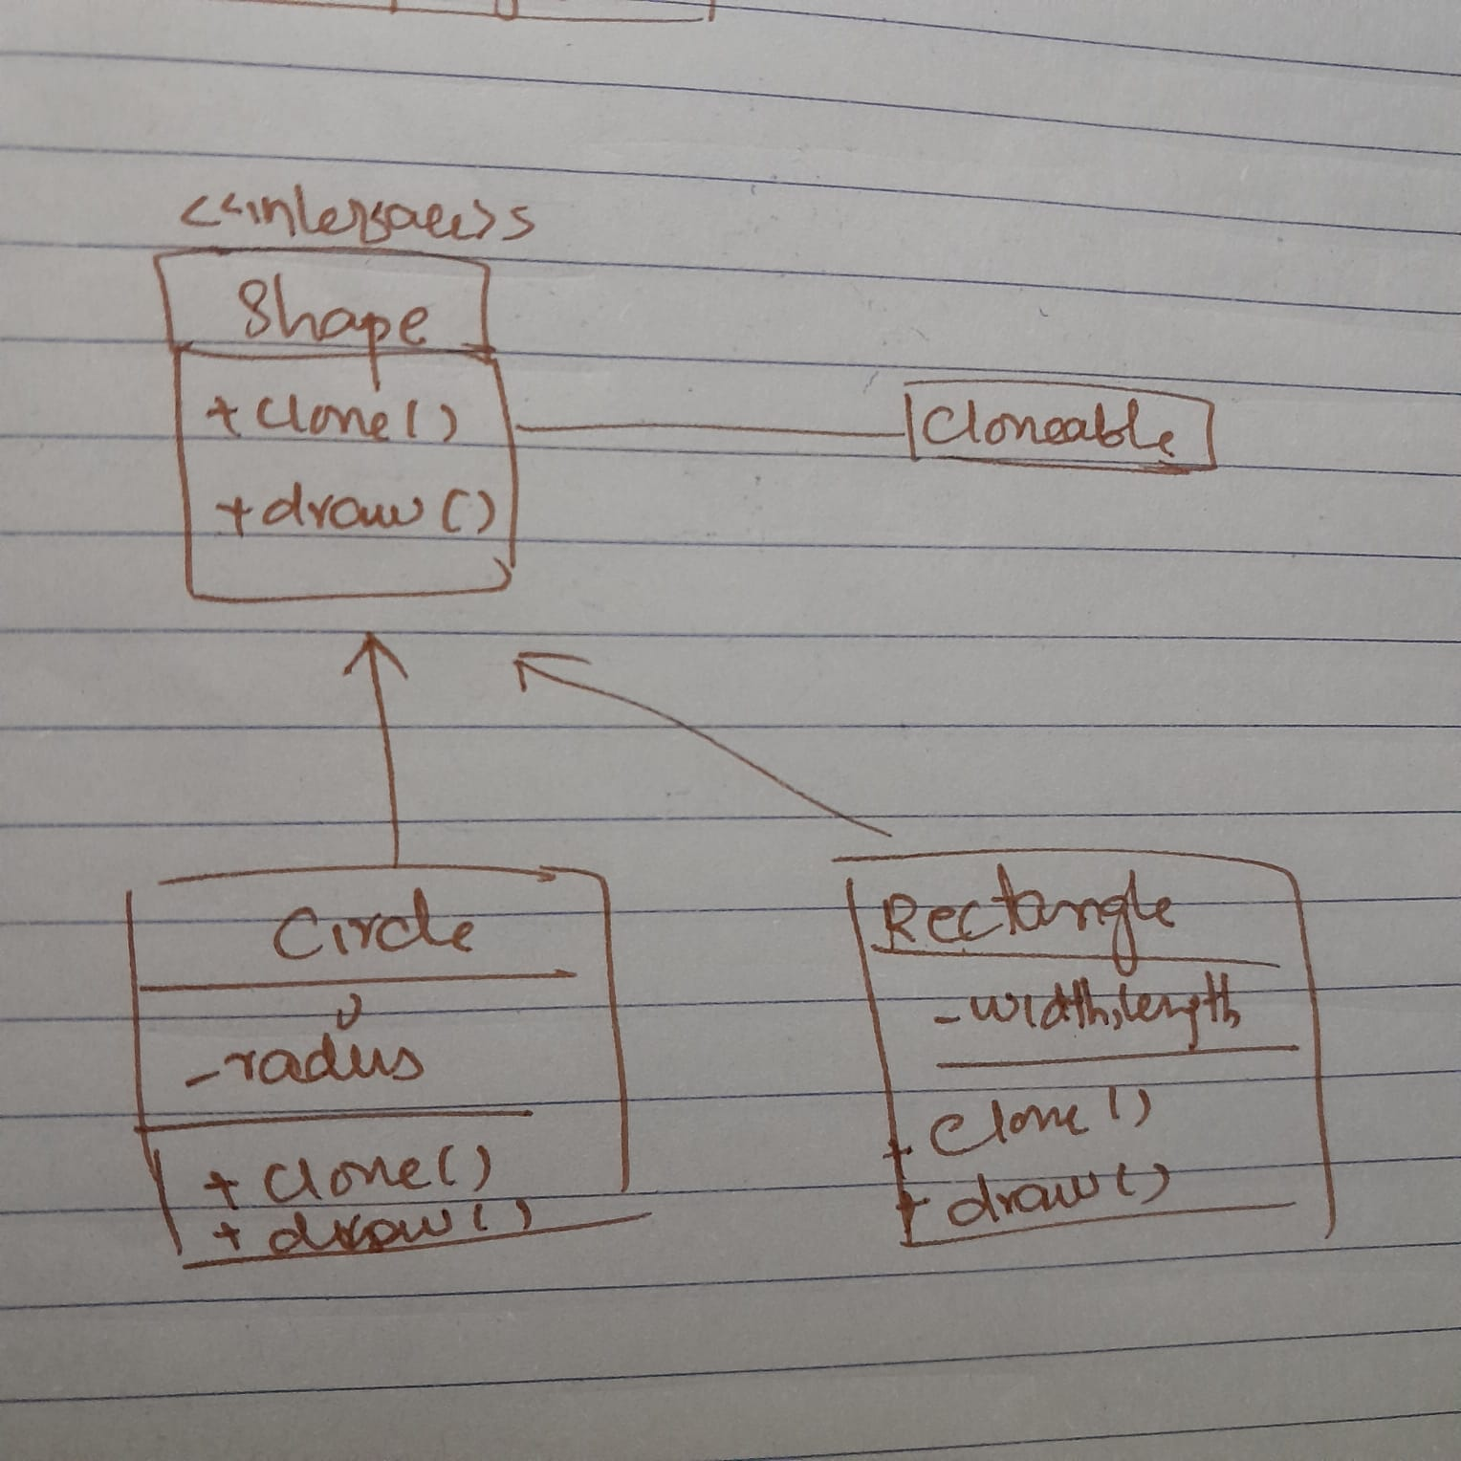

## Task 2: Cloning Employee Records

### Code

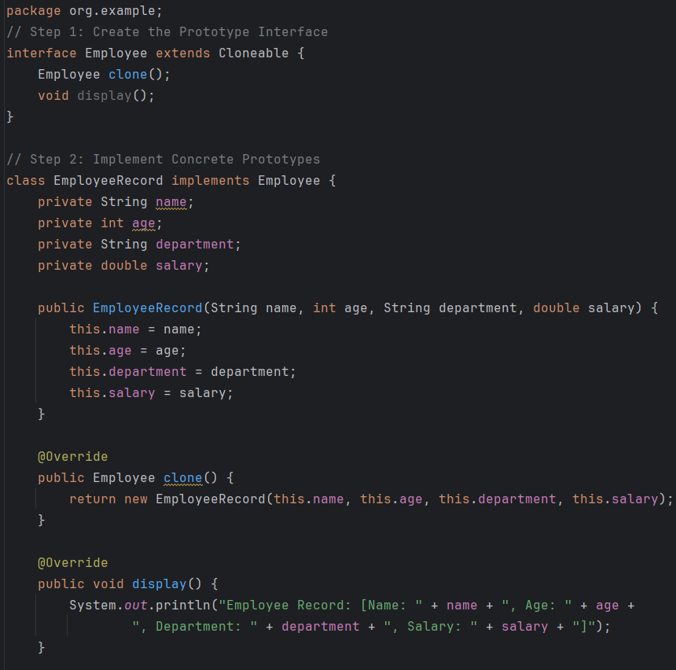

### Class diagram

