

**COMSATS University Islamabad**

**Abbottabad, Pakistan**

***Learning Management System-StudyPool***

**PREPARED FOR**

*Dr. Nosheen Gul*

**PREPARED BY**

*AIZAZ ULLAH FA21-BSE-007(3A)*

*LAIBA BINTA TAHIR FA21-BSE-019(3A)*

*ARFAH ALI FA21-BSE-080(3A)*

**DATED**

*11 January 2022*

**EXECUTIVE SUMMARY**

In the recent years, there has been increasing demand in joining of new technologies into educational processes. Learning Management System (LMS) as a web based technology in educational programs, provides support to instructors to reach their pedagogical goals, organize course contents and support students.

The Online Learning Management System utilizes the process of teaching techniques. The system specifically focuses on the teaching process and also its efficiency and effectiveness. It also focuses on the learning Material for the students. These are provided through documents, written lectures, and video lectures. The proposed system will help decrease time and effort of the Students and teachers to disseminate their learning materials and also offers faster and easier task to the faculty and student of Bachelor of Science in Information Systems Department.

LMS provides workspaces to facilitate information sharing and communication among students and lecturers to participate in course activities. Educators are able to distribute information to students, produce content material, prepare assignments and tests, engage in discussions, manage distance learning and enable collaborative learning using forums, chats and news services.

**ABBREVIATIONS**

|  |  |
| --- | --- |
| **SRS** | Software Require Specification |
| **LMS** | Learning Management System |
| **UI** | Personal Identification Number |
| **MS** | Microsoft |
| **DFD** | Data Flow Diagram |
| **ERD** | Entity Relationship Diagram |
| **UML** | Unified Modeling Language |
| **SD** | Sequence Diagram |

Table Of Contents

**1.** **Introduction** 7

**1.1.** **Relevance to Course Modules** 7

**4.1.** **Project Background** 7

**4.2.** **Literature Review** 8

**4.3.** **Methodology and Software Lifecycle for This Project** 8

**1.6.1.** **Rationale behind Selected Methodology** 8

**2.** **Problem Definition** 10

**2.1.** **Problem Statement** 10

**2.2.** **Deliverables and Development Requirements** 10

**2.3.** **Activity Plan** 12

**2.3.1.**  **Work Breakdown Structure (WBS)** 12

**2.3.2.** **Gantt Chart** 13

13

**3.** **Requirement Analysis** 14

**3.1.** **Functional Requirements** 14

1. Every user of the system has to login in order to access the system. 14

**3.1.** **Non-Functional Requirements** 14

**3.2.** **Use Cases Diagram(s)** 16

17

**3.3.**  **Fully dressed and Detailed Use Case** 17

**4.** **System Design** 19

**4.1.** **Entity Relationship Diagram** 19

19

**4.2.** **Data Flow Diagram** 22

**4.3.** **Design Models** 24

**5.** **Prototyping** 27

**5.1.** **User Interface** 27

**6.** **Testing and Evaluation** 33

6.1. **Test Case Scenarios and Test Cases** 34

**1.1.** **Conclusion** 37

**1.2.** **Future Work** 37

**7.** **References** 38

**8.** **Appendices** 39

**LIST OF FIGURES**

Fig 1: Work Breakdown Structure 10

Fig2: Gantt Chart 11

Fig 3:UseCae Diagram………………………………………………..……………………...13

Fig 4:Entity Relationship Diagram…………………………………………..……………....16

Fig 7:Data Flow Diagram 19

Fig 9:Class Diagram 21

Fig 10:Sequence Diagram 22

Fig 12:Activity Diagram 24

Fig 13:Flow chart………………...………………………………………………………..….36

Fig 14:Sequence Diagram(login/logout)…………………………………………………......37

**LIST OF TABLES**

Table 1: use case description for view class schedule…………………………………………….14

Table 2: use case description for upload grade……………………………………………………14

Table 3 use case description for view grade………………………………………………………15

Table 4: use case description for logout…………………………………………………………..15

Table 5: Connect with Tutor through Chat box…………………………………………………..31

Table 6: Functional Test cases: Test Cases to Register for Course……………………………….32

Table 7: Functional Test cases: Students apply for different scholarships. ………………………32

Table 8: Functional Test cases: Students apply for different scholarships. ……………………….33

Table 9: Display the result of students according to the module………………………….…….…33

Table 10: Functional Test cases: Reset/change the user’s password in the profile settings………...34

1. **Introduction**

A learning management system is a software application named STUDY POOL for the administration, documentation, tracking, reporting, automation, and delivery of educational courses, training programs, materials, or learning, and development programs. The learning management system concept emerged directly from e-Learning. It is a framework that handles all aspects of the learning process. With a user-friendly interface, educators can easily manage content, automate tasks, and streamline their curriculum.

* 1. **Relevance to Course Modules**

Our Project is almost related to almost every module that is studied in Software Engineering. Following are the main modules that are directly related to our project:

1. The first phase is planning, here we use the concepts of **Introduction to Software Engineering:**

The main concept **ISE** is how you can manage Software Development. We can use the process models in ISE to develop our project, by first listing requirements, then formulating the system design, listing tests and in the end making a plan for the development of our project.

1. The next phase is coding, here **OOP** and **PF** and **Web Development** comes in handy:

These Subjects will help us in developing websites, mobile application and other functionalities of our software. These modules will help us in writing codes of our project.

1. Similarly **Data Structures** will help us creating a secure and efficient database for our project.
   1. **Project Background**

The main idea behind this project is to help those students who cannot afford to pay large sums of fees for higher education, by giving them quality education for free of cost. Additionally it will have portions containing notebooks, lecture notes, examination papers, and all other study material on all subjects. This system also intends to help in sharing student work. By uploading and selling documents and serving as an instructor. It will also be possible to have an income from this. In this, users can ask questions to tutors and get answers so that they can get ahead in learning. This platform also gives a chance to participate in contests in any subject and will get certificates.

* 1. **Literature Review**

E-learning started in the early in 1990s, with time many countries started using this method for teaching. Now in 2023 there are millions of Learning Management Systems (LMS) or e-learning platforms. Still now LMS is growing a high rate, new methodologies are being introduced to improve e-learning, these include micro learning, game based learning, augmented and virtual reality etc. The main benefit of e-learning is that every student has the opportunity to obtain the same type of curriculum, study materials, and training, and you can save both time and money, not to mention the cost of transportation.

* 1. **Methodology and Software Lifecycle for This Project**

The methodology we will be using for the making of our project is **V model**. As this model will help us in clearly understanding all the requirements and ease up our work in creating the final **SRS** document of our project.

1. 6. 1. **Rationale behind Selected Methodology**

We prioritized using **V model** for the making of our software due to the following reasons:

* The main advantage of using V model is that it offers testing and verification on each step during the software development, which in return increases accuracy.
* V model includes [White Box Testing](https://www.guru99.com/white-box-testing.html) (design testing) and [Black Box Testing](https://softwaretestingfundamentals.com/black-box-testing/) (functional testing), integration testing, and acceptance testing. These are all the factors that will improve software quality.
* This verification and validation at each phase reduces the downward flow of defects, as most of the defects are eliminated at an early stage.
* It includes thorough documentations of requirements and other planning. This will help the developers in easily understanding the project and tasks.
* As one phase is completed at a time, it will enable the project management to track the progress accuratel.

1. **Problem Definition**

This section discusses the precise problem to be solved. It should extend to include the outcome.

4. 1. **Problem Statement**
5. How will we assign some students and teachers as course helpers, tutors?
6. How do the tutor and students communicate with each other?
7. How will ensure that the system is size adaptable and works on smartphones, tablets, and other devices?
8. Will System’s interface be Synchronous or Asynchronous interface?
9. How can we make our system more responsive?
10. How are we going to cope with excessive pop-ups?
11. How are we going to reduce the response time of our system?
12. How does our system be browser compatible?
13. How can we provide a platform to those students who want to sell their documents?
14. How can a person donate to our organization?
15. How we will be offering contests.
    1. **Deliverables and Development Requirements**

**Deliverables:**

* Semester Project Report
* User Interface Design

**Requirement tools:**

Star UML

Fluid UI

MS Project

MS Word

Lucid Chart

**Required Diagrams:**

WBS

Gantt chart

ERD

DFD

Sequence Diagrams

Class Diagrams

Activity Diagrams

System Design

* 1. **Activity Plan** 
     1. 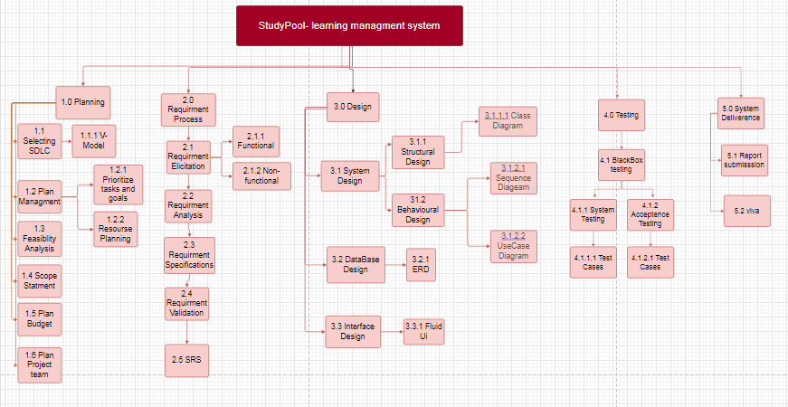**Work Breakdown Structure (WBS)**

*Figure 1 Work Breakdown Structure*

* + 1. **Gantt Chart**

11-Jan-23

Figure 2 Gantt Chart

1. **Requirement Analysis**


5. 1. **Functional Requirements**
6. Every user of the system has to login in order to access the system.
7. Students and Instructors will have separate personal profiles, students can see the progress they have recently in form of dashboards. System users have access to change passwords and update their profiles.
8. Students can view the course outlines and take important info about available courses. Students can apply for registration for different courses. After the selection, of the course, learning starts.
9. Students can attempt quizzes and assignments from their registered courses; quizzes and assignments are weekly basis and after every quiz mark initiated itself.
10. On completion of a course students will be given certificates; not only those weekly biweekly contests occur that also give certificates but for every contest, the student must register accordingly.
11. Students can apply for different available scholarships; before applying must check their eligibility criteria.
12. Helpers can upload Notes and other helping material for students, but these notes must be approved through the admin; also approved documents will give money to the uploader.
13. To connect with the tutor there is the option of a discussion box where students have a QnA session.
14. Also have the option to give suggestions to improve the system or any complaints that are managed by the admin of the system.
15. A donation section is established to support the system donors have the right to reveal their identity or to stay anonymous.
    1. **Non-Functional Requirements**

* **Reliability** shows how long the system can work without any technical issues leading to the failure of the operation. It will regularly check the average server response time. A stable platform keeps users engaged.
* **The efficiency of use**demonstrates the simplicity of operating the system and the time to achieve the goals.
* **Performance**relates tohow the LMS responds to an increasing volume of users.
* **Security**shows the level of protection against viruses and illegal access to the database. Additional features that help keep the platform safe include advanced data encryption, antivirus and anti-spam software, IP blockers for unwanted addresses, and advanced password authentication with a limited number of attempts to log in.
* **Availability** can be measured by the time when the system's operations are available for users, including the periods of scheduled maintenance. How easy is it for a customer to use the system?
* **Scalability** Which hardware, operating systems, and browsers, along with their versions does the software run on?
* **Compatibility** How well is the system and its data protected against attacks?
  1. 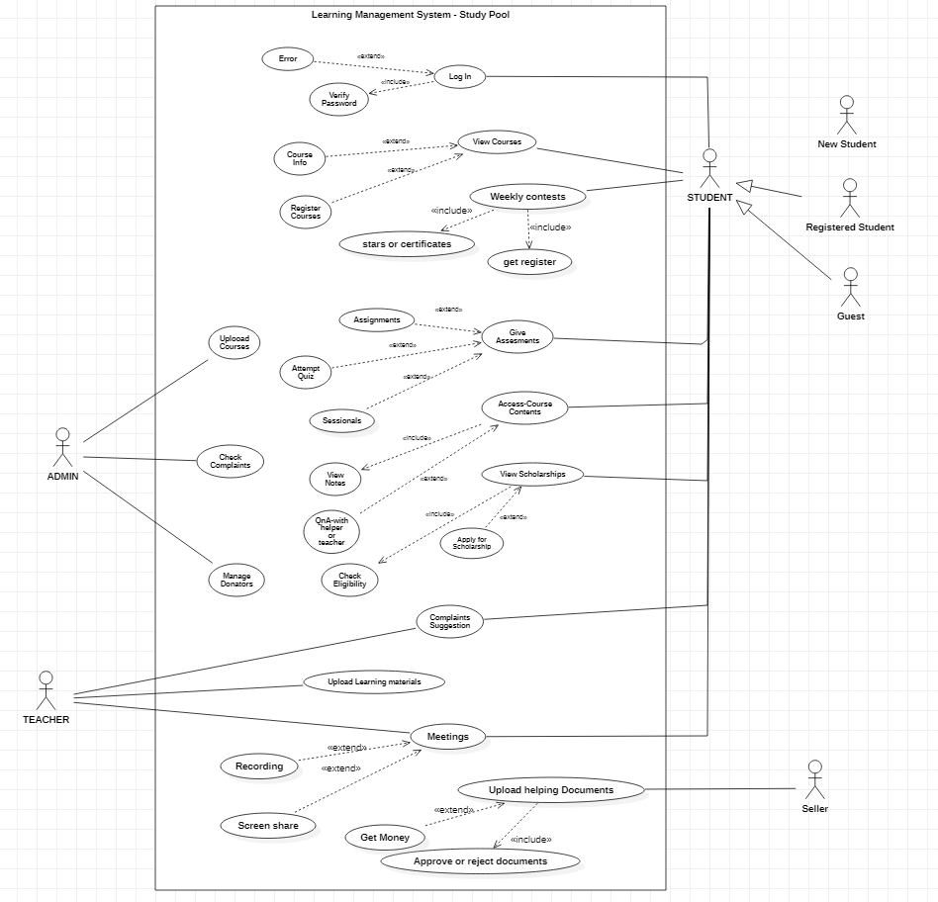**Use Cases Diagram(s)**

Fig 1.3

*Figure 3 Use Case Diagram*

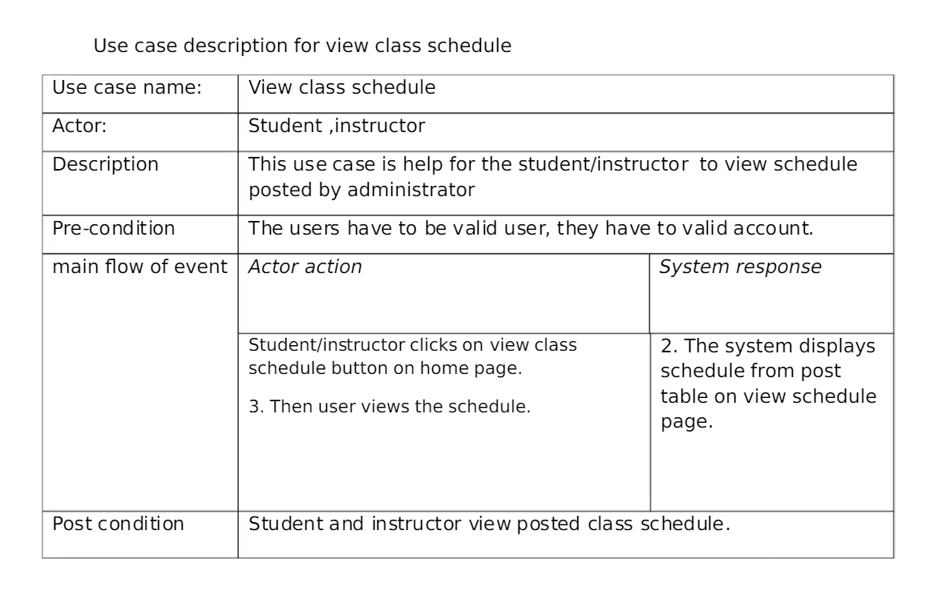

* 1. Table

     Description automatically generated with medium confidence**Fully dressed and Detailed Use Case**

Table.2 use case description for upload grade

Table 1 use case description for view class schedule

Table 4 use case description for logout

Table 3 use case description for view grade

1. **System Design**

The following parts of Software Design Description (SDD) report includes ERD, DFD, Class Diagram, Sequence Diagram, and in this section.

8. 1. **Entity Relationship Diagram**

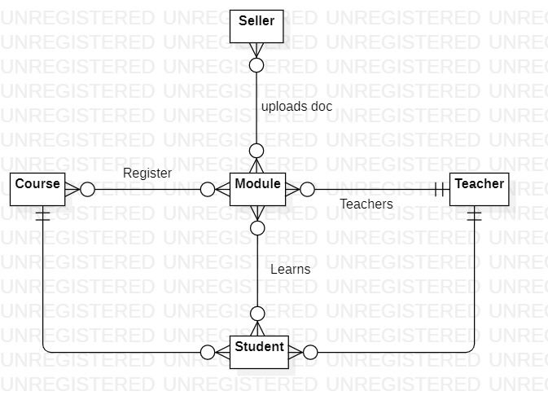

Fig 1.4

*Figure 4 ER Diagram*

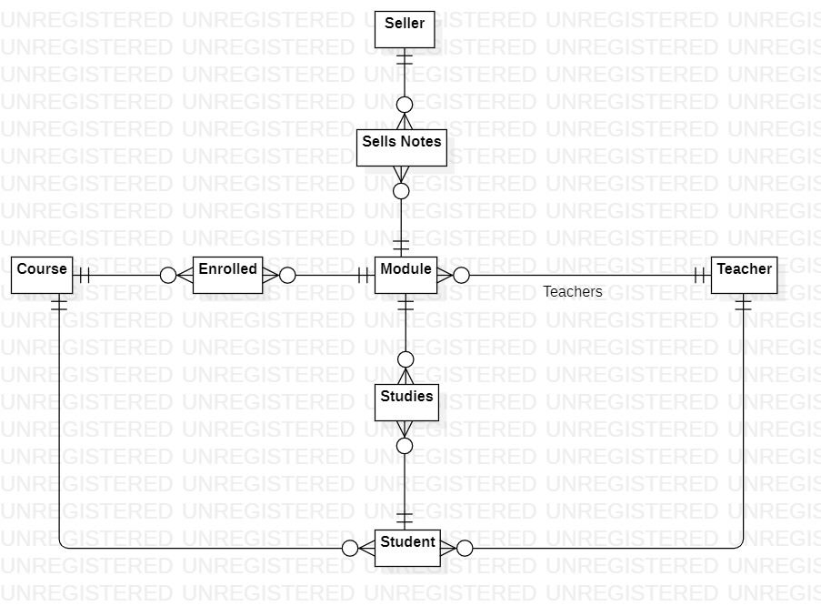

*Figure 5 ER Diagram(resolved M:M)*

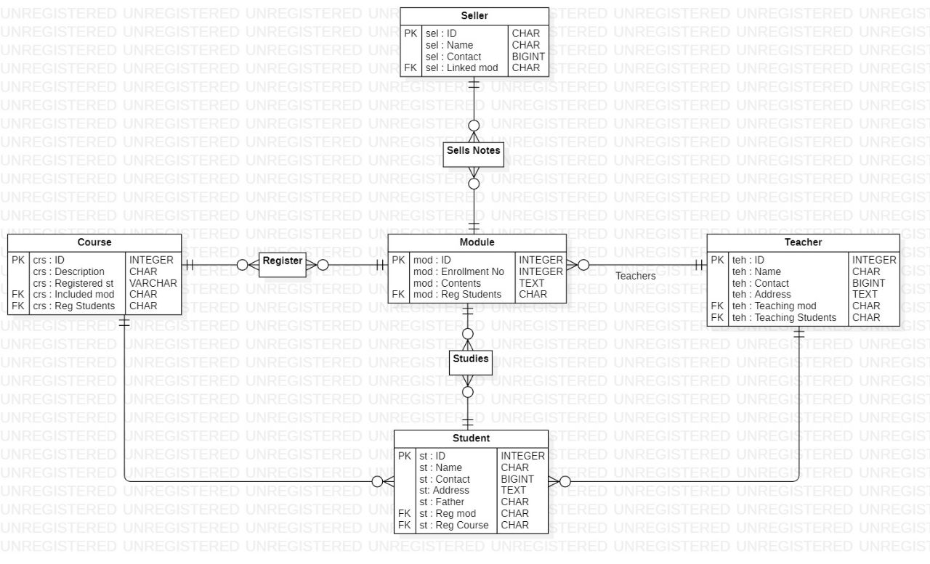

*Figure 6 ER Diagram*

* 1. **Data Flow Diagram**

Data Flow Diagram 0

In DFD 0 we have 4 Entities admin, seller, instructor and student who are interacting with learning management system and the data is flowing among them.

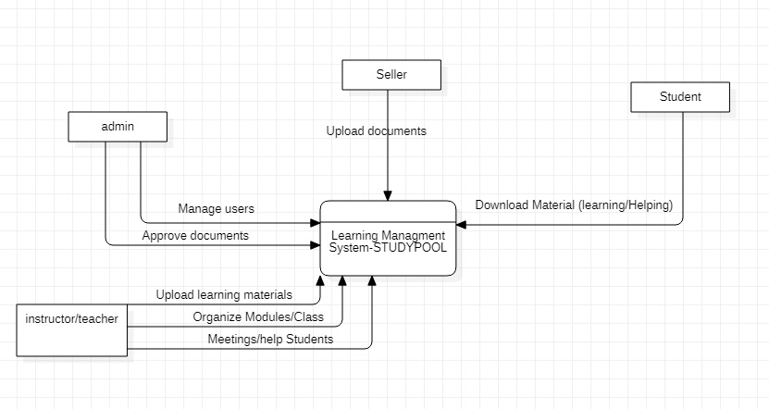

*Figure 7 DFD Level 0*

Data Flow Diagram 1

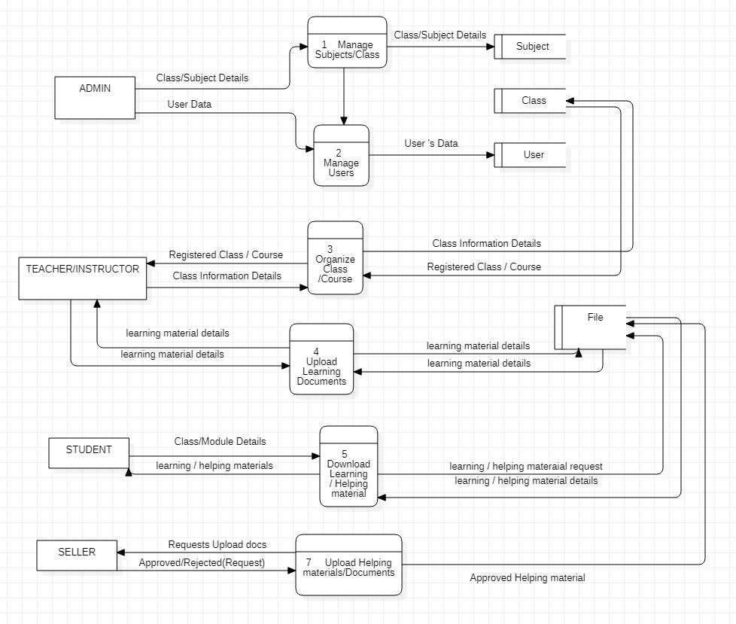All details, Information, data, and files are passing from one entity to other or from entity to process through Data stores.

*Figure 8 DFD level* 1

* 1. **Design Models**

**Class Diagram:**

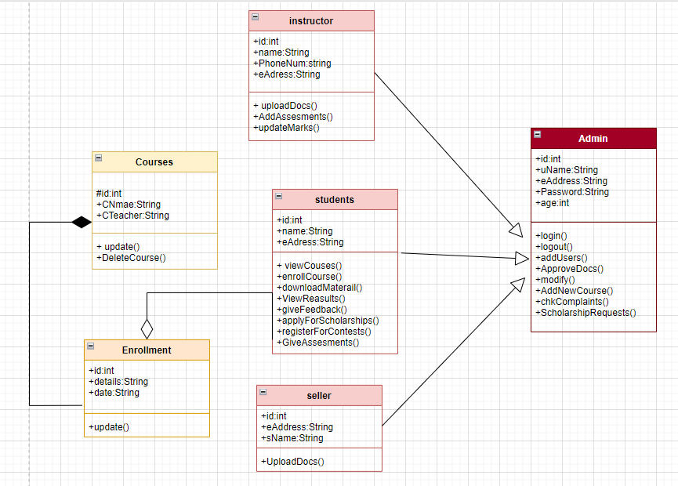The following UML class diagram shows the generalization, composition and association between classes.

Figure 9 UML Class Diagram

Sequence Diagram of course enrollment

Figure 10 Sequence Diagram(login/logout)

The following Sequence diagram of system represents how the course enrollment occurs. First student inquires course enrollment and on processing list of courses are provided. If student purse the course list of requirements have to be provided by student. On completion of all requirements system checks whether the user is eligible for enrollment or not

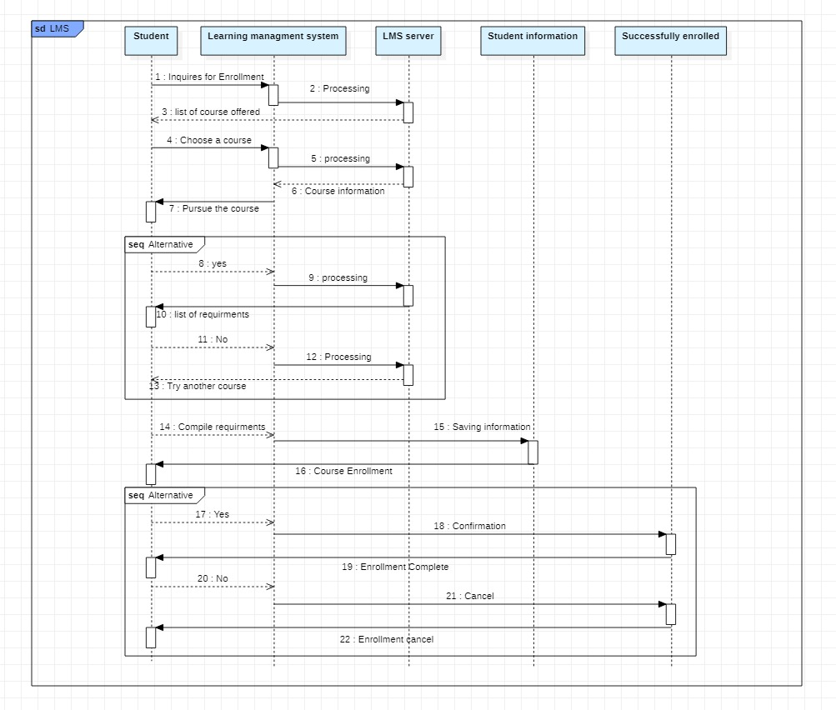

*Figure 11 SD Course Enrollment*

Activity diagrams

Activity diagram shows that user login to system, enroll courses, register course, upload documents.

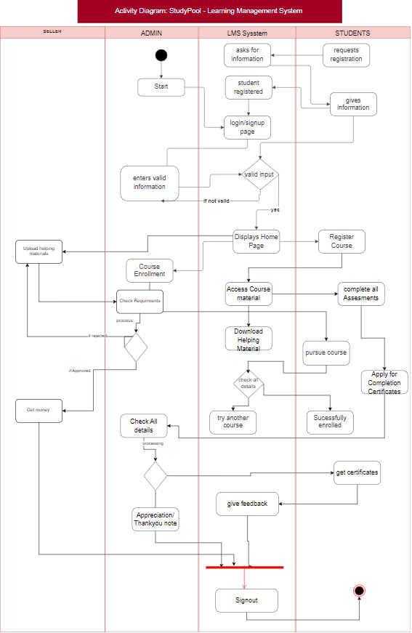

*Figure 12 Activity Diagram*

1. **Prototyping**

* 1. **User Interface**

This User Interface has 10 Pages and every page is linked with previous and next page through Buttons. Each page has Features covering all the functional requirements of the project.

This first page allows user to sign up or login. On pressing login User will access Login page and then to the main page of the Application/System.

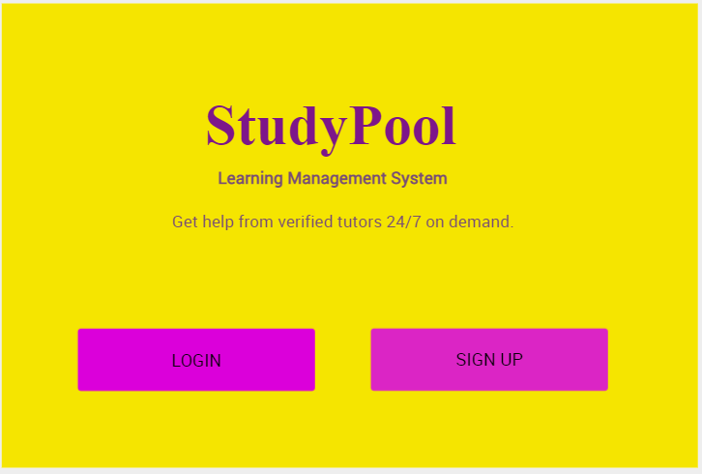

**Sign Up Page:**

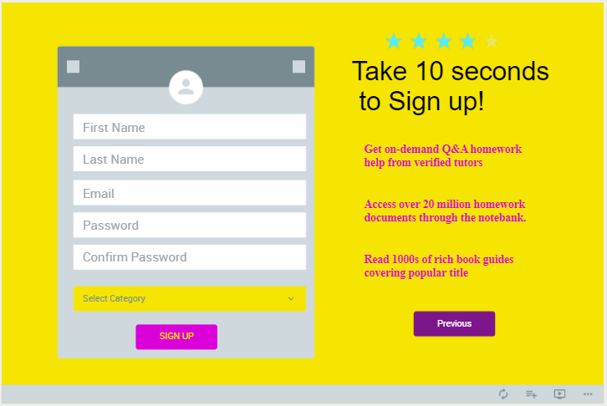

Welcome main Page:

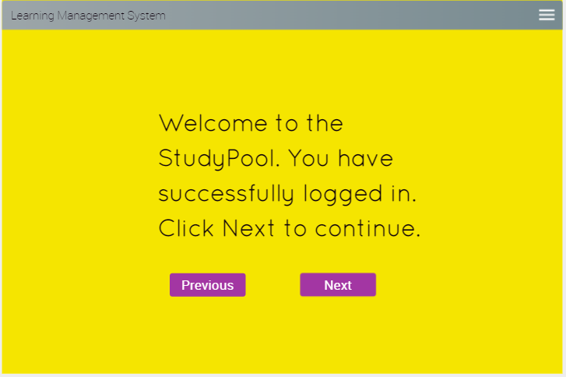

Menu Options:

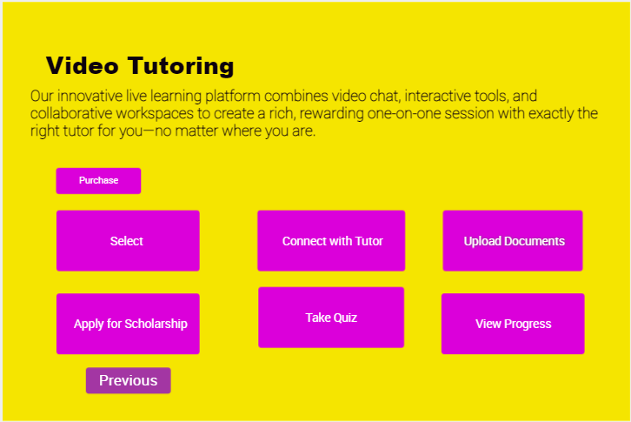

Connect with tutor button will allow access to this page through which a student can clarify all the queries.

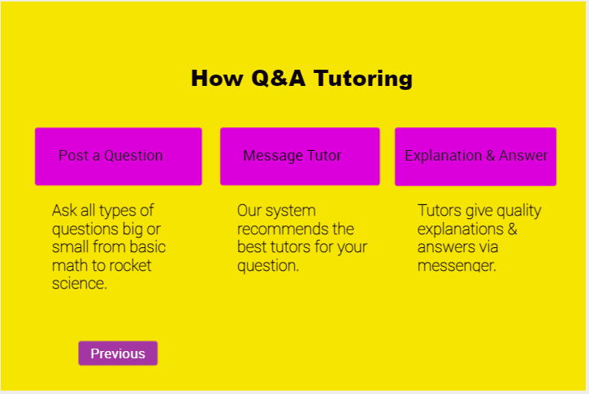

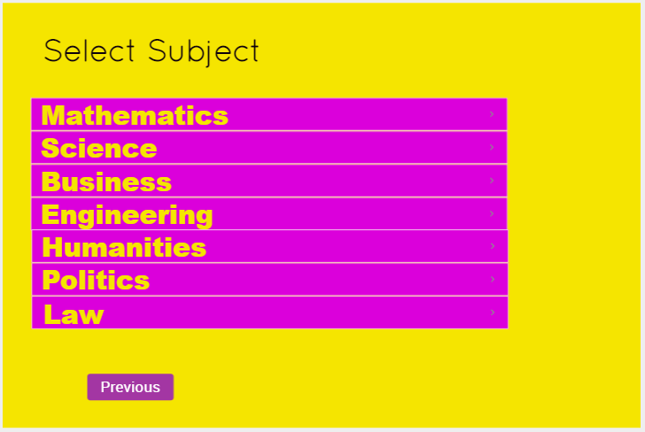

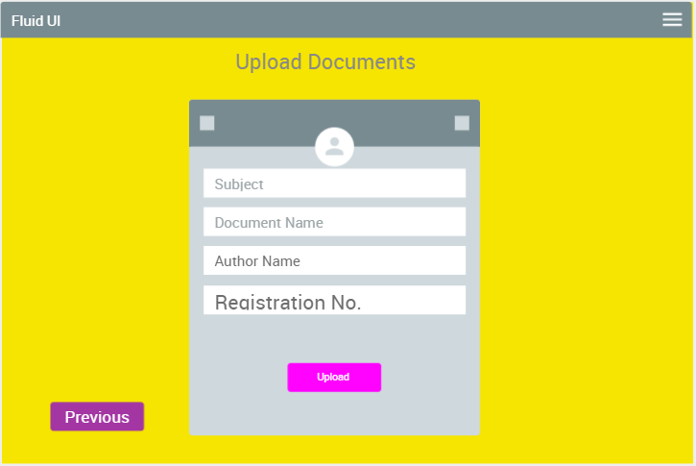

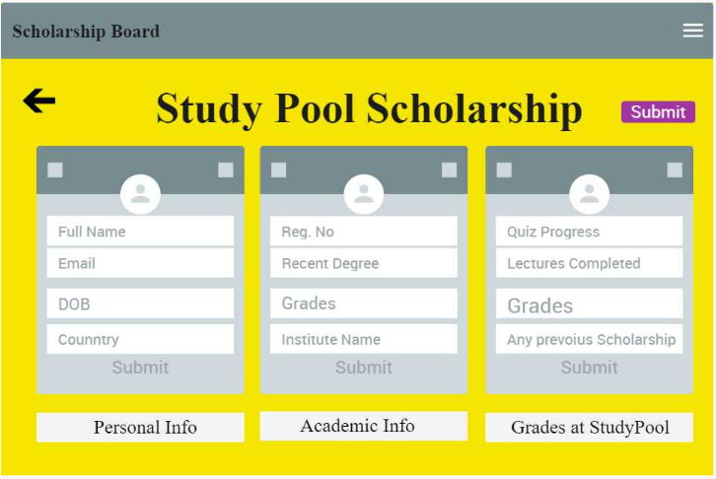

Links:

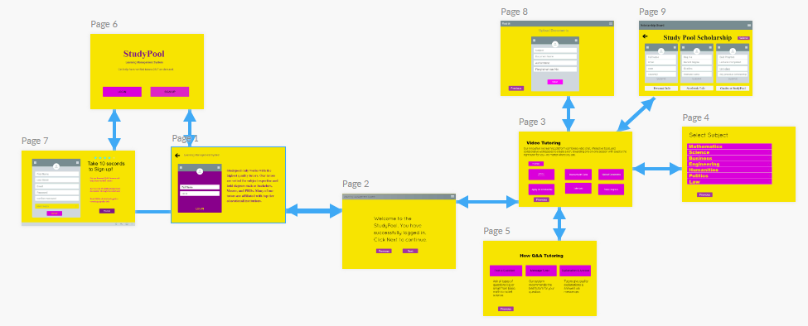

1. **Testing and Evaluation**

Software Testing is a method to check whether the actual software product matches expected requirements and to ensure that software product is Defect free. It involves execution of software/system components using manual or automated tools to evaluate one or more properties of interest. The purpose of software testing is to identify errors, gaps or missing requirements in contrast to actual requirements.

Test plan is that we will use dynamic testing (Black box) for our project.

In black box we will follow acceptance and system testing along with test cases. In these testing we will look into behavior of the system. We will examine the functionality of our system as our system doesn’t contain any code. We will check either the system meets the requirement specifications or not.

7. 1. **Test Case Scenarios and Test Cases**

*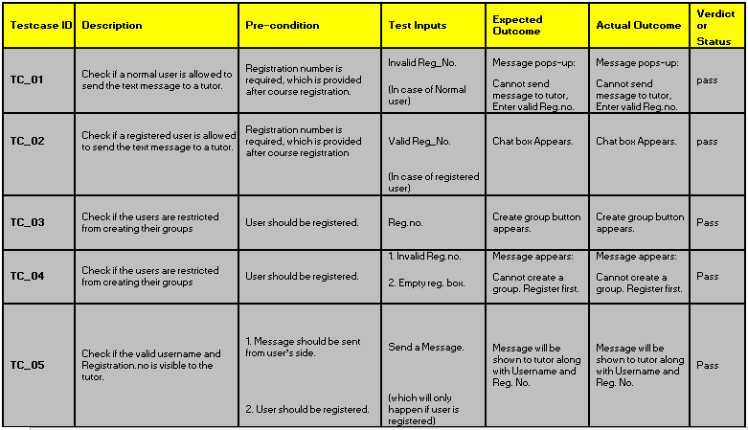Table* *5: Connect with Tutor through Chat box.*

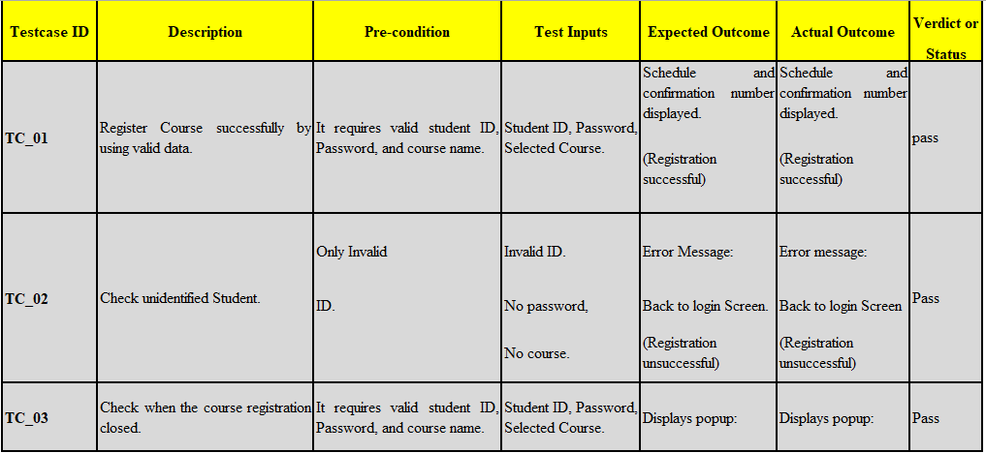*Table 6:* *Functional Test cases:* *Test Cases to Register for Course*

T*able 7:* *Functional Test cases: Students apply for different scholarships.*

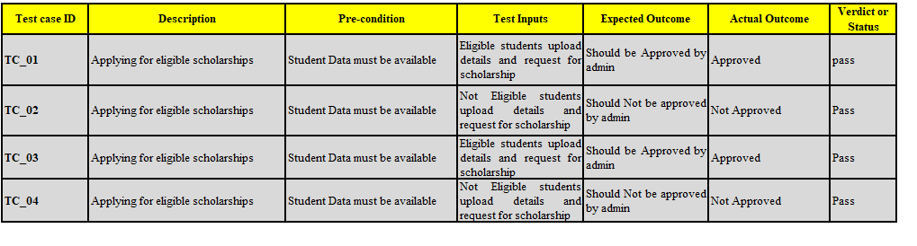

*Table 8:* *Functional Test cases: Students apply for different scholarships.*

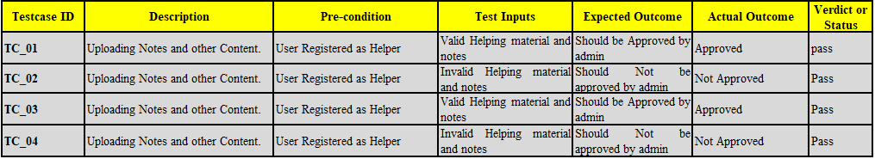

*Table 9:* *Display the result of students according to the modules*

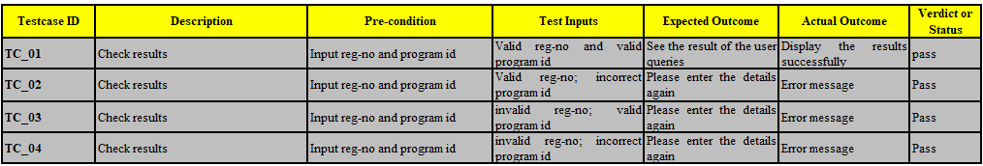

*Table* *10:Functional Test cases: Reset/change the user’s password in the profile settings*

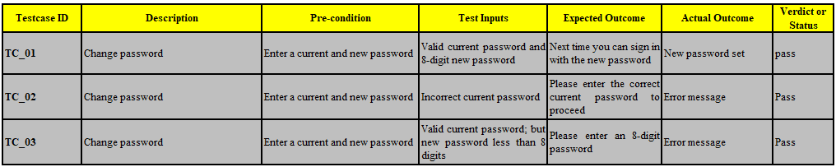

1. **Conclusion and Future Work**
2. 1. **Conclusion**

To sum up, the system is functional and accessible. This system is for the teachers and the students to have a communication even outside the classroom.

It gives the user the ability to acquire reliable learning resources accessible on the internet that will help the student and the teachers to disseminate their learning materials. It can enhance student learning by providing information from the teachers and all the available documents, lectures, test, assignments and researches. Apart from this it can be a good source of income for those who want to teach by sitting at home.

* 1. **Future Work**

The future of LMS promises better training outcomes for students and teachers. LMS trends and predictions about online education in the future show that the market for these platforms is growing. The global market for LMS software is expected to reach $7.57 billion by 2026.

1. **References**

* Learning Management System (LMS) Phase 1 Rollout: Regulatory Employee Training, Office of OSU Human Resources: Representative Donna Chastain **2022.**
* capstoneguide: Online Learning Management System Capstone Project Document, November 11th, 2022, https://capstoneguide.com/online-learning-management-system-capstone-project-document/
* Erin Frost (HR); Linda Sather (HR IT); Gabe Merrell (Equal Opportunity & Access); Chris
* Viggiani (Compliance), (1996), Software Engineering Fundamentals, Oregon State University. Chapter 8, pp255-235.
* Acadmia, project of e-learning.docx, https://www.academia.edu/31050464/project_of_e_learning_docx, 2023.

1. 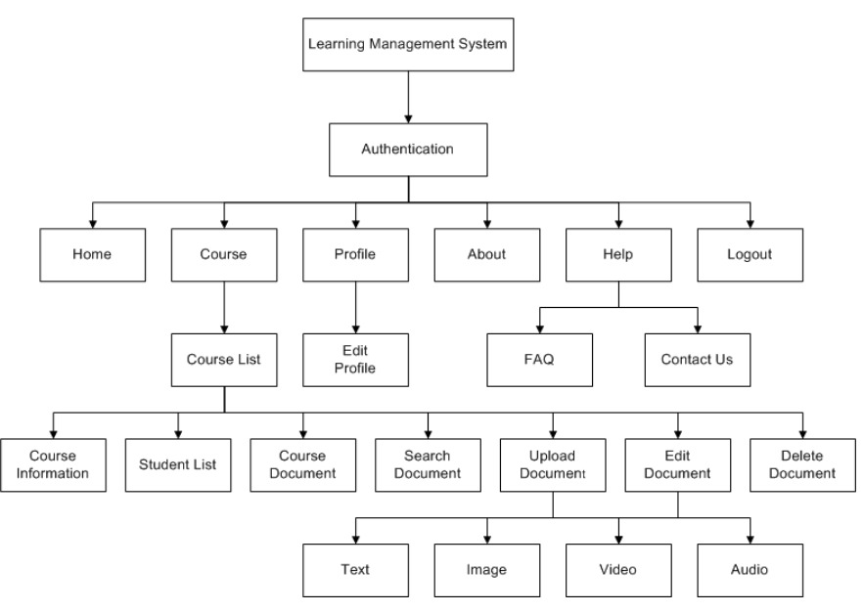**Appendices**

*Figure 13 Flow Chart Of LMS*

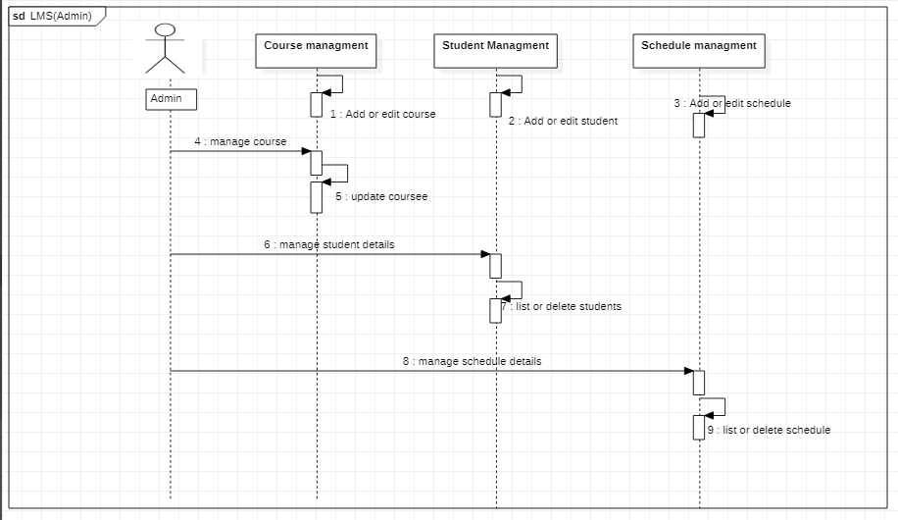

*Figure 14 SD LMS managment*

Figure 10 Sequence Diagram(login/logout)