

**COMSATS University Islamabad, Abbottabad Campus**

**Design pattern (Lab final)**

**Content generation Engine for AI-Assisted LMS**

***Submitted By***

**Laiba Binta Tahir CIIT/FA21-BSE-019/ATD**

**Arfah Ali CIIT/FA21-BSE-080/ATD**

**Hanzla Nouman CIIT/FA21-BSE-015/ATD**

**Abdul Rehman CIIT/FA21-BSE-062/ATD**

***Submitted to***

**Mam Faiza Hameed**

Contents

**1. Project Scope** 3

Objectives: 3

Scope: 3

**2. Stakeholders** 3

**3. Functional Requirements** 3

**4. Use Case Diagram** 5

**5. Sequence Diagram** 6

**6. Class Diagram** 6

**7. Design Pattern** 7

Factory Pattern 7

Observer Pattern 7

Decorator Pattern 8

Chain Of Responsibility 8

Adapter Pattern 9

Command Pattern 9

Facade Pattern 10

**8. Project Screens** 10

Content generation Engine

# **1. Project Scope**

The Content Generation Engine (CGE) is a core module of the AI-Assisted Learning Management System (LMS) that leverages artificial intelligence to automate and enhance educational content creation.

## Objectives:

* Automate the generation of high-quality educational content, including notes, quizzes, and multimedia resources.
* Improve efficiency for educators by reducing time and effort in manual content creation.
* Provide personalized, adaptable learning experiences to address diverse teaching styles and student needs.

Scope:  
The CGE focuses on transforming raw data and inputs (such as weak topic insights and clustered resources) into well-structured educational materials. Its application spans lecture planning, assessments, and student engagement content, making it a pivotal component of the LMS.

# **2. Stakeholders**

**Primary Stakeholders:**

* **Teachers:** Users creating and reviewing lecture content.
* **Students:** Beneficiaries accessing personalized and dynamic learning materials.
* **Educational Institutions:** Administrators ensuring the system aligns with curriculum standards.

**Secondary Stakeholders:**

* **Developers:** Engineers maintaining and enhancing the CGE module.
* **Content Creators:** Experts providing base-level content for AI training.
* **System Administrators:** Professionals managing data integrity and platform functionality.

# **3. Functional Requirements**

1. **Content Input Handling:**
   * Accept teacher inputs such as topics, objectives, and duration.
   * Process pre-existing insights (e.g., weak topic analysis, resource clusters) from the database.
2. **AI-Driven Content Generation:**
   * Generate comprehensive lecture content, including:
     + Notes
     + Quizzes
     + Multimedia resources
   * Adapt content for various teaching styles and student needs.
3. **Content Storage and Retrieval:**
   * Save generated content and associated metadata in the LMS database.
   * Ensure efficient retrieval for editing, publishing, and access by students.
4. **Content Review and Editing:**
   * Enable teachers to review and edit generated content.
   * Allow updates to metadata, including status changes (e.g., draft to be published).
5. **Publication and Distribution:**
   * Provide seamless publication of finalized lectures.
   * Distribute published content to students via the LMS frontend.

# **4. Use Case Diagram**

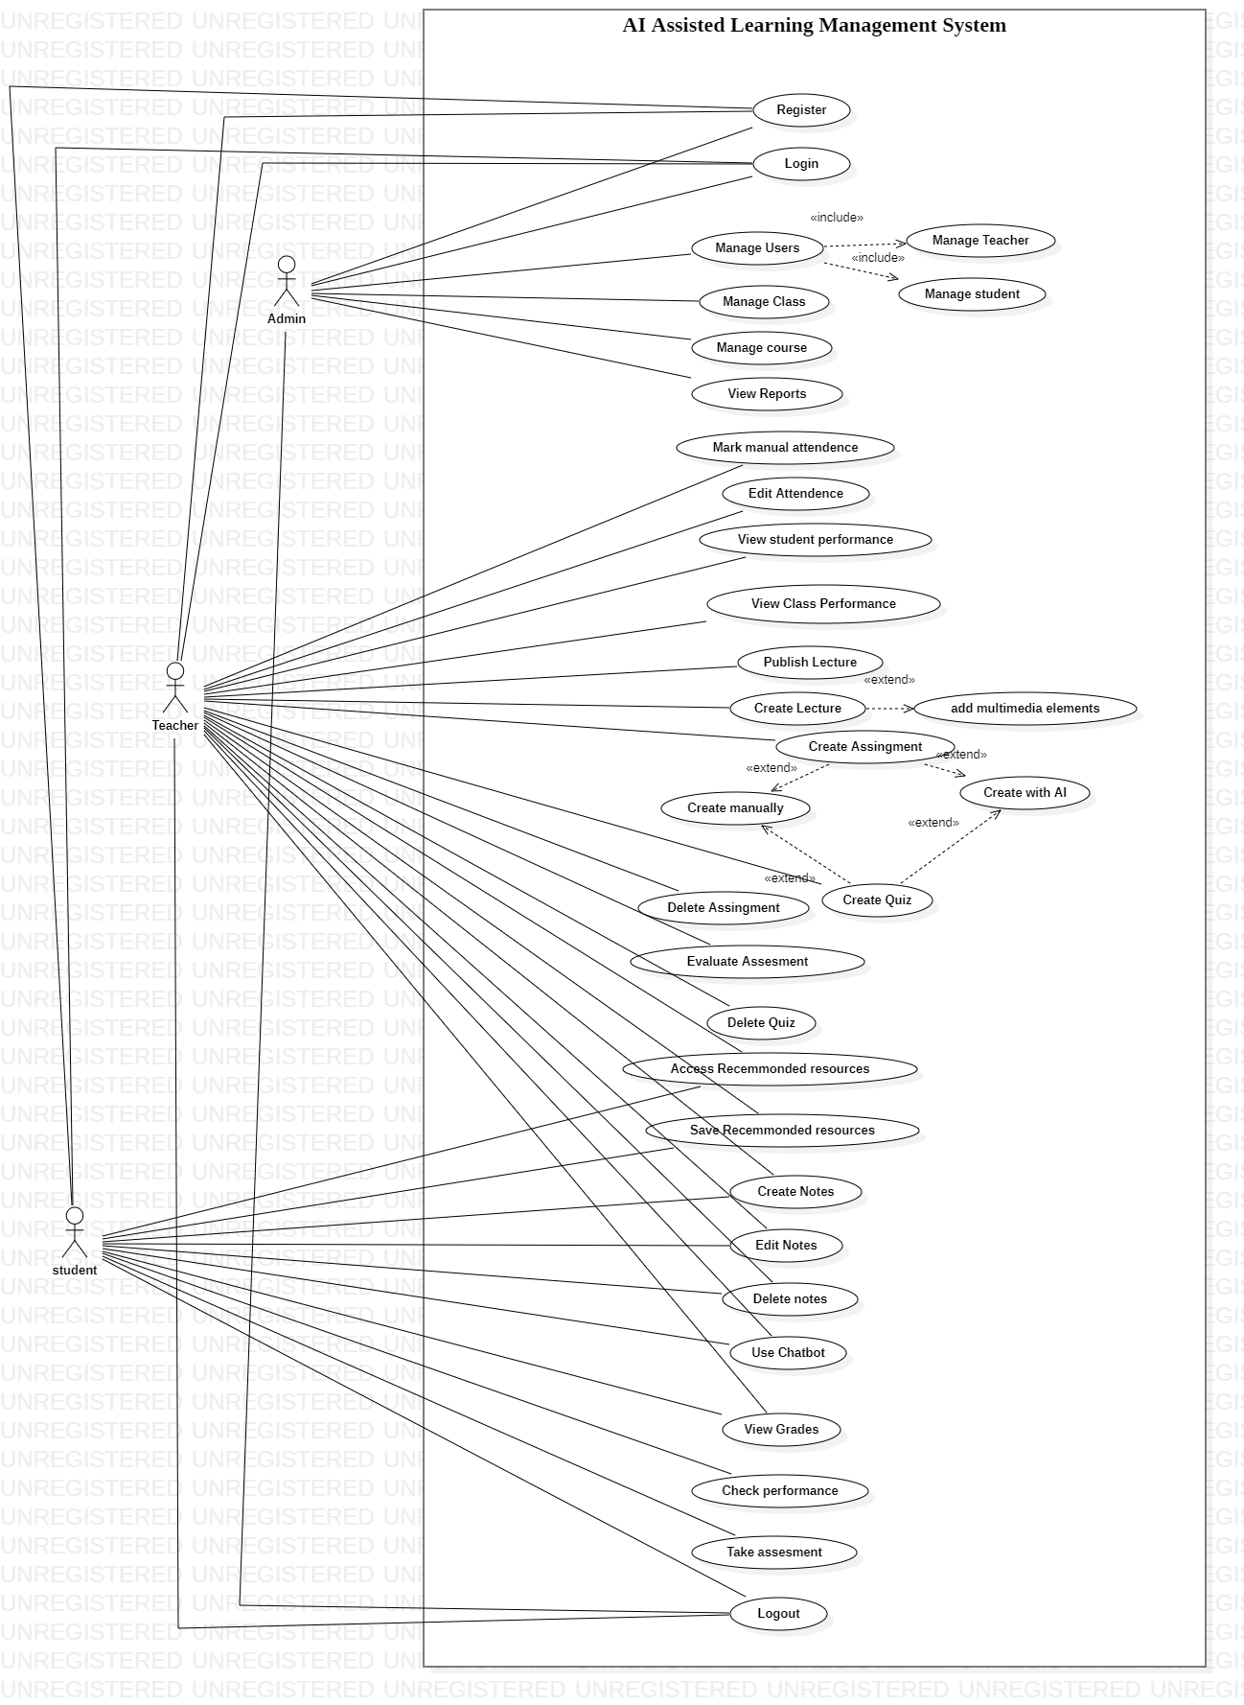

# **5. Sequence Diagram**

**6. Class Diagram**

# **7. Design Pattern**

## Factory Pattern

## Observer Pattern

Anywhere where useState and useEffect Hook is used)

## Decorator Pattern

## Chain Of Responsibility

The pipeline for generating lecture content (file parsing → chunking → embedding → AI generation) resembles a chain of responsibility.

## Adapter Pattern

Converts AI response format into a structure usable by the application

## Command Pattern

Used in the RichTextEditor for executing browser commands like bold, italic, or justifyLeft

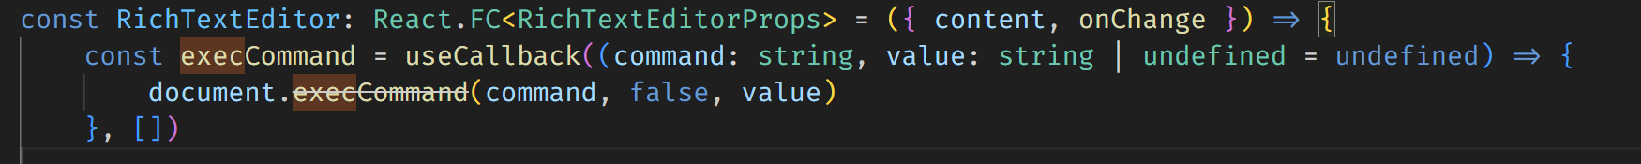

## Facade Pattern

The **LectureService** simplifies complex workflows like file parsing, embedding generation, and AI integration into a single method.

# **8. Project Screens**

Figure 1 Enrolled Courses

Figure 2 Specific course screen

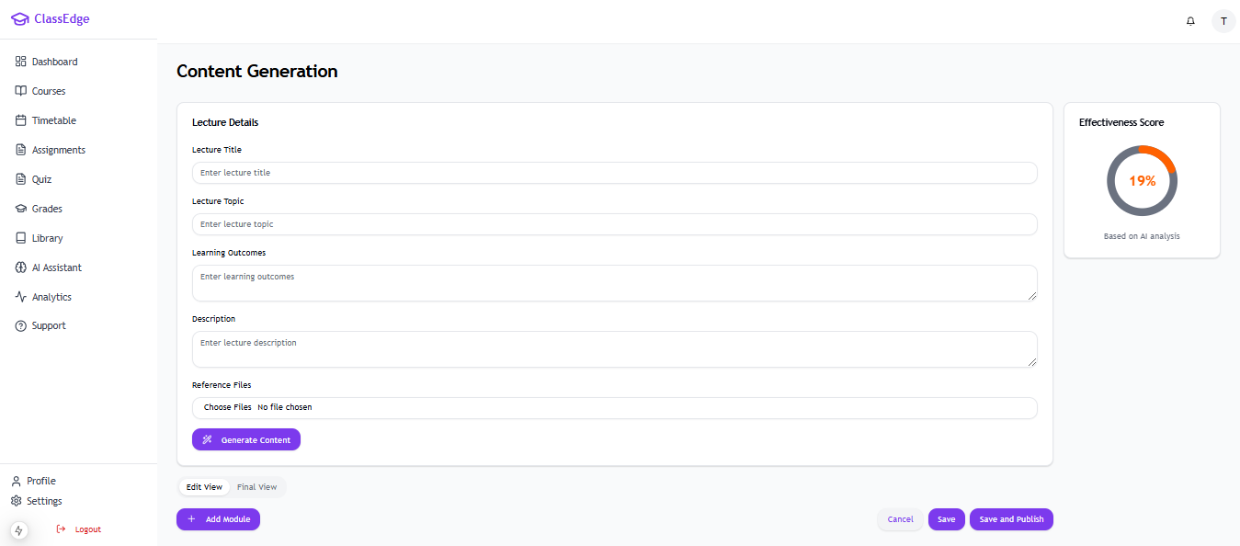

Figure 3 Content generation screen