**COMSATS UNIVERSITY ISLAMABAD, ABBOTTABAD CAMPUS**

**Assignment # 01 - Digital Image Processing (CSC331)**

***Submitted by:***

Laiba Binte Tahir

FA21-BSE-019-6A

***Submitted To:***

Dr. Mubashir Ahmad

**Histogram Equalization:**

**A:** Please calculate the histogram equalization of the following 13x9 grayscale 4-bit image with a graphical representation. Please follow all the steps in histogram equalization.

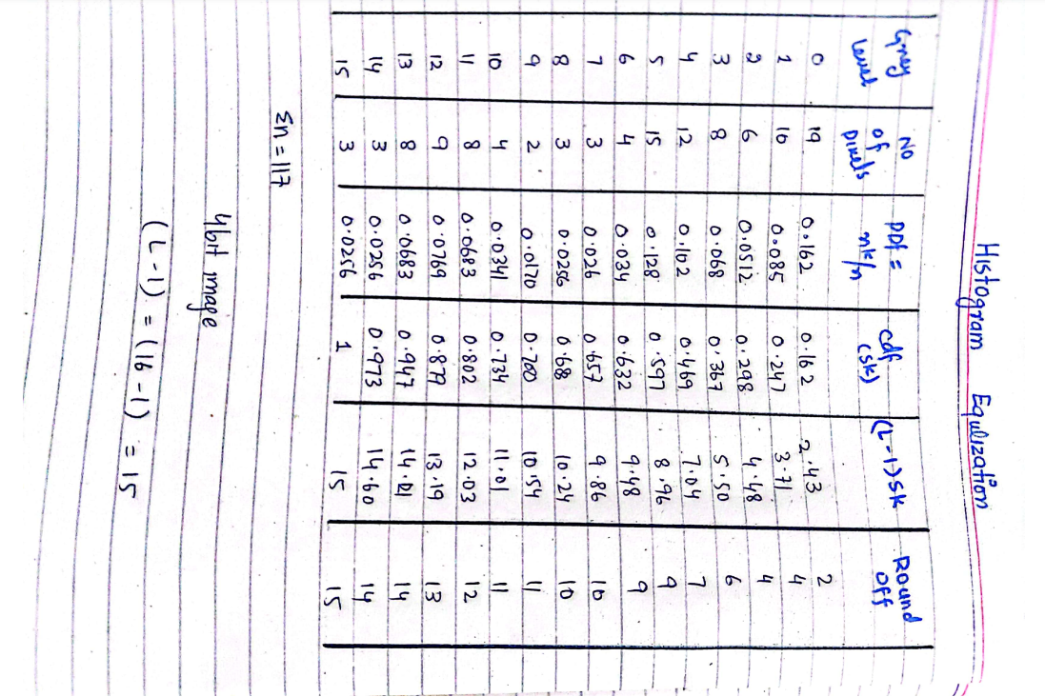

**B:** Implement the histogram equalization in MATLAB. Please write a code and generate the results of the above metrics with a graph that should show the histogram before and after HE.

**Code:**

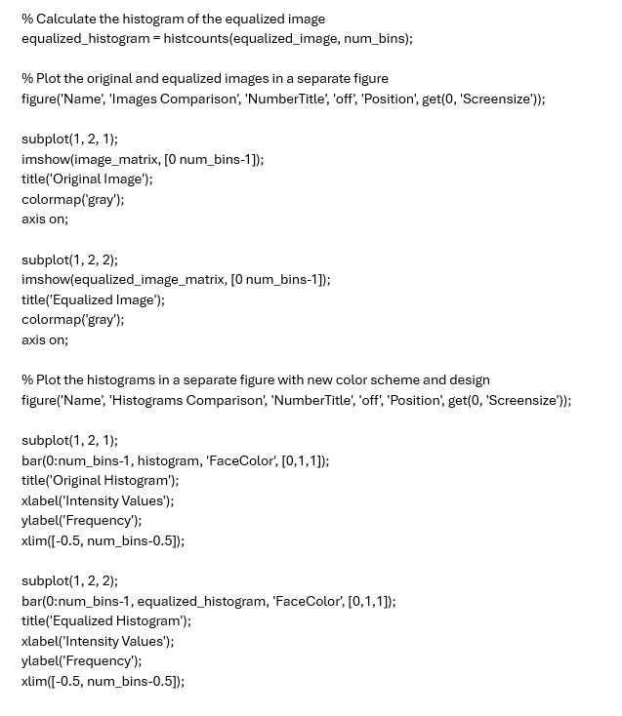

**Original histogram (Before Equalization)**

**Equalized histogram (After Equalization)**

