# Lab # 11

# GANTT Chart Construction using MS EXCEL for the Software Project

## 11.1 Objectives

The objective of this lab is to make the students learn how to work in MS Excel and to construct a GANTT chart by considering the task dependencies of a project.

## 11.2 Scope

The scope of this lab includes:

* To identify the task dependencies
* Identify the task constraints like the earliest start and finish dates
* Identify the latest start and latest finish dates
* Constructing the GANTT Chart

## 11.3 Useful Concepts

The **Gantt chart**bears a name of Henry Gantt, American mechanical engineer and management consultant who invented this chart as early as in 1910s. A Gantt diagram in Excel represents projects or tasks in the form of cascading horizontal bar charts. A Gantt chart illustrates the breakdown structure of the project by showing the start and finish dates as well as various relationships between project activities, and in this way helps you track the tasks against their scheduled time or predefined milestones.

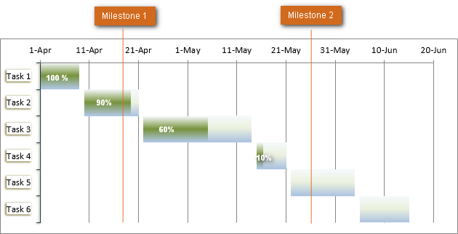

* **How to make Gantt chart in Excel**

Microsoft Excel does not have a built-in Gantt chart template as an option. However, you can quickly create a Gantt chart in Excel by using the bar graph functionality and a bit of formatting.Please follow the below steps closely and you will make a simple Gantt chart in under 3 minutes. We will be using Excel 2010 for this Gantt chart example, but you can simulate Gantt diagrams in Excel 2019, 2016 and Excel 2013 exactly in the same way.

**1. Create a project table**

You start by entering your project's data in an Excel spreadsheet. List each task is a separate row and structure your project plan by including the Start date, End date and Duration, i.e., the number of days required to complete the tasks. Only the Start date and Duration columns are necessary for creating an Excel Gantt chart. If you have Start Dates and End Dates, you can use one of these simple formulas to calculate Duration, whichever makes more sense for you:

Duration = End Date - Start Date

Duration = End date - Start date + 1

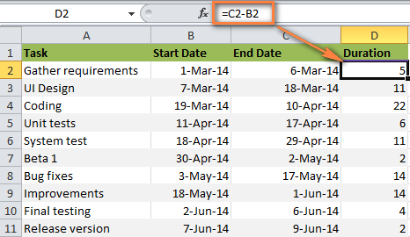

2. **Make a standard Excel Bar chart based on Start date**

You begin making your Gantt chart in Excel by setting up a usual *Stacked Bar* chart.

Select a range of your Start Dates with the column header, it's B1:B11 in our case. Be sure to select only the cells with data, and not the entire column.

Switch to the *Insert* tab > *Charts* group and click Bar.

Under the *2-D Bar* section, click Stacked Bar.

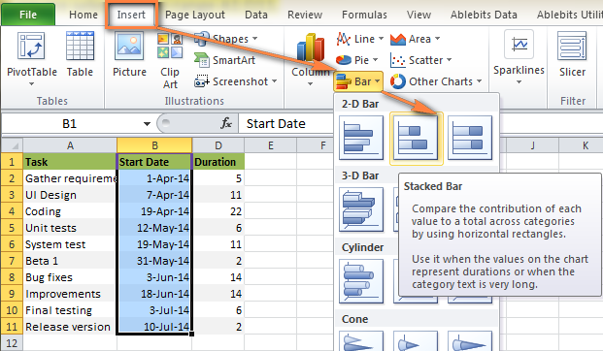

As a result, you will have the following Stacked bar added to your worksheet:

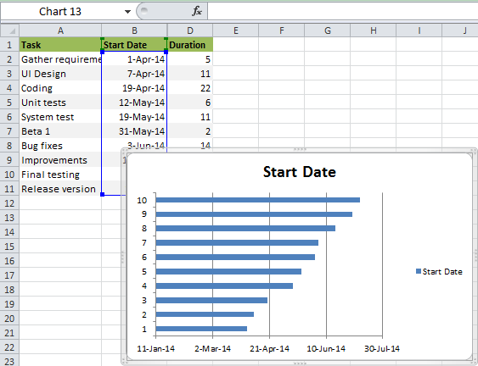

Some other Gantt Chart tutorials you can find on the web recommend creating an empty bar chart first and then populating it with data as explained in the next step. But I think the above approach is better because Microsoft Excel will add one data series to the chart automatically, and in this way save you some time.

**3. Add Duration data to the chart**

Now you need to add one more series to your Excel Gantt chart-to-be. Right-click anywhere within the chart area and choose Select Data from the context menu.

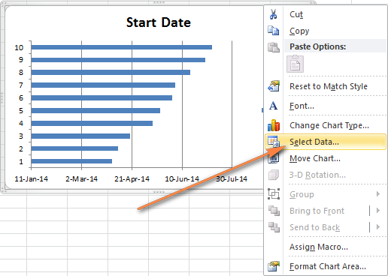

The Select Data Source window will open. As you can see in the screenshot below, *Start Date* is already added under Legend Entries (Series). And you need to add *Duration* there as well. Click the Add button to select more data (Duration) you want to plot in the Gantt chart.

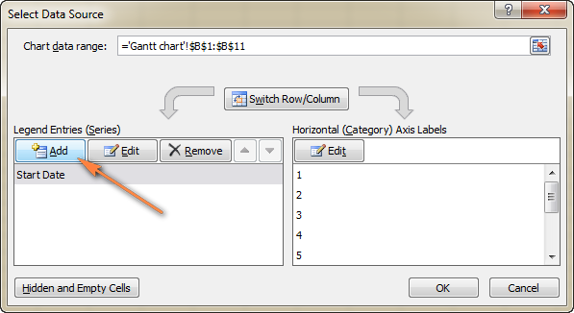

The *Edit Series* window opens and you do the following:

In the Series name field, type "*Duration*" or any other name of your choosing. Alternatively, you can place the mouse cursor into this field and click the column header in your spreadsheet, the clicked header will be added as the *Series name* for the Gantt chart.

Click the range selection icon  next to the Series Values field.

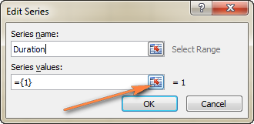

A small *Edit Series* window will open. Select your project Duration data by clicking on the first Duration cell (D2 in our case) and dragging the mouse down to the last duration (D11). Make sure you have not mistakenly included the header or any empty cell.

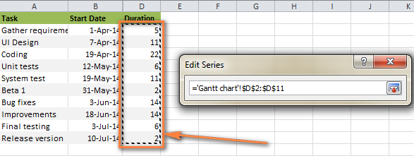

Click the Collapse Dialog icon to exit this small window. This will bring you back to the previous *Edit Series* window with *Series name* and *Series values* filled in, where you click *OK*.

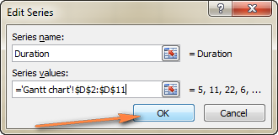

Now you are back at the *Select Data Source* window with both *Start Date* and *Duration* added under Legend Entries (Series). Simply click *OK* for the Duration data to be added to your Excel chart.

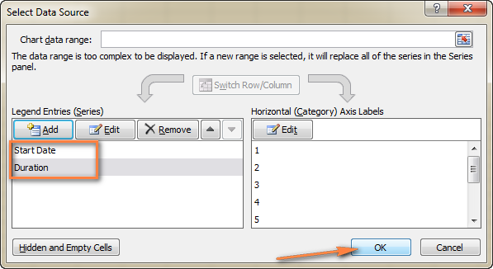

The resulting bar chart should look similar to this:

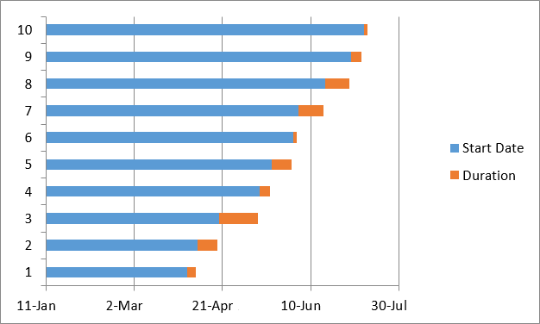

**4. Add task descriptions to the Gantt chart**

Now you need to replace the days on the left side of the chart with the list of tasks. Right-click anywhere within the chart plot area (the area with blue and orange bars) and click Select Data to bring up the *Select Data Source* window again.

Make sure the Start Date is selected on the left pane and click the Edit button on the right pane, under *Horizontal (Category) Axis Labels*.

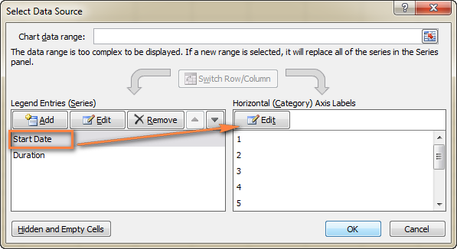

A small *Axis Label* window opens and you select your tasks in the same fashion as you selected Durations in the previous step - click the range selection icon , then click on the first task in your table and drag the mouse down to the last task. Remember, the column header should not be included. When done, exit the window by clicking on the range selection icon again.

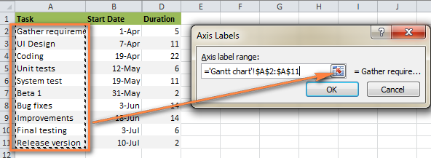

Click *OK* twice to close the open windows.

Remove the chart labels block by right-clicking it and selecting *Delete* from the context menu.

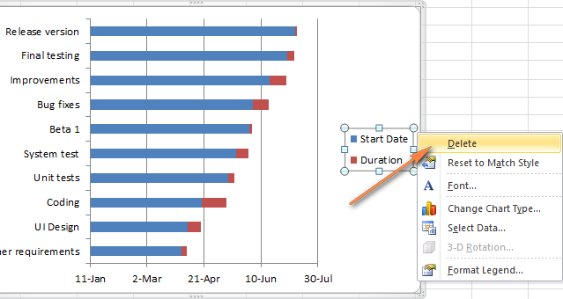

At this point your Gantt chart should have task descriptions on the left side and look something like this:  
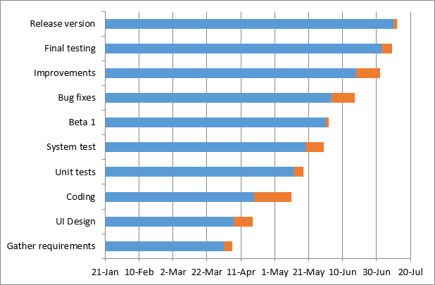

**5. Transform the bar graph into the Excel Gantt chart**

What you have now is still a stacked bar chart. You have to add the proper formatting to make it look more like a Gantt chart. Our goal is to remove the blue bars so that only the orange parts representing the project's tasks will be visible. In technical terms, we won't really delete the blue bars, but rather make them transparent and therefore invisible. Click on any blue bar in your Gantt chart to select them all, right-click and choose Format Data Series from the context menu.

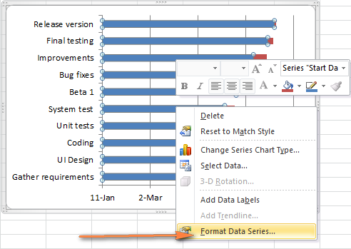

The *Format Data Series* window will show up and you do the following:

Switch to the *Fill tab* and select No Fill.

Go to the *Border Color* tab and select No Line.

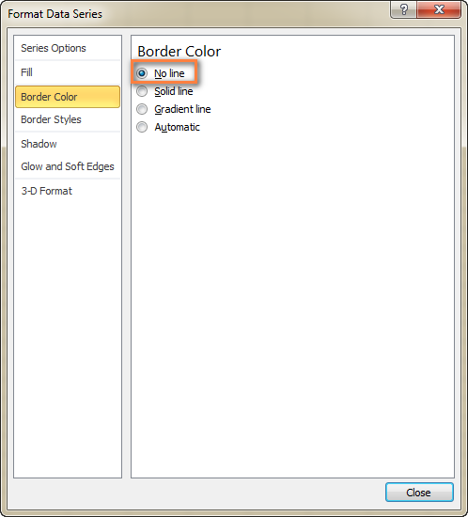

Note. You do not need to close the dialog because you will use it again in the next step.

As you have probably noticed, the tasks on your Excel Gantt chart are listed in reverse order. And now we are going to fix this.

Click on the list of tasks in the left-hand part of your Gantt chart to select them. This will display the *Format Axis* dialog for you. Select the Categories in reverse order option under *Axis Options* and then click the *Close* button to save all the changes.

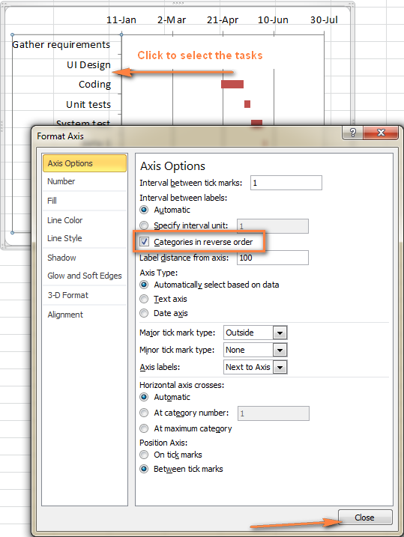

The results of the changes you have just made are:

Your tasks are arranged in a proper order on a Gantt chart.

Date markers are moved from the bottom to the top of the graph.

Your Excel chart is starting to look like a normal Gantt chart, isn't it? For example, my Gantt diagram looks like this now:

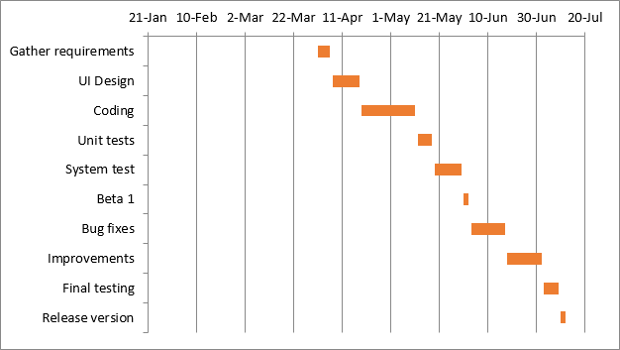

**6. Improve the design of your Excel Gantt chart**

Though your Excel Gantt chart is beginning to take shape, you can add a few more finishing touches to make it really stylish. As you remember, originally the starting date blue bars resided at the start of your Excel Gantt diagram. want to make any changes here.

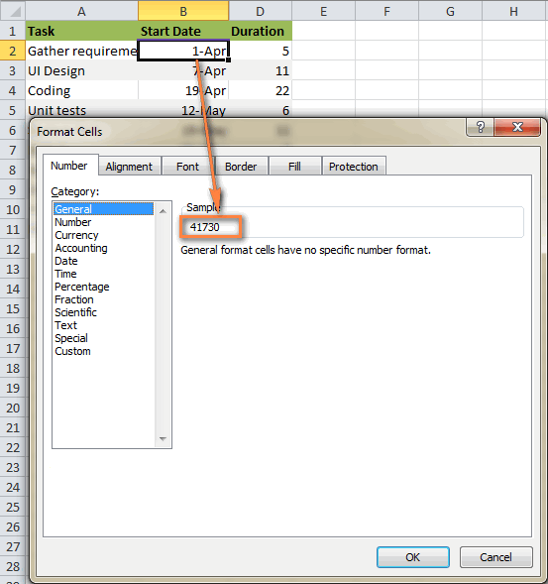

Click on any date above the task bars in your Gantt chart. One click will select all the dates, you right click them and choose Format Axis from the context menu.

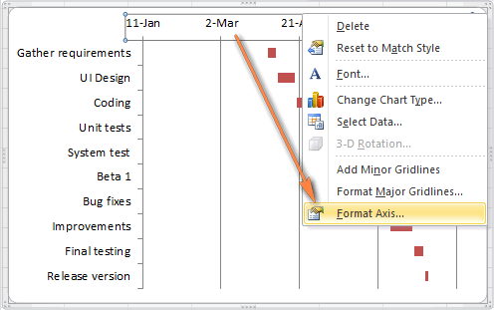

Under *Axis Options*, change Minimum to Fixed and type the number you recorded in the previous step.

**Adjust the number of dates on your Gantt chart.**

In the same *Format Axis* window that you used in the previous step, change Major unit and Minor unit to Fixed too, and then add the numbers you want for the date intervals.

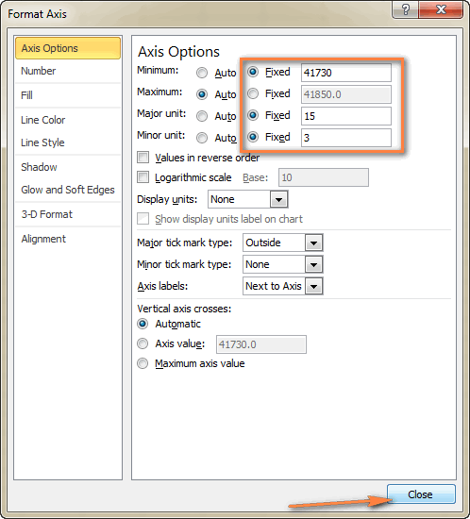

**Remove excess white space between the bars.**

Compacting the task bars will make your Gantt graph look even better.

Click any of the orange bars to get them all selected, right click and select Format Data Series.

In the Format Data Series dialog, set Separated to 100% and Gap Width to 0% (or close to 0%).

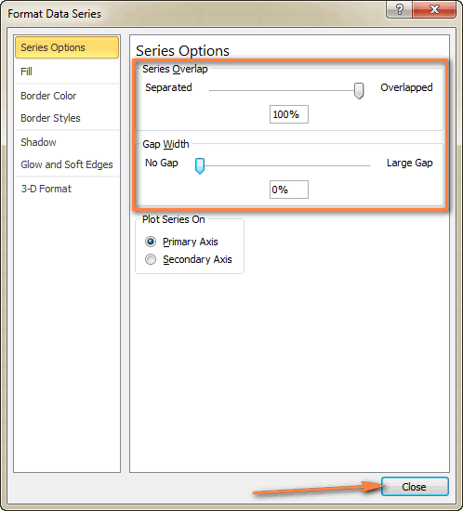

And here is the result of our efforts - a simple but nice-looking Excel Gantt chart:  
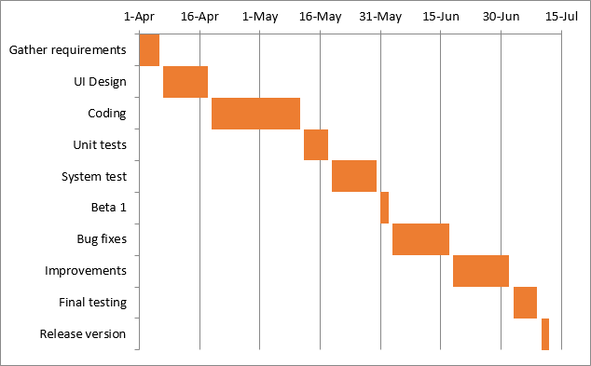

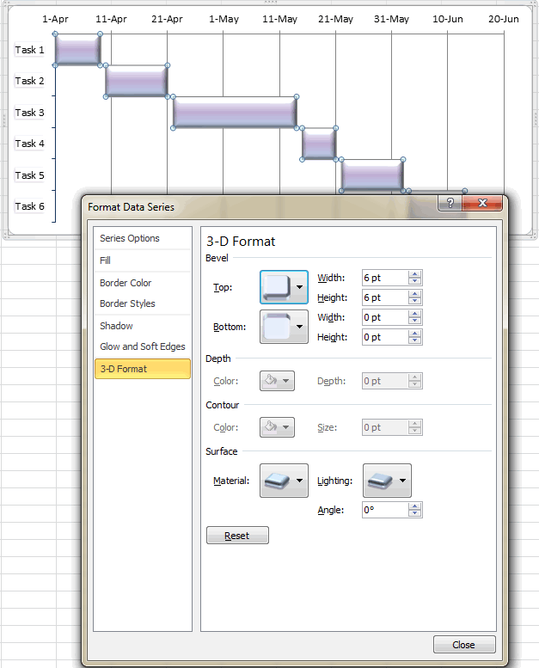

When you have created an awesome design, it might be a good idea to save your Excel Gantt chart as a template for future use. To do this, click the chart, switch to the *Design* tab on the ribbon and click Save as Template.

## 11.4 Exercise

* 1. For the data given in the following table draw a GANTT Chart in Excel.

|  |  |  |  |  |
| --- | --- | --- | --- | --- |
|  | **Task No** | **Task Name** | **Duration** | **Predecessors** |
| **Column 0** | **Column 1** | **Column 2** | **Column 3** | **Column 4** |
| 1 | 1 | SPM_Project_Team0 |  |  |
| 2 | 1.1 | Project Initiation |  |  |
| 3 | 1.1.1 | Develop project charter | 5 days |  |
| 4 | 1.1.2 | Develop Statement Of Work | 7 days | 3 |
| 5 | 1.1.3 | Develop preliminary scope development | 3 days | 4 |
| 6 | 1.1.4 | Develop preliminary architectural model | 4 days | 5 |
| 7 | 1.1.5 | Project initiation complete | 0 days | 3, 4, 5, 6 |
| 8 | 1.2 | Project plan |  |  |
| 9 | 1.2.1 | Develop scope management plan | 1 day | 2 |
| 10 | 1.2.2 | Develop change management plan | 2 days | 2 |
| 11 | 1.2.3 | Develop initial descriptive budget | 10 days | 9 |
| 12 | 1.2.4 | Develop schedule | 2 days | 9 |
| 13 | 1.2.5 | Develop quality management plan | 2 days | 2 |
| 14 | 1.2.6 | Develop human resource plan | 3 days | 9 |
| 15 | 1.2.7 | Develop risk management plan | 2 days | 9 |
| 16 | 1.2.8 | Project plan complete | 0 days | 9 – 15 |
| 17 | 1.3 | Project Execution |  |  |
| 18 | 1.3.1 | Release 1 |  |  |
| 19 | 1.3.1.1 | Analysis phase | 18 days | 8 |
| 20 | 1.3.1.2 | Design phase | 15 days | 19 |
| 21 | 1.3.1.3 | Construction phase | 12 days | 20 |
| 22 | 1.3.1.4 | Validation phase | 12 days | 21 |
| 23 | 1.3.1.5 | Deployment phase | 3 days | 22 |
| 24 | 1.3.1.6 | Closeout | 1 day | 23 |
| 25 | 1.3.1.7 | Release 1 Complete | 0 days | 24 |
| 26 | 1.3.2 | Release 2 |  |  |
| 27 | 1.3.2.1 | Analysis phase | 9 days | 18 |
| 28 | 1.3.2.2 | Design phase | 7 days | 27 |
| 29 | 1.3.2.3 | Construction phase | 6 days | 28 |
| 30 | 1.3.2.4 | Validation phase | 6 days | 29 |
| 31 | 1.3.2.5 | Deployment phase | 1 day | 30 |
| 32 | 1.3.2.6 | Closeout | 1 day | 31 |
| 33 | 1.3.2.7 | Release 2 Complete | 0 days | 32 |
| 34 | 1.3.3 | Execution complete | 0 days |  |
| 35 | 1.4 | Project Closeout | 1 day | 17 |