**Main Layout**

|  |  |  |
| --- | --- | --- |
| **MENU** | | |
| **Left Sidebar** | **Middle Section** | **Right Sidebar** |
| **Footer** | | |

Create the following menu with the given submenu. For the moon, bell, categories, and search icons to the right, you can use font awesome icons.

website: [www.espncricinfo.com](http://www.espncricinfo.com)

1 - Menu

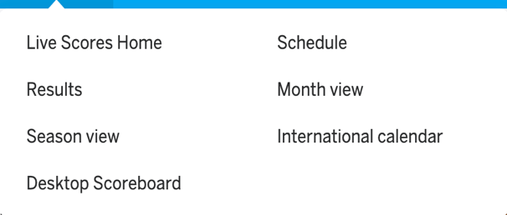



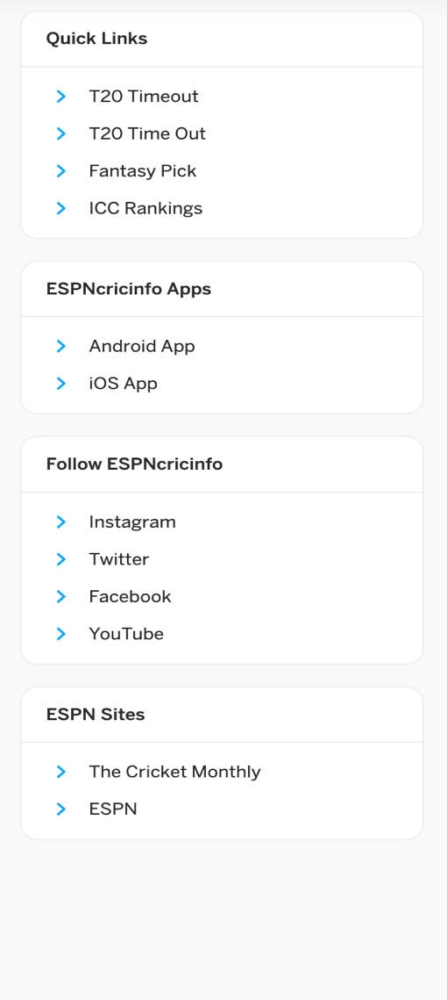2 - left Sidebar

3 – Middle section – top

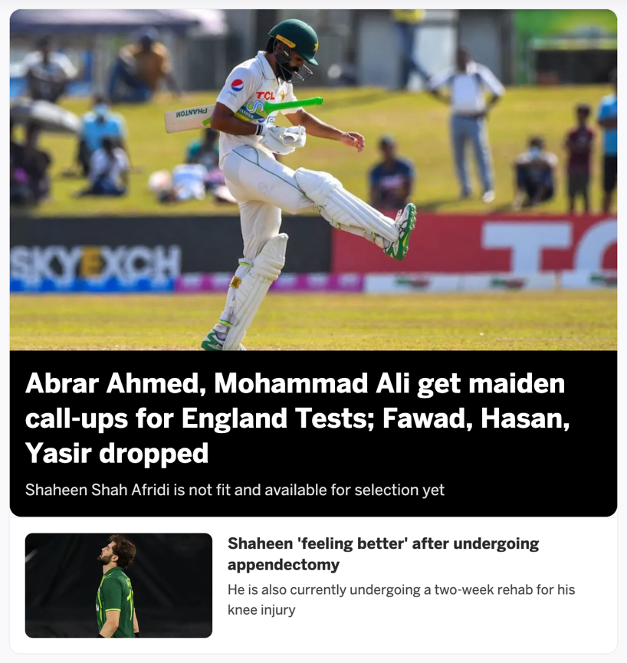

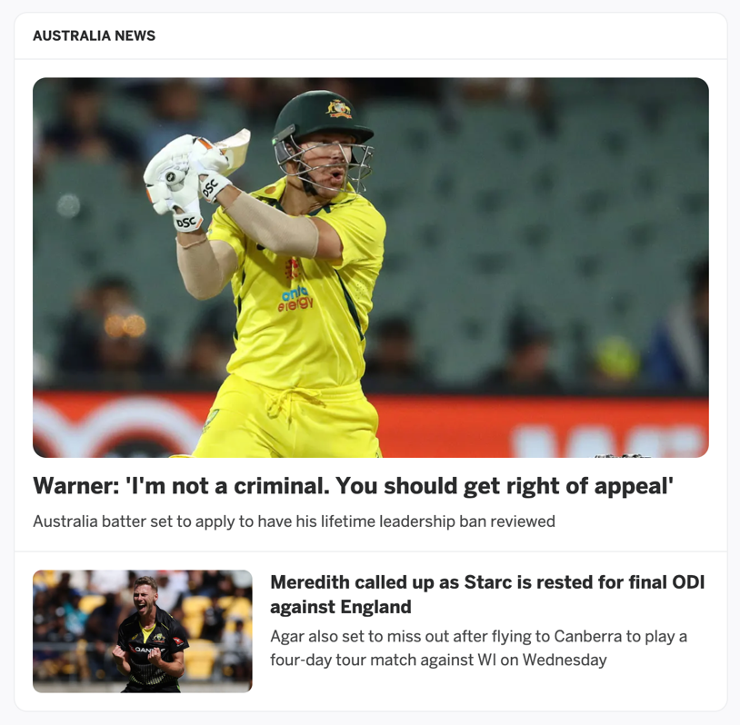

4 – Right sidebar

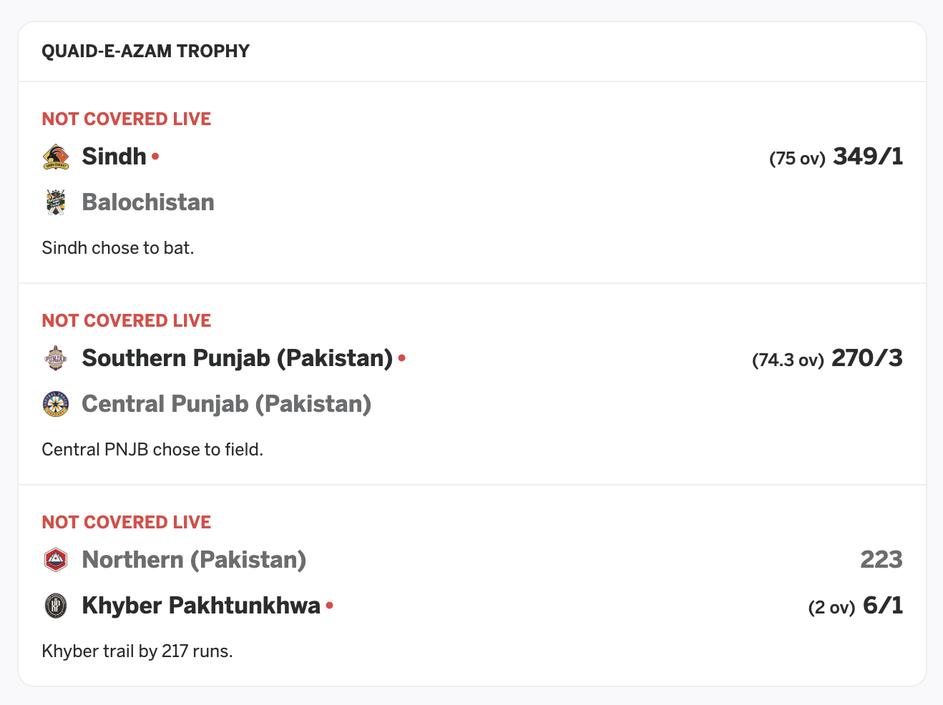

5 – Footer

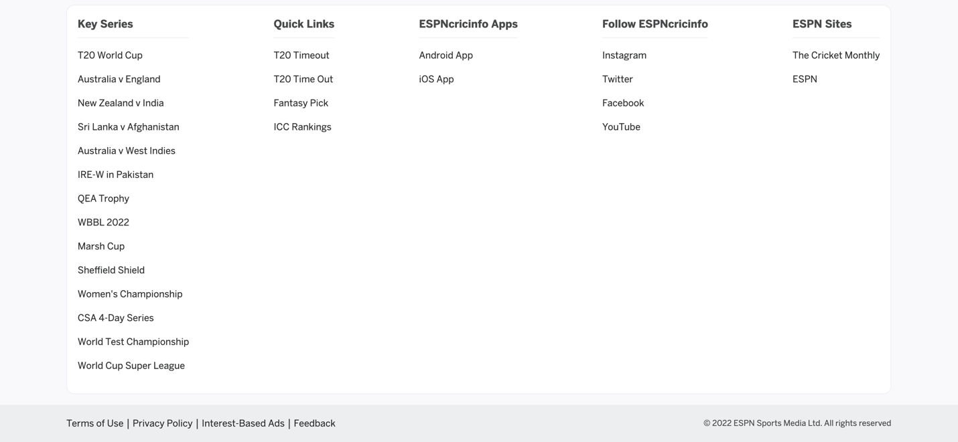

**Lab Midterm – Fall 2022 Examination (Time: 1.5 hours) (Maximum Marks: 30)**

**Modifications**

1. Change the middle content layout as follows. Moreover, add a delete button that will delete the card/division. You must use map and filter functions. **[Marks: 12]**

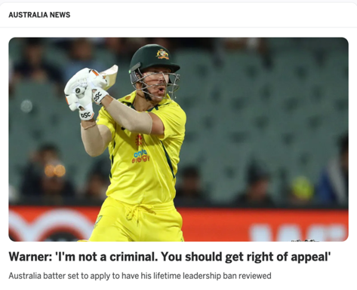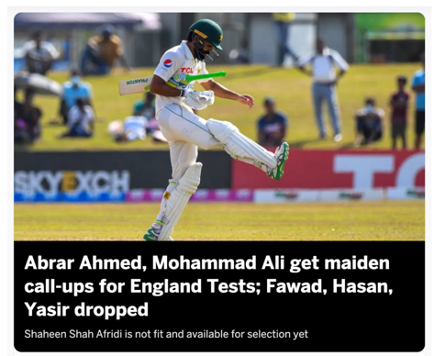



1. Route the QEA Trophy link in the footer and the IOS App link in the left sidebar at URL “/qeaTrophy” and “/iosApp” respectively. **[Marks: 06]**
2. In the left sidebar, remove already written content and add the following using state and props. Failure to do using state and props will credit ZERO marks. **[Marks: 12]**

