SOFTWARE ARCHITECTURE DIAGRAMS

Contents

Package diagram. 2

Communication diagram 3

Sequence diagram 5

Prototypes 9

Domain Model 13

Use case diagram. 14

DFD 15

DFD level 0 & 1 15

Activity diagram 17

Deployment diagram 19

Composite diagram 20

Class Diagram 20

Component diagram 20

# Package diagram.

# Communication diagram

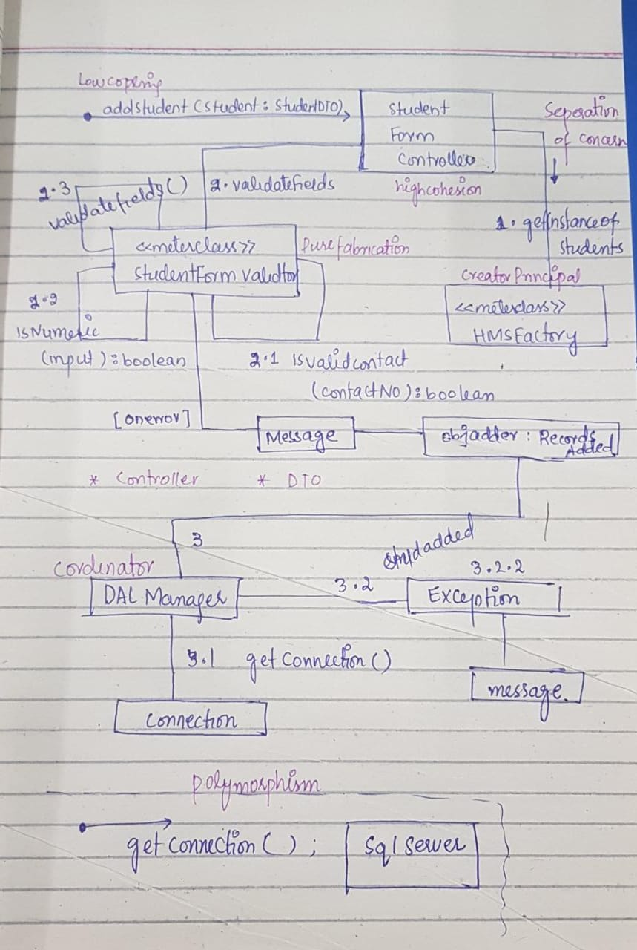*Add student :*

Add Incident :

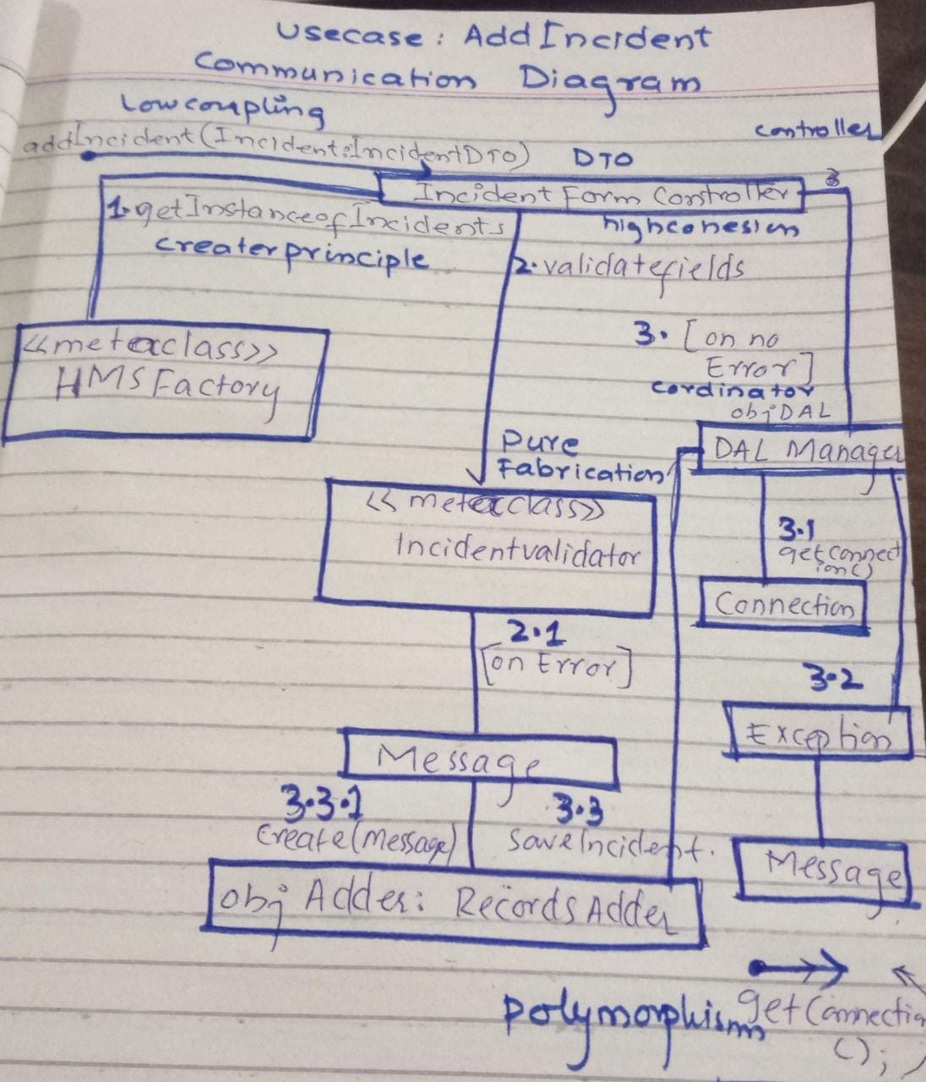

# Sequence diagram

Add student:

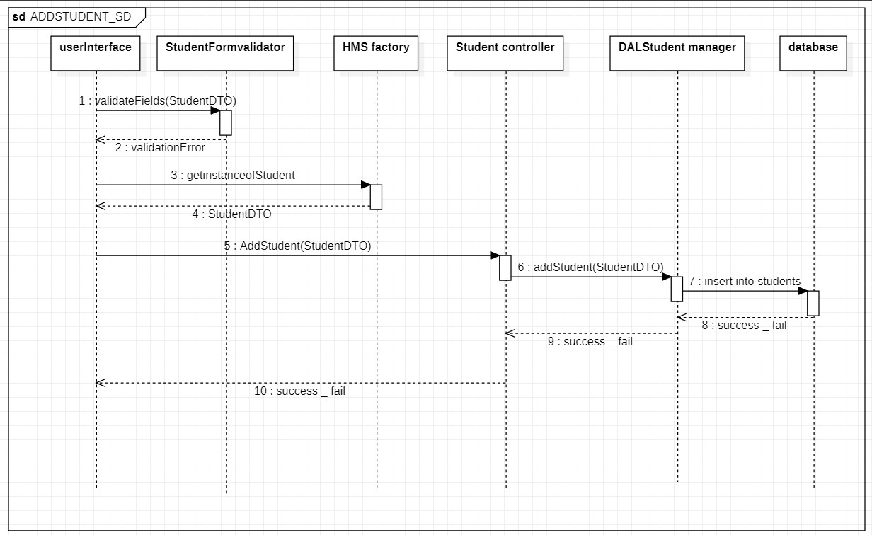

Add Incident :

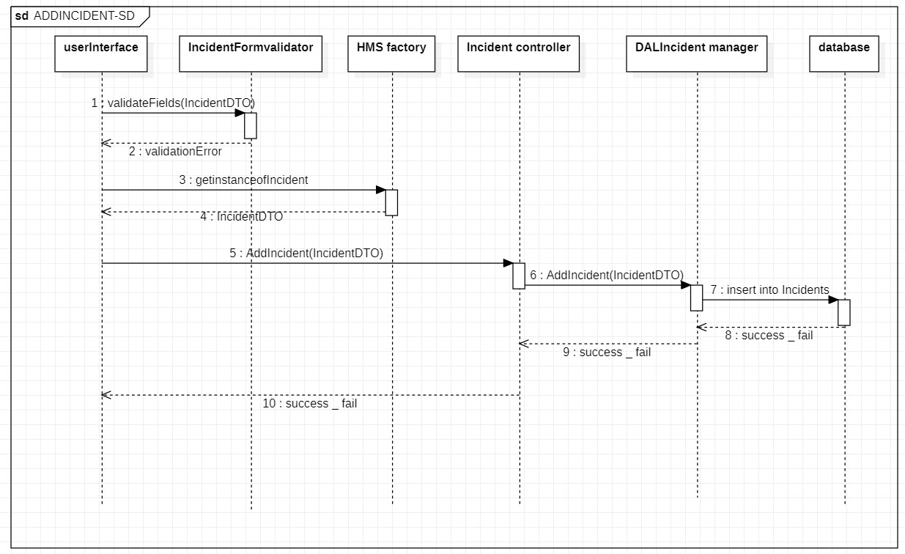

Add Room :

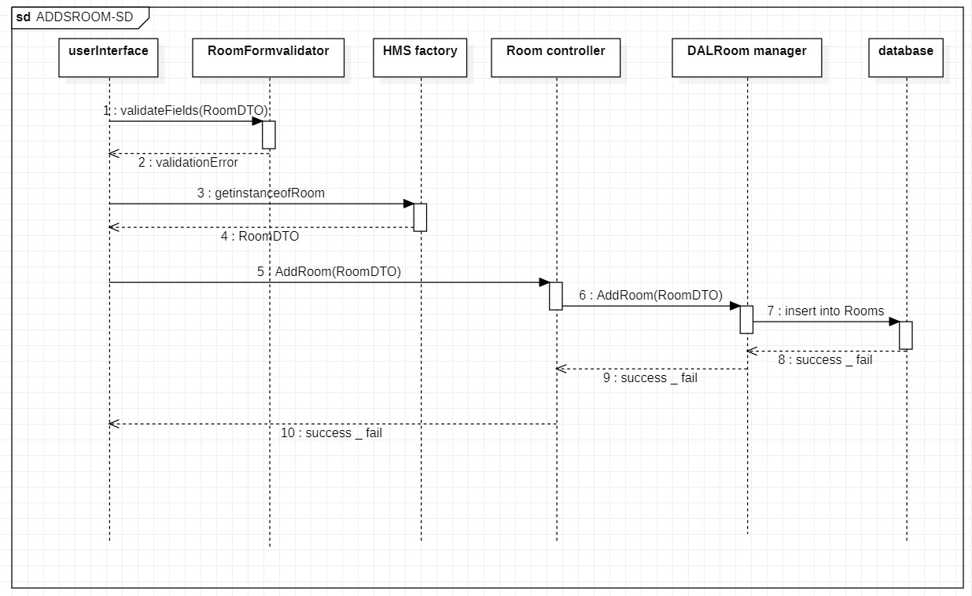

Add Warden:

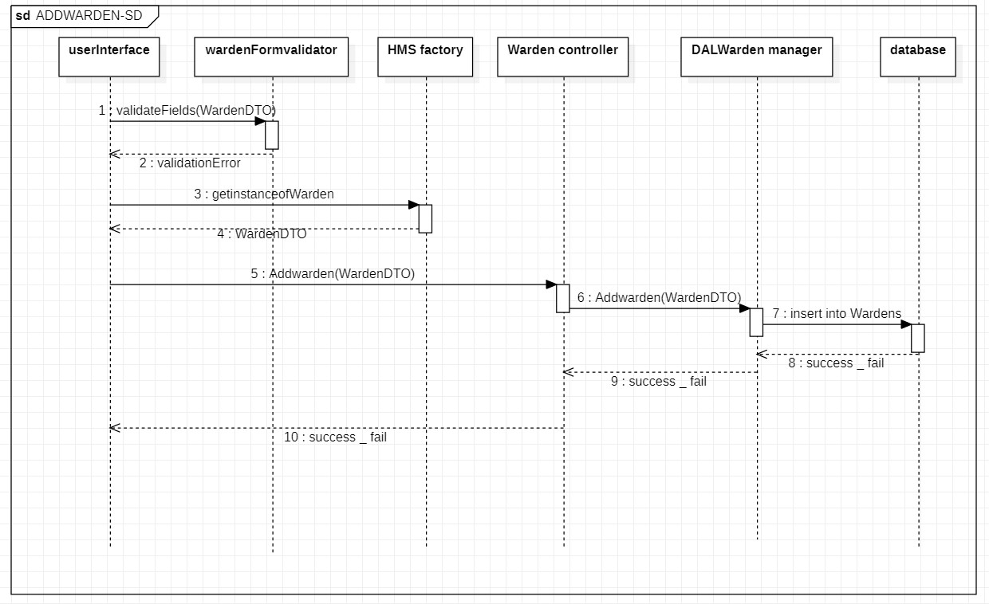

# Prototypes

# 

# Domain Model

# Use case diagram.

# DFD

## DFD level 0 & 1

Figure 5 DFD Level 0 and 1

Figure 6 DFD Level 2

# Activity diagram

Figure 3 Activity diagram (for student)

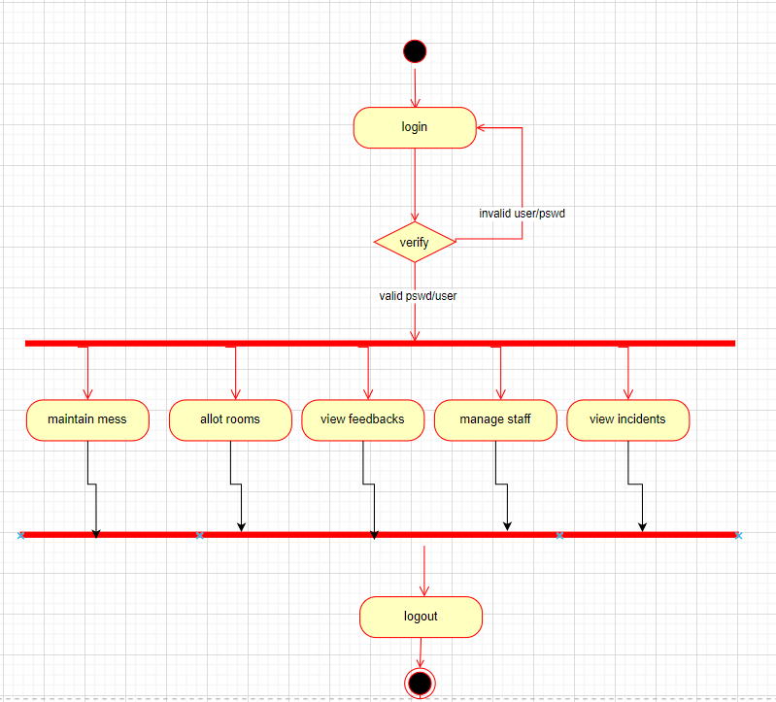

Figure 4 Activity diagram for admin

# Deployment diagram

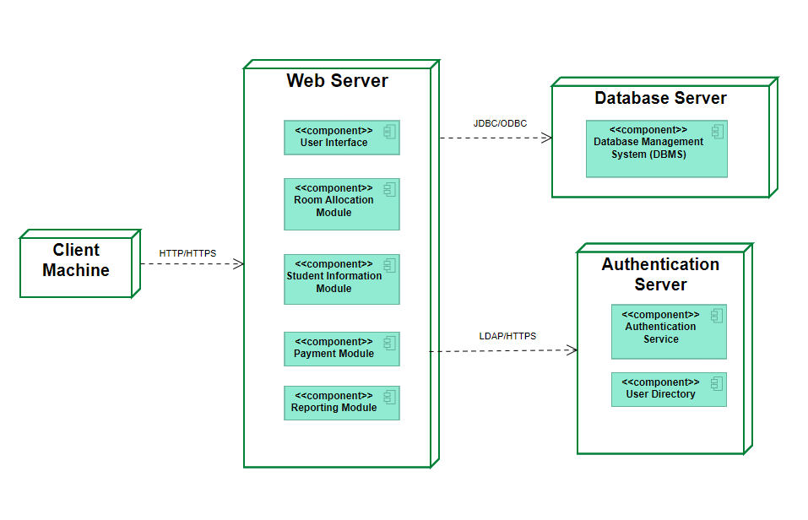

**Detailed Description**

* **Client Machine**: User's device accessing the web application.
* **Web Server**: Hosts the application with multiple components.
* **Database Server**:
  + **Database Management System (DBMS)**: Software like MySQL/PostgreSQL.
  + **Data Storage**: Physical or cloud-based storage for data.
* **Authentication Server**:
  + **Authentication Service**: Manages authentication protocols.
  + **User Directory**: Stores user credentials and related data.

# Composite diagram

# Class Diagram

# Component diagram