**COMSATS UNIVERSITY ISLAMABAD, ABBOTTABAD**

Game development

Assignment # 02 Car Driving

***Submitted by:***

Laiba binte tahir FA21-BSE-019

Mahnoor Qazi FA21-BSE-020

***Submitted to:***

Sir Ibtisam Gul

# Story Boards:

# Onion architecture:

# Two Game functionalities:

For our assignment, we have the following functionalities:

**1. Level 1: Free Drive Gameplay**

* Level 1 serves as the introductory level where players can freely drive the car and practice controls.
* **Details:**
  + Includes basic mechanics like moving forward, braking, and turning using keys (W, S, A, D).
  + Displays distance covered and speed in kilometers per hour (KPH).
  + Focuses on the core driving experience, which is central to the game.

**2. Pause Menu Functionality**

* The Pause Menu allows players to pause the game during gameplay. It provides options to resume the game or return to the main menu.
* **Details:**
  + Triggered by pressing a specific key (e.g., Esc).
  + Displays overlay with buttons for "Resume" and "Main Menu."
  + Enhances user control and improves the player experience by allowing interruptions without losing progress.

**3. Main Menu Functionality :**

The Main Menu serves as the starting point of the game, allowing players to navigate to different parts of the game. It includes a car-themed background and soothing background music to enhance the ambiance.

**Details:**

Buttons: Play, Lobby, and Quit Game.

Background music matches the car racing theme.

# Game Screen shots

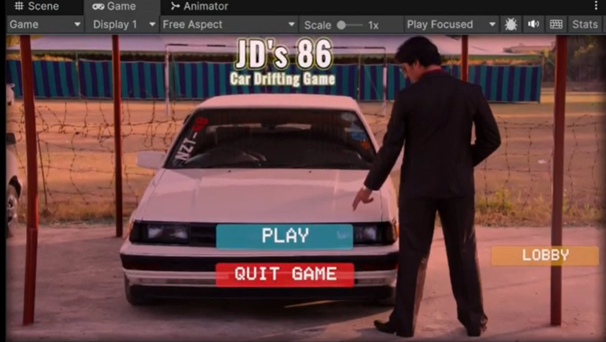

# Video Link:

<https://drive.google.com/file/d/1Ws8IA4UdZyfdMyMqWP4gWSrM9Mp90sf-/view?usp=sharing>