**Assignment 1.**

**Mobile Application Development.**

Maximum allowed students per group: 2 (can be less)

You need to show assignment on Cell phone or emulator

Two groups having same logic/assignment will get zero.

**Task 1:** Create a login and a registration page, with proper react native styling. Here is a sample, but your work can be different and better than this.

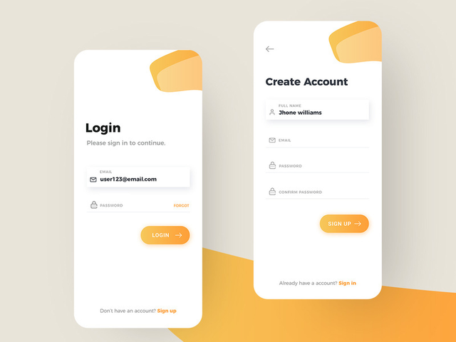

When user Click on LOGIN Button information must be shown below using FlatList

**Task 2:** You need to create a mobile phone portrait layout:



When the same app is opened in a tablet layout (landscape), it should display like this.

Submit

30 chars max

Email

50 chars max

Name

Gender

Male

Female

Country

Subjects

Phy

Chem

Address

Bio

C++

Java

Javascript

C#

Skills

Use flex layout to make it responsive.



**Task 3:** Using Flex design and calculate logic for CALCULATOR

