Assignment 4 - Reverse Engineering

* Fully Dress Use Case
* Class Diagram
* Operation Contract
* SSD
* SD

#### Use Case: Add student.

**Use Case Name:** Add Student

**Scope:** Hostel Management System

**Level:** User Goal (Primary)

**Stakeholders and Interests:**

Hostel Staff: Wants to manage student records and information efficiently, including registration, room allocation, and fee payment.

Students: Want to register for accommodation in the hostel and pay the necessary fees.

**Preconditions:**

The user is authorized to access the hostel management system.

The student has expressed interest in registering for accommodation in the hostel.

**Postconditions:**

The student's information is added to the hostel management system.

The student can be allocated a room based on availability and preferences.

The student can pay the necessary fees for accommodation and other services.

**Basic Flow of Events:**

|  |  |
| --- | --- |
| **User Interaction** | **System Response** |
| 1. User selects the option to add a new student. | 1. System prompts the user to enter the student's information, such as name, contact information, room number, and any other relevant details. |
| 2. User enters the student's information. | 2. System validates the information provided by the user to ensure that it is complete and accurate. |
| 3. User confirms the addition of the new student. | 3. If the information provided by the user is valid, the system adds the new student's record to the database and displays a success message to the user. |
|  | 4. The success message includes the student's ID, which is assigned by the system, as well as their name and other relevant details. |
| 4. User reviews the new student's record. | 5. System waits for the user to finish reviewing the new student's record before returning to the main menu. |
|  | 6. If the user selects to add another student, the system repeats the above process. Otherwise, it returns to the main menu. |

**Alternative Flows:**

If the student has already paid the fees, the user can skip the fee payment step and proceed to allocate a room.

If there are no rooms available for the student's preferred room type and bed preference, the system will display alternative options for the user to choose from.

**Exceptional Flows:**

If there is an error in the system while adding the student's information, the system displays an error message to the user and prompts them to try again.

If there is a problem with the payment, the system will display an error message and prompt the user to enter the correct details.

## *Sequence diagram*

Add student :

*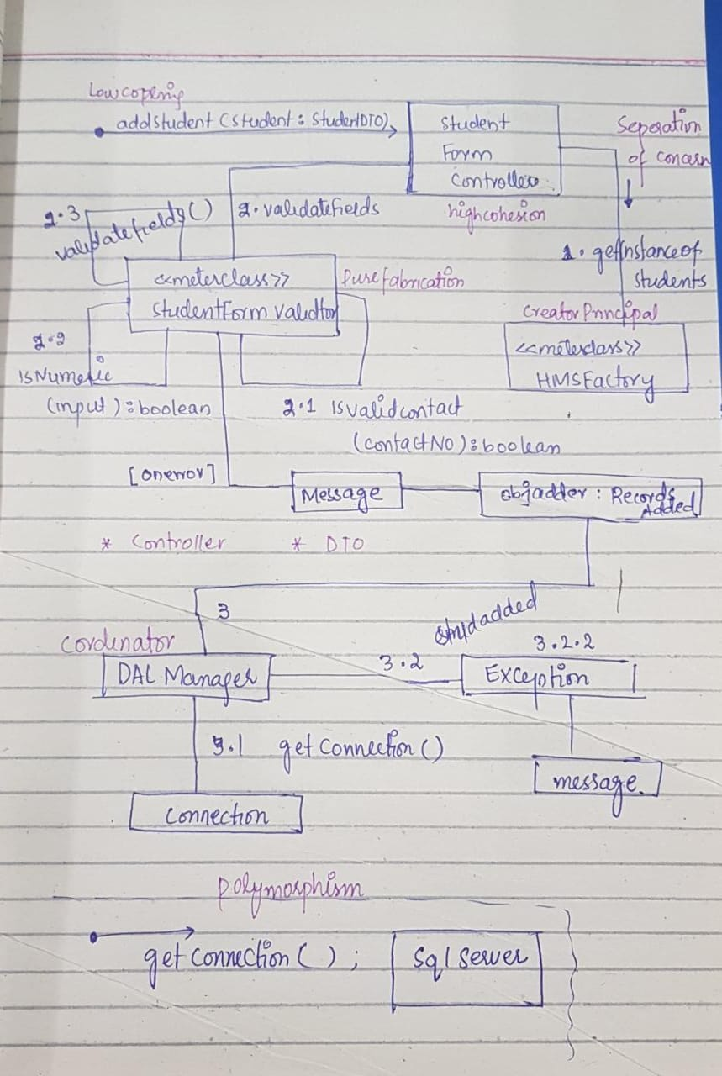Communication Diagram*

*Operation Contract*

|  |  |
| --- | --- |
| **Operation** | **AddStudent** (StudentName, StudentID, Gender, RoomNumber, HostelName) |
| Cross-Reference | This contract operation is related to the use case of adding a new student to the hostel management system. |
| Pre-Conditions | 1. The user must have administrative privileges to access the "Add Student" functionality in the hostel management system.  2. The user must have entered valid student details, including the student's name, ID, gender, room number, and the name of the hostel where the student will reside. |
| Post-Conditions | 1. The system will validate the student's details and ensure that the student does not already exist in the system.  2. The system will add the new student's details to the hostel management system and assign them a unique student ID.  3. The student's details will be saved to the system's database for future reference. <br> 4. The system will generate a confirmation message indicating that the student has been successfully added to the hostel management system. |

*System Sequence Diagram*

*Class diagram*

