**Lab 11 High Fidelity Prototyping**

The purpose of this lab is to help students learn the prototyping as a method to involve the users in testing design ideas and get their feedback in the early stage of development, thus reducing the time and cost.

**Activity Outcomes:**

The activities provide hands - on practice with the following topics

* Mood Boards.
* High Fidelity Prototyping.

**Instructor Note:**

You can use Figma or any other prototyping tool of your choice

1. **Useful Concepts**

**Mood Boards**

A collection of assets and materials intended to communicate the style, voice, direction, and language of a particular design, brand, or project.

**What does a mood board include?**

It can include any reference, but the most important thing is the correlation and balance between all the elements that compose the mood board. Some common elements are:

**Colors –** Register the colors of the brand or competitors, try new palettes related to the emotions you want to explore within new concepts.

**Textures and Patterns** – These are great ways to evoke affectional memories and can indirectly indicate established concepts.

**Text –** Organize your notes, insights, keywords, or quotes, along with other elements of the board, to emphasize your ideas.



**Figure 12.1: Example of a Mood Board**

**Hi Fidelity Prototyping:**

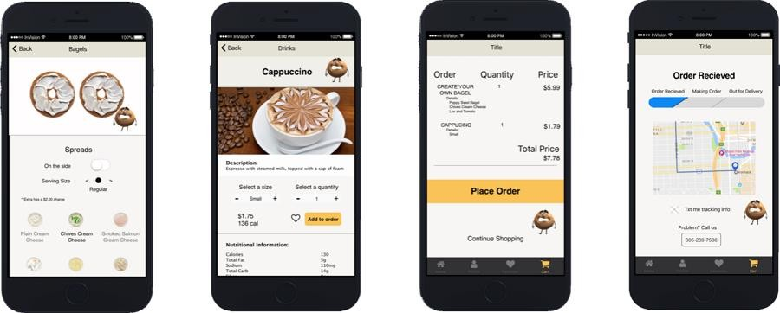

**Figure 12.2: Hi-Fidelity Prototype Example**

**Activity 1:**

***Create Hi-fidelity prototype for Bus reservation app.***

|  |  |
| --- | --- |
|  |  |
|  |  |

|  |  |
| --- | --- |
|  |  |
|  |  |

|  |  |
| --- | --- |
|  |  |

1. **Graded Lab Tasks**

***Note: The instructor can design graded lab activities according to the level of difficulty and complexity of the solved lab activities. The lab tasks assigned by the instructor should be evaluated in the same lab.***

**Lab Task 1:**

*You are creating a new and improved CUOnline. Create mood board for your application.*

**Lab Task 2:**

*Draw high fidelity prototypes for the same application. Create protoptypes to cover the following aspects*

* *Home Screen*
* *Course Registration*
* *Course performance (Quizzes assignments marks etc)*
* *Attendance*

**Objective:**

**Lab 12 User Evaluation**

This lab will make students learn the technique of evaluating interactive system’s design through user participation where the actual users are asked to interact with the system.

**Activity Outcomes:**

The activities provide hands - on practice with the following topics

* How to evaluate design with users.
* What are the different steps involved?
* When to evaluate design with users.
* Benefits and drawbacks of evaluation with users

**Instructor Note:**

Please refer to lecture notes.

**Useful Concepts**

**Formative Evaluation:** The main concept is to provide a prototype to the user (it can be either low or high fidelity or even finished product). Give a task to the user, watch the user perform the task while thinking out loud. Record the observations.

**Activity 1**

***Formative Evaluation***

*https://*[*www.youtube.com/watch?v=9wQkLthhHKA&list=PLctSiTSKouvc6oESBymSehv186AgQh*](http://www.youtube.com/watch?v=9wQkLthhHKA&list=PLctSiTSKouvc6oESBymSehv186AgQh) *4M3*

*watch the above video for a complete demonstration of formative evaluation.*

**Lab Task 1:**

*Perform formative evaluation for the prototypes you developed in the previous labs. Exchange prototypes, so the person sitting next to you would be evaluation your prototype and you would be evaluating theirs. Write a complete report of your observations and also provide the video of the user performing the task. Make sure you get permission first. Also you only need to record video of the hands and prototype rather then face.*