**Main Layout**

|  |  |
| --- | --- |
| **MENU** | |
| **Left Sidebar** | **Middle Section - Top** |
| **Middle Section - Bottom** |
| **Footer** | |

Create the following menu with the given submenu. You can use font awesome icons.

website: [www.fifa.com](http://www.fifa.com)

1 - Menu

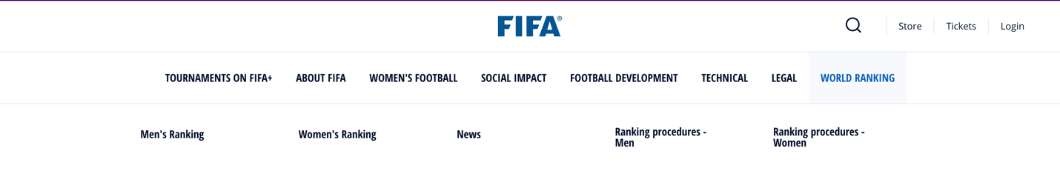

2 – Middle section – top

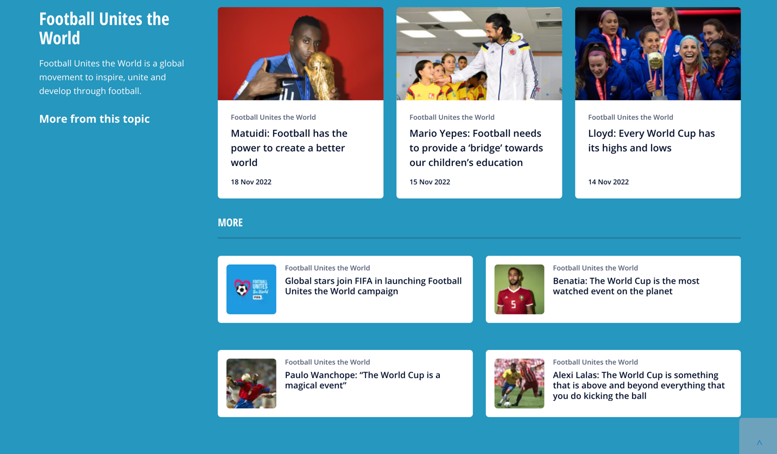

3 – Middle section – bottom

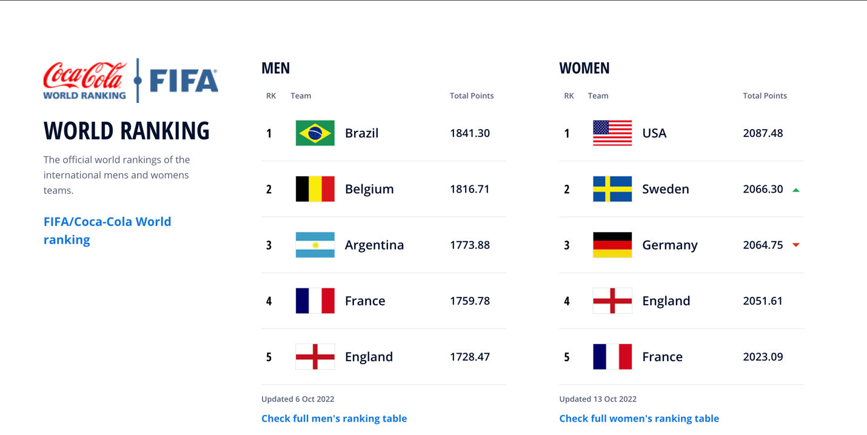

4 – Footer

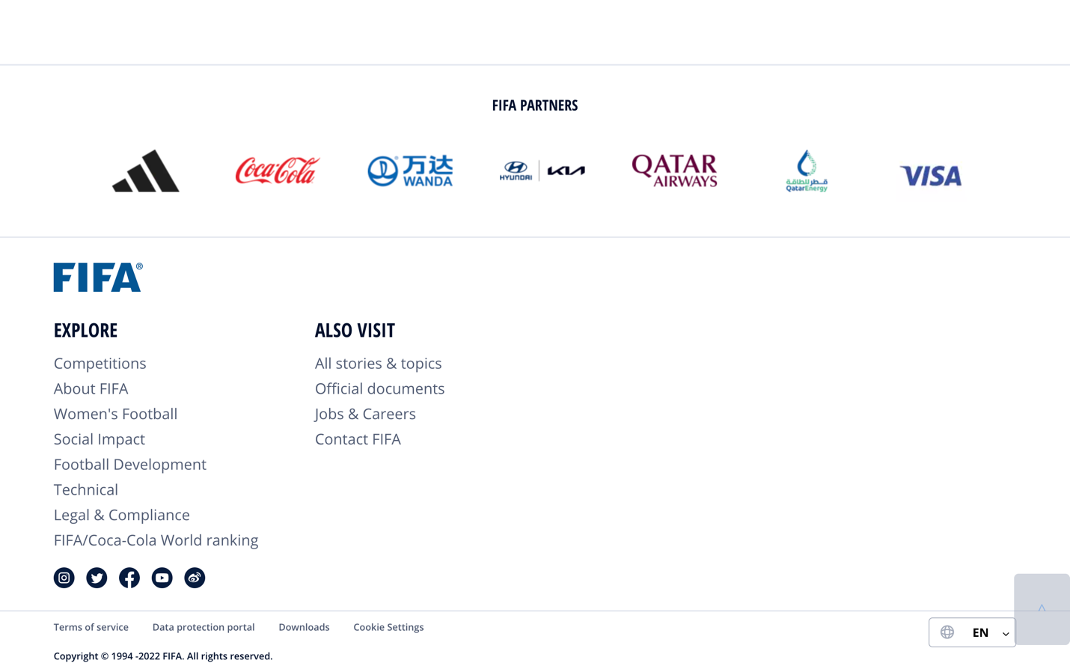

**Lab Midterm – Fall 2022 Examination (Time: 1.5 hours) (Maximum Marks: 30)**

**Modifications**

1. On hovering the LEGAL menu, a submenu appears consisting of two pages (the first page is called Privacy, and the second page is called Terms) **[Marks: 04]**
2. Apply routing on the two submenu pages in part 1. The Privacy page is at URL “/privacy” and the Terms page is at URL “/terms”. **[Marks: 06]**
3. Two (divisions/cards) render in one line in the following figure. Add two more divisions/cards and make them appear in two lines (three cards/divisions per line). Moreover, add a delete button on each card that will delete that card/division.

**[Marks: 12]**

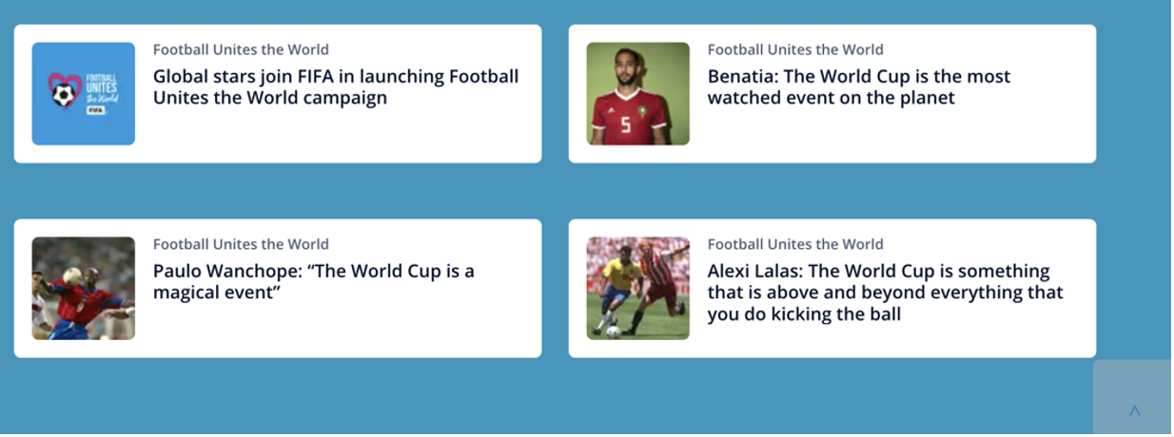

1. Make the following cards appear vertically in the left sidebar. **[Marks: 08]**

