**COMSATS UNIVERSITY ISLAMABAD, ABBOTTABAD CAMPUS**

(Virtual Campus)

Assignment #02: HUM102 Report Writing Skills-Fall 2022

**Submitted To:**

Moderator: Muhammad Talal Hassan

**Submitted By:**

Laiba Binta Tahir FA21-BSE-019(3A)

**Dated:**

8 November-2022

**ANALYSIS OF DOCUMENT REGARDING ETIQUETTE OF ZOOM MEETINGS.**

* **WITH RESPECT TO TRAITS OF TECHNICAL WRITING**

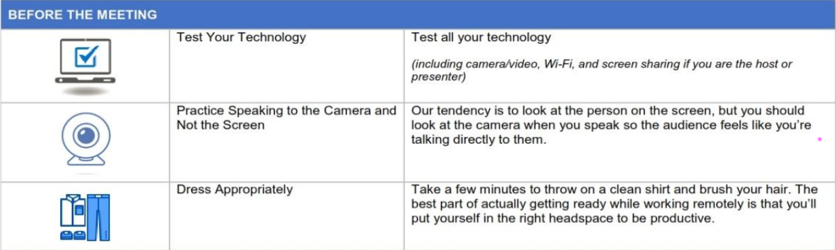Following are the traits of technical writing present in the given document regarding the etiquette of zoom meetings

1. **Clarity**

The context is clear and comprehensive as the

document has

* easy vocabulary
* short sentences
* proper headings
* There is no personal introduction of the

writer or any conclusion in, the context.

**For example,** this part of the document shows the use of proper headings (e-g: before the meeting) and each heading also had subheadings having short sentences instead of large sentences. And those subheadings are further elaborated for the users.

1. **Conciseness**

The language used is concise as the document is written in the form of

* short paragraphs
* Lengthy details are presented in the form of headings with vivid details.
* There is no unnecessary repetition of words.
* Positive language has been used for example:

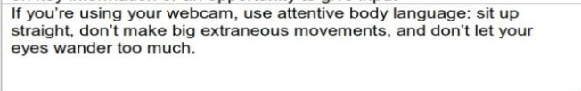

1. **Audience recognition**

The document is used to provide some tips on etiquette and best practices for participants when joining a zoom meeting, therefore, its target audience is all those users of virtual meetings, and its main aim is the audience so the writer considering its audience has used simple language and provided all necessary information.

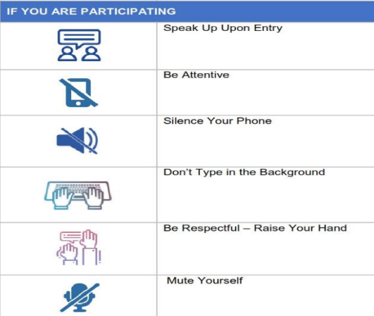

1. **Accessible document design**

The document is easily readable by all types of people due to the use of

* Images for uneducated people or low-sighted people
* Headings are used for clarity
* Meaningful hyperlink is given:

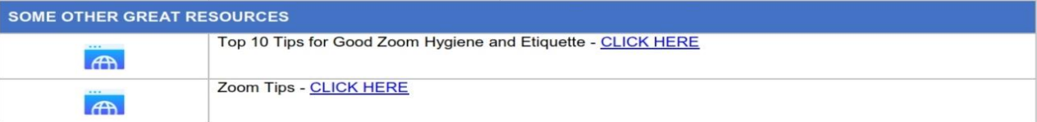

* **WITH RESPECT TO THE SEVEN C’S OF COMMUNICATION**

The seven C’s of communication that is observed in the brochure are given as

1. **Clarity**

The writing is clear as

* It has an appropriate length of paragraphs
* There is unity in writing **for example** in the heading “if you are hosting” the sentences have a single idea it does not explain any other thing related to other participants.
* By using headings, and images simportant points are emphasized.
* There is no use of the personal pronoun.
* Familiar vocabulary is used.

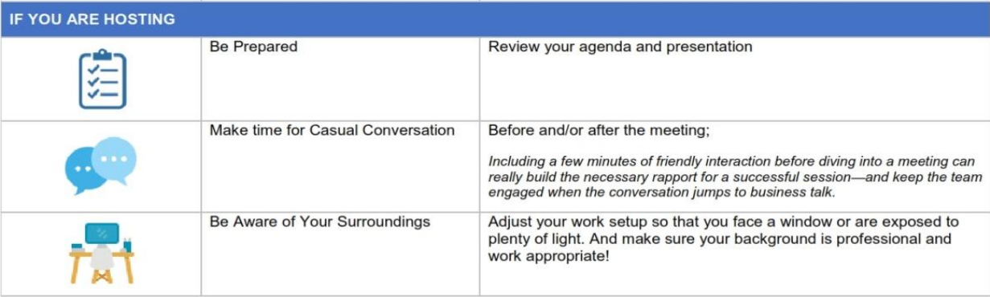

1. **Conciseness**

The writing is concise as

* Short sentences are used
* Headings and subheadings are used
* There is no irrelevant information and no use of prepositional phrases.
* There is no unnecessary repetition of words and pronouns are used where repletion becomes necessary.

1. **Completeness**

The information given in the pamphlet is complete as

* All necessary information is provided regarding zoom meeting etiquette.
* It answers all questions that rise in the mind of the reader, what are the do’s and the don’ts of video conferencing in the zoom, and how to have a productive meeting? etc.

1. **Concreteness**

The information provided in the document is concrete as

* Only specific details are provided, and no unnecessary information is given **for example** document explains the etiquette of zoom meetings, as it does not explain the methodology of video conferencing of any other platform which can only rise queries and diverts them from an important point (i-e about zoom platform).
* Grammar and punctuation marks used are accurate.

1. **Consideration**

In this written communication writer has shown respect to the receiver as

* You-attitude has been preferred
* There is no discouragement in the writing**, for example:** when you dress appropriately you will put yourself in the right headspace to be productive.



1. **Courtesy**

A courteous tone has been used in the document as

* Courtesy stems from sincere you-attitude and it is used in the writing
* No gender-specific pronoun is used like He or She
* Irritating expressions are not used instead positive tone has been adopted

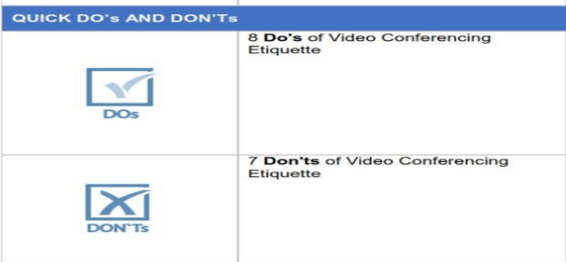

1. **Correctness**

The core of correctness is proper grammar, punctuation, and spelling and the writer has considered all these points. All the data provided is authentic as a proper hyperlink is provided.