**Lab # 10**

**The Forward Pass and Backward Pass for the Activity on Node Network**

# Lab # 10

# The Forward Pass and Backward Pass for the Activity on Node Network

## 10.1 Objective:

The purpose of this lab is to teach the students to calculate the project duration using an activity on the node diagram

## 10.2 Scope:

The student should know the calculation of the following at the end of this lab:

Forward Pass

* 1. Earliest Start time
  2. Earliest Finish time

Backward Pass

* 1. Latest Start Time
  2. Latest Finish time

## 10.3 Concepts

By knowing how early an activity can start and how late it can finish gives you the flexibility to juggle resources between other activities that can potentially impact critical path, and hence the project completion date. The shorter a network path is in relation to critical path, more schedule flexibility you will have on activities on that path.

**Earliest Start Time (EST) and Earliest Finish Time (EFT)**

Indicates the earliest time an activity on a network path can start and earliest it can finish. If you decide to start an activity on its early start (assuming previous activities on that network path are completed on their early finishes), that activity can finish on its early finish (if it does not slip). And when the last activity on a network path is completed by its early finish, you have all the resources of those activities at your disposal to deploy on other high-risk activities.

**Calculating EST and EFT (FORWARD pass-through activity diagram)**

**Step 1:** Early start of first activity on critical path is always 1. Write it at the top left corner of that activity box (see the image below).

**Step 2:** Add its activity duration to this early start number and reduce it by one. Write the resulting number on the top right corner of activity box.

**Step 3:** Take the subsequent number of this early finish and write as early start for next activity. Continue this till you reach the end of critical path.

**Step 4:** Select the network path with second highest total duration and calculate early starts and finishes. If you find an activity with early start and finish already written do not overwrite them. Do the same for remaining network paths.

**Note:** If you find two activities converging on a single activity (say, activity-G), it indicates that the activity-G will start only AFTER converging activities finish. So, you will take the largest value amongst the early finish of these two activities and write subsequent number as early start of the activity-G. Why add duration to early start and then reduce by one, to get early finish? Because the duration of an activity includes both start and finish days (or any other unit of measurement you use). So, if first activity duration is 5 days, and early start is 1 then early finish is 1+6-1 = 6. That is 6 days including the start and finish days.

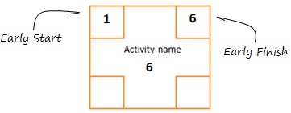

**Early start and finish:**As you noticed, **early start number is written at the top left corner** **of activity box, and** **early finish on the top right corner**. The critical path with early start and early finish days will look like this –

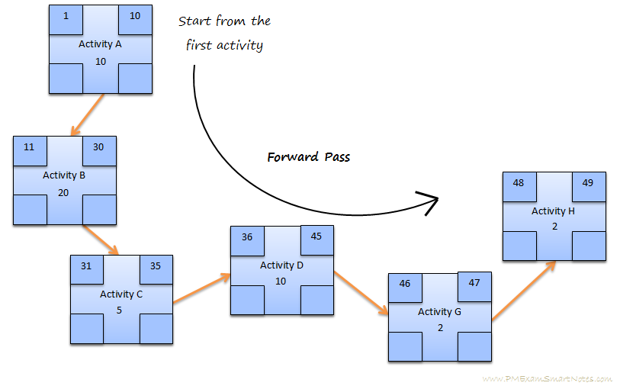

**Early start and early finish for critical path**

**Late Start Time (LST) and Late Finish Time (LFT) (Backward pass-through activity diagram)**

Indicates the latest time an activity on a network path can start and latest it can finish. Knowing how late the last activity on the network path can start and still finish within the time to not impact critical path, will let you decide how much of flexibility you want to exercise on its schedule. However, once the last activity on the network path starts on its late start day it should not slip, else it will impact project completion date. Start with the critical path, beginning at the last activity’s late finish.

**Step 1:** Late finish of last activity on the critical path is same as its early finish. Write this number at the bottom right corner.

**Step 2:** Calculate late start of this activity as the late finish minus activity duration plus 1. This calculation has the same reason – start and finish are both included in the duration. Write this number at the bottom left corner.

**Step 3:** Write this late start of the activity minus 1, as the late finish of previous activity. Continue this way all way till you reaches the late start of first activity on the critical path.

**Step 4:** Select the network path with second highest total duration and write late starts and finishes beginning at the last activity of that path. Do the same for remaining network paths.

**Notes:**

* If you find two activities converging on a single activity (say, activity-C), take the smallest value amongst the late start of these activities and write previous number as late finish of the activity-C.
* If you find an activity with late start and finish already written do not overwrite them.

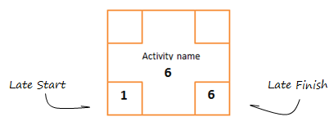

**Late start and Late finish**

**Late start number is written at the bottom left corner of activity box, and late finish on the bottom right corner.** The critical path of our example with late starts and late finishes will look like this –

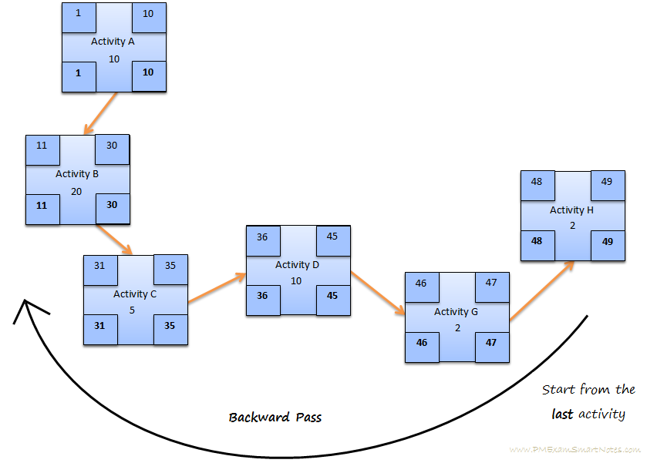

**Late start, finish for the critical path**

Let us go back to our example and calculate early/late start/finish for the entire schedule network diagram.

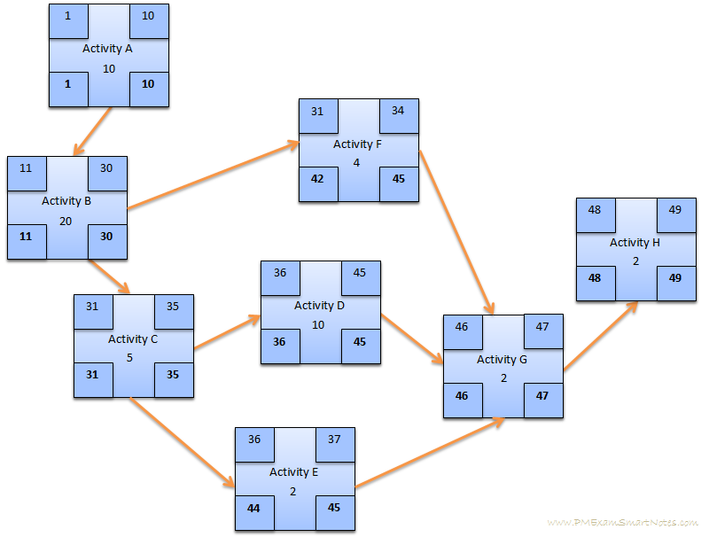 Early start, finish and Late start, finish for the entire schedule network diagram

* **Critical Path (CP):** Critical path in a network schedule diagram is the network path with longest total duration. Critical path sure is the longest network path, but this indicates Shortest Duration of the project – which means any activity slipping on this path will cause a delay in project completion. It is calculated by simply adding up duration of all activities on each network path and finding the one with largest number
* **Float:** Float (also known as Slack) of an activity is the duration that it can slip without delaying the next activity or the project end date
* Float for every activity on critical path is zero
* Float for every activity on a network path is the difference between its total duration and that of critical path (excluding the activities that have float calculated already)
* Float is calculated for network paths in the descending order of their total duration, starting with critical path

**Calculating Early and Late Starts and Finishes**

Early start and finish are calculated by forward pass through the network path, and Late start and finish are calculated by backward pass

Both are calculated first for the critical path

Both are calculated for remaining network paths in the descending order of their total duration

During calculation if you come across any activity with duration already calculated, do not overwrite

## 10.4 Exercises for lab

|  |  |  |
| --- | --- | --- |
| **Activity** | **Predecessor** | **Duration** |
| A | - | 7 |
| B | A | 15 |
| C | A | 10 |
| D | C | 12 |
| F | B | 17 |
| G | D | 6 |
| H | D,F | 11 |
| I | G,H | 13 |

* Draw Activity on the node diagram of the following table and identify the critical path or paths in it. Apply Forward pass and backward pass to calculate the EST, LST, EFT and LFT.

## 10.5 Homework

* Draw Activity on the node diagram of the following table and identify the critical path or paths in it. Apply Forward pass and backward pass to calculate the EST, LST, EFT and LFT.