UDP Pinger

Ping server:

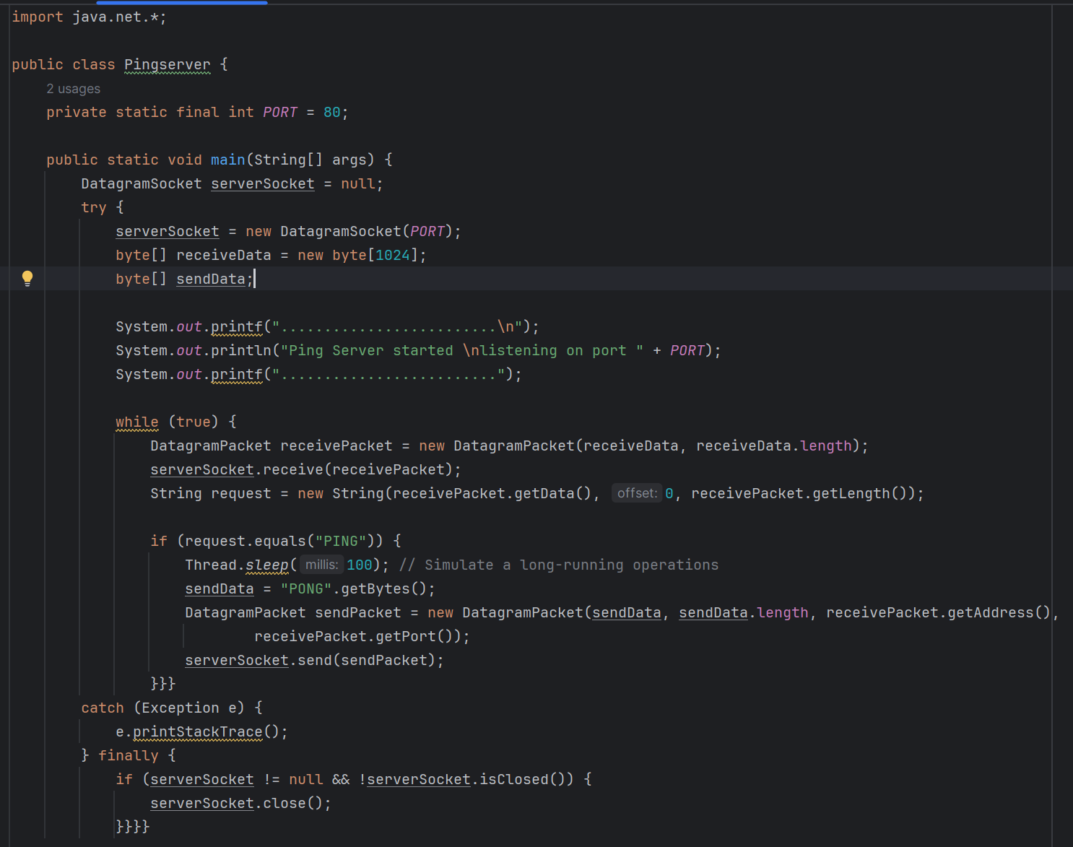

Ping client:

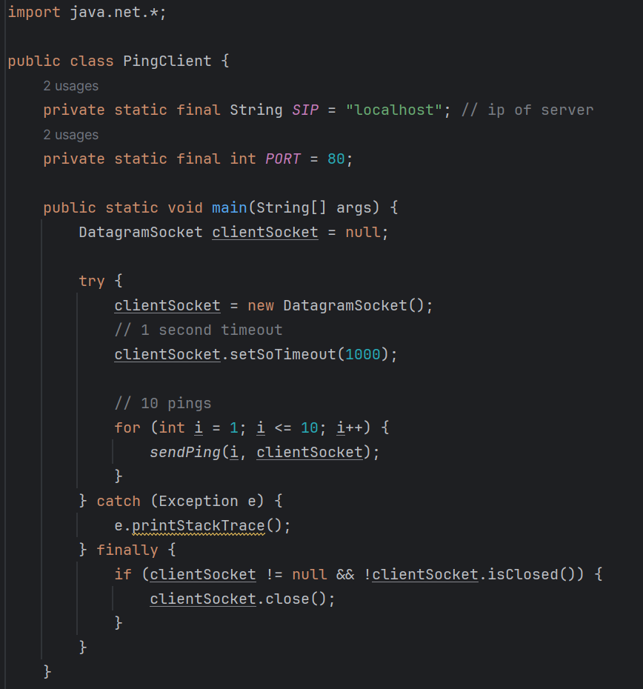

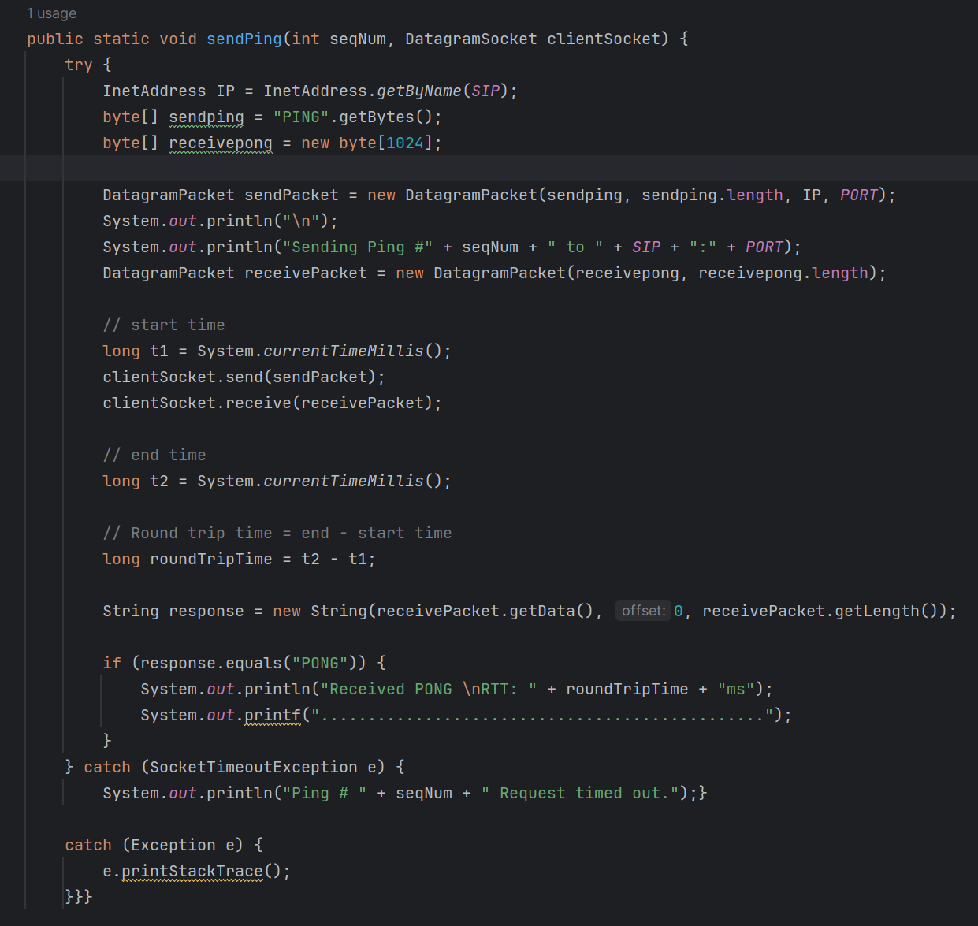

Output:

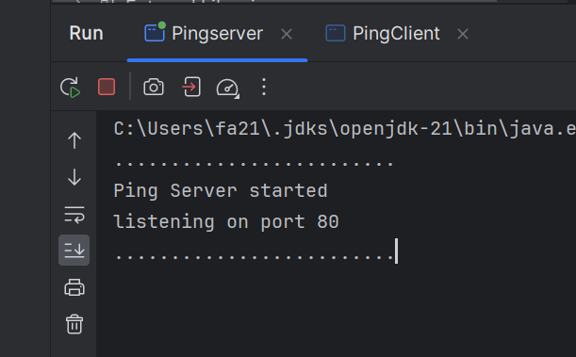

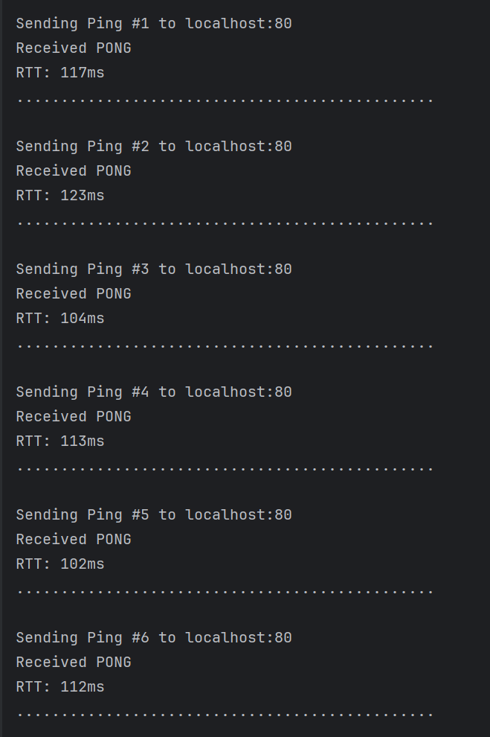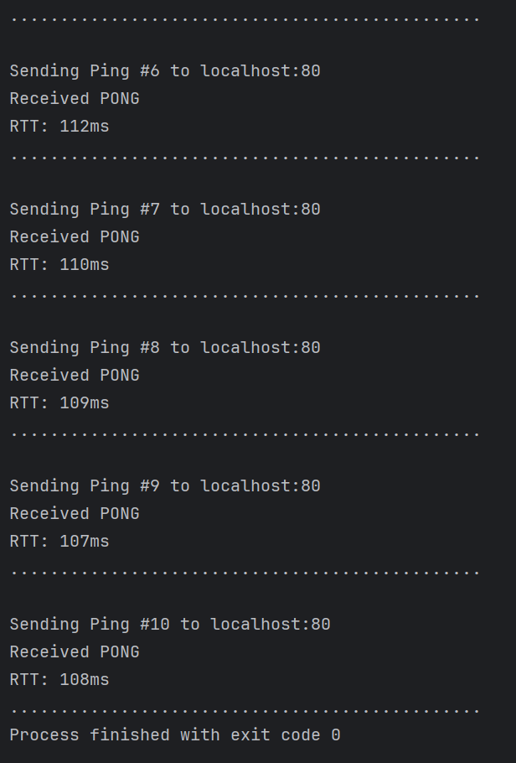

1. Explain the architecture of Google`s Content Delivery Network across the globe.

Google’s Content Delivery Network (CDN) are designed to deliver content quickly across the globe. It’s a globally distributed network infrastructure. Google’s CDN architecture is based on multiple layers of servers placed in different location having strategically placed services. The following discussion is an overview of the architecture:

Content delivery has three components: router, cache, cache filter. Router handles user requests cache checks whether it has requested content or not if it lacks then it will request from origin server using specific cache keys. The cache filters modify headers of the content from the origin. Once the content is fetched it returned to router to deliver to end user. [1]

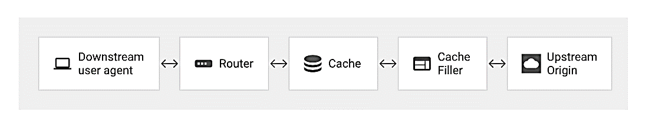

Google handle many edge locations placed around world i-e data centers where the copies of content is cached thus bringing closer to end-users. When user request for any content, the edge location will respond rather than the origin server thus reducing the latency and increased availability. But in some of the cases it is entertained from the from the origin server where it is hosted originally. And sometimes when content is considered invalid then it is removed from cache and when request made for this specific content the CDN fetches fresh copy directly from origin server.

Google CDN uses load balancing approach and provide the enhanced HTTP routing to map the traffic to specific edge which results in increased performance and users are not overwhelmed; reliability of architecture.

Frequently requested content is cached at edge server and when any user request for cached content it will be directly delivered from edge server. For that reason google CDN make intelligent algorithms to find what content have to be cached based on popularity, user need, etc.

Google’s CDN ensures the accelerated delivery of content in real-time on the basis of user interaction i-e dynamic delivery is improved by minimizing the processing time at origin and using caching reasonably. Google cloud Armor to allow or deny access to content filtering based on region codes and geographical location.

Google’s CDN keep Secure Sockets Layer & Transport Layer Security termination thus ensuring the secure communication between end user and server (edge-server).

Google’s CDN also integrate security measures like DDoS defense thus protecting CDN infrastructure and content to be delivered. Media CDN uses multiple modern protocols from client to edge thus increasing throughput.

**References:**

Google cloud (2023-10-09) Leverage Google’s decade of experience delivering content. Google Cloud

<https://cloud.google.com/cdn?hl=en>

1. Google cloud (2023-10-09) Media CDN overview. Google Cloud

   <https://cloud.google.com/media-cdn/docs/overview>