**Objective:**

# Lab 9

**Prototyping & Storyboarding**

The purpose of this lab is to help students learn the prototyping as a method to involve the users in testing design ideas and get their feedback in the early stage of development, thus reducing the time and cost.

## Activity Outcomes:

After completing this lab, students will be able to:

* Build prototypes for any given project

## Instructor Note:

All prototypes in this lab will be hand drawn.

## Useful Concepts

Prototyping provides an efficient and effective way to refine and optimize interfaces through discussion, exploration, testing and iterative revision. Early evaluation can be based on faster and cheaper prototypes before the start of a full-scale implementation. The prototypes can be changed many times until a better understanding of the user interface design has been achieved with the joint efforts of both the designers and the users.

It provides an efficient and effective way to refine and optimize interfaces through discussion, exploration, testing and iterative revision.

Early evaluation can be based on faster and cheaper prototypes before the start of a full-scale implementation. The prototypes can be changed many times until a better understanding of the user interface design has been achieved with the joint efforts of both the designers and the users. Prototypes are experimental and incomplete designs which are cheaply and fast developed. Prototyping, which is the process of developing prototypes, is an integral part of iterative user- centered design because it enables designers to try out their ideas with users and to gather feedback.

##### Types of Prototyping

Prototyping can be divided into low-fidelity prototyping, medium-fidelity prototyping and high- fidelity prototyping. In some literature, it is only simply classified as low-fidelity prototyping (also called Lo-Fi) and high-fidelity prototyping (also called Hi-Fi), where low-fidelity prototyping is mainly about paper-based mock-up, and high-fidelity is mainly about computer- based simulation. The determining factor in prototype fidelity is the degree to which the prototype accurately represents the appearance and interaction of the product, not the degree to which the code and other attributes invisible to the user are accurate.

Low-fidelity prototypes are quickly constructed to depict concepts, design alternatives, and screen layouts, rather than to model the user interaction with a system. Low-fidelity prototypes provide limited or no functionality.

In contrast, high-fidelity prototypes are fully interactive, simulating much of the functionality in the final product. Users can operate on the prototype, or even perform some real tasks with it.

##### Sketches

Sketching techniques, a kind of visual brainstorming, can be useful for exploring all kinds of design ideas. After producing initial sketches the best ideas can be further developed by constructing cardboard representations of the design, which can be evaluated with users. This can then be followed by developing scenarios, software or video prototypes.

Freehand sketches are essential for crystallizing ideas in the early stages of design. Through the act of putting ideas down on paper and inspecting them, designers see new relations and features

that suggest ways to refine and revise their ideas. Sketches make apparent to designers not only perceptual features but also inherently non-visual functional relations, allowing them to extract functions from perception in sketches.

The type of mock-up depends on how advanced the idea is. It may be quicker and cheaper to use paper-and-pencil forms at early stages, whereas computer-based prototypes may be important in later stages for exploring and demonstrating interaction and design consistency.

As one can imagine, the sketch technique is as simple as drawing the outward appearance of intended system on paper. However, creativeness is needed. There are some useful training exercises in to help designers get used to visual thinking.

##### Storyboard

Storyboard origins from the film industry, where a series of panels roughly depicts snapshots from an intended film sequence in order to get the idea about the eventual scene. Storyboard is a graphical depiction of the outward appearance of the intended system without accompanying system functionality. Storyboard provides snapshots of the interface at particular points in the interaction so that the users can determine quickly if the design is heading in the right direction.

Storyboards do not require much in terms of computing power to construct, in fact, they can be mocked up without the aid of computers. The materials needed are office stationery, such as pens or pencils of different colors, Post-It, stickers, and so on. However, modern graphical drawing packages make it possible to create storyboards with the aid of a computer instead of by hand. It is also possible to provide crude but effective animation by automated sequencing through a series of snapshots

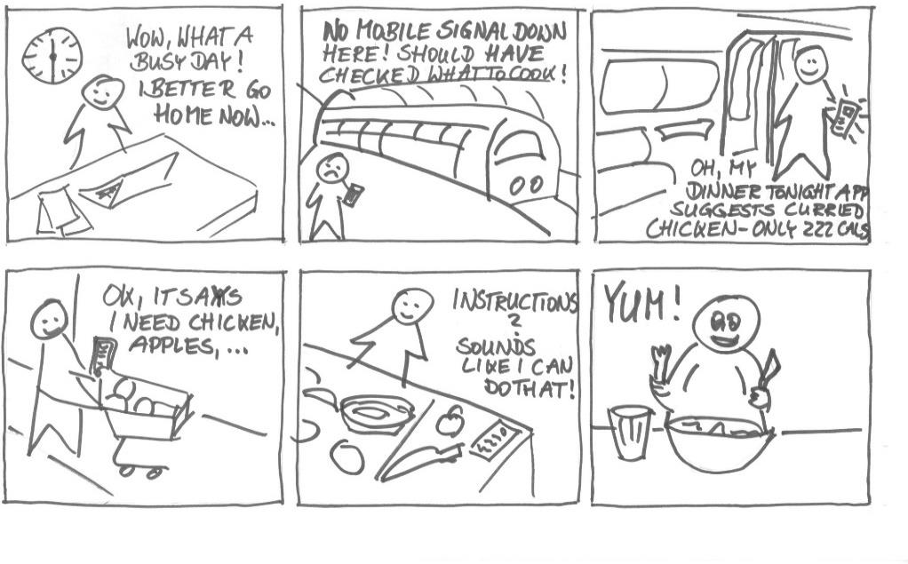

**Figure 10.1: Storyboard**

## Solved Lab Activites

|  |  |  |  |
| --- | --- | --- | --- |
| ***Sr.No*** | ***Allocated Time*** | ***Level of Complexity*** | ***CLO Mapping*** |
| ***Activity 1*** | ***30 min*** | ***High*** | ***CLO-6*** |

### Activity 1:

***We allow ourselves to clutter our lives with our immediate to-dos and goals, often neglecting to remember the moments of happiness that we can be grateful for. Keeping track of these moments can help us appreciate them, grow in self-awareness and be happier. Everyone being happier makes the world a happier place.***

***We need to do storyboarding and prototyping for the above described idea.***

##### Solution

The complete solution is available on

<http://d.ucsd.edu/class/intro-hci/2016/assignments/examples/a03example1.html>

## Graded Lab Tasks

***Note: The instructor can design graded lab activities according to the level of difficult and complexity of the solved lab activities. The lab tasks assigned by the instructor should be evaluated in the same lab.***

## Lab Task 1

*Draw a storyboard depicting your project concept.*

## Lab Task 2

*Draw the low fidelity prototypes of your project.*