**COMSATS UNIVERSITY ISLAMABAD, ABBOTTABAD**

***Design Pattern***

Lab assignment # 02

***Submitted by:***

Laiba Binta Tahir FA21-BSE-019

***Submitted to:***

Mam Faiza Hameed

Contents

**Facade Pattern** 3

Code 3

Class diagram 6

**Prototype pattern** 7

Code 7

Class Diagram 10

**Proxy pattern** 11

Code 11

Class Diagram 13

**Observer pattern** 13

Code 13

Class Diagram 16

# **Facade Pattern**

Example: home automation with multiple systems.

## Code

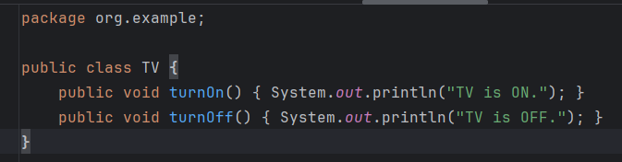

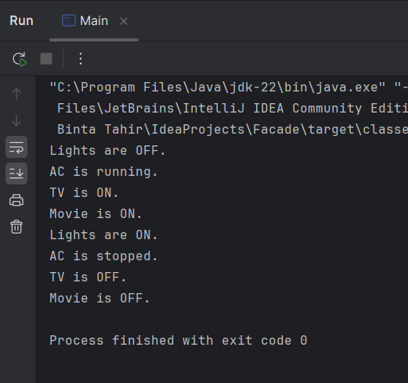

## Class diagram

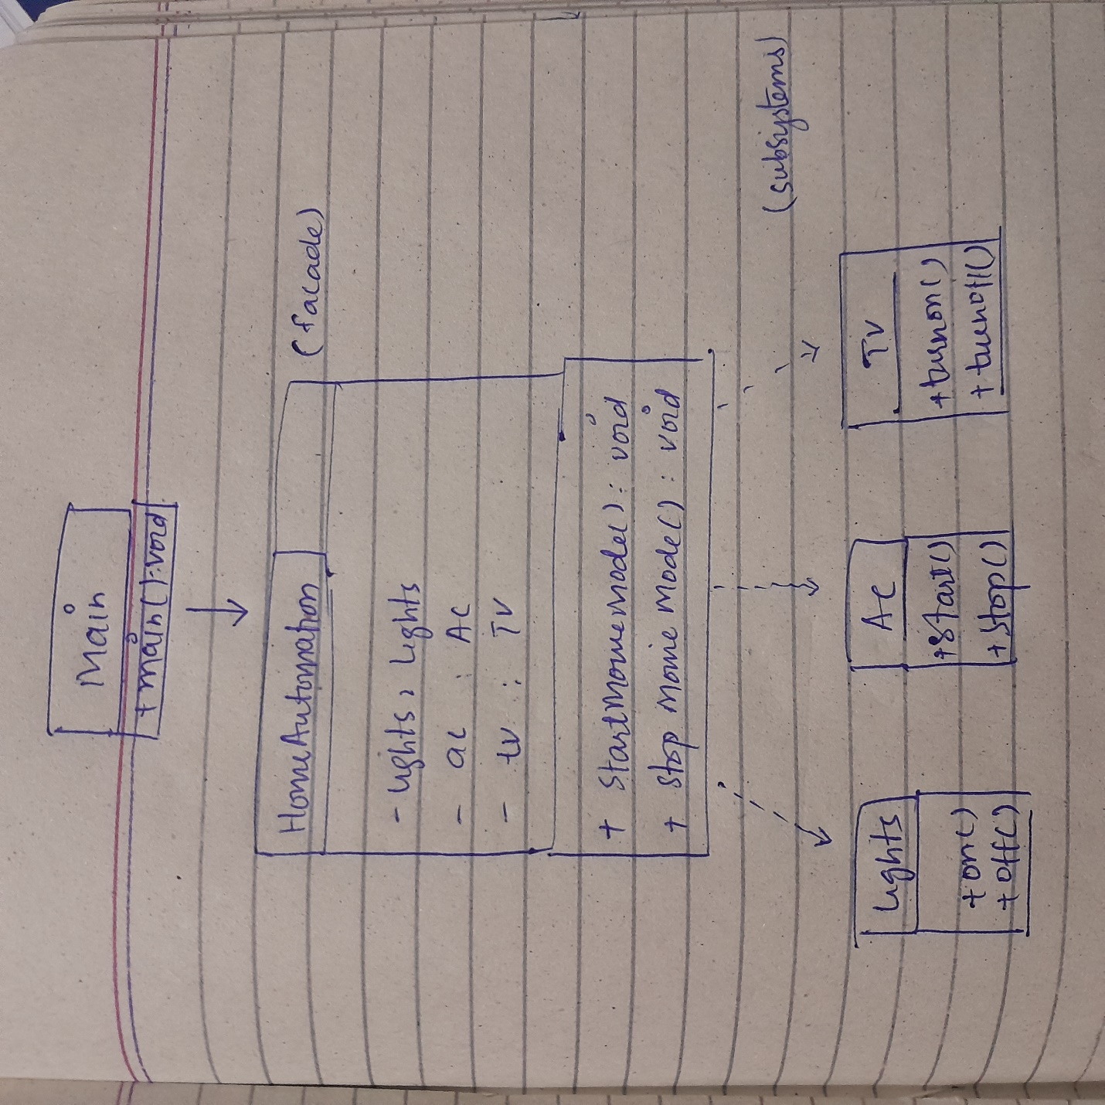

Figure Facade pattern

# **Prototype pattern**

Example: A Shape class where cloning is required.

## Code

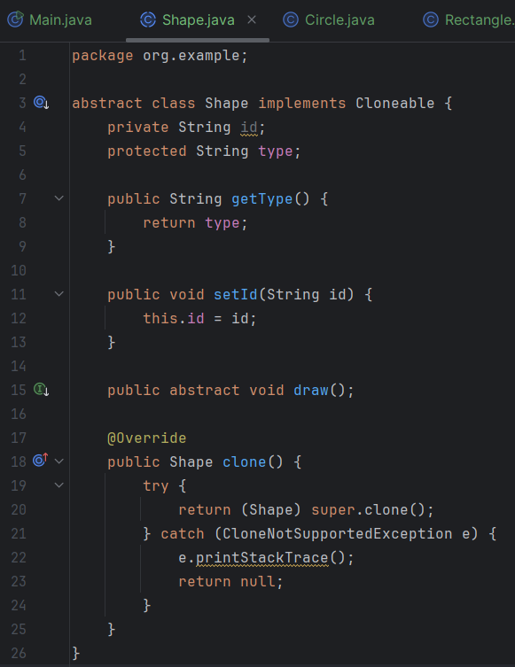

## Class Diagram

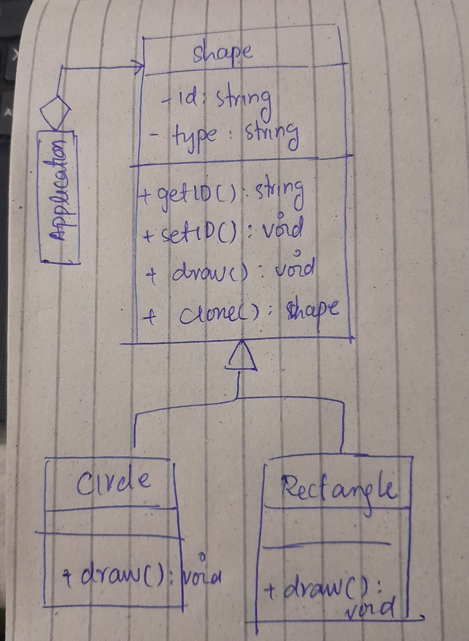

Figure Prototype pattern

# **Proxy pattern**

Example: A Proxy for accessing a Remote Server.

## Code

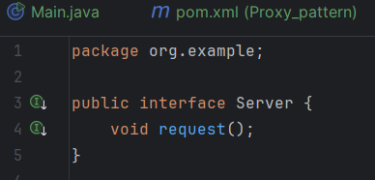

## Class Diagram

Figure proxy pattern

# **Observer pattern**

Example: A News Publisher (subject) notifies Subscribers (observers) when there's a new article.

## Code

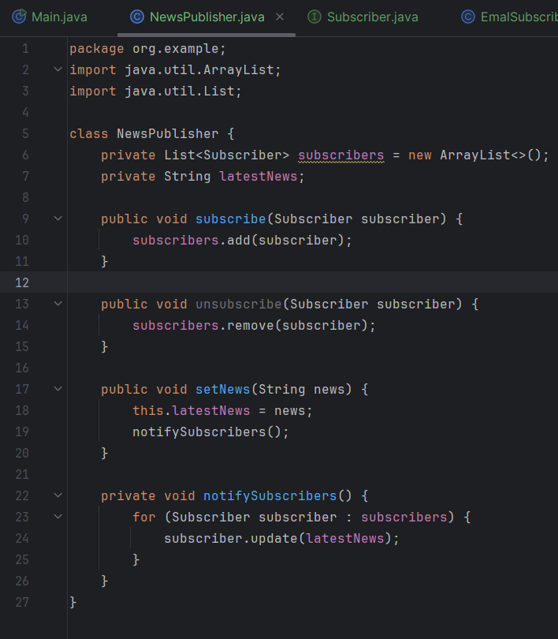

## Class Diagram

