**Lab – 11**

**laiba binta tahir**

**Task-01**

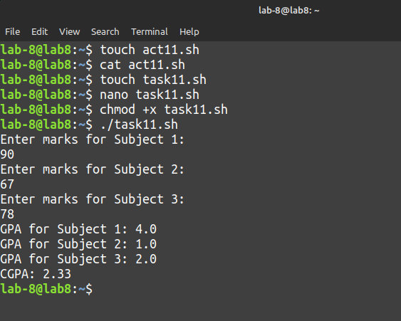

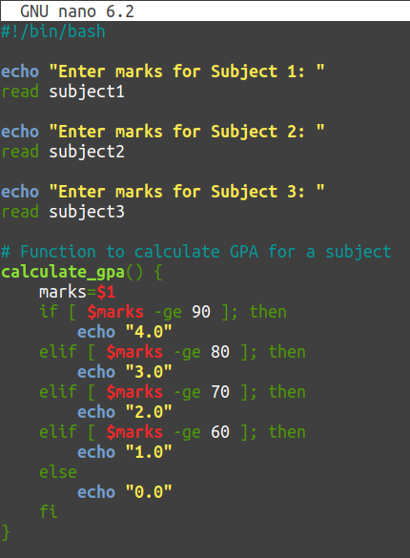

**Task-02**

#!/bin/bash

while true; do

echo "Select an option:"

echo "A. Display host-name and uptime"

echo "B. Display disk and memory space"

echo "C. Display home space utilization"

echo "Q. Quit"

read option

case $option in

A) echo "Hostname: $(hostname)"

echo "Uptime: $(uptime)"

;;

B) echo "Disk and Memory Space:"

df -h

free -m

;;

C)echo "Home Space Utilization:"

du -sh ~

;;

Q)echo "Quitting program."

exit 0

;;

*)echo "Invalid option. Please enter A, B, C, or Q."

;;

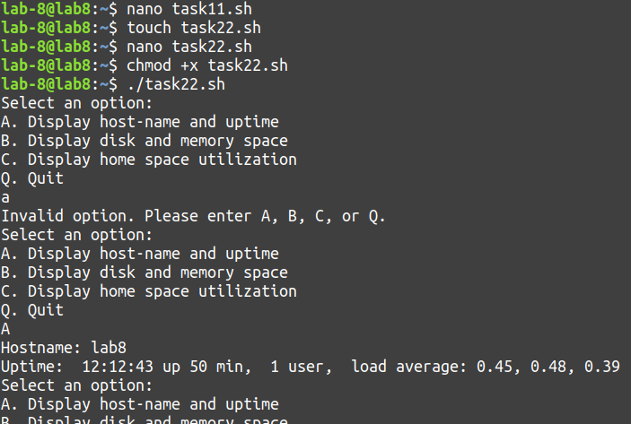 esac

done

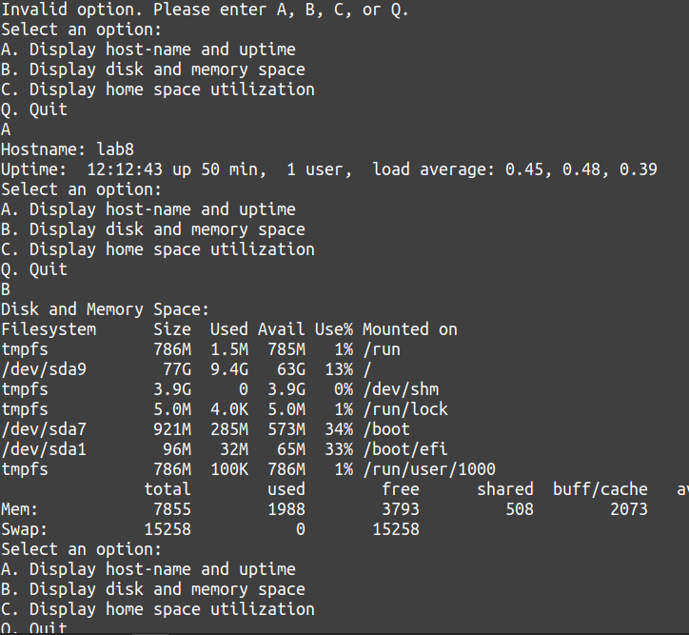

**Task-03**

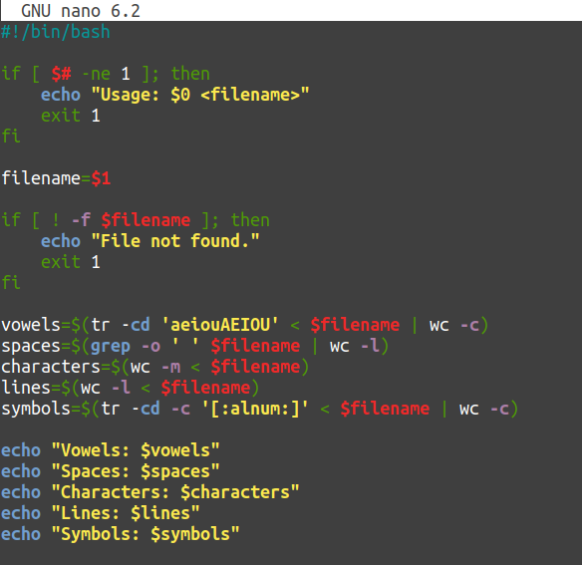

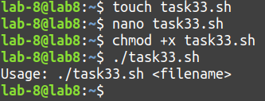

**Activity 01**

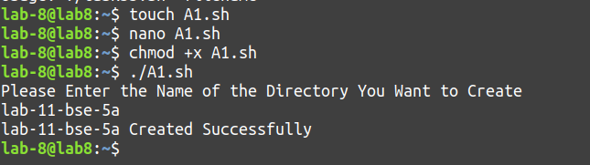

**Activity-02**

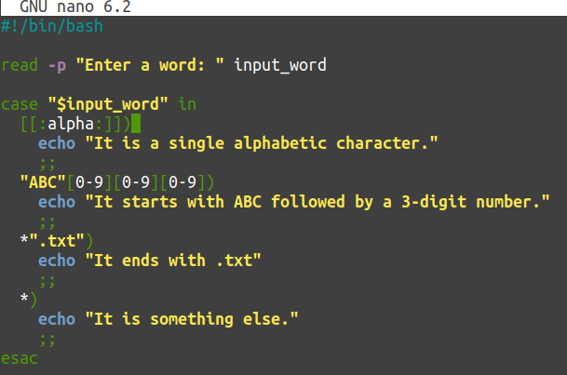

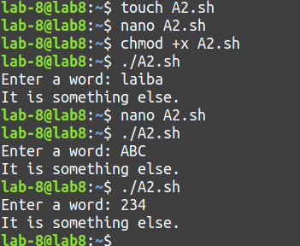

**Activity-03**

