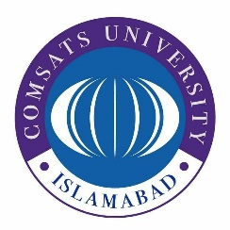

**COMSATS UNIVERSITY ISLAMABAD,**

**ABBOTTABAD CAMPUS**

**Report Writing (Semester Project)**

Economic and Administrative Challenges Related To the Textile Industry in Pakistan

***PREPARED FOR:***

Mam Sara Saeed

***PREPARED BY:***

Aftab Ali FA21-BSE-178

***DATED:***

21 November -2023

Table of Contents

1. INTRODUCTION 2

1.1 Background of Pakistan textile industry 2

1.2 Purpose of report 2

1.3 Significance of report 3

1.4 Limitation of study 3

2. LITERATURE REVIEW 3

3. METHODOLOGY 3

4. FINDING AND DISCUSSION 4

4.1 Gas Shortage 4

4.2 Electricity Crisis 4

4.3 Increasing Raw Material Prices 5

4.4 Lack of Modern Equipment and Machinery 5

4.5 Lack of New Investments 6

5. CONCLUSION 6

6. RECOMMENDATION 7

7. REFERENCES 8

8. APPENDIX-I (Tables) 9

Executive summary

**Aims and objective:** Textile industry is the backbone of Pakistan. Pakistan ranks fourth in the textile market. The main objective of this report is to assess the various challenges faced by the textile sector Pakistan, highlight the shortcomings in Pakistan administrative system and economic problems that has slowed the developmental pace of textile industry. **Design and methodology:** The data used for this study is secondary data. It is the qualitative study and all the information and statistics in this report has been taken from the research work of others. **Findings of the report:** This study reveals that the textile industry of Pakistan is suffering a lot because of the lack of seriousness of concerned authorities in government. The economic and administrative challenges are energy crises, gas shortage fluctuating prices, devaluation of Pakistani rupee, lack of modernized machinery and increased cost of production cost. **Recommendation:** Pakistan’s textile industry can once again come on winning track if government normalizing the above mentioned challenges. Proper planning and strategies are need to be implemented by the present government and relevant textile governing institutions. **Limitation:** limitations of this study is that we have used secondary data hence the conclusions are derived from the data collected through various sources. Many statistical values in the study can vary by present values as most of the used research articles was written around 2017. This study focus on only economic and administrative challenges faced by textile industry, not on political and social challenges in the textile industry.

# INTRODUCTION

In world textile industry Pakistan comes on fourth rank, and is included in the list of largest manufacturer of textile goods. According to report of ***All Pakistan Textile Mills Association*** in an era of 2009-2012 textile industry had contributed to 52% of total exports of the country, 8.5% of total Gross Domestic Products and 5% of the market capitalization.

## Background of Pakistan textile industry

At the time of independence Pakistan had only two textile mills, Okara Textile Mills, Okara and Lyallpur Cotton Mills in Faisalabad were in process. With the passage of time this sector started its development process, finally industry started picking up gradually and Pakistan became 4th largest textile exporter. Since 1947 states cotton production has increased and textile industry has expanded. According to records of Textile Commissioner’s Organization there are 523 textile units in Pakistan with 65% of textile units set in Punjab, 25% in Sindh, KPK there are 5% and remaining are present in Azad Kashmir and Baluchistan.

Over the period of FY13-FY17 decrease trend in states export has been observed and Textile exports are in-line with the decrease trend of total exports and shows a negative compound growth of 1% over the period (FY13-17).

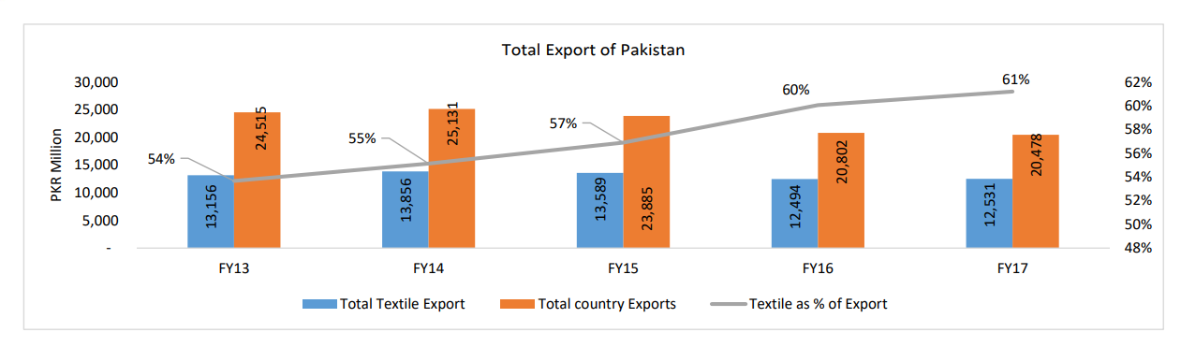

*Figure 1 total export of the country*

## Purpose of report

The aim of this document is to;

* Identify the challenges and difficulties faced by the textile industry of Pakistan
* Highlight the reasons why the producers and exporters of Pakistan are lagging behind in global markets.
* And based on the analysis also suggest some solutions which can help our textile industry to restart its journey towards the development process of the economy of the country.

## Significance of report

Pakistan is a developing country, whose economy mainly relies on textile and agro-industry. As world is progressing, developing countries like Pakistan are becoming more dependent on developed country, dept. on the state is increasing day-by-day. Moreover COVID situation has struck a huge blow to Pakistan economy.

## Limitation of study

Due to limited time frame for the semester project widespread data has not been used in the study to make this report most relevant and authentic. This study is of descriptive nature because all the information is taken from others research work. This study focus on only economic and administrative challenges faced by textile industry, it does not cover the political and social challenges in the textile industry.

# LITERATURE REVIEW

Most important part of Pakistan economy is textile industry. But over the year this industry has undergone an ups and down due to various reasons. The main contributor of this sector are readymade fabrics, garments and clothing, chemical processing sector and twisting sector. The sector still today is struggling and unable to perform to its full potential. Global tension, worldwide recession and market competence are also threats to the sector. (J. Memon 2020)

Case Study on the Economic Impact of Energy Crisis on the Textile Sector show that load-shedding after 2007 has greatly impacted Pakistan textile industry. Software E-views 07 was used for the study. Study emphasize that if we improve our energy resources then our textile sector could improve too. (Iqbal, M. 2017).

# METHODOLOGY

The data used for the study is secondary data. The method used for analyzing the economic and administrative challenges of Pakistan textile industry involve the review of various literature on the topic. As there is no specific method of analyzing qualitative data, all the information, statistical values and graphs are taken from other researchers work, explanation and interpretation and situations is analyzed and has been put in to meaningful paragraphs.

# FINDING AND DISCUSSION

For Pakistan textile sector is the export cash cow but this national share is facing continuous contraction. Based on the study we will point out and discuss the main economic and administrative reasons of crisis in textile industry.

## 4.1 Gas Shortage

Gas is the second form of energy that is required in production and manufacturing sector. Gas load-shedding is common in central hub of textile sector. Spokesman of All Pakistan Textile Mills Association explained that 60 to 70 % of textile had been affected and was unable to accept export orders coming in from around the globe due to gas shortage.

## 4.2 Electricity Crisis

Electricity is the basic component of nature and one of the most commonly and vastly used energy form. Previously economists described labor and capital as important element of every industry. But now scenario is different modern economists along with previous factor consider electrical energy as important determinant of every industry around the globe.

This study below was up to 2010 and in current scenario electricity situation has worsened and Pakistan export orders has decreased.

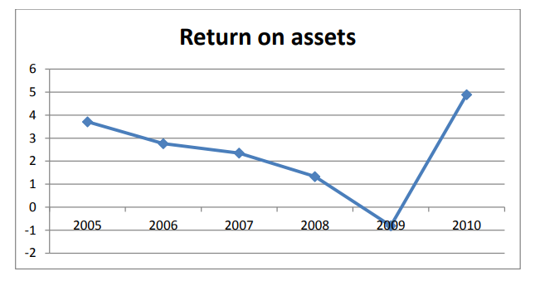

*Figure 2 return on assets of textile sector*

## 4.3 Increasing Raw Material Prices

Cotton is an ideal clothing material and Pakistan cotton production is very good. But due to declining international cotton prices Pakistan local market has faced problem and Prices of cotton & other raw material used in textile industry has fluctuated in Pakistan.

Administration should take serious step to sustain the textile industry. To decrease the prices of raw material, production capability of state should be increased. Moreover to enhance value; government should introduce international system of Cotton Standardization. (Aftab A. Khan 2010)

## 4.4 Lack of Modern Equipment and Machinery

Another major economic challenge faced by textile industry is the lack of working equipment and modernized machinery. This deficiency has declined the Pakistani textile competitiveness.

Rotors are very important equipment in textile as it give to good orientation of the fibers. Until Jul-Mar, 2017 as per record of Textile Commissioner’s Organization there are only total 185 thousand Rotors installed in Pakistan out of which 140 thousands rotors in operation with a 84 percent and 76 percent capacity utilization respectively.

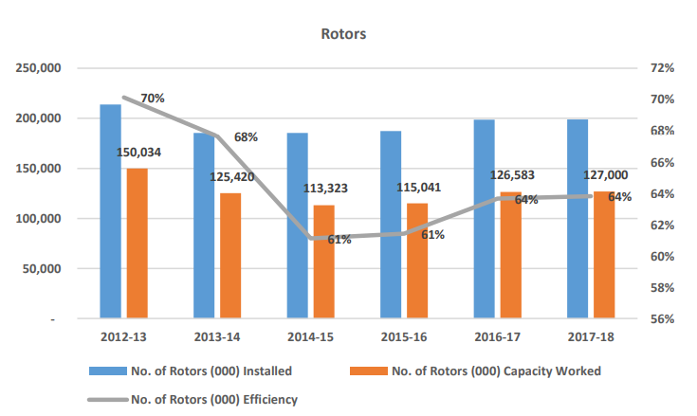

*Figure 3 Number of total installed and working rotors in Pakistan*

## 4.5 Lack of New Investments

The textile industry of Pakistan is facing enormous challenges of stunted growth and slowed production due to its inefficient textile equipment and machines. Economic Review of NBP in 2009 highlighted that around US$32 billion of investment was required till 2010 in order to achieve the government's export target. But unfortunately Pakistan social situation around 2015 has greatly impacted the investors and there is very limited international investment.

# CONCLUSION

Pakistan textile industry along with agro-industry is backbone of Pakistan economy. There is no doubt textile industry in current time contributes more than 60% in states export but still we are not as competitive as other Asian countries. Limited resources, inflation, under-developed equipment’s and management and poor Government policies of taxes and interest rate has forced slowed the pace growth the Pakistani textile sector. If this situation continued than not only Pakistan will always remain a developing country.

It is important that Pakistan carefully evaluate current scenario develop strategies to rectify all challenges. Administration should provide subsidy to the textile industry, withholding tax on imported essential raw material should be withdraw, sales taxes should be withdrawn, and industrial machineries should be upgraded.

# RECOMMENDATION

A lot of rectifications and improvements is required in the textile sector of Pakistan. Based on the review of the literature and personal observation following are some suggestions and solutions to current economic and administrative challenges faced by textile industry.

* Electricity and gas must be provided to textile organization at low rate for specific period of time which helps to establish the industry.
* For continuous supply of energy textile industries can go for private electricity production that can increase cost of production but in long-run there can be beneficial results.
* Research institutes must be established in affiliation with various agriculture universities, so that we can improve the quality of cotton, produce pest and herbicide resistant plants. Administration should fund the research initiatives and also recover the already established institution.
* To boost financing in the technology and infrastructure micro corporations be introduced, necessary unprocessed materials be supplied in uninterruptable
* Technology Up-gradation & Capacity Building is very significant for textile sector. To overcome the shortcomings of equipment, apparatus should be manufactured in house with guidance and partnership with friendly countries like China which can result in cheaper manufacturing.
* Pakistan can utilize CPEC and good relations with China by investing and partnering with them to advance our textile technology
* To Attract Foreign Direct Investment government Pakistan foreign ministry should establish good relation with other countries.
* Pakistan through international media needs to clear the point that there is a good social environment in Pakistan so that we can gain confidence of foreign investors.

# REFERENCES

Aftab A. Khan, Mehreen Khan, Pakistan Textile Industry Facing New Challenges Research Journal of Internatıonal Studıes - Issue 14 (May, 2010)

Aslam. (2019, August 27). Yarn merchants reject 4.0pc WHT on textile value chain. PAKISTAN CUSTOMS, SHIPPING & BUSINESS NEWS RESOURCE. Retrieved from [https://customnews.pk/2019/08/27/yarn-merchants-reject-4-0pc-wht-on-textile-value- chain/](https://customnews.pk/2019/08/27/yarn-merchants-reject-4-0pc-wht-on-textile-value-%09chain/)

Ali, A., Khan, M., Ishaq, A., Hussain, A., Rehman, S. U., Khan, I. A., & Shah, S. F. (2020). Pakistan textiles can bounce back vigorously. International Review of Management and Marketing, 10(2), 30-40. doi:10.32479/irmm.9377

H Afzal 2012. Impact of Electricity Crisis and Interest Rate on Textile Industry of Pakistan. Academy of Contemporary Research Journal Volume 1, Issue 1 (September 2012)

J. Memon, Abdul Aziz, Muhammad Qayyum. (2020). The rise and fall of Pakistan’s textile Industry: An analytical view. European Journal of Business and Management. doi:10.7176/ejbm/12-12-12

Malik, A. (2000). Demand for textile and clothing exports of Pakistan. Retrieved from <https://www.researchgate.net/publication/242117239>

# APPENDIX-I (Tables)

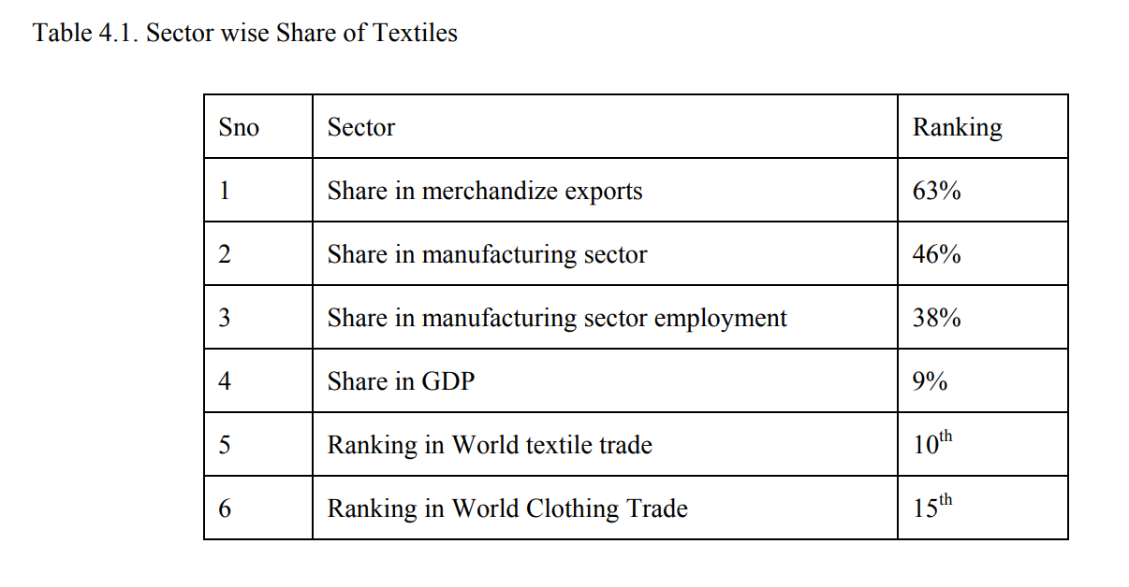

Table 1 Sector wise share of Textiles

Source *(Iqbal, M.2010)*

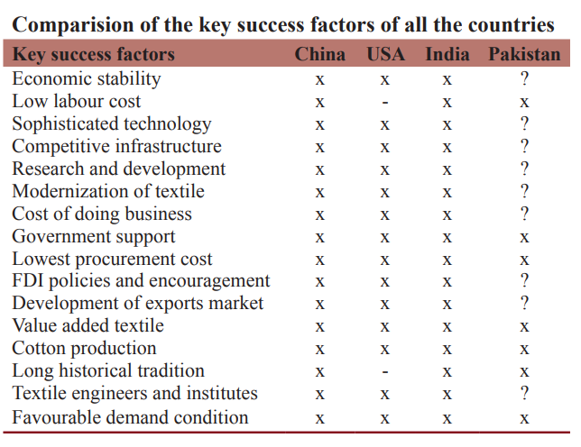

Table 2 Comparison of key factor of other countries with Pakistan

Source (Ali 2020)

In the above table (x) means presence of success factor, question mark (?) means improvement required and the areas with (--) are of no importance in this research study.