**Principles of User Interface Design**

1. Clarity

When a user visits a new website, it should be made clear to them what the website is about and most importantly, why they should use it.

When your interface is cluttered or obscure, there is no clarity. Without clarity, there is frustration.

2. Consistency

That’s not to say that a website should be exactly the same page by page, but elements with the same purpose should look the same.

Product pages, service pages, contact forms, and informational sections, should all feature a similar appeal and look exactly how they behave.

Look at how Apple’s website is consistent with their “Learn more” button styling on all pages of their site. Even when they decide to switch it up with darker backgrounds, they maintain consistency with their element styles and contrast.



3. Accessibility

At the heart of a website’s interface usability is accessibility. To briefly summarize, accessibility is the practice of making a product usable to as many users as possible.

This includes those with low vision, colour blindness, hearing impairments and situational disabilities.

In user interface design, accessibility refers specifically to improving your interface to **enhance the usability** and ease of use for all users.

4. Feedback

The association of feedback with actions on an interface is something we often take for granted.

To name a few, this would include button hovers, error pop-ups, confirmation messages, completion animations, check marks and colour changes.

These days, users have become so familiar with receiving feedback from interfaces that they have come to expect it. I sure do, and odds are you expect feedback as well.

According to [**Zendesk**](https://d1eipm3vz40hy0.cloudfront.net/pdf/cxtrends/cx-trends-2020-full-report.pdf), roughly 50% of customers say they would switch to a new brand after just *one bad experience*.

5. Familiarity

I’m sure you’ve noticed, but the majority of interfaces will resemble one another to a certain extent, especially web interfaces.

When users visit a website and are searching for a specific section of your website, they expect to find it within just a few clicks.

Whether it be a contact form, navigation menu, gestures or even the use of favicons for social media links, we all look for familiarity. As humans, we are **creatures of habit**. When we find key areas where we expect them, we feel comfort and reassurance.

Familiarity can also play a major factor in specific industries. Where we expect all websites to look and act mostly the same.



Like how we expect all websites to have their logo in the top left which leads to their home page. This wasn’t always a standard, but now we expect it on every website visit.

6. Design Standards

Throughout the process of creating an intuitive and useful interface for your user, it’s crucial that you set, understand and follow design standards.

Design standards are key to creating valuable products in all facets of design. Whether it be user interface design, graphic design, product design or software design, stay up to date with design standards and follow set guidelines.

When we follow guidelines, we achieve an exceptional end result which **meets the needs** of a broader audience.

In user interface design, these standards include the proper use of colour, contrast, balance, layout, alignment, hierarchy, the placement of elements and much more.

7. Structure & Hierarchy

By now, you know that UI design is all about creating interfaces that users can interact with.

But before the user can interact with an interface, they’ve got to know the purpose of the interface.

In user interface design, this is achieved with visual hierarchy, the design principle that puts emphasis on the most important visual elements.

Put simply, visual hierarchy helps the user know**where to look first**.

This can be done in a number of ways, but a great start is with size. More specifically, the size of text and elements.

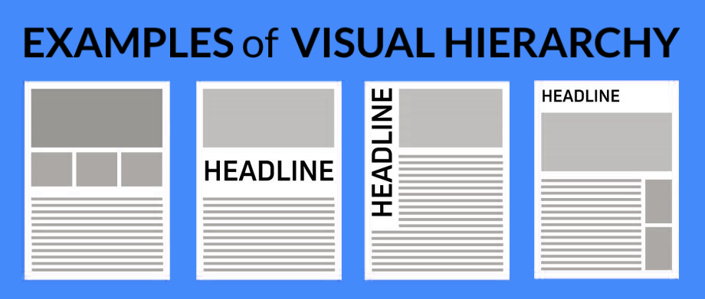

8. Simplicity

Designing a simple interface is pivotal to UI design, but it’s often easier said than done.

In user interface design, simplicity is the process of minimizing, refining and making a positive impact with less. In brief, a simple interface is not only clear or concise but much more pleasing as it rids us of an aspect we all despise: clutter.

Without clutter, users will feel comfortable and effortlessly use your product to the best of their ability.

Here’s an example of an extremely simple interface: [**exploding topics**](https://explodingtopics.com/).

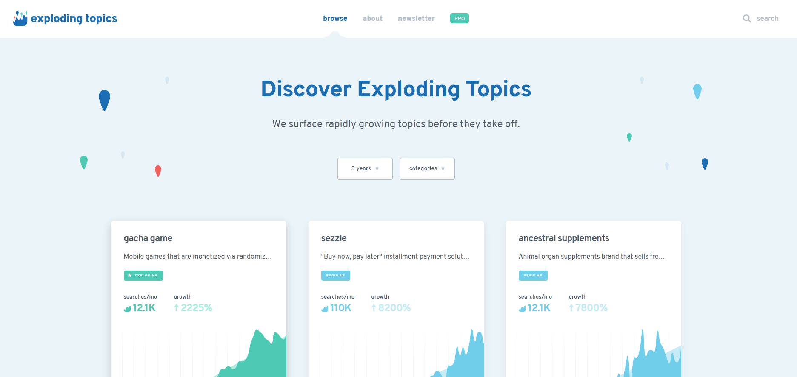

9. Control

Good user interface design isn’t just simple or familiar, it instills a deep sense of control in its users.

When the user feels in control of the application, they feel more comfortable and are much more likely to stay for**extended periods**.

But what does it mean to make the user “feel in control”?

To create an interface that instills control in its users is to create one that’s forgiving. This means that applications should always allow users to reverse actions at all stages of the interface.

However, it also means creating an interface that’s easy to use, and easy to navigate. Users shouldn’t have to scramble or dig through pages to find what they’re looking for.

User control goes hand in hand with feedback, when the application gives them the feedback they’d predicted, they will feel more in control.

10. Empathy

One of the greatest difficulties of user interface design is to truly understand users and empathize with them.

As designers and developers, we often think that we understand our users’ intent, goals and motivations, but usually, we don’t. And in the rare case that we do, we often forget about empathy.

The role of empathy in design is to observe, identify, analyze and resolve any previously unidentified behaviours, methods, and problems.

With empathetic design, we can remove bias, uncover weaknesses and design interfaces which users will truly appreciate.

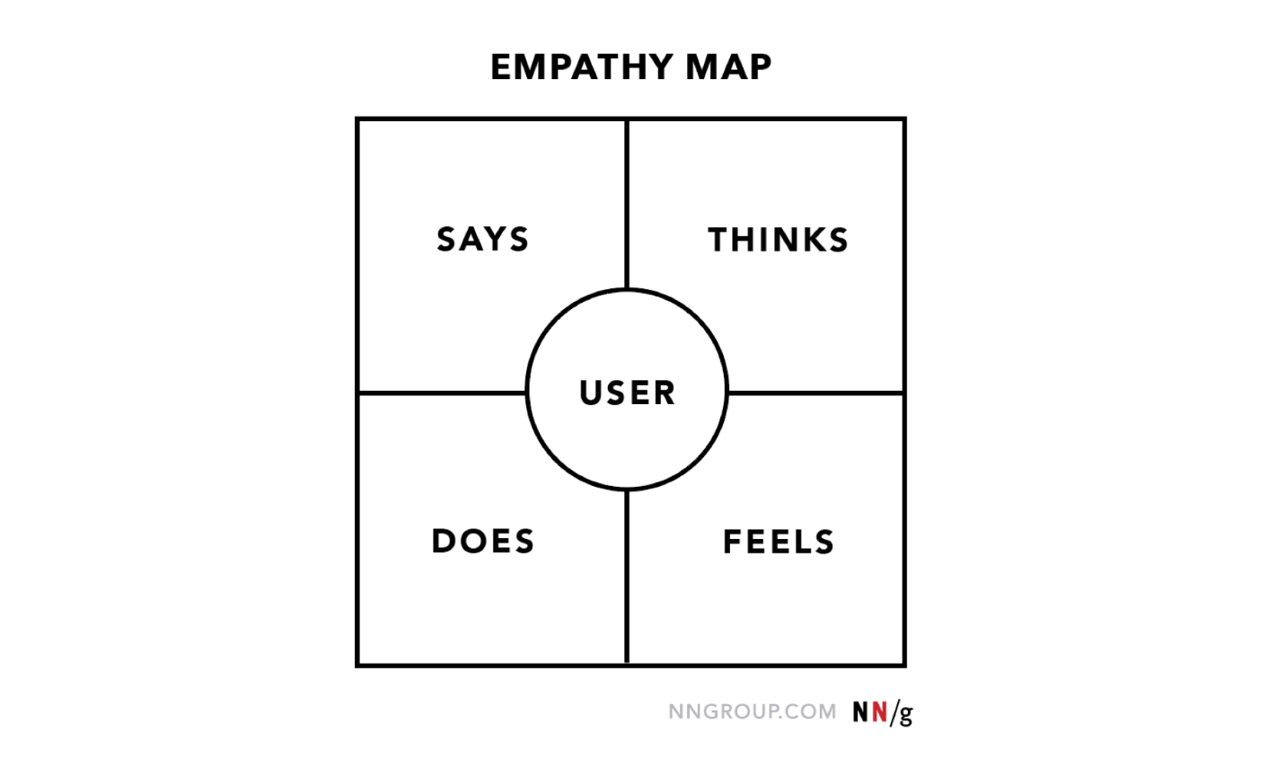

v