FA21-BSE-019-4A

LAIBA BINTA TAHIR

OOSE LAB MID

Case study

Electricity Theft Detection System (ETDS) is a solution with digital meters which periodically report the number of units consumed by each output line along with input units disperesed in multiple lines. Reported data is processed by a service in such a manner that every output line is either mapped to a customer or another digital meter for splitting. In case of meters the input energy is checked against consumed and if more than threshold value difference between two meters then a theft line is detected and reported to WAPDA line man. Line man are monitoring the lines according to allocated area in two shifts. At the end of the month bills are generated for customers and their collection is reported to SDO. WAPDA policies are enforced by the system along with warnings, notifications and then court cases for detected thefts. The system ensure a minimal loss of energy and also takes care of the allowed quota system for each WAPDA employee.

Use case:

Use case: stop monitoring.

Actor: lineman

Main success scenario:

|  |
| --- |
|  |
| **Action** | **System Response** |
| Notifies the system to stop monitoring a specific line or area. |  |
|  | Accept the request to stop monitoring the specified line or area. |
|  | Updates the system to reflect the change in monitoring status for the specified line or area.  Confirms the successful stoppage of monitoring for the specified line or area by sending message. |
| Acknowledges the system response. |  |

System sequence diagram

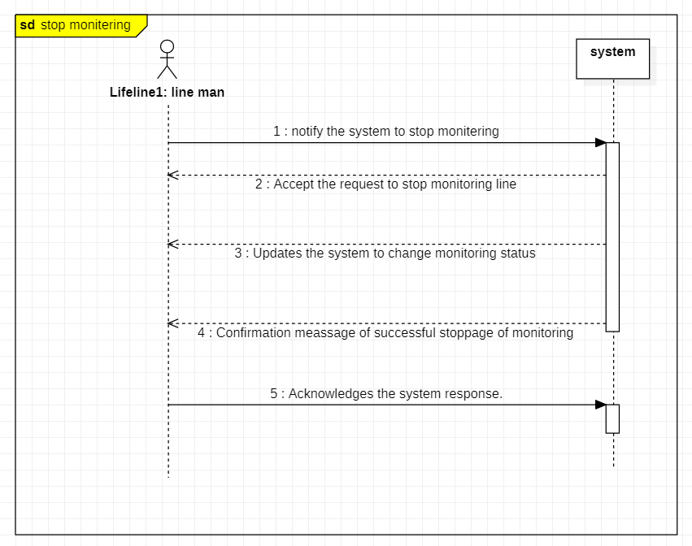

SSD handwritten: 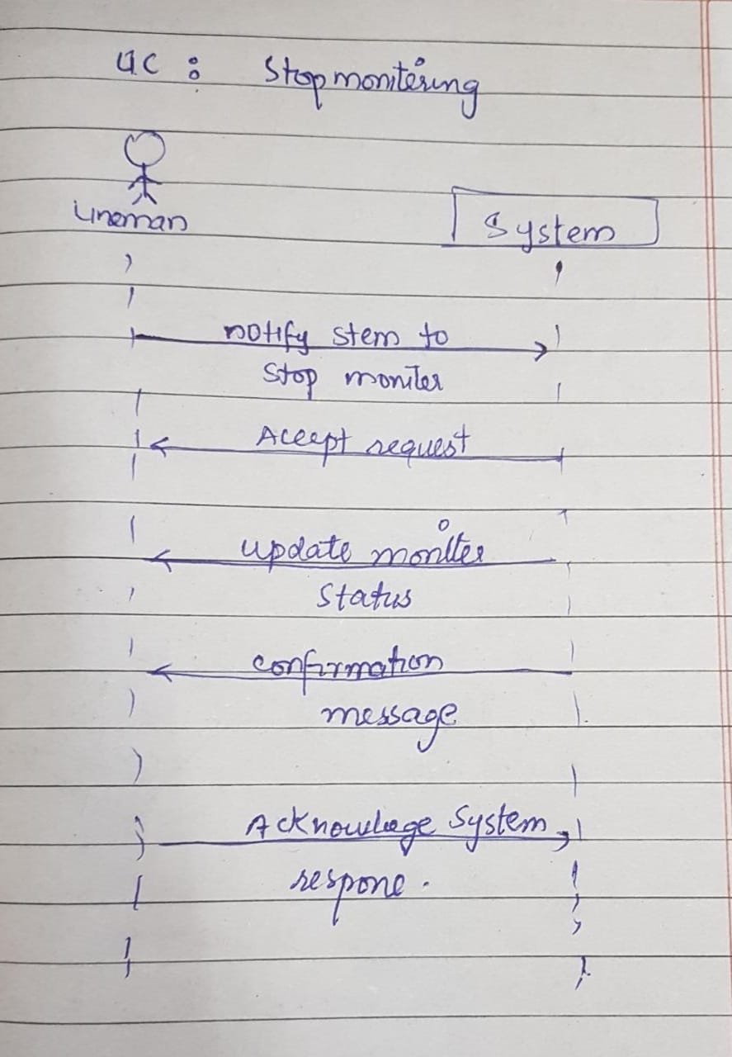

Prototypes:

