Video Link : <https://drive.google.com/file/d/1afRGsajA3ezs5czIlUkKe6qwFmpyj2wX/view?usp=sharing>

Student controller

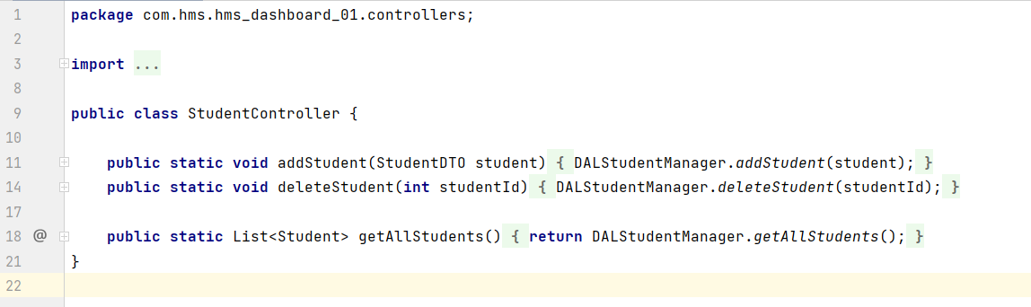

Student validator

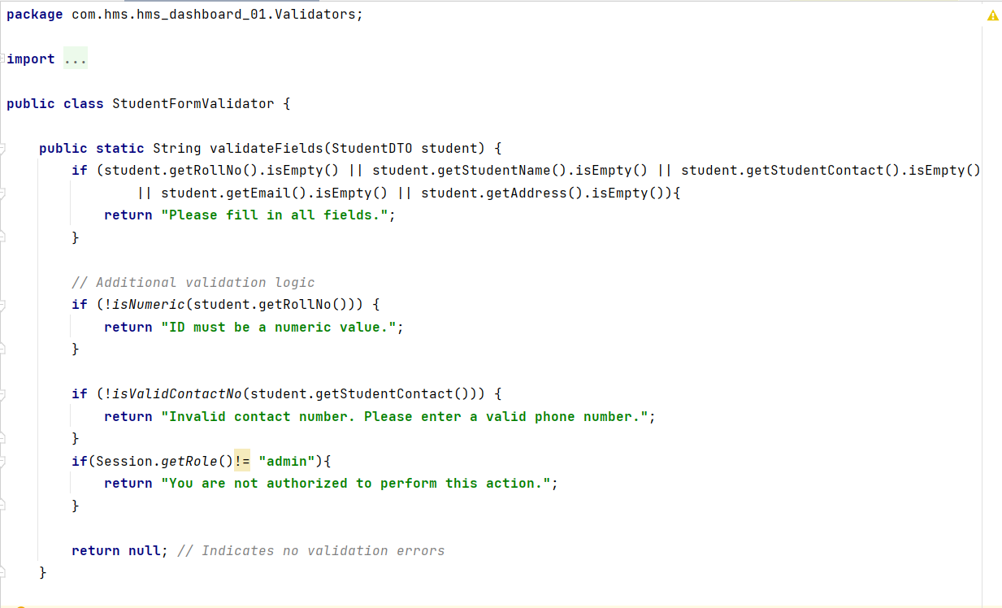

DAL Manager



