**REACT NATIVE PRACTICE PROBLEMS**

Contents

INTRODUCTION (CLO-1) 1

JAVASCRIPT (CLO-2) 4

REACT NATIVE CORE COMPONENTS (CLO-3) 9

REACT NATIVE STYLES (CLO-3) 29

REACT NATIVE NAVIGATION (CLO-4) 34

# INTRODUCTION (CLO-1)

#### Question: 1

**Define positive impacts of mobile apps on an organization**

Mobile apps can have numerous positive impacts on an organization, including:

1. **Enhanced Customer Engagement:** Mobile apps provide a direct and personalized channel for organizations to engage with their customers. Through features like push notifications, businesses can send targeted messages, promotions, and updates to keep users engaged.
2. **Increased Accessibility:** Mobile apps allow users to access information and services anytime, anywhere, leading to improved accessibility. This is particularly beneficial for businesses aiming to reach a global audience and cater to users on the go.
3. **Improved Customer Satisfaction:** Well-designed mobile apps can enhance the overall customer experience by offering convenient and user-friendly interfaces. This, in turn, contributes to increased customer satisfaction and loyalty.
4. **Streamlined Operations:** Organizations can use mobile apps to streamline internal processes, improving communication and collaboration among employees. Mobile apps can facilitate task management, document sharing, and other essential business functions.
5. **Data Collection and Analytics:** Mobile apps enable organizations to collect valuable user data, providing insights into user behavior and preferences. This data can be leveraged for informed decision-making, targeted marketing, and product/service improvement

#### Question: 2

**What are the negative impacts of mobile apps.**

While mobile apps bring many benefits, they can also have some negative impacts, such as:

1. **Security Concerns:** Mobile apps may be susceptible to security breaches, putting sensitive user data at risk. Organizations need to implement robust security measures to protect against potential threats.
2. **Compatibility Issues:** Developing apps for multiple platforms can lead to compatibility issues. Ensuring consistent performance across various devices and operating systems can be challenging.
3. **High Development and Maintenance Costs:** Creating and maintaining mobile apps can be expensive, especially when developing for multiple platforms. Regular updates and addressing compatibility issues can contribute to ongoing costs.
4. **Overdependence on Mobile Technology:** Organizations may become overly reliant on mobile apps, neglecting other channels. This could result in missed opportunities and limit the organization's overall reach.

#### Question: 3-4

**What are native app and Define hybrid apps.**

**Native Apps:** Native apps are applications specifically built for a particular mobile operating system (e.g., iOS or Android). They are designed to leverage the full capabilities of the device, offering optimal performance and a seamless user experience.

**Hybrid Apps:** Hybrid apps combine elements of both native and web applications. They are built using web technologies (HTML, CSS, and JavaScript) and are then encapsulated within a native container. Hybrid apps aim to provide a balance between cross-platform compatibility and performance.

#### Question: 5

**Define swift programming language.\**

Swift is a programming language developed by Apple for building iOS, macOS, watchOS, and tvOS applications. It is designed to be fast, modern, and safe, offering developers a more efficient and expressive way to write code compared to Objective-C.

#### Question: 6

**Define flutter framework**

Flutter is an open-source UI software development toolkit created by Google. It is used for building natively compiled applications for mobile, web, and desktop from a single codebase. Flutter uses the Dart programming language and is known for its fast development and expressive UI.

#### Question: 7

**Define Xamarin framework**

Xamarin is a Microsoft-owned framework for building cross-platform mobile applications. It allows developers to use C# for building apps that can run on iOS, Android, and Windows. Xamarin provides a single codebase for different platforms, streamlining development.

#### Question: 8

**Define react native framework**

React Native is an open-source framework developed by Facebook for building cross-platform mobile applications. It allows developers to use React (a JavaScript library) to create native-like experiences on both iOS and Android platforms, sharing a significant portion of the codebase.

#### Question: 9

**Discuss four benefits of react-native framework.**

Four Benefits of React Native Framework:

1. **Cross-Platform Development:** React Native enables developers to write code once and deploy it on both iOS and Android platforms, reducing development time and effort compared to building separate native apps.
2. **Hot Reloading:** React Native supports hot reloading, allowing developers to instantly view the effects of code changes during development without restarting the entire application. This speeds up the development process and enhances productivity.
3. **Native-Like Performance:** React Native apps deliver performance comparable to native apps because they use native components. This is achieved through the use of a bridge that connects React Native code to native modules.

**Large Developer Community:** React Native has a large and active developer community, providing a wealth of resources, libraries, and third-party plugins. This community support can be advantageous

# JAVASCRIPT (CLO-2)

#### Question: 1

**Create a javascript class Person with attributes: id, name, age. Derive two classes from person, named Student and Teacher.**

**The extra attributes of Student are cgpa, currently enrolled semester (e.g., FA22 or SP22, etc), admission date.**

**The extra attributes of Teacher are salary, designation (Lecturer, Assistant Professor, Professor, etc), department, and joining date.**

**Populate at least 3 records in each class use class objects.**

**A user should be able to search a student or teacher with the provided ID. To manage that you should store objects of Teacher and Student in an array.**

#### Solution:

#### class Person {

#### constructor(id, name, age) {

#### this.id = id;

#### this.name = name;

#### this.age = age;

#### }

#### }

#### class Student extends Person {

#### constructor(id, name, age, cgpa, enrolledSemester, admissionDate) {

#### super(id, name, age);

#### this.cgpa = cgpa;

#### this.enrolledSemester = enrolledSemester;

#### this.admissionDate = admissionDate;

#### }

#### }

#### class Teacher extends Person {

#### constructor(id, name, age, salary, designation, department, joiningDate) {

#### super(id, name, age);

#### this.salary = salary;

#### this.designation = designation;

#### this.department = department;

#### this.joiningDate = joiningDate;

#### }

#### }

#### // Populating records

#### let students = [

#### new Student(1, "John Doe", 20, 3.5, "FA22", "2022-01-01"),

#### new Student(2, "Jane Doe", 22, 3.8, "SP22", "2021-09-15"),

#### new Student(3, "Bob Smith", 21, 3.2, "FA21", "2021-02-28")

#### ];

#### let teachers = [

#### new Teacher(101, "Prof. Johnson", 35, 60000, "Professor", "Computer Science", "2020-07-10"),

#### new Teacher(102, "Dr. Williams", 40, 75000, "Assistant Professor", "Mathematics", "2019-05-20"),

#### new Teacher(103, "Lecturer Davis", 28, 50000, "Lecturer", "Physics", "2022-01-15")

#### ];

#### // Searching function

#### function searchPersonById(array, id) {

#### return array.find(person => person.id === id);

#### }

#### // Example usage

#### console.log(searchPersonById(students, 2)); // Search for Student with ID 2

console.log(searchPersonById(teachers, 101)); // Search for Teacher with ID

#### Question: 2

**Write arrow functions for the following equations:**

**𝐴 = 𝑥2 + 2𝑥𝑦 + 𝑃. 𝑧**

**𝐴 = 𝑛2 + 𝑞𝑛 + 1**

**Z = x 2 + 4y2 – 8y + 2x**

#### Solution:

#### // Equation 1

#### const calculateA1 = (x, y, P) => x ** 2 + 2 * x * y + P * z;

#### // Equation 2

#### const calculateA2 = (n, q) => n ** 2 + q * n + 1;

#### // Equation 3

#### const calculateZ = (x, y) => x ** 2 + 4 * y ** 2 - 8 * y + 2 * x;

#### Question: 3

**Suppose the equation is: Z = x2 + 4y2 – 8N + 2x**

**Where N is represented by a separate equation: N = p2z + rq2 + s**

**Solve ‘Z’ with arrow function. Note, here you are calling an arrow function within an arrow function.**

#### 

#### Question: 4 Suppose you have the following array of objects,

**var myarray: [ {‘name‘: ‘ali’, ‘age’:’45’}, {‘name’:’noman’, ‘age’:’34’}] Display the values of array using map function.**

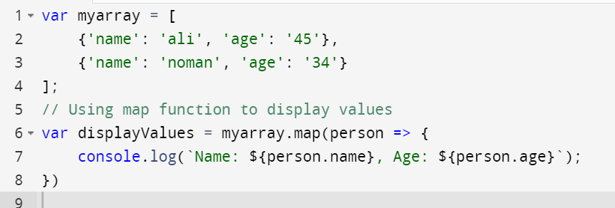

**Question: 5 Suppose we have the following arrays in JavaScrip var myArray1 = [3, 4, 5]**

**var myArray2 = [6, 7, 8]**

**Write code to append the myArray2 into myArray1.**

#### 

#### Question: 6 Suppose we have an object var myObject1 = { name: 'Devin', hairColor: 'brown' } Write code to change value of hairColor using spread syntax (…) three dots.

#### 

#### Question: 7 Write an example of defining an arrow function within another arrow function.

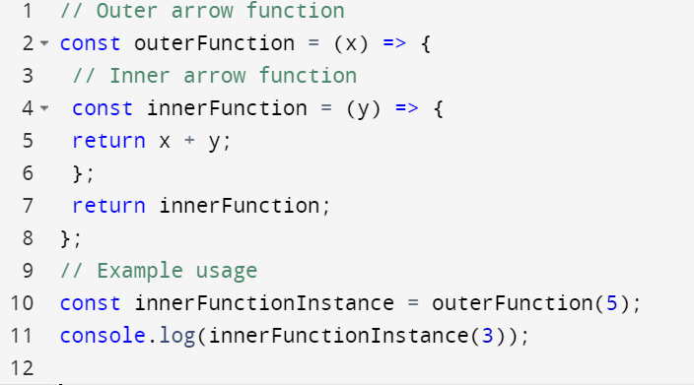

# REACT NATIVE CORE COMPONENTS (CLO-3)

#### Question: 1

**Make an app in react native that shows the following on screen:**



Orange

Banana

**For this task, create a folder “images” and place the banana.jpg and orange.jpg in the images folder.**

// ImageList.js

import React from 'react';

import { View, Image, Text, StyleSheet } from 'react-native';

const ImageList = () => {

return (

<View style={styles.container}>

<Image source={require('./images/banana.jpg')} style={styles.image} />

<Text style={styles.text}>Banana</Text>

<Image source={require('./images/orange.jpg')} style={styles.image} />

<Text style={styles.text}>Orange</Text>

</View>

);

};

// App.js

import React from 'react';

import ImageList from './ImageList';

const App = () => {

return <ImageList />;

};

export default App;

#### Question: 2

**Write a function component to show grade of a student for the given marks. The marks are provided to a javascript arrow function as argument, e.g., calculateGrade(marks) which is called in the <Text></Text> of function component. Here is the grade distribution:**

**< 50 --- F**

**>= 50 and < 60 --- E**

**>= 60 and < 70 --- D**

**>= 70 and < 80 --- C**

**>= 80 and < 90 --- B**

**>= 90 --- A**

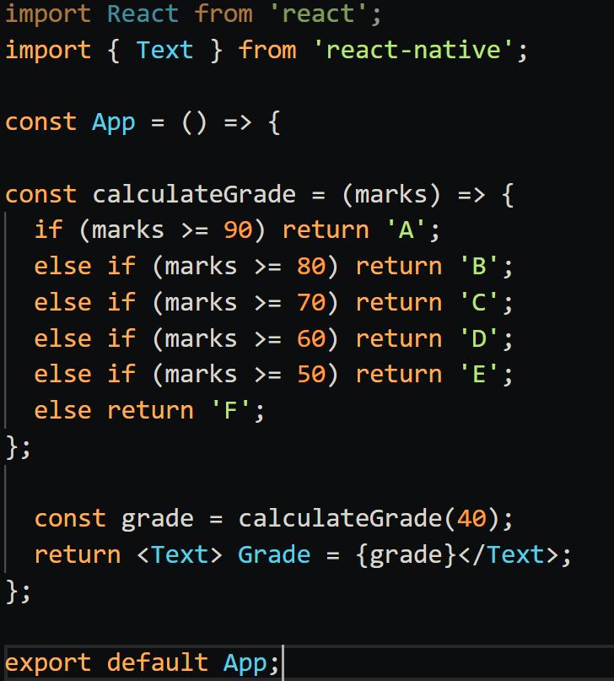

### **QUESTION 3**

**Use props and pass names of students from a Name() function component to Attendance() function component. The following should be the output by Attendance() function component.**

**Ali Khan Present**

**Noman Present**

**Faisal Absent**

**Javed Absent**

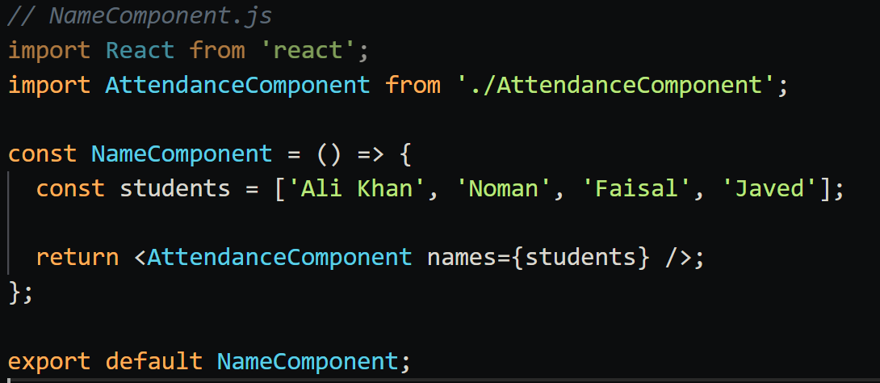

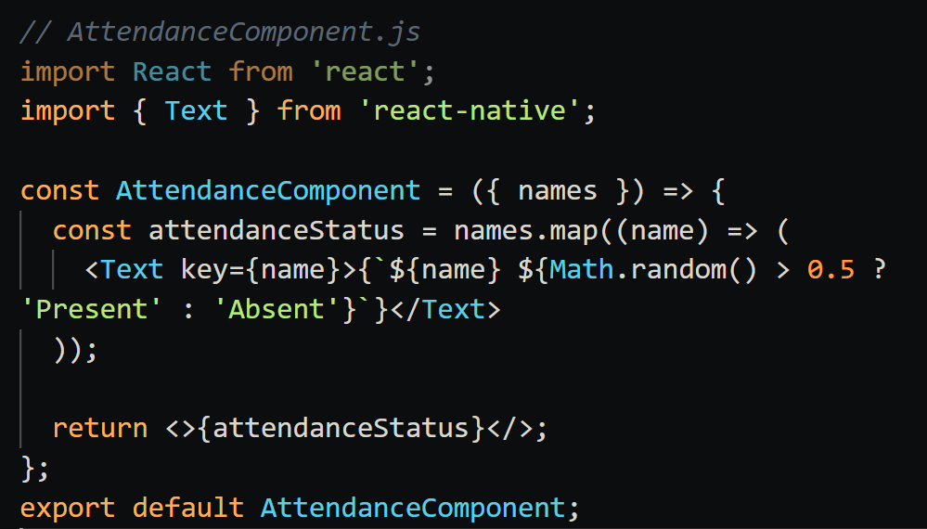

### **QUESTION 4**

**Write code to add a button in React Native. The text showing in the button should be Click Here. When the button is clicked, an alert dialog should be shown with message “hello world”.**

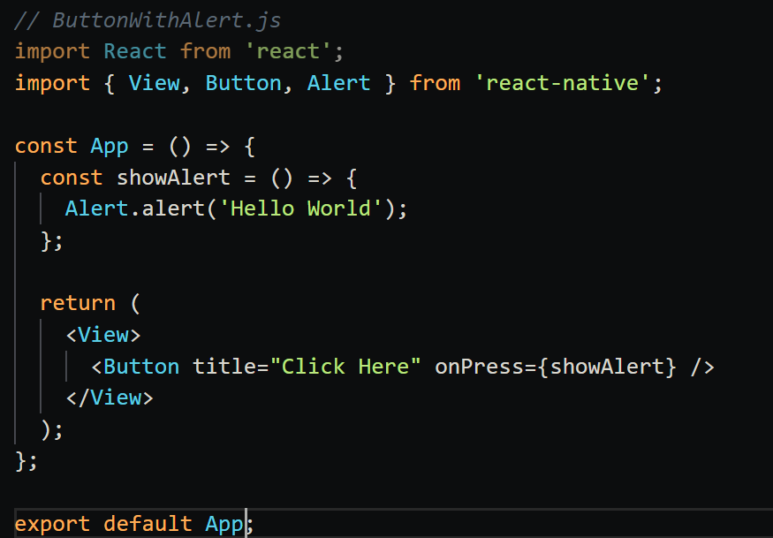

### **QUESTION 5**

**Write the code of App function. When a user enters any text in the TextInput, it is also automatically written in another TextInput.**

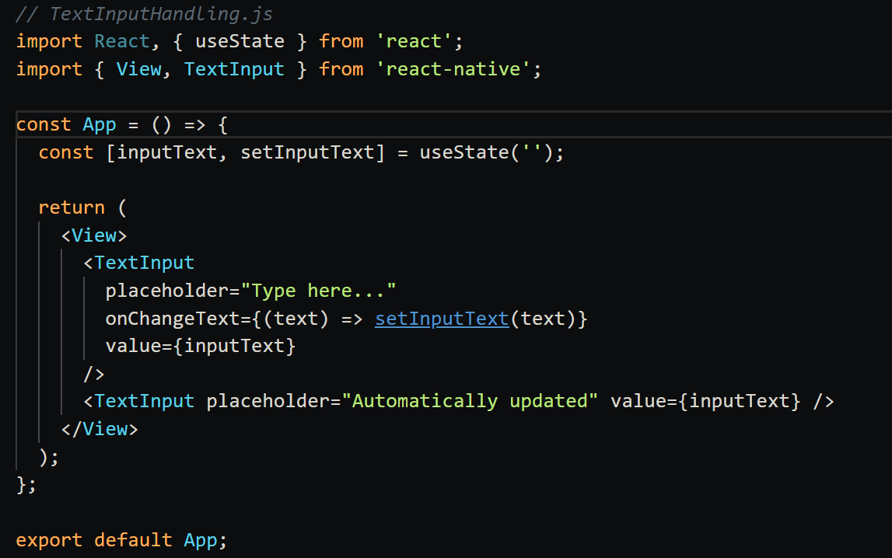

**QUESTION 6**

**Create a simple registration page in react native asking for users username, email, name, and cell number. When the user click on register button, the information should be shown using <Text></Text> elements. However, if any input is missing, message should be shown about the missing element.**

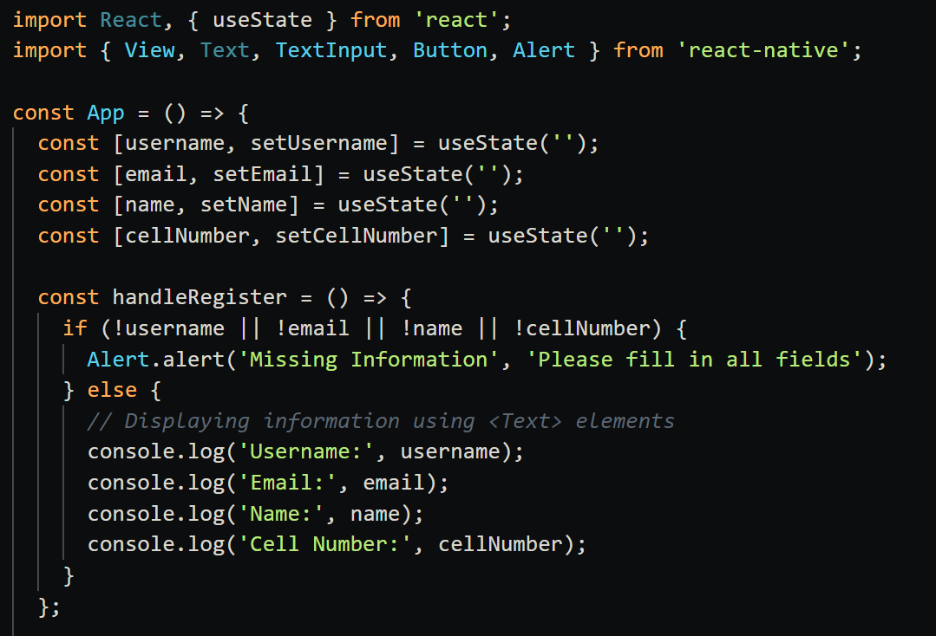

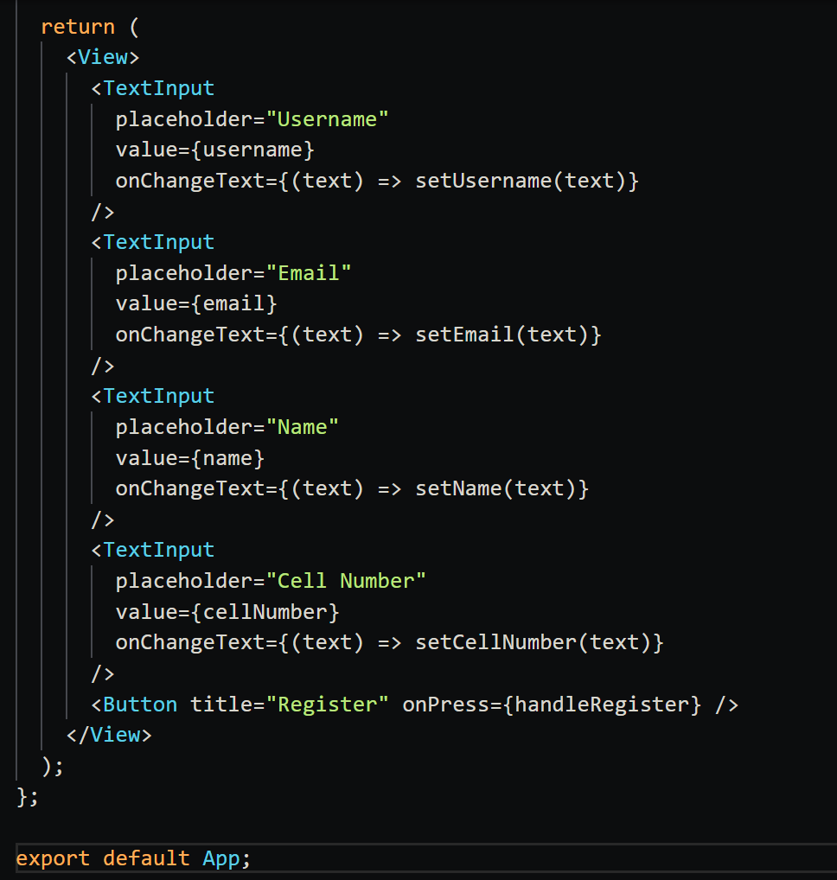

**QUESTION 7**

**Use the class component to do the following: Create a simple registration page in react native asking for users username, email, name, and cell number. When the user click on register button, the information should be shown using <Text></Text> elements. However, if any input is missing, message should be shown about the missing element.**

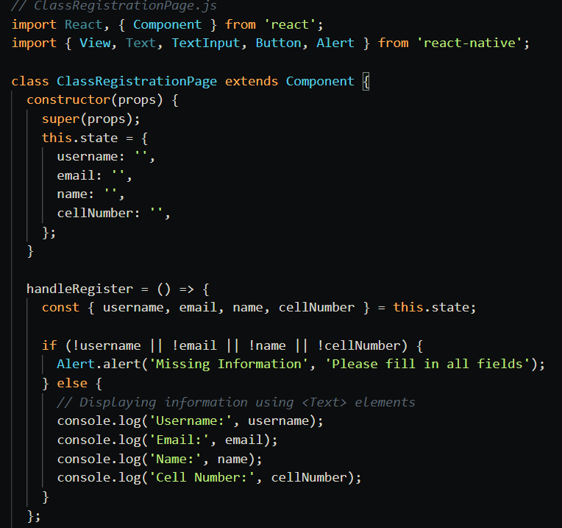

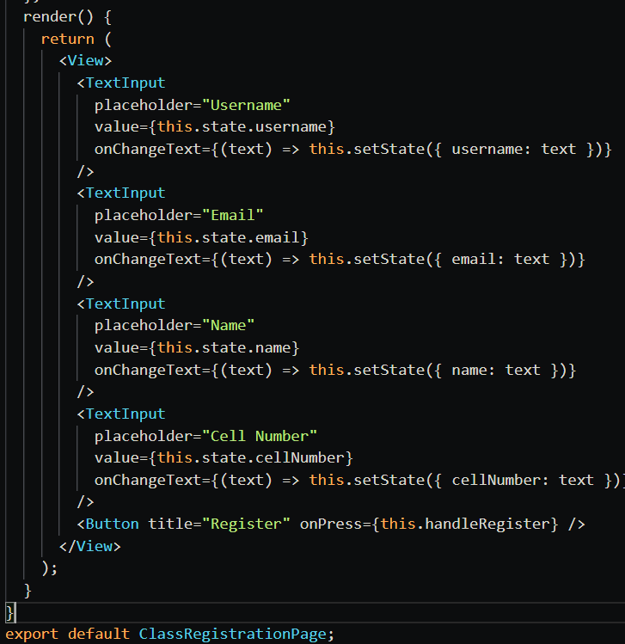

**QUESTION 8**

**Suppose that you have a string defined in strings.js. The name of the string is country_name and value is “Pakistan”. Write a program that shows the value of string in your app function. (You need to import the string from strings.js)**

// strings.js

export const country_name = 'Pakistan';

// App.js

import React from 'react';

import { Text } from 'react-native';

import { country_name } from './strings';

const App = () => {

return <Text>{country_name}</Text>;

};

export default App;

**QUESTION 9**

**Suppose you have two TextInputs, each containing a number, and a button to add the values of the two TextInputs. When the button is clicked, the values of the TextInputs are added and result should be shown in console**.

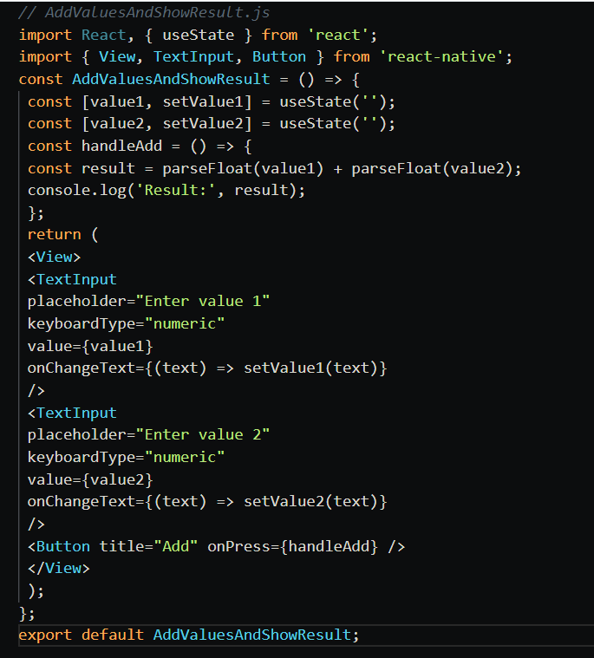

**QUESTION 10**

**Suppose we have data in this format:**

**{ [**

**{ “name”: “ali”, “age”: “23” },**

**{ “name”: “shazia”, “age”: “22” }**

**] }**

**Write code to show the above array of objects in a <FlatList>**

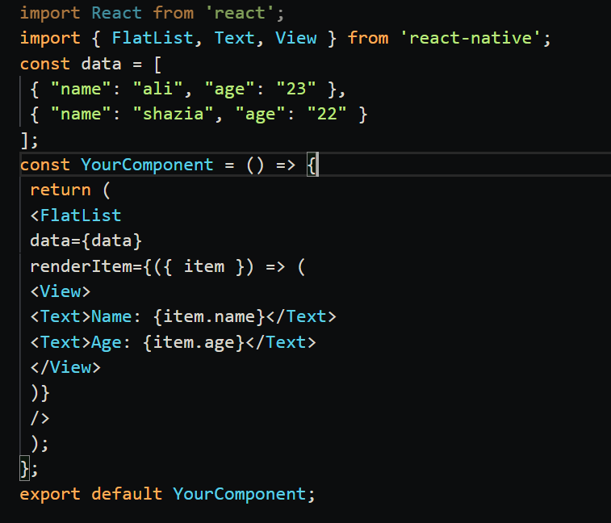

**QUESTION 11**

**Suppose we have a predefined function that has following prototype:**

**function GetComputerChoice().When this function is called in a button click event, it returns either “fire”, “wood”, or “water”. In the same button click event, a random number is generated from 1 to 3, such that if 1 is generated, this means, the user gets “fire”, if 2 is generated, the user gets “wood”, and if 3 is generated, the user gets “water”. You need to check against the button click event that which of the computer or user has WON. Show name of winner in alert. NOTE: Wood > Water; Water > Fire; Fire > Wood**

function GetComputerChoice() {

const choices = ["fire", "wood", "water"];

const randomIndex = Math.floor(Math.random() * choices.length);

return choices[randomIndex];

}

function handleButtonClick() {

const computerChoice = GetComputerChoice();

const userChoiceIndex = Math.floor(Math.random() * 3) + 1;

let userChoice;

if (userChoiceIndex === 1) {

userChoice = "fire";

} else if (userChoiceIndex === 2) {

userChoice = "wood";

} else {

userChoice = "water";

}

// Check the winner based on the rules

let winner;

if (

(userChoice === "wood" && computerChoice === "water") ||

(userChoice === "water" && computerChoice === "fire") ||

(userChoice === "fire" && computerChoice === "wood")

) {

winner = "User";

} else if (

(computerChoice === "wood" && userChoice === "water") ||

(computerChoice === "water" && userChoice === "fire") ||

(computerChoice === "fire" && userChoice === "wood")

) {

winner = "Computer";

} else {

winner = "It's a tie!";

}

// Show the winner in an alert

alert(`Winner: ${winner}\nComputer's Choice: ${computerChoice}\nUser's Choice: ${userChoice}`);

}

// Example usage in a button click event

// You can call handleButtonClick() when the button is clicked

**QUESTION 12**

**Suppose we have a layout like this:**



CLICK

Pakistan

**When the button is clicked, the value from above TextInput should be written to the below TextInput. You need to write the code for the event handler defined for button.**

import React, { useState } from 'react';

import { View, TextInput, Button } from 'react-native';

const YourComponent = () => {

const [inputValue, setInputValue] = useState('');

const [outputValue, setOutputValue] = useState('');

const handleButtonClick = () => {

// Set the value of the second TextInput using the state

setOutputValue(inputValue);

};

return (

<View>

{/* First TextInput */}

<TextInput

placeholder="Enter text"

value={inputValue}

onChangeText={(text) => setInputValue(text)}

/>

{/* Button to trigger the event handler */}

<Button title="Copy Text" onPress={handleButtonClick} />

{/* Second TextInput */}

<TextInput

placeholder="Copied text will appear here"

value={outputValue}

// You can make the second TextInput read-only if needed

editable={false}

/>

</View>

);

};

export default YourComponent;

### **QUESTION 13**

**Create a program with following layout:**

Click Here

**When the button is clicked, the text “hello world” should be shown in the textbox, and the button should be disabled. You can use hooks and state variables.**

import React, { useState } from 'react';

import { View, TextInput, Button, Alert } from 'react-native';

const YourComponent = () => {

const [textValue, setTextValue] = useState('');

const [buttonDisabled, setButtonDisabled] = useState(false);

const handleButtonClick = () => {

// Show "hello world" in the textbox

setTextValue('hello world');

// Disable the button

setButtonDisabled(true);

// Optionally, show an alert

Alert.alert('Button Clicked', 'Text set to "hello world", button disabled');

};

return (

<View>

{/* TextInput */}

<TextInput

style={{ height: 40, borderColor: 'gray', borderWidth: 1, marginBottom: 10, padding: 10 }}

placeholder="Text will appear here"

value={textValue}

editable={false} // To make TextInput read-only

/>

{/* Button */}

<Button

title="Click Me"

onPress={handleButtonClick}

disabled={buttonDisabled}

/>

</View>

);

};

export default YourComponent;

### **QUESTION 14**

**Suppose we have layout like this:**



CLICK

Pakistan

**When the button is clicked, the message in the TextInput should display in a dialog. Write code for event handler of button.**

import React, { useState } from 'react';

import { View, TextInput, Button, Alert } from 'react-native';

const YourComponent = () => {

const [message, setMessage] = useState('');

const handleButtonClick = () => {

// Display the message in a dialog

Alert.alert('Message', message);

};

return (

<View>

{/* TextInput */}

<TextInput

style={{ height: 40, borderColor: 'gray', borderWidth: 1, marginBottom: 10, padding: 10 }}

placeholder="Type your message here"

value={message}

onChangeText={(text) => setMessage(text)}

/>

{/* Button */}

<Button

title="Show Message"

onPress={handleButtonClick}

/>

</View>

);

};

export default YourComponent;

### **QUESTION 15**

**Suppose you want to build a game in which a user either can press fire or wood, and then a random choice is generated for computer. The player that gets fire is the winner. Write the code of the program. In case both user and computer get same value, it will be a draw.**

#### Your choice Computer choice

**wood**

**fire**

#### Winner

**user**



import React, { useState } from 'react';

import { View, Text, Button, Alert } from 'react-native';

const YourComponent = () => {

const [userChoice, setUserChoice] = useState('');

const [computerChoice, setComputerChoice] = useState('');

const [winner, setWinner] = useState('');

const handleChoice = (choice) => {

setUserChoice(choice);

const computerChoices = ['fire', 'wood'];

const randomIndex = Math.random() * computerChoices.length;

setComputerChoice(randomIndex);

if (choice === 'fire' && computerChoice === 'wood') {

setWinner('You');

} else if (choice === 'wood' && computerChoice === 'fire') {

setWinner('Computer');

} else {

setWinner('Draw');

}

Alert.alert('Game Result' : ${winner}`);

};

return (

<View>

<Text>Your choice: {userChoice}</Text>

<Text>Computer choice: {computerChoice}</Text>

<Text>Winner: {winner}</Text>

<Button title="Fire" onPress={() => handleChoice('fire')} />

<Button title="Wood" onPress={() => handleChoice('wood')} />

</View>

);

};

export default YourComponent;

### **QUESTION 16**

**The following layout has three number buttons, a plus and equal operator, and a TextInput initialized with a zero “0”.**



1 2 3 + =

0

**The user should be able to enter a string of numbers like 12232213. The user need to enter a number, click on + operator, and then input another number. When user click on equal, the result of sum should display in TextInput (Hint: Check eval method of javascript).**

import React, { useState } from 'react';

import { View, TextInput, TouchableOpacity, Text, StyleSheet } from 'react-native';

const CalculatorApp = () => {

  const [inputText, setInputText] = useState('0');

  const handleNumberPress = (number) => {

    setInputText((prevInput) => (prevInput === '0' ? String(number) : prevInput + String(number)));

  };

const handlePlusPress = () => {

  setInputText((prevInput) => prevInput + '+');

};

  const handleEqualPress = () => {

    try {

      const result = eval(inputText);

      setInputText(String(result));

    } catch (error) {

      setInputText('Error');

    }

  };

  return (

    <View style={styles.container}>

      <TextInput style={styles.input} value={inputText} editable={false} />

      <View style={styles.buttonsContainer}>

        <TouchableOpacity style={styles.button} onPress={() => handleNumberPress(1)}>

          <Text style={styles.buttonText}>1</Text>

        </TouchableOpacity>

        <TouchableOpacity style={styles.button} onPress={() => handleNumberPress(2)}>

          <Text style={styles.buttonText}>2</Text>

        </TouchableOpacity>

        <TouchableOpacity style={styles.button} onPress={() => handleNumberPress(3)}>

          <Text style={styles.buttonText}>3</Text>

        </TouchableOpacity>

        <TouchableOpacity style={styles.operatorButton} onPress={handlePlusPress}>

          <Text style={styles.buttonText}>+</Text>

        </TouchableOpacity>

        <TouchableOpacity style={styles.operatorButton} onPress={handleEqualPress}>

          <Text style={styles.buttonText}>=</Text>

        </TouchableOpacity>

      </View>

    </View>

  );

};

### **QUESTION 17**



The capital of Pakistan is *<TextInput>*

ISLAMABAD

LAHORE

KARACHI

**You have a layout as given in the following. You need to write a “single method” for all the three buttons. The prototype of method is:**

**function button_Click().**

**In this method, you need to get the text of the button clicked. If the text is matching with the string “ISLAMABAD”, the <TextInput> should be assigned value ISLAMABAD, otherwise it remains blank.**

import React, { useState } from 'react';

import { View, TextInput, Button, Text, StyleSheet } from 'react-native';

const YourComponent = () => {

const [capital, setCapital] = useState('');

const button_Click = (clickedText) => {

if (clickedText === 'ISLAMABAD') {

setCapital('ISLAMABAD');

} else {

setCapital('');

}

};

return (

<View style={styles.container}>

<Text>The capital of Pakistan is</Text>

<TextInput

style={styles.input}

value={capital}

editable={false} // Make TextInput read-only

/>

<View>

<Button title="Karachi" onPress={() => button_Click('Karachi')} />

<Button title="Lahore" onPress={() => button_Click('Lahore')} />

<Button title="Islamabad" onPress={() => button_Click('ISLAMABAD')} />

</View>

</View> );

};

# REACT NATIVE STYLES (CLO-3)

### **QUESTION 01**

**Suppose you have an <Text> field and two buttons. The first button is labeled as BLUE and the second button is labeled as GREEN. When the BLUE button is clicked, the color of text in <Text> should changed to BLUE, and when GREEN button is clicked, the color of text in <Text> should change to GREEN. Write also the code of defining the style classes of two colors.**

import React, { useState } from 'react';

import { View, Text, Button, StyleSheet } from 'react-native';

const App= () => {

  const [textColor, setTextColor] = useState('black');

const handleColorChange = (color) => {

    setTextColor(color);

  };

return (

    <View>

      <Text style={{ color: textColor }}> This is the colored text.</Text>

      <Button title="BLUE" onPress={() => handleColorChange('blue')} />

      <Button title="GREEN" onPress={() => handleColorChange('green')} />

    </View>

  );

};

export default App;

### **QUESTION 02**

**Suppose you have a layout like the above. In the below example, the blue button is clicked, and its text size is increased and text color is changed to black.**

**In the above layout, the buttons are touchable opacity. The buttons are created by using array of color names, and the text in the buttons is shown in upper case. When a button is clicked, the color of the text below is changed and the name of color is shown as shown in the above example. Moreover, the button that is clicked has font weight changed to bold and font size increased to indicate which button is currently clicked.**

### 

RED

GREEN

**BLUE**

BLUE is clicked

import React, { useState } from 'react';

import { View, Text, TouchableOpacity, StyleSheet } from 'react-native';

const ColorButtonsApp = () => {

  const colors = ['red', 'blue', 'green'];

  const [selectedColor, setSelectedColor] = useState('');

  const handleButtonPress = (color) => {

    setSelectedColor(color);

  };

  return (

    <View style={styles.container}>

      {colors.map((color, index) => (

        <TouchableOpacity

          key={index}

          style={[

            styles.button,

            { borderColor: selectedColor === color ? 'black' : color },

          ]}

          onPress={() => handleButtonPress(color)}

        >

          <Text

            style={[

              styles.buttonText,

              { color: selectedColor === color ? 'black' : color },

              selectedColor === color ? { fontWeight: 'bold', fontSize: 18 } : null,

            ]}

          >

            {color.toUpperCase()}

          </Text>

        </TouchableOpacity>

      ))}

      <Text style={{ color: selectedColor }}>{selectedColor.toUpperCase()}</Text>

    </View>

  );

};

const styles = StyleSheet.create({

  container: {

    flex: 1,

    justifyContent: 'center',

    alignItems: 'center',

  },

  button: {

    width: 100,

    height: 50,

    justifyContent: 'center',

    alignItems: 'center',

    borderWidth: 2,

    margin: 5,

  },

  buttonText: {

    textTransform: 'uppercase',

  },

});

export default ColorButtonsApp;

#### Question: 03

**Show a list of students, such that :**

|  |  |  |
| --- | --- | --- |
| **ID** | **Name** | **CGPA** |
| **1** | **Javed** | **3.0** |
| **2** | **Noman** | **2.7** |
| **3** | **Ali** | **3.7** |
| **4** | **Faisal** | **3.3** |
| **5** | **Shahid** | **4.0** |
| **6** | **Kamal** | **3.1** |
| **7** | **Zahid** | **2.3** |

**The students whose CGPA are in the range between 2 and less than 3 should be shown in bold and red font.**

**The students whose CGPA are in the range between 3 and less than 3.7 should be shown in blue font without bold**

**The students whose CGPA are greater than and equal to 3.7 should be shown in italic, bold, and green font.**

import React from 'react';

const StudentList = () => {

const students = [

{ id: 1, name: 'Javed', cgpa: 3.0 },

{ id: 2, name: 'Noman', cgpa: 2.7 },

{ id: 3, name: 'Ali', cgpa: 3.7 },

{ id: 4, name: 'Faisal', cgpa: 3.3 },

{ id: 5, name: 'Shahid', cgpa: 4.0 },

{ id: 6, name: 'Kamal', cgpa: 3.1 },

{ id: 7, name: 'Zahid', cgpa: 2.3 },

];

const getStudentStyle = (cgpa) => {

if (cgpa >= 2 && cgpa < 3) {

return { color: 'red', fontWeight: 'bold' };

} else if (cgpa >= 3 && cgpa < 3.7) {

return { color: 'blue' };

} else if (cgpa >= 3.7) {

return { color: 'green', fontWeight: 'bold', fontStyle: 'italic' };

}

return {};

};

return (

<div>

<table>

<thead>

<tr>

<th>ID</th>

<th>Name</th>

<th>CGPA</th>

</tr>

</thead>

<tbody>

{students.map((student) => (

<tr key={student.id} style={getStudentStyle(student.cgpa)}>

<td>{student.id}</td>

<td>{student.name}</td>

<td>{student.cgpa}</td>

</tr>

))}

</tbody>

</table>

</div>

);

};

export default StudentList;

# REACT NATIVE NAVIGATION (CLO-4)

### QUESTION 01

Write code that launches a screen Display from Home screen. Send two numbers from Home to Display, where they should be shown in <TextInputs>.

*// HomeScreen.js*

import React, { useState } from 'react';

import { View, TextInput, Button } from 'react-native';

import { useNavigation } from '@react-navigation/native';

const HomeScreen = () => {

  const navigation = useNavigation();

  const [number1, setNumber1] = useState('');

  const [number2, setNumber2] = useState('');

  const navigateToDisplay = () => {

    navigation.navigate('Display', { number1, number2 });

  };

  return (

    <View>

      <TextInput

        placeholder="Enter number 1"

        keyboardType="numeric"

        value={number1}

        onChangeText={(text) => setNumber1(text)}

      />

      <TextInput

        placeholder="Enter number 2"

        keyboardType="numeric"

        value={number2}

        onChangeText={(text) => setNumber2(text)}

      />

      <Button title="Go to Display" onPress={navigateToDisplay} />

    </View>

  );

};

export default HomeScreen;

*// DisplayScreen.js*

import React from 'react';

import { View, TextInput } from 'react-native';

import { useRoute } from '@react-navigation/native';

const DisplayScreen = () => {

  const route = useRoute();

  const { number1, number2 } = route.params;

  return (

    <View>

      <TextInput

        placeholder="Number 1"

        value={String(number1)}

        editable={false}

      />

      <TextInput

        placeholder="Number 2"

        value={String(number2)}

        editable={false}

      />

    </View>

  );

};

export default DisplayScreen;

### QUESTION 02

Suppose we have a layout like this



RANDOM COUNTER SEND

0

The value is 33

Write code for button RANDOM such that when user click button, a random number from one to hundred is shown in text box. Write code for button COUNTER such that when the user click the button, the value in the TextInput start incrementing. Write code for button SEND such that when user click on button, the value in TextInput is passed to a new screen (Display) and shown as indicated in the figure.

*// HomeScreen.js*

import React, { useState } from 'react';

import { View, TextInput, Button } from 'react-native';

import { useNavigation } from '@react-navigation/native';

const HomeScreen = () => {

  const navigation = useNavigation();

  const [randomNumber, setRandomNumber] = useState('');

  const [counterValue, setCounterValue] = useState(0);

  const [textInputValue, setTextInputValue] = useState('');

  const generateRandomNumber = () => {

    const randomNum = Math.floor(Math.random() * 100) + 1;

    setRandomNumber(randomNum.toString());

  };

  const incrementCounter = () => {

    setCounterValue((prevValue) => prevValue + 1);

  };

  const navigateToSend = () => {

    navigation.navigate('Display', { inputValue: textInputValue });

  };

  return (

    <View>

      <Button title="RANDOM" onPress={generateRandomNumber} />

      <TextInput placeholder="Random Number" value={randomNumber} editable={false} />

      <Button title="COUNTER" onPress={incrementCounter} />

      <TextInput placeholder="Counter Value" value={counterValue.toString()} editable={false} />

      <TextInput

        placeholder="Enter text for SEND"

        value={textInputValue}

        onChangeText={(text) => setTextInputValue(text)}

      />

      <Button title="SEND" onPress={navigateToSend} />

    </View>

  );

};

export default HomeScreen;

*// DisplayScreen.js*

import React from 'react';

import { View, Text } from 'react-native';

import { useRoute } from '@react-navigation/native';

const DisplayScreen = () => {

  const route = useRoute();

  const { inputValue } = route.params;

  return (

    <View>

      <Text>{inputValue}</Text>

    </View>

  );

};

export default DisplayScreen;

### QUESTION 03

### **the user click on button in Home screen, the both strings in TextInputs should be passed separately to the Display screen where they are shown as concatenated string in display function of Display screen.**

Home Display



CLICK

Pakistan

Abbottabad

Abbottabad, Pakistan

*// HomeScreen.js*

import React, { useState } from 'react';

import { View, TextInput, Button } from 'react-native';

import { useNavigation } from '@react-navigation/native';

const HomeScreen = () => {

  const navigation = useNavigation();

  const [string1, setString1] = useState('');

  const [string2, setString2] = useState('');

  const navigateToDisplay = () => {

    navigation.navigate('Display', { string1, string2 });

  };

  return (

    <View>

      <TextInput

        placeholder="Enter string 1"

        value={string1}

        onChangeText={(text) => setString1(text)}

      />

      <TextInput

        placeholder="Enter string 2"

        value={string2}

        onChangeText={(text) => setString2(text)}

      />

      <Button title="Go to Display" onPress={navigateToDisplay} />

    </View>

  );

};

export default HomeScreen;

*// DisplayScreen.js*

import React from 'react';

import { View, Text } from 'react-native';

import { useRoute } from '@react-navigation/native';

const DisplayScreen = () => {

  const { string1, string2 } = useRoute().params;

  const displayConcatenatedString = () => {

    const concatenatedString = string1 + string2;

    return <Text>{concatenatedString}</Text>;

  };

  return (

    <View>

      {displayConcatenatedString()}

    </View>

  );

};

export default DisplayScreen;

### QUESTION 04

Pass a number from 1 to 3 from the Home screen to the Display screen. In the Display screen, check which of the number is received, and then write the number in words.

For example, you passed 3 from Home screen, and in Display screen, you will print “three” as shown below.

*// HomeScreen.js*

import React, { useState } from 'react';

import { View, TextInput, Button } from 'react-native';

import { useNavigation } from '@react-navigation/native';

const HomeScreen = () => {

  const navigation = useNavigation();

  const [selectedNumber, setSelectedNumber] = useState('');

  const navigateToDisplay = () => {

    navigation.navigate('Display', { selectedNumber });

  };

  return (

    <View>

      <TextInput

        placeholder="Enter a number (1 to 3)"

        keyboardType="numeric"

        value={selectedNumber}

        onChangeText={(text) => setSelectedNumber(text)}

      />

      <Button title="Go to Display" onPress={navigateToDisplay} />

    </View>

  );

};

export default HomeScreen;

*// DisplayScreen.js*

import React from 'react';

import { View, Text } from 'react-native';

import { useRoute } from '@react-navigation/native';

const DisplayScreen = () => {

  const route = useRoute();

  const { selectedNumber } = route.params;

  const numberToWords = (number) => {

    switch (parseInt(number)) {

      case 1:

        return 'one';

      case 2:

        return 'two';

      case 3:

        return 'three';

      default:

        return 'Invalid number';

    }

  };

  return (

    <View>

      <Text>{numberToWords(selectedNumber)}</Text>

    </View>

  );

};

export default DisplayScreen