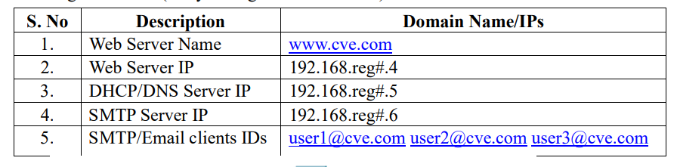

**NETWORK:**

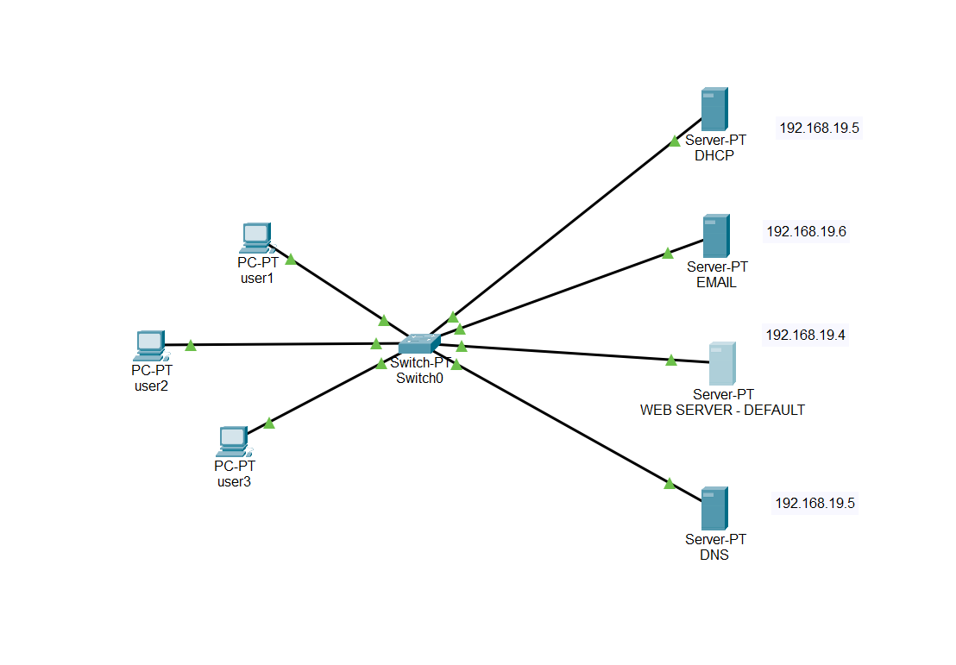

**CONFIGURE DHCP:**

Give dhcp the start ip adress and default gateway and add it.

Then go in ip configuration to give ip to dhcp as 192.168.19.5

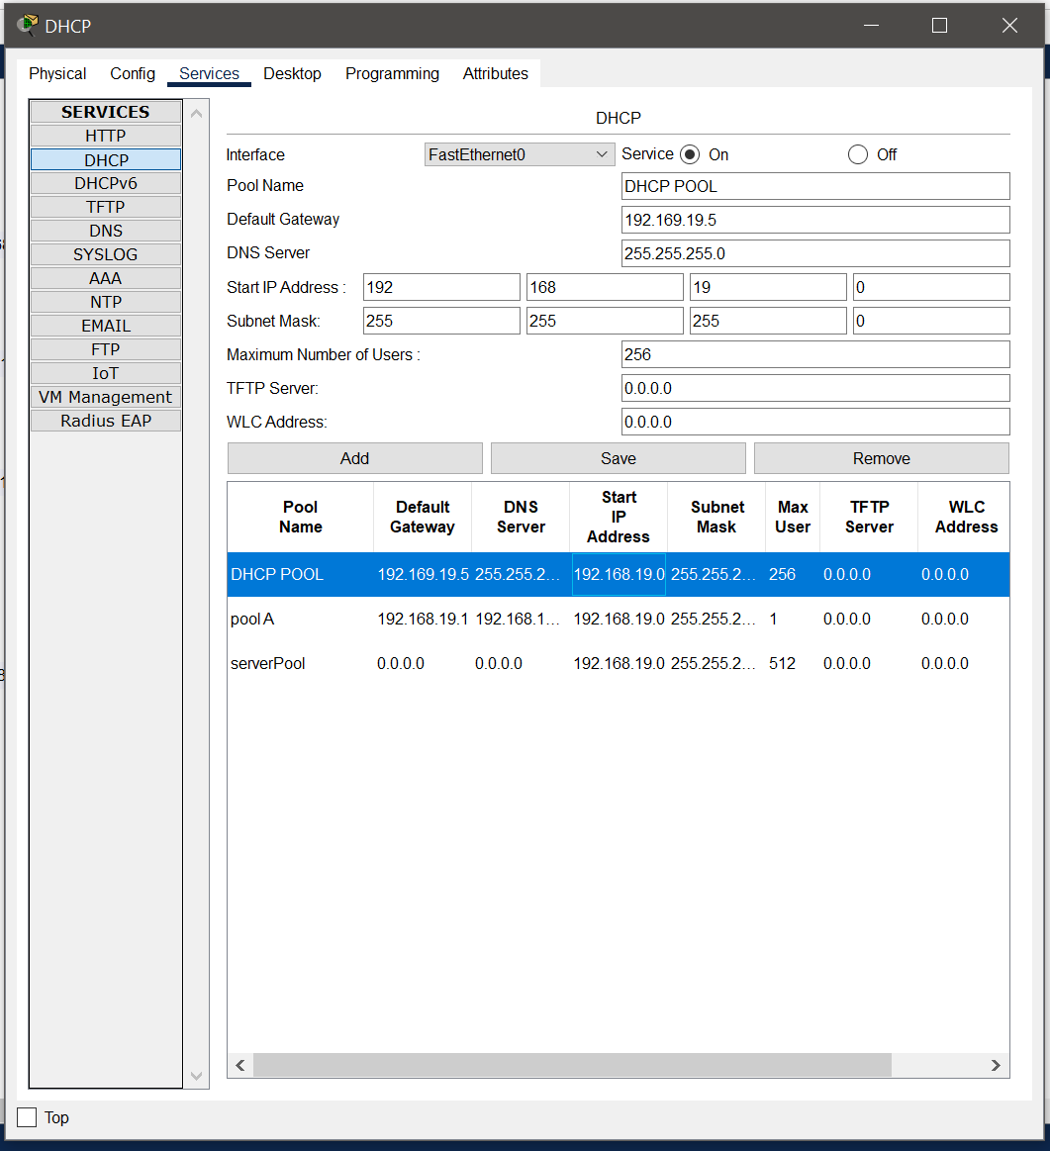

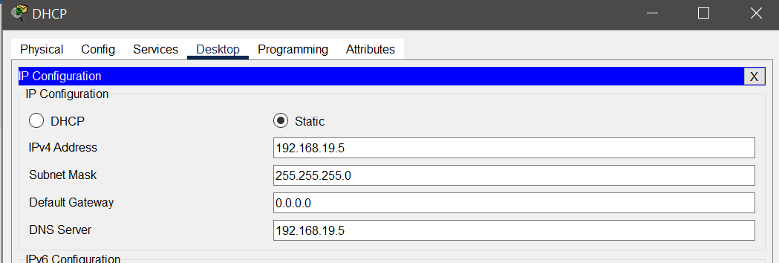

**CONFIGURE PCS**

Set the ip address to DHCP for all user pc’s

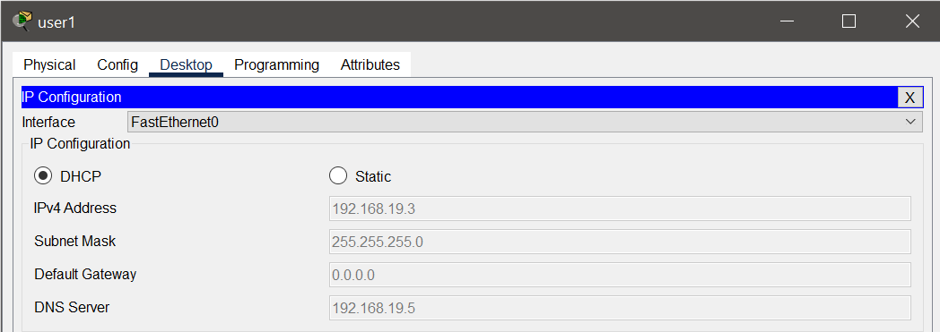

**CONFIGURE DNS**

On the DHCP service ; add the name of website and its web ip

Also set the ip of DNS in ip configuration.

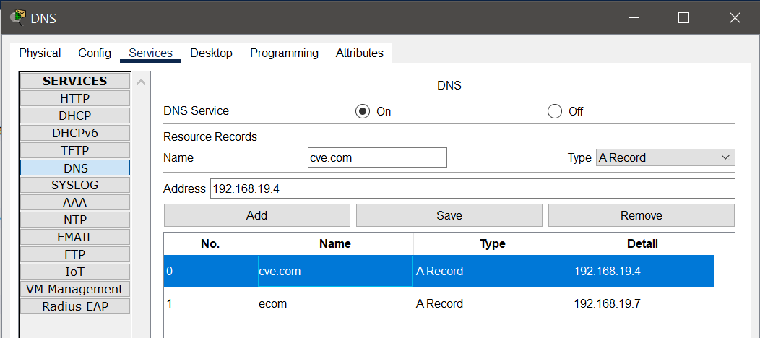

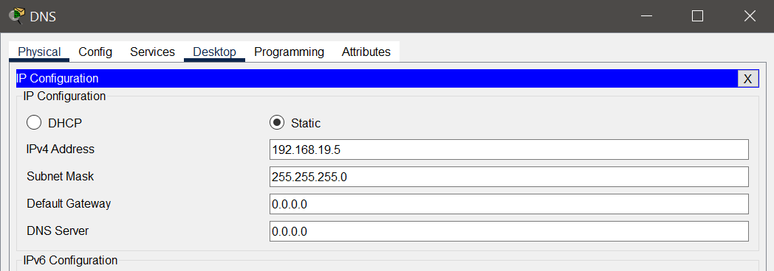

**WEB SERVER CONFIGURATION:**

Edit the cve.com web page and also configure the IP

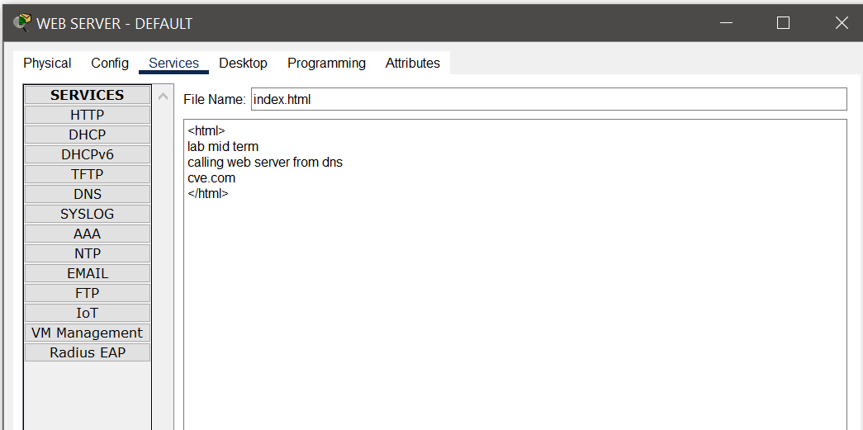

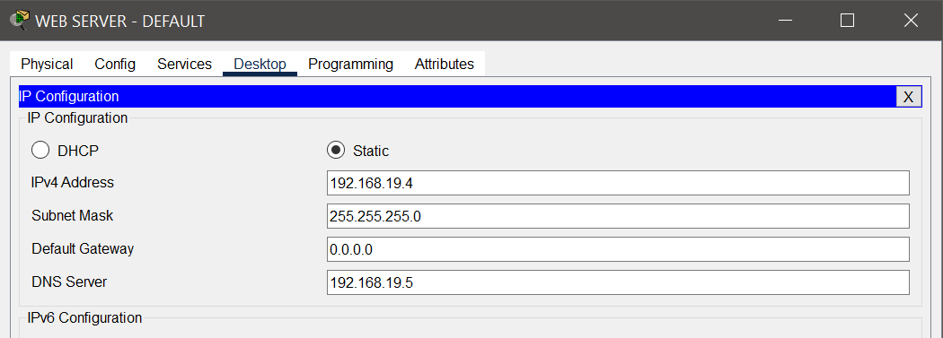

**EMAIL SERVER CONFIGURATION:**

Configure the email services and add the users

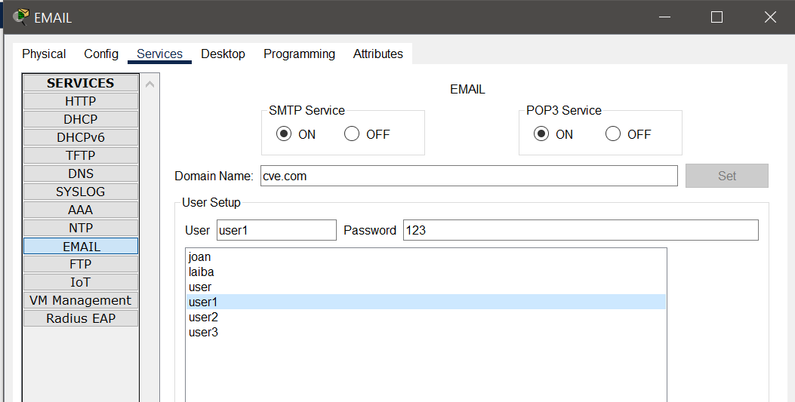

Also give the IP to email server

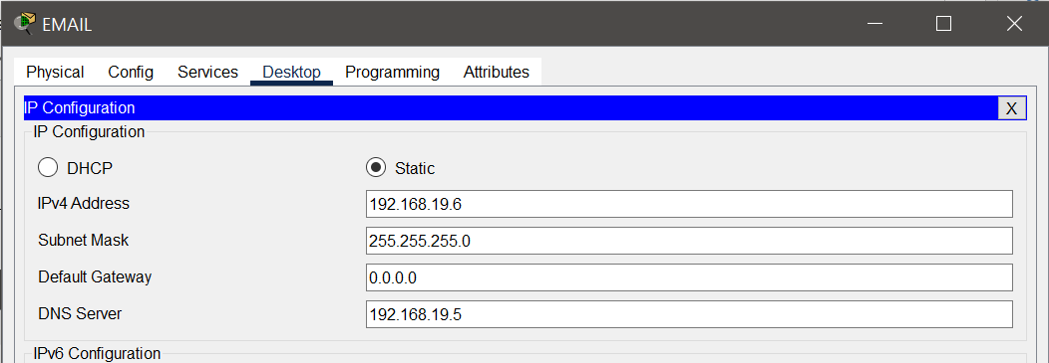

**GIVE USERS EMAIL AND ADDRESS**

Give the name and password as set in email server also the mail server ip; for each user pc.

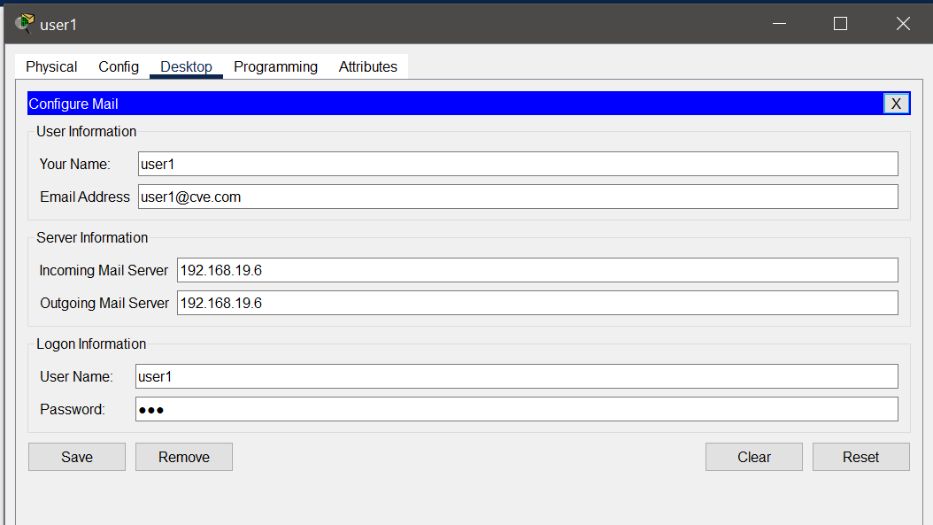

**SEND MAIL TO ANY USER**

Compose the mail and send to user2 ; i-e mail from user 1 to user 2

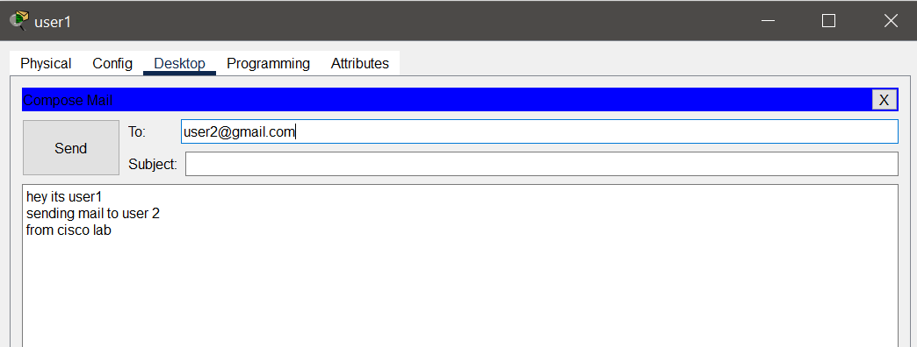

Check the mail browser and receive the mail;

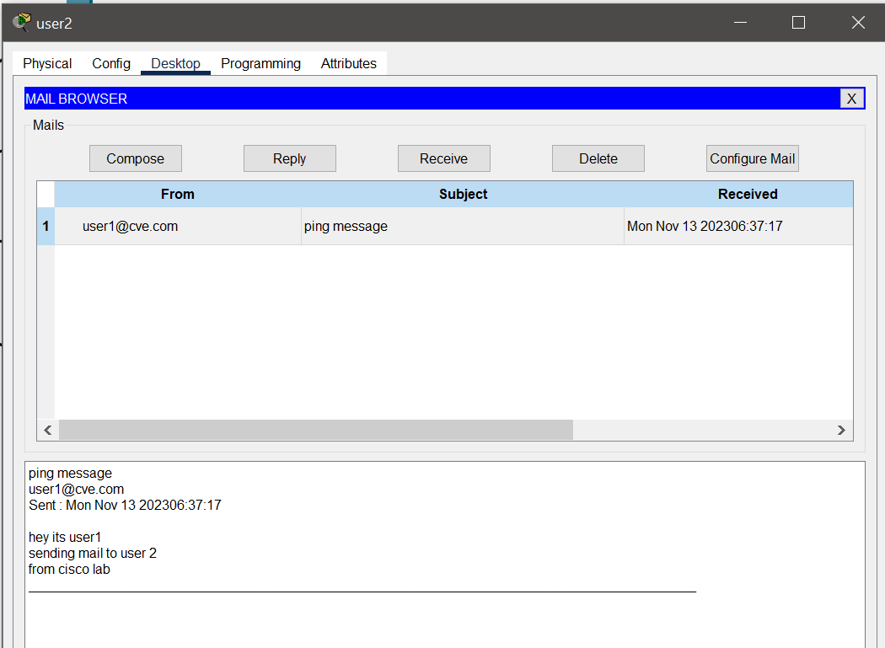

**WEB BROWSER**

Browse the cve.com from any host

