

COMSATS UNIVERSITY ISLAMABAD, ABBOTTABAD CAMPUS

DATA STRUCTURES AND ALGORITHMS

Submitted By: FA21-BSE-019-4A Laiba binta tahir.

ASSINGEMENT # 04

Submitted To : Man Sana Malik

Date: 4 July-2023

**Q: write a program to input data values from user one by one and build an AVL tree. Include all necessary functionalities to maintain AVL’s properties.**

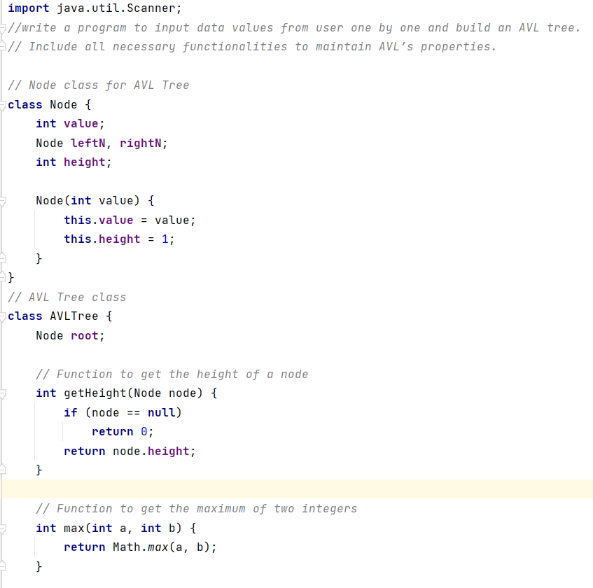

**Balance Factor of nodes and Insertion**

**Main Method**

**Output**

