

**COMSATS UNIVERSITY ISLAMABAD, ABBOTTABAD CAMPUS.**

***Report writing skills: Semester Project***

Physical Abuse: Its Types and Consequences on the Victim

***Dated:*** *21st of November 2023*

***Prepared For:*** Mam Sara Saeed

***Prepared By:***

Ghani Abdul Rahman Khan FA22-BSE-153

Warda Sohail FA22-BSE-141

Ali Usman Tajik FA22-BSE-134

Zainab Kalim FA22-BSE-110

Zainab Arshad FA22-BSE-151

Table of Contents

INTRODUCTION 4

1.1 Background Information: 4

1.2 Statement of the problem/Purpose: 4

1.3 Significance of the Study: 4

1.4 Scope of the Study: 4

1.5 Limitations of the Study: 5

REVIEW OF RELATED LITERATURE 5

METHODS OF STUDY: 6

RESULTS AND DISCUSSION 6

4.1.1 Types of Physical Abuse: 6

4.1.1.2 Sexual abuse: 7

4.1.1.3 Types of Sexual Assault 8

4.1.1.4 Impacts of sexual abuse: 8

4.2 Effects: 8

4.2.1 Traumatic grief: 8

4.2.2 Traumatic grief therapy: 9

4.2.3 What Traumatic Grief Therapy Can Help with? 9

CONCLUSION 10

RECOMMENDATIONS 10

REFERENCES: 12

APPENDICES: 13

Appendix A: Result of Questionnaire 13

Appendix B: Table of Figures 13

**Executive Summary**

This **document** **aims to** comprehensively examine physical abuse, its types, consequences, and the ensuing physical and emotional trauma experienced by victims**.** The study emphasizes the critical need for awareness, prevention, and robust support systems in addressing the multifaceted nature of physical abuse.The **primary objective** of this report is to explore diverse forms of physical abuse and analyze their far-reaching consequences on victims. By doing so, the report contributes to a broader understanding of the dynamics of physical abuse, advocating for effective measures to prevent its occurrence. **References and limitation of study** encompasses secondary data and hence, the conclusions are based on findings and data collected from various sources including blogs, videos, and books, have been consulted to provide a comprehensive and explanatory account of physical abuse for the reader's in-depth understanding. The findings of this report uncover a spectrum of physical abuse, *encompassing domestic violence, child abuse, elder abuse, and bullying*. These manifestations occur in various settings, leading to consequences beyond physical harm, such as psychological trauma, long-term health effects, and the perpetuation of the cycle of abuse. The urgency of addressing this pervasive issue comprehensively is underscored by these findings. The **document** **concludes** that physical abuse is ethically and legally wrong, with severe consequences for both physical and mental well-being. It strongly advocates refraining from engaging in such behavior. **Recommendations include** *immediate cessation of physical abuse, reporting witnessed cases* to authorities promptly, and, for victims, informing authorities about the perpetrator and seeking therapy to address psychological trauma and restore well-being. This multifaceted approach aims to contribute to the prevention and resolution of instances of physical abuse.

# 

# **INTRODUCTION**

## 1.1 Background Information:

An abused individual may be struck, shaken, choked, bit, kicked, punched, burnt, poisoned, smothered, or held underwater. Bruises, cuts, welts, burns, fractures, internal injuries, and, in the worst-case scenario, death can all result from physical abuse. Bodily violence is defined as an act that is intended to cause or results in pain or physical injury. As with other forms of violence, the perpetrator's primary goal is to limit the other's ability to self-determine, which may or may not always include physical suffering.

## 1.2 Statement of the problem/Purpose:

The perpetrator's use of physical violence sends a clear message to the victim: "I can do things to you that you don't want to happen." Such violence may be used to illustrate societal power imbalances or to advocate certain demands, sometimes regularly, through compulsion. Domestic violence, or physical violence in personal relationships, continues to be a pervasive problem in every country.

## 1.3 Significance of the Study:

[***Ope***](https://www.apa.org/research/action/writing)***n*** [***Up***](https://www.apa.org/research/action/writing)***!*** [***Writin***](https://www.apa.org/research/action/writing)***g*** [***Abou***](https://www.apa.org/research/action/writing)***t*** [***Traum***](https://www.apa.org/research/action/writing)***a*** [***Reduce***](https://www.apa.org/research/action/writing)***s*** [***Stress***](https://www.apa.org/research/action/writing)***,*** [***Aid***](https://www.apa.org/research/action/writing)***s*** [***Immunity***](https://www.apa.org/research/action/writing)

Writing about difficult, even traumatic, experiences appear to be good for health on several levels - raising immunity and other health measures and improving life functioning.

[***Recoverin***](https://www.apa.org/topics/disasters-response/recovering)***g*** [***emotionall***](https://www.apa.org/topics/disasters-response/recovering)***y*** [***from disaster***](https://www.apa.org/topics/disasters-response/recovering)

Understanding the emotions and normal responses that follow a disaster or other traumatic event can help you cope with your feelings, thoughts, and behaviors.

## 1.4 Scope of the Study:

Since the context we examined is where one party has power over another and the victim is a youth who may not fully understand what a sexual relationship means, we have the term “bullying” as relevant but too weak viewed. “Abuse” is the legal term used to describe children (including adolescents) who are exploited by an adult (and sometimes another child) because of their greater power and for their own benefit or satisfaction. uses the term “abuse” to generally describe the behavior documented in this study, while the term “bullying” is narrowed down to a “milder” but widespread form of abusive behavior.

We interpret sexual abuse as any type of abuse that has a sexual dimension such that it can include physical, verbal, and **often** vaguely psychological or emotional abuse.

## 1.5 Limitations of the Study:

Due to limited time frame for the semester project widespread data has not been used in the study to make this report most relevant and authentic. This study is of descriptive nature because all the information is taken from others research work.

Additional research is needed to assess the results of this look at with studies using different elder abuse reporting formats (e.g., institutional self-file, crook justice reports, and government/enterprise statistics series).

# **REVIEW OF RELATED LITERATURE**

Two-thirds of injuries that occur in elder abuse affect the upper extremity and maxillofacial region. The social context in which injuries occur remains crucial for an accurate identification of abuse. This includes a culture of violence within the family; a victim who is demented, weakened or depressed and socially isolated; and a profile of the perpetrator of a mental illness, alcohol or drug abuse, or emotional and / or financial dependence of the victim. *(Murphy, Waa, 2013)*

Because of their increased vulnerability, young victims of physical and sexual abuse need better prevention, early intervention and treatment services related to drug use. Physical and sexual abuse were linked to a higher likelihood of consuming alcohol, marijuana, and almost everyone else. Medicines for both men and women in the three grades studied. Colleagues and gave other reasons for using it, including using to cope with painful emotions and to escape problems. *(Harrison, Fulkerson, 1997) Harrison, Fulkerson, P. J. (1997).*

Recognition of abuse via way of means of clinicians and reporting suspicion of abuse to the proper government will enhance care of older adults and save you critical morbidity and mortality. The geriatric populace is projected to growth dramatically over the subsequent 10 years, and the variety of abused people is projected to growth also. It is important that fitness care vendors feel able in addressing bodily elder abuse. The instances offered illustrate the type of providing signs that can be attributed to bodily elder abuse. *(Young, 2014) Young, L. (2014).*

# **METHODS OF STUDY:**

The data used for the study is secondary data. The method used for analyzing the physical abuse involve the review of various literature on the topic. As there is no specific method of analyzing qualitative data, all the information, statistical values and graphs are taken from other researchers work, explanation and interpretation and situations is analyzed and has been put in to meaningful paragraphs.

And then based on the above process the data is used to explain the challenges and to suggest the solution for these presented challenges.

# **RESULTS AND DISCUSSION**

## 

## 4.1.1 Types of Physical Abuse:

Physical abuse can involve : Scratching or Biting, Pushing or Shoving, Slapping, Kicking, Choking or Strangling, Throwing things, Force-feeding or denying you food, Using weapons or objects that could hurt you, Physically restraining, Reckless driving, Other acts that hurt or threaten you.

It has many short-term as well as long-term effects on mental and physical health.

Following are some of the mental health issues related to bullying.

* + - * The person suffers from depression and becomes prone to anxiety.
      * Feeling of inferiority.
      * Increased sadness, loss of hunger, lack of interest in almost all activities.
      * Unable to keep mental peace.
      * Unable to respond effectively in classroom activities.
      * 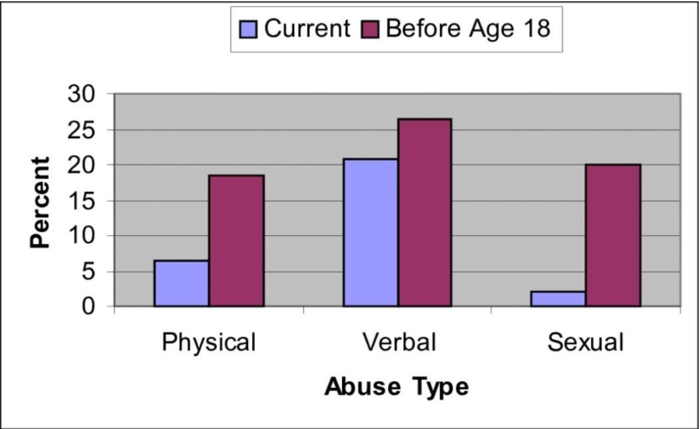Physical pains as a result of aggressive bullying as well.

Figure 1 Abuse rate with respect to type

## 4.1.1.2 Sexual abuse:

Sexual abuse is when a woman, man, or kid is compelled to engage in sexual behavior or perform act without their consent. Sexual assault occurs when perpetrators use force, threaten victims, or take advantage of victims who are unable to give permission. The majority of victims and perpetrators are acquainted. Shock, anxiety, and denial are common first reactions to sexual abuse. Anxiety, fear, and post-traumatic stress disorder are examples of long-term symptoms.

Figure 2 Oppressed women rate accoss country

Sexual abuse is a form of violence perpetrated by an assailant against someone they perceive to be weaker than themselves. It is not the result of an overwhelming sex drive, but rather of a crime committed with the intention of manipulating and humiliating the victim.

## 4.1.1.3 Types of Sexual Assault

Sexual assault is a broad phrase that encompasses all sexual offenses. Any sexual act or statement carried out without the consent of both parties.

Its Different types include: Rape, Sodomy, Attempted rape, Gang rape, Serial rape, Incest

**Sexual Harassment in Different Forms**

* Extortion occurs when the person being forced to undertake a sexual act.
* An indecent act is done to humiliate, stimulate, or satisfy sexual desires.
* Repeated sexual propositions are directed against a person who has previously shown to the harasser that they are not interested in the advances.
* Repetitive comments about the individual's sexuality after the person has already demonstrated to the harasser that they are uninterested in the remarks.
* Without the person's agreement, publishing a photograph, film, or recording of them focusing on humiliating or degrading them.

## 4.1.1.4 Impacts of sexual abuse:

Regardless of the age at which the event happened, sexual abuse has been demonstrated to have long-term emotional and physical consequences for women. Women who were assaulted before the age of 12 were more likely to experience body dissatisfaction and match eating disorder criteria, according to one study.

## 4.2 Effects:

### 4.2.1 Traumatic grief:

Following the death of a loved one, grief will certainly impede mental functioning. While sorrow is a normal process of adapting emotionally and cognitively to the loss or absence of a loved one, the depth of a person's grief can occasionally be overwhelming or continue longer than is healthy. This can happen for several reasons.

A diagnosis of Traumatic Mourning may be appropriate when grief lasts longer than is healthy or becomes overwhelming. It could be helpful to compare it to a medical ailment. A disease is a state that a person is in at a specific time, not a personality trait. "Traumatic sorrow can also occur when a survivor is involved in the incident that claimed the life of a loved one, witnessed what happened, or discovers a deceased loved one," Levin explains.

### 4.2.2 Traumatic grief therapy:

Traumatic grief therapy is a sort of treatment that is intended to assist those who have lost a loved one suddenly. People who are left behind typically feel profound loss when a loved one goes away unexpectedly. Therapy can be a helpful and healthy approach to process difficult feelings when dealing with this type of sorrow.

### 4.2.3 What Traumatic Grief Therapy Can Help with?

Traumatic grief therapy is a type of grief counseling that is specifically designed to assist people cope with the trauma of a sudden loss. There are two telltale symptoms that you're suffering with traumatic grief:

* The shattered assumptive assumptions that govern you in the world
* The trauma reaction that combines with grieving.

Given below statistical data shows the rate of physical violence over the year’s which can be in all its forms is a weed that grows slowly among its victims and spreads, making life hell. This evil disguise itself in many forms such as sexual abuse, domestic violence and child abuse to name a few, and sadly most of them go unreported. Left unattended, it can have harmful and lasting effects not only on the physical condition, but it can also psychologically harm the victim forever! It has many short- and long-term effects on mental and physical health.

* 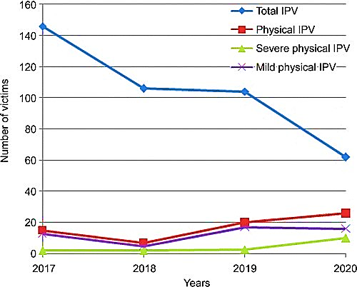

Figure 3 rate of physical violence

# **CONCLUSION**

Physical abuse in whatever form is a weed that grows slowly inside of its victims and spreads, making life a living hell. It ranges from minor physical injuries to severe psychological disorders increasing excessive fear, anxiety, isolation and distrust in victims. This evil disguise itself in many forms such as Sexual Abuse, Domestic Violence and Child Abuse to name a few, and unfortunately most of them are not even reported, as in most of the cases, Victims fear to explain what they faced which pushes them towards more mental trauma. Left unattended, it can have damaging and long-lasting effects on not just the physical condition, but can psychologically damage the victim for good!

# **RECOMMENDATIONS**

Based on the review of the literature and personal observation following are some suggestions and solutions to physical abuse:

* Reduces Stress, Aids Immunity Writing approximately difficult, even demanding ,reviews seem to be correct for fitness on numerous levels - elevating immunity and different fitness measures and enhancing existence functioning.
* Understanding the feelings and regular responses that comply with a catastrophe or different demanding occasion will let you address your feelings, thoughts, and behaviors.
* Advocate for the integration of educational programs in schools and communities aimed at preventing physical abuse. These programs can focus on fostering empathy, teaching conflict resolution skills, and promoting healthy relationships.
* Promote awareness and intervention strategies within workplaces to identify and address potential cases of physical abuse among colleagues. This includes implementing clear reporting mechanisms and support systems.
* Encourage the development of community support networks that provide resources and assistance to individuals and families affected by physical abuse. This may involve collaborating with local organizations and agencies to establish community-driven initiatives.
* Advocate for reforms in legal frameworks to strengthen the consequences for perpetrators of physical abuse. This includes ensuring that legal measures are effectively enforced, providing justice for victims, and acting as a deterrent for potential abusers.
* Promote the inclusion of mental health first aid training for community members, law enforcement, and healthcare professionals. This can enhance the ability to recognize signs of psychological trauma in victims and provide appropriate support.

# 

# **REFERENCES:**

**Blogs:**

Grief Recovery Method Blog. (n.d.). Retrieved from <https://www.griefrecoverymethod.com/blog>

Impact of child abuse: A blog of Alabama. (n.d.). Retrieved from <https://sites.uab.edu/>

Blogging about sexual assault. (n.d.). Retrieved from <https://e-space.mmu.ac.uk/>

NCTSN Learning Center. (n.d.). Retrieved from [https://mendingthesoul.org](https://mendingthesoul.org/)

NSVRC Blogs. (n.d.). Retrieved from <https://www.nsvrc.org/blogs>

PR Newswire Media Blog. (n.d.). Retrieved from <https://mediablog.prnewswire.com/>

**Videos:**

Foundation for Professional Development. (2023, November). Gender-Based Violence- Types of Abuse | Physical abuse. Retrieved from <https://www.youtube.com/watch?v=YGTGLgKBtCE>

Kati Morton. (2018, September). Physical Abuse and Its Long-Term Effects. Retrieved from <https://www.youtube.com/watch?v=1O3Y9ddzDG8>

Kati Morton. (2013, June). Sexual Abuse: How do we recover & how long does it take? Retrieved from <https://www.youtube.com/watch?v=JAMwyyybA7I>

TEDx Talks. (2018, September). Finding your coping mechanism | Joseph Lewis. Retrieved from <https://www.youtube.com/watch?v=gaKrutVZ-Xk>

TEDx Talks. (Date and Year). Title of video “Healing From Sexual Abuse Can Start With One Word | Rena Romano.” Retrieved from <https://www.youtube.com/watch?v=rQ4RoldUzHc>

UCLA. (2020, January). Recovering from trauma and grief. Retrieved from <https://www.youtube.com/watch?v=SSPnE9RpeKI>

**Books:**

Anderson, L. H. (Illustrated, January 15, 2019). *Speak*.

Bonino, G. A. (Illustrated, November 5, 2019). *The Other Side of Sadness*.

Densen, S. (Illustrated, February 28, 2008). *Just Listen*.

Gilbert, A. (Illustrated, April 12, 2016). *Past and Present*.

# **APPENDICES:**

## Appendix A: Result of Questionnaire

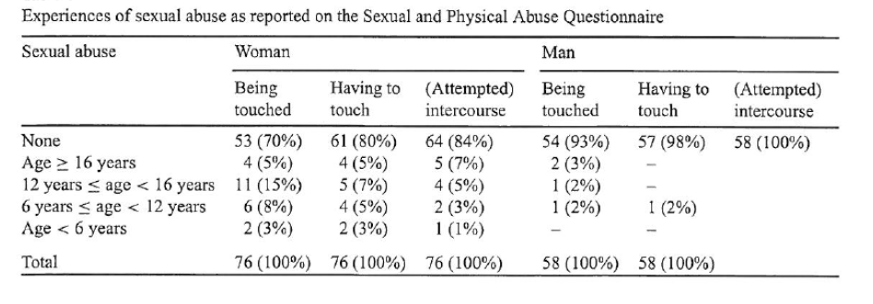

Figure 4 results of Sexual abuse questionnaire

Source: September 2002Child Abuse & Neglect 26(9):939-953

## Appendix B: Table of Figures

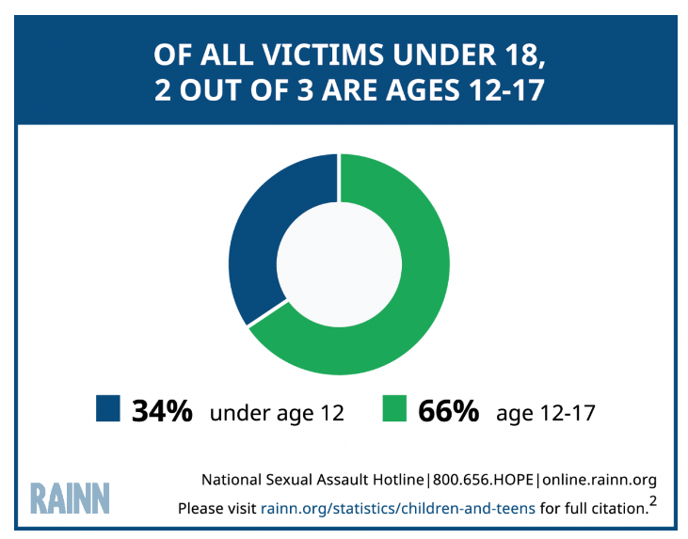

Figure 4 the age that experience sexual abuse or assault

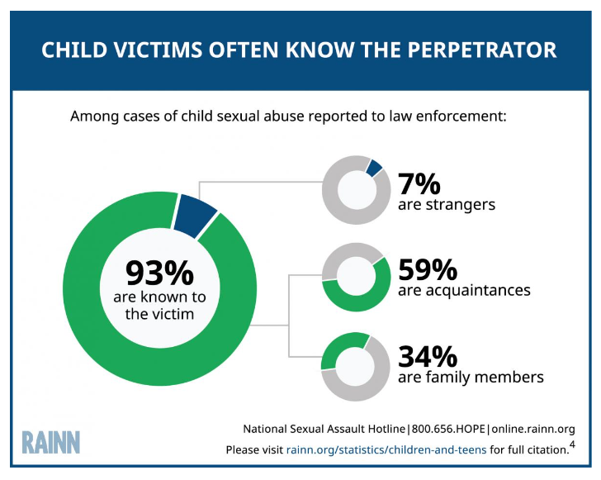

Figure 5 Perpetrators of Child Sexual Abuse Are Often Related to the Victim

**Source:** United States Department of Health and Human Services, Administration for Children and Families, Administration on Children, Youth and Families, Children’s Bureau. Child Maltreatment Survey, 2016 (2018).