COMSATS UNIVERSITY ISLAMABAD, ABBOTTABAD CAMPUS.

***Islamic studies: Semester Project***

#### Discrimination of Gender, Racial Discrimination and Religious Discrimination in the Workplace.

***Dated:*** *21st of November 2023*

***Prepared For:*** MAM ASMAT SHAHEEN

***Prepared By:***

###### MUHAMMAD JUNAID FA23-BSE-1B-069

###### MUHAMMAD ILYAS FA23-BSE-1B-067

###### HAMID ABDULLAH FA23-BSE-1B-042

###### MUHAMMAD ABDULLAH FA23-BSE-1B-063 ISRAR KHAN FA23-BSE-1B-048

###### HAMAD ULLAH SHAH FA23-BSE-1B-041

###### MAISAM ALI FA23-BSE-1B-054

###### MUBASHIR FA23-BSE-1B-061

###### HASAN ALI FA23-BSE-1B-044

Contents

CHAPTER: 01 INTRODUCTION 3

* 1. Meaning & Definition: 3
  2. Relationship with main topic: 3
  3. Significance of Addressing Discrimination 3
  4. Limitations of the Study 4

CHAPTER: 02 METHODS OF STUDY 4

CHAPTER: 03 FINDINGS AND DISCUSSIONS: 5

* 1. Gender Discrimination: 5
  2. Racial or Ethnic Discrimination 7
  3. Age Discrimination: 8
  4. Disability Discrimination: 9

CHAPTER: 04 CONCLUSION 10

CHAPTER: 05 RECOMMENDATIONS: 10

CHAPTER: 06 REFERENCES 11

CHAPTER: 07 APPENDIXES 12

# CHAPTER: 01 INTRODUCTION:

## Meaning & Definition:

The word discrimination comes from a Latin word “**discriminate**” which means “**distinguished between**”.

Discrimination is treatment or consideration of, or making a distinction towards a person based on the group class or category to which the person is perceived to belong. Beside this many other types and forms of discrimination are practiced throughout the world such as age discrimination, caste discrimination, disability discrimination, linguistic discrimination, religious discrimination etc. These trends are coming since the age of Jahiliya when girls were killed on the spot of their birth, Arabs were preferred over Ajam, etc. But when Islam came, all these trends were eradicated, and a lesson of equality was given.

## Relationship with main topic:

Discrimination is very closely related to ethical dilemma. It is one of the main examples of ethical dilemma that affects the business in many ways. Discrimination in the workplace is experienced when “an employer takes some unjust action against some employee due to color, race, age, sex, and religion, etc. A very common type of discrimination which is widely practiced is gender-based discrimination. In many companies’ male workers are paid more as compared to female workers. Due this the reputation of the targeted companies effected badly.

## Significance of Addressing Discrimination:

#### Discrimination of any sort can be completely addressed if we remain closely connected to Islam and act on the teachings of Islam.

#### According to Islam, there is no discrimination based on caste, color, gender etc. if there is any discrimination then it is based on virtuousness and knowledge.

### The Holy Quran says, “Is one who is devoutly obedient during periods of the night, prostrating and standing [in prayer], fearing the Hereafter and hoping for the mercy of his Lord, [like one who does not]? Say, “Are those who know equal to those who do not know?” Only they will remember [who are] people of understanding.” (Surah Az-zumar, 39:9).

In another Surah Allah (SWT) says, *“****Mankind! We have created you from a male and female, and made you into people and tribes, so that you might come to know each other. The noblest of you in God’s sight is the one who fears God most. God is all-knowing and all-aware****” (Surah Al-Hujurat, 49:13)*

The Holy Prophet (Peace Be Upon Him) said, ***“Allah does not look upon your outward appearance, He looks upon your hearts and your deeds”.***

#### In the early days of Islam, when the Prophet (Peace Be Upon Him) used to deliver speeches about Islam, people from remote areas used to come to listen to the Holy Prophet (PBUH) and got benefited from the teachings of the Holy Prophet (PBUH). At that time those who came early got space in the masjid easily, but there was not enough space for those who came later. In that case the Holy Prophet (PBUH) used to spread his own chadar e Mubarak (sheet) for those who came later and sat them on it so that they may get benefit from the preaching of the Holy Prophet (PBUH).

#### Although the Prophet (Peace Be Upon Him) was the most beloved to Allah (SWT), but He (PBUH) did not understand Himself prominent from others. He (PBUH) did not ever wear anything that could distinguish Him from the rest of His companions (Razi Allah Anha). The Prophet (PBUH) used to remain so simple that if someone from a faraway area came then he would have severe difficulty in recognizing.

## Limitations of the Study:

#### Due to limited time frame for the semester project widespread data has not been used in the study to make this report most relevant and authentic. This study is of descriptive nature because all the information is taken from others research work.

#### Additional research is needed toassess the results of this look at with studies using different elder abuse reporting formats (e.g., institutional self-file, crook justice reports, and

#### Government/enterprise statistics series).

# CHAPTER: 02 METHODS OF STUDY:

#### The data used for the study is secondary data. The method used for analyzing the discrimination at workplace involve the review of various literature on the topic. As there is no specific method of analyzing qualitative data, all the information, statistical values and graphs are taken from other researchers work, explanation and interpretation and situations is analyzed and has been put into meaningful paragraphs.

#### And then based on the above process, the data is used to explain the challenges and to suggest the solution for the presented challenges.

# CHAPTER: 03 FINDINGS AND DISCUSSIONS:

Ethical challenges face around the world due to discrimination whether in form of Gender Discrimination, racial or ethical discrimination, age, or disability discrimination and we will be discussing them in detail in the draft:

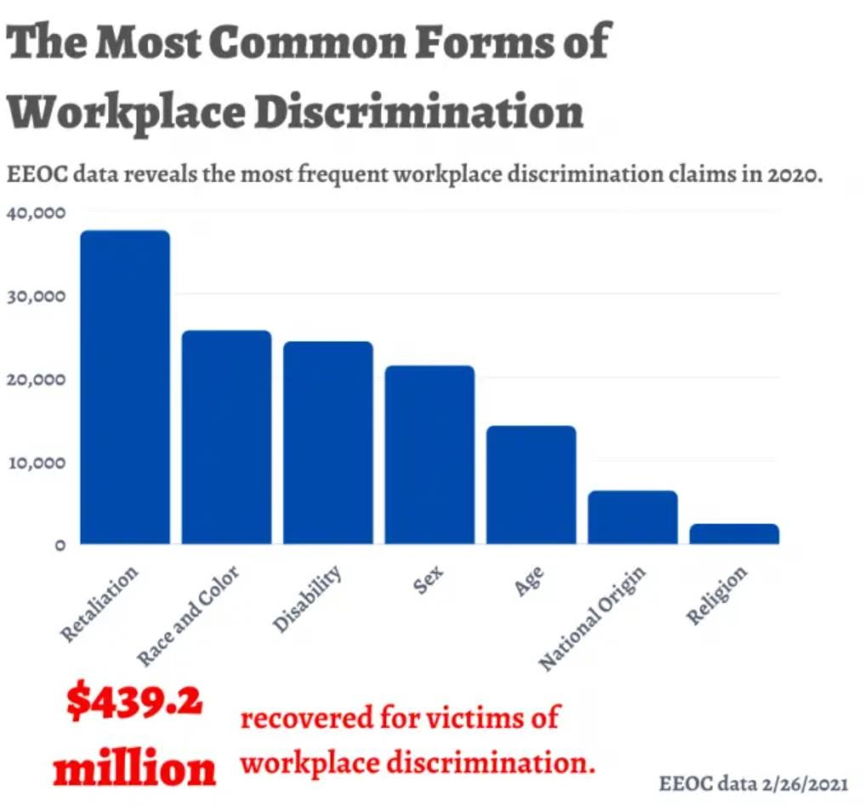

*Figure 1 Common forms of discrimination 2020, the EEOC*

## Gender Discrimination:

Gender discrimination is deeply rooted in societal norms, cultural beliefs, and legal structures. Throughout history, women have faced unequal treatment in various aspects of life, including education, employment, and legal rights. The struggle for gender equality has been marked by movements such as the suffragist movement in the late 19th and early 20th centuries, advocating for women's right to vote, and the feminist movements of the 20th century, which sought broader equality in various spheres.

Despite progress in many countries, gender discrimination persists globally. Laws and policies have been enacted to address gender inequality, but implementation and enforcement vary.

##### Where Gender Discrimination Is Faced:

Gender discrimination is commonly experienced in the workplace, affecting hiring, promotions, and pay. Occupational stereotypes may limit women's access to certain professions or leadership roles.

Gender bias can be present in educational settings, affecting access to quality education and reinforcing societal expectations about traditional gender roles.

In some regions, discriminatory laws or inadequate legal protection can contribute to gender inequality. *Over 70 percent are not seeking work either because their husband or father won't let them, or because of their household duties (2019 PSLM).*

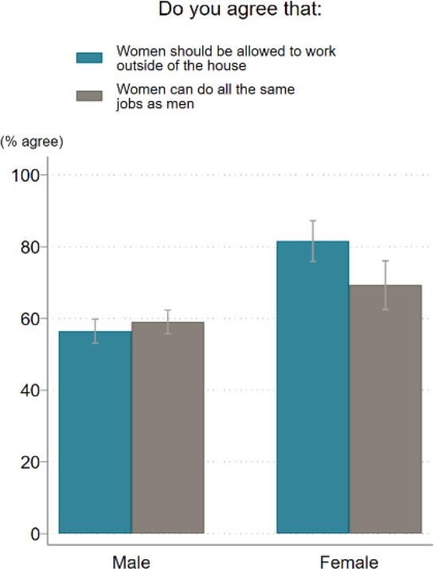

*Figure 2 Gender roles and biases on female participation in the labor market*

##### Number of People Facing Gender Discrimination:

The World Economic Forum's Global Gender Gap Report 2023 provides that about 68.4% of gender discrimination gap has been closed while still about 32% remaining but it is reducing by time. At the current rate of progress over the 2006-2023 span, it will take 162 years to close the Political Empowerment gender gap, 169 years for the Economic Participation and Opportunity gender gap, and 16 years for the Educational Attainment gender gap. The time to close the Health and Survival gender gap remains undefined.

When women secure employment, they often face substandard quality of working conditions. A significant portion of the recovery in employment since 2020 can be attributed to informal employment. The ILO estimates that out of every five jobs created for women, four are within the informal economy, whereas for men, the ratio is two out of every three jobs.

##### Consequences of Gender Discrimination:

Gender discrimination often contributes to a wage gap, where women are paid less than men for similar work and qualifications. This economic disparity can affect women's financial well-being, limiting their ability to save, invest, and plan for the future. It can hinder women's access to career advancement opportunities. Glass ceilings and biased promotion processes may prevent qualified women from reaching leadership positions. Thus they may experience lower levels of job satisfaction.

## Racial or Ethnic Discrimination:

Racial and ethnic discrimination has a long history globally (figure 3), marked by systemic biases, prejudices, and unequal treatment based on race or ethnicity. Some key historical events include:

The transatlantic slave trade and colonization led to the systemic dehumanization and discrimination against African and indigenous populations. In the United States, the Jim Crow laws enforced racial segregation, institutionalizing discrimination against African Americans from the late 19th century to the mid-20th century. Apartheid, a policy of racial segregation, was implemented in South Africa, institutionalizing discrimination against the majority black population.

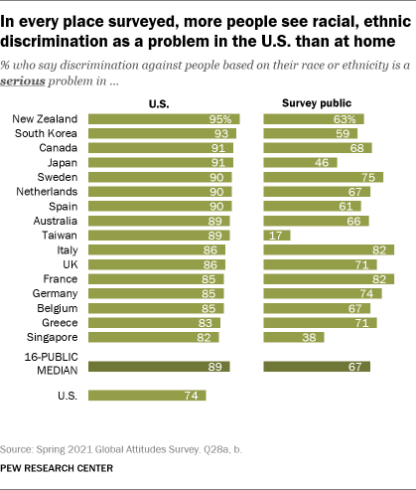

*Figure 3 racial ethnic discrimination*

U.S. Equal Employment Opportunity Commission (EEOC) reported over 33,000 charges related to race-based discrimination in 2021.

**Where Racial or Ethnic Discrimination is faced:** Racial or ethnic discrimination occurs in the workplace, affecting hiring, promotions, and day-to-day interactions. The glass ceiling phenomenon often limits career advancement for minority individuals**.** Discrimination can manifest in unequal educational opportunities, disproportionately affecting minority students. Racial profiling and bias in law enforcement contribute to disparities in arrests, sentencing, and incarceration rates.

##### Consequences of Racial or Ethnic Discrimination:

* Discrimination can lead to stress, anxiety, and depression.
* Limited opportunities can result in economic disparities.
* Discrimination can lead to social isolation and a sense of exclusion and undermines social cohesion and can lead to social unrest.
* Discrimination contributes to economic inefficiencies by excluding talented individuals from full participation in the workforce.

## Age Discrimination:

Age discrimination, also known as ageism, involves treating individuals unfairly or unfavorably based on their age. Historically, age discrimination has roots in societal perceptions of aging and stereotypes associated with different age groups. The perception that older workers may be less productive or adaptable has contributed to discriminatory practices in various areas, including the workplace.

According to the U.S. Equal Employment Opportunity Commission (EEOC), age discrimination claims accounted for approximately 21.4% of all discrimination complaints filed in the fiscal year 2020 in the United States.

##### Where Age Discrimination is faced:

Age discrimination is commonly encountered in the workplace during various employment phases, such as hiring, promotion, and termination. Older individuals may face challenges in securing new employment, experience involuntary early retirement, or encounter biased attitudes and assumptions about their abilities.

##### Consequences of Age Discrimination:

Older workers may experience challenges in finding new employment opportunities, leading to financial strain.

Age discrimination can contribute to feelings of isolation, depression, and a diminished sense of self-worth among older individuals. It occurs in healthcare and social services and also in market level which may result in a loss of valuable skills, knowledge, and experience within the workforce.

## Disability Discrimination:

The disability discrimination has seen significant changes in legal frameworks worldwide. In the United States, the Americans with Disabilities Act (ADA) was signed into law in 1990, prohibiting discrimination against individuals with disabilities in various areas, including employment, public services, and accommodations.

The medical model of disability, prevalent in the past, viewed disabilities as deficiencies that needed to be fixed or cured, contributing to stigmatization. The shift towards the social model of disability has emphasized societal barriers and discrimination as the primary obstacles for people with disabilities.

According to the World Health Organization (WHO) and the World Bank, over 1 billion people, or approximately 15% of the world's population, live with some form of disability. The prevalence of disability varies across regions and age groups. The International Labor Organization (ILO) reports that individuals with disabilities often face discrimination in the workplace, including barriers to hiring, promotion, and job retention.

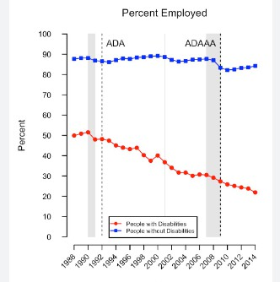

*Figure 4 Situating Disability in America's System Internationally, the United Nations Convention on the Rights of Persons with Disabilities (CRPD), adopted in 2006, aims to protect the rights and dignity of persons with disabilities globally.*

##### Consequences of Disability Discrimination:

Discrimination in employment can lead to economic disparities, with individuals with disabilities facing higher rates of unemployment and underemployment. It contributes to feelings of isolation, lower self-esteem, and mental health challenges among individuals with disabilities.

Failing to accommodate and support individuals with disabilities results in the loss of valuable talent for organizations. Organizations that engage in disability discrimination may face legal consequences, including lawsuits and financial penalties.

# CHAPTER: 04 CONCLUSION

#### In conclusion; discrimination whether on the basis pf gender, race, age, or disability is deeply intertwined with ethical dilemmas. The discussion highlighted that Islam emphasis on equality for all; regardless of any cast, color or moral values. The exploration revels the complex historical and contemporary facets of each; emphasizing on the need of solution to discrimination.

# CHAPTER: 05 RECOMMENDATIONS:

In recommendations, we will be dealing with Islamic teachings on discrimination at work place, solutions to discrimination at workplace and how to implement solutions to discrimination at workplace according to Islam.

*"Indeed, Allah commands justice, good conduct, and liberality to kith and kin. And He forbids all shameful deeds, injustice, and rebellion, and He instructs you, so that you may take heed." (Quran 16:90)*

Ensure that there will be no Discrimination: As in holy Quran Allah Said "O mankind, indeed; We have created you from male and female and made you peoples and tribes that you may know one another. Indeed, the most noble of you in the sight of Allah is the most righteous of you." (Quran 49:13)

* Give Fair Treatment to Employees as Prophet Muhammad (peace be upon him) said, *"Give the worker his wages before his sweat dries." (Ibn Majah)*
* Implement educational programs that raise awareness about diversity and inclusion, emphasizing Islamic teachings on equality.
* Develop and communicate clear policies against discrimination, emphasizing adherence to Islamic principles of justice and fairness.
* Ensure that hiring practices are fair and inclusive, focusing on qualifications and skills rather than irrelevant factors.
* Provide reasonable accommodations for individuals with disabilities, in line with Islamic principles of compassion and understanding.
* Establish effective channels for employees to report discrimination and ensure that conflicts are addressed promptly and justly.
* Leaders should set an example by promoting inclusivity and diversity, aligning with Islamic values.
* Invest in training and development opportunities for all employees, fostering an environment of continuous learning and growth.
* Engage with local communities and organizations to promote diversity and inclusion beyond the workplace.
* Leadership should demonstrate a genuine commitment to eradicating discrimination, fostering a culture of fairness and justice.
* Regularly assess workplace practices to identify any discriminatory tendencies and address them proactively. By aligning workplace practices with Islamic teachings and implementing proactive solutions, organizations can foster environments that promote justice, equality, and respect for all employees. These measures not only contribute to a positive workplace culture but also align with the ethical principles outlined in Islamic teachings.

# CHAPTER: 06 REFERENCES

#### World Health Organization (WHO): Disability and Health World Health Organization. (2023). Disability and Health. <https://www.who.int/news-room/fact-sheets/detail/disability-and-health>

#### International Labor Organization (ILO): Disability at a Glance 2019 International Labor Organization. (2019). Disability at a Glance 2019. [https://www.ilo.org/wcmsp5/groups/public/---ed_emp/---](https://www.ilo.org/wcmsp5/groups/public/---ed_emp/---ifp_skills/documents/publication/wcms_729457.pdf) [ifp_skills/documents/publication/wcms_729457.pdf](https://www.ilo.org/wcmsp5/groups/public/---ed_emp/---ifp_skills/documents/publication/wcms_729457.pdf)

#### Americans with Disabilities Act (ADA): ADA Home Page U.S. Department of Justice. (Year). ADA Home Page. <https://www.ada.gov/>

#### EEOC Data Reveals Most Common Types of Workplace Discrimination☹15 march 2021) [https://www.workingnowandthen.com/blog/eeoc-data-reveals-most-common-types-of-workplace-](https://www.workingnowandthen.com/blog/eeoc-data-reveals-most-common-types-of-workplace-discrimination/) [discrimination/](https://www.workingnowandthen.com/blog/eeoc-data-reveals-most-common-types-of-workplace-discrimination/)

#### World Health Organization (WHO): Ageing and Health World Health Organization. (2023). Ageing and Health. [https://www.who.int/teams/maternal-newborn-child-adolescent-health-and-ageing/ageing-and-](https://www.who.int/teams/maternal-newborn-child-adolescent-health-and-ageing/ageing-and-health) [health](https://www.who.int/teams/maternal-newborn-child-adolescent-health-and-ageing/ageing-and-health)

#### AARP: Age Discrimination Data and Research AARP. (Year). Age Discrimination Data and Research. <https://www.aarp.org/work/age-discrimination/>

#### World Economic Forum - Global Gender Gap Report: WEF Gender Gap Report World Economic Forum. (Year). Global Gender Gap Report. [https://www.weforum.org/publications/global-gender-gap-](https://www.weforum.org/publications/global-gender-gap-report-2023) [report-2023](https://www.weforum.org/publications/global-gender-gap-report-2023)

**Books:**

#### The Holy Quran.Al-Quran. <https://quran.com/en>

#### Hadith compilations such as Sahih Bukhari, Sahih Muslim, Ibn Majah, and others

#### Islamic scholars and commentaries on Islamic jurisprudence (Fiqh) <https://www.allahsword.com/free_islamic_books_fiqh.html>

# CHAPTER: 07 APPENDIXES

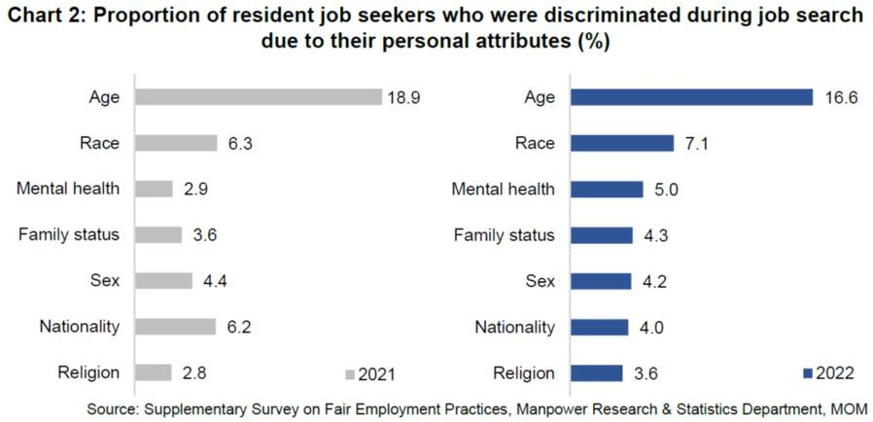

*Figure 5 Discrimination faced by job seeking people*