

**NAME: LAIBA BINTA TAHIR**

**REGISTRATION NO # FA21-BSE-019 (2A)**

[**PROGRAMMING FUNDAMENTALS**](javascript:__doPostBack('ctl00$DataContent$gvCourseSummary$ctl06$lbCourse',''))

**ASSINGMENT 01**

**TEACHER: DR. ABDUL NASIR KHAN**

**Problem:**

**If a five-digit number is input through the keyboard, write a program to reverse the number?**

**Program:**

#include<stdio.h>

int main()

{

int num;

printf("----Enter any 5_digit number----\n\nNumber = ");

scanf("%d",&num);

int tenThousandDigit=num%10;

num=num/10;

int thousandDigit=num%10;

num=num/10;

int hundredDigit=num%10;

num=num/10;

int tenDigit=num%10;

num=num/10;

int unitDigit=num%10;

num=num/10;

int reverse=(unitDigit*10 + tenDigit*100 + hundredDigit*1000 + thousandDigit*10000 + tenThousandDigit*100000)/10;

printf("Reverse of digit = %d",reverse);

return 0;}

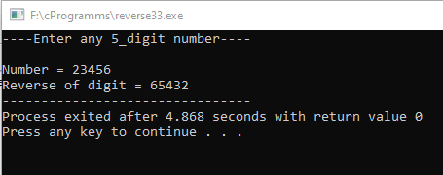

**Problem:**

**If a five-digit number is input through the keyboard, write a program to print a new number by adding one to each of its digits. For example if the number that is input is 12391 then the output should be displayed as 23402.**

**Program:**

#include<stdio.h>

int main ()

{

int value,dig1,dig2,dig3,dig4,dig5,temp;

printf("Enter a five-digit number: ");

scanf("%d",&value);

temp = value ;

dig1 = value % 10; //separating digits

value = value / 10;

dig2 = value % 10;

value = value / 10;

dig3 = value % 10;

value = value / 10;

dig4 = value % 10;

value = value / 10;

dig5 = value % 10;

dig1 = ((dig1+1)%10); //adding 1 to each digit

dig2 = ((dig2+1)%10);

dig3 = ((dig3+1)%10);

dig4 = ((dig4+1)%10);

dig5 = ((dig5+1)%10);

printf("\nAdding one in each digit of %d : %d%d%d%d%d",temp,dig5,dig4,dig3,dig2,dig1);

}

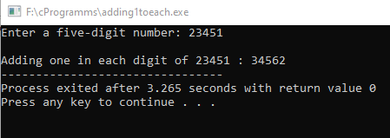

**Problem:**

**Two characters are input through the keyboard into two locations C and D. Write a program to interchange the contents of C and D without using any additional variable.**

**Program:**

#include<stdio.h>

int main()

{

int C;

printf("Enter value of C: ");

scanf("%d",&C);

int D;

printf("Enter value of D: ");

scanf("%d",&D);

printf("\nBefore swaping C is : %d\n",C);

printf("Before swaping D is : %d\n",D);

D=C+D;

C=D-C;

D=D-C;

printf("\nAfter swaping the value of C is : %d ",C);

printf("\nAfter swaping the value of D is : %d ",D);

}

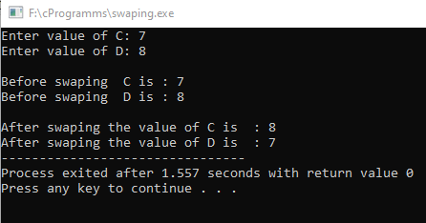

**Problem:**

**Write a program that finds the area of a triangle given the length of its sides: a, b, c.**

**Program:**

#include<stdio.h>

#include<math.h>

int main()

{

float a,b,c;

printf("....Three sides of triangle are....\n\n");

printf("Enter value of a : ");

scanf("%f",&a);

printf("Enter value of b : ");

scanf("%f",&b);

printf("Enter value of c : ");

scanf("%f",&c);

float s;

s=(a+b+c)/2;

float X;

X=s*(s-a)*(s-b)*(s-c);

float area;

area = sqrt(X);

printf("\n....Area of a triangle....\n");

printf("Area = %0.2f",area);

return 0; }

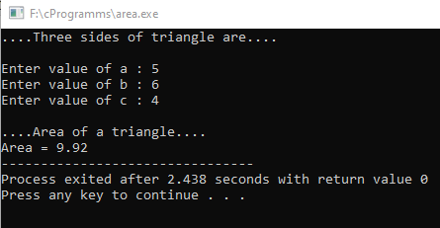

**Program:**

**Write a program that prints the formatted DMC of a student. Your program should take obtained marks and total marks of each subject from user. Your program should also calculate the percentage marks of the student.**

**Program:**

#include<stdio.h>

int main()

{

int a,b,c,d,e,f;

float per;

printf("========================================================================================\n");

printf("------------------FEDERAL BOARD OF INTERMEDIATE AND SECONDARY EDUCATION-----------------\n");

printf("========================================================================================\n");

printf("Name : laiba binta tahir\n");

printf("Roll No : 182532\n");

printf("Group : Pre-Engineering\n\n");

printf("Enter english marks : ");

scanf("%d",&a);

printf("Enter chemistry marks :");

scanf("%d",&b);

printf("Enter mathematics marks : ");

scanf("%d",&c);

printf("Enter physics marks : ");

scanf("%d",&d);

printf("Enter islamiat marks : ");

scanf("%d",&e);

printf("Enter urdu marks : ");

scanf("%d",&f);

printf("\t\t======================================\n");

printf("\t\t|SUBJECT |OBT.MARKS |T.MARKS\n");

printf("\t\t======================================\n");

printf("\t\t|English |%d \t\t|100|\n",a);

printf("\t\t|Chemistry |%d \t\t|100|\n",b);

printf("\t\t|Mathematics |%d \t\t|100|\n",c);

printf("\t\t|Physics |%d \t\t|100|\n",d);

printf("\t\t|Islamiat |%d \t\t|100|\n",e);

printf("\t\t|Urrdu |%d \t\t|100|\n",f);

printf("\t\t======================================\n");

printf("\n");

int sum = a+b+c+d+e+f;

printf("\t\tOobtained marks = %d \n",sum);

per = (sum * 100.00)/600;

printf("\t\tPercentage is = %0.2f ",per);

return 0 ;

}

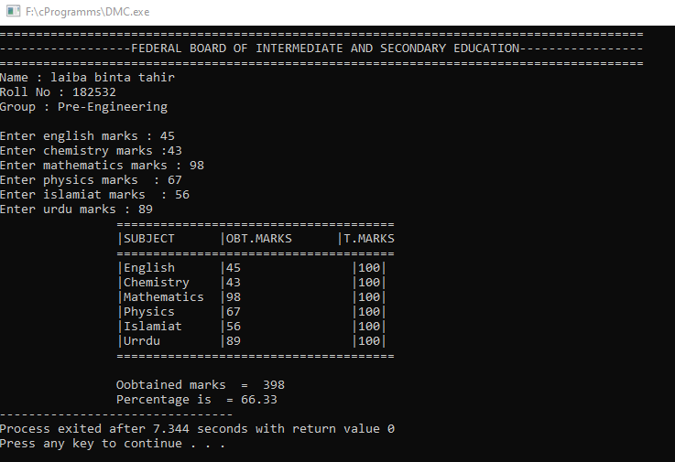

**Program:**

**Write a program that reads in the radius of a circle and prints the circle’s diameter, circumference and area**

**Program:**

#include<stdio.h>

int main()

{

float radius;

float pi=3.14;

printf("Enter Radius of Circle : ");

scanf("%f",&radius);

float diameter=radius/2;

float circumference=2*pi*radius;

float area=pi*radius*radius;

printf("\nDiameter of Circle : %0.1f\n",diameter);

printf("Circumference of Circle : %0.1f\n",circumference);

printf("Area of Circle : %0.1f\n",area);

return 0;

}

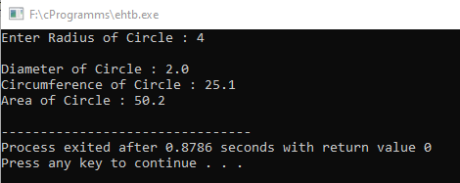

**Problem:**

**Write a program converts a temperature from Celsius to Fahrenheit. Use the following formula: F = 1.8 x C + 32 .**

**Program:**

#include<stdio.h>

int main()

{

float temperature;

printf("Temperature in Celcius : ");

scanf("%f",&temperature);

printf("\nTemperature in Farenhite :");

float tempFaren=1.8*temperature + 32 ;

printf("%0.1f F",tempFaren);

return 0;

}

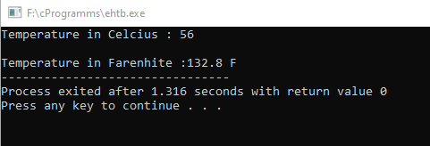

**Problem:**

**Write a program that takes any capital letter (A to Z) from user and display next five char after that ASCII value in small letters (a to z).**

**Hint: - if user enters H, your program should display i,j,k,l and m.**

**Program:**

#include <iostream>

using namespace std;

int main()

{

char ch,ch1,ch2,ch3,ch4,ch5;

printf("Enter a character in Uppercase: ");

scanf("%c",&ch);

ch=ch+32;

ch1=ch+1;

ch2=ch1+1;

ch3=ch2+1;

ch4=ch3+1;

ch5=ch4+1;

printf("Next 5 chracters in Lowercase are :\n %c=%d\n %c=%d\n %c=%d\n %c=%d\n %c=%d\n",ch1,ch1,ch2,ch2,ch3,ch3,ch4,ch4,ch5,ch5);

return 0;

}

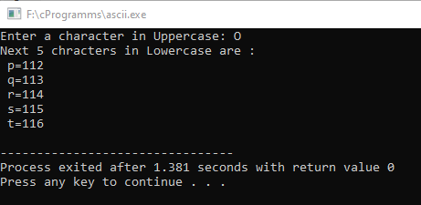

**Problem:**

**Write a program to solve the quadratic equation using quadratic formulas:**

**Program:**

#include <stdio.h>

#include <math.h>

int main()

{

float a,b,c,X1,X2;

printf("Please enter a :");

scanf("%f",&a);

printf("Please enter b :");

scanf("%f",&b);

printf("Please enter c :");

scanf("%f",&c);

X1 = (-b + sqrt(b*b-4*a*c) ) / (2*a);

X2 = (-b - sqrt(b*b-4*a*c) ) / (2*a);

printf("\n First root is %0.2f ",X1);

printf("\n Second root is %0.2f ",X2);

printf("\n ");

return 0;

}

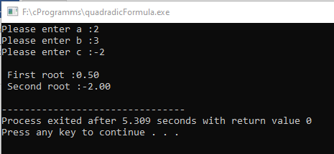

**Problem:**

**Write a program that reads three integers representing hours, minutes, and seconds of a time. Then it calculates the equivalent time in seconds.**

**Program:**

#include<stdio.h>

int main()

{

int sec , min , hour,S ;

printf("Enters seconds : ");

scanf("%d",&sec);

printf("Enters minutes : ");

scanf("%d",&min);

printf("Enters hour : ");

scanf("%d",&hour);

int hours_in_seconds = hour * 3600;

int minutes_in_seconds = min *60;

//equivalent time in seconds

S = hours_in_seconds + minutes_in_seconds + sec ;

printf("\n==== %d Hours : %d Minutes : %d seconds===\n ",hour , min ,sec );

printf("\nEquivalent time in seconds = %d Seconds",S);

return 0;

}

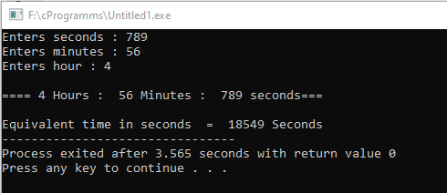

**Problem:**

**Write a program to evaluate the following formulas. Your Program should prompt the user for the values of *a* and *b* and evaluates the following expressions**

**Formula #01**

#include<stdio.h>

int main()

{

int a;

printf("Enter value of a :");

scanf("%d",&a);

int b;

printf("Enter value of b :");

scanf("%d",&b);

int formula=(a-b)*(a+b);

printf("formula =");

printf("(a-b)*(a+b)\n\t=(%d-%d)(%d+%d)\n\t=%d",a,b,a,b,formula);}

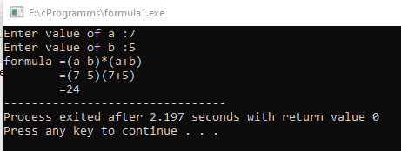

**Formula #02**

#include<stdio.h>

int main()

{

int a;

printf("Enter value of a :");

scanf("%d",&a);

int b;

printf("Enter value of b :");

scanf("%d",&b);

int formula=a*a+2*a*b+b*b;

printf("formula =");

printf("a*a + 2*a*b + b*b\n\t=%d*%d + 2*%d*%d + %d*%d \n\t=%d",a,a,a,b,b,b,formula);

}

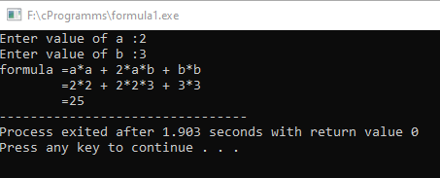

**Formula #03**

#include<stdio.h>

int main()

{

int a;

printf("Enter value of a :");

scanf("%d",&a);

int b;

printf("Enter value of b :");

scanf("%d",&b);

int formula=(a-b)*(a-b)+2*a*b;

printf("formula =");

printf("(a-b)*(a-b) + 2*a*b \n\t=(%d-%d)*(%d-%d) + 2*%d*%d \n\t=%d",a,b,a,b,a,b,formula);

}

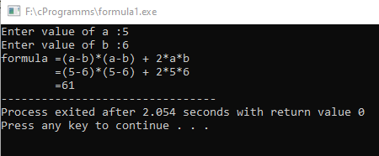

**Formula #04**

#include<stdio.h>

int main()

{

int a;

printf("Enter value of a :");

scanf("%d",&a);

int b;

printf("Enter value of b :");

scanf("%d",&b);

int formula=a*a-2*a*b+b*b;

printf("formula =");

printf("a*a - 2*a*b + b*b\n\t=%d*%d - 2*%d*%d + %d*%d \n\t=%d",a,a,a,b,b,b,formula);

}

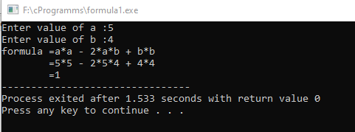

**Formula #05**

#include<stdio.h>

int main()

{

int a;

printf("Enter value of a :");

scanf("%d",&a);

int b;

printf("Enter value of b :");

scanf("%d",&b);

int c;

printf("Enter value of c :");

scanf("%d",&c);

int formula=a*a + b*b + c*c +2*a*b +2*a*c +2*b*c;

printf("formula =");

printf("a*a + b*b + c*c +2*a*b +2*a*c +2*b*c\n\t=%d*%d + %d*%d + %d*%d + 2*%d*%d + 2*%d*%d + 2*%d*%d \n\t=%d",a,a,b,b,c,c,a,b,a,c,b,c,formula);

}

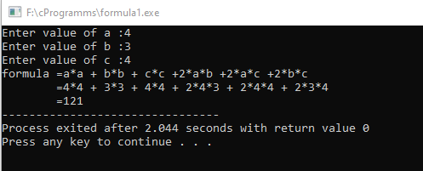

**Formula #06**

#include<stdio.h>

int main()

{

int a;

printf("Enter value of a :");

scanf("%d",&a);

int b;

printf("Enter value of b :");

scanf("%d",&b);

int c;

printf("Enter value of c :");

scanf("%d",&c);

int formula=a*a + b*b + c*c -2*a*b -2*a*c +2*b*c;

printf("formula =");

printf("a*a + b*b + c*c -2*a*b -2*a*c +2*b*c\n\t=%d*%d + %d*%d + %d*%d - 2*%d*%d - 2*%d*%d + 2*%d*%d \n\t=%d",a,a,b,b,c,c,a,b,a,c,b,c,formula);}

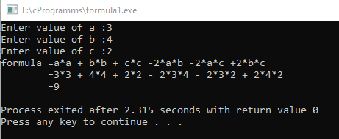

**Formula #07**

#include<stdio.h>

int main()

{

int a;

printf("Enter value of a :");

scanf("%d",&a);

int b;

printf("Enter value of b :");

scanf("%d",&b);

int formula=a*a*a + 3*a*a*b +3*a*b*b +b*b*b;

printf("formula =");

printf("a*a*a + 3*a*a*b +3*a*b*b +b*b*b\n\t=%d*%d*%d + 3*%d*%d*%d + 3*%d*%d*%d +%d*%d*%d \n\t=%d",a,a,a,a,a,b,a,b,b,b,b,b,formula);

} ­­

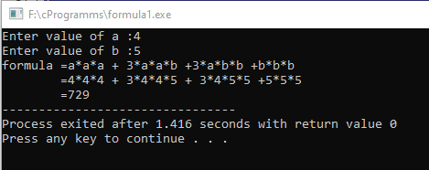

**Formula #08**

#include<stdio.h>

int main()

{

int a;

printf("Enter value of a :");

scanf("%d",&a);

int b;

printf("Enter value of b :");

scanf("%d",&b);

int formula=a*a*a - 3*a*a*b +3*a*b*b -b*b*b;

printf("formula =");

printf("a*a*a - 3*a*a*b +3*a*b*b -b*b*b\n\t=%d*%d*%d - 3*%d*%d*%d + 3*%d*%d*%d -%d*%d*%d \n\t=%d",a,a,a,a,a,b,a,b,b,b,b,b,formula);

}

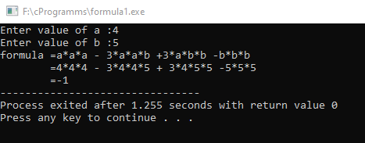

**Formula #09**

#include<stdio.h>

int main()

{

int a;

printf("Enter value of a :");

scanf("%d",&a);

int b;

printf("Enter value of b :");

scanf("%d",&b);

int formula=(a-b)*(a*a+a*b+b*b);

printf("formula =");

printf("(a-b)(a*a + a*b + b*b)\n\t=(%d-%d)(%d*%d + %d*%d + %d*%d) \n\t=%d",a,b,a,a,a,b,b,b,formula);

}

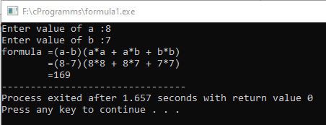

**Formula #10**

#include<stdio.h>

int main()

{

int a;

printf("Enter value of a :");

scanf("%d",&a);

int b;

printf("Enter value of b :");

scanf("%d",&b);

int formula=(a+b)*(a*a-a*b+b*b);

printf("formula =");

printf("(a+b)(a*a - a*b + b*b)\n\t=(%d+%d)(%d*%d - %d*%d + %d*%d) \n\t=%d",a,b,a,a,a,b,b,b,formula);

}

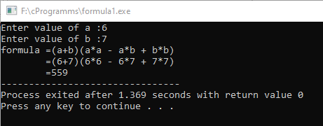

**Formula #11**

#include<stdio.h>

int main()

{

int a;

printf("Enter value of a :");

scanf("%d",&a);

int b;

printf("Enter value of b :");

scanf("%d",&b);

int formula=a*a*a*a + 4*a*a*a*b + 6*a*a*b*b + 4*a*b*b*b + b*b*b*b ;

printf("formula =");

printf("a*a*a*a + 4*a*a*a*b + 6*a*a*b*b + 4*a*b*b*b + b*b*b*b\n\t=%d*%d*%d*%d + 4*%d*%d*%d*%d + 6*%d*%d*%d*%d + 4*%d*%d*%d*%d + %d*%d*%d*%d \n\t=%d",a,a,a,a ,a,a,a,b , a,a,b,b , a,b,b,b ,b,b,b,b,formula);

}

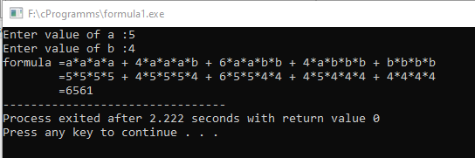

**Formula #12**

#include<stdio.h>

int main()

{

int a;

printf("Enter value of a :");

scanf("%d",&a);

int b;

printf("Enter value of b :");

scanf("%d",&b);

int formula=a*a*a*a - 4*a*a*a*b + 6*a*a*b*b - 4*a*b*b*b + b*b*b*b ;

printf("formula =");

printf("a*a*a*a - 4*a*a*a*b + 6*a*a*b*b - 4*a*b*b*b + b*b*b*b\n\t=%d*%d*%d*%d - 4*%d*%d*%d*%d + 6*%d*%d*%d*%d 4*%d*%d*%d*%d + %d*%d*%d*%d \n\t=%d",a,a,a,a ,a,a,a,b , a,a,b,b , a,b,b,b ,b,b,b,b,formula);

}

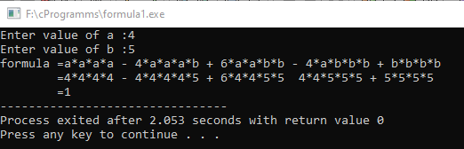

**Formula #13**

#include<stdio.h>

int main()

{

int a;

printf("Enter value of a :");

scanf("%d",&a);

int b;

printf("Enter value of b :");

scanf("%d",&b);

int formula=(a-b)*(a+b)*(a*a+b*b) ;

printf("formula =");

printf("(a-b)*(a+b)*(a*a+b*b)\n\t=% (%d-%d)*(%d+%d)(%d*%d + %d*%d)\n\t=%d",a,b,a,b,a,a,b,b,formula);

}

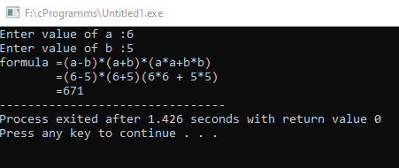

**Formula #14**

#include<stdio.h>

int main()

{

int a;

printf("Enter value of a :");

scanf("%d",&a);

int b;

printf("Enter value of b :");

scanf("%d",&b);

int formula=(a-b)*(a*a*a*a + a*a*a*b + a*a*b*b +a*b*b*b + b*b*b*b) ;

printf("formula =");

printf("(a-b)*(a*a*a*a + a*a*a*b + a*a*b*b + a*b*b*b + b*b*b*b)\n\t=% (%d-%d)*(%d*%d*%d*%d + %d*%d*%d*%d + %d*%d*%d*%d + %d*%d*%d*%d + %d*%d*%d*%d)\n\t=%d",a,b, a,a,a,a ,a,a,a,b ,a,a,b,b , a,b,b,b ,b,b,b,b,formula);}

