**COMSATS UNIVERSITY ISLAMABAD**

**ABBOTTABAD CAMPUS**

**Semester project**

**CURRENT ECONOMIC AND ADMINISTRATIVE CHALLENGES AND SOLUTION RELATED TO TEXTILE INDUSTRY IN PAKISTAN**

**PREPARED FOR**

**28 May-2023**

**PREPARED BY**

**Muhammad Afaq Ahmad FA22-BSE-153**

**Table of Contents**

**EXECTIVE SUMMARY…………………………………………………………………………………………………………………………..1**

**CHAPTER 1: INTRODUCTION 2**

1.1 Background of Pakistan textile industry 2

1.2 Purpose of report 4

1.3 Significance of report 4

1.4 Limitation of study 4

C**HAPTER 2: LITERATURE REVIEW 5**

**CHAPTER 3: METHODOLOGY 6**

**CHAPTER 4: FINDING AND DISCUSSION 6**

4.1 Electricity Crisis 7

4.2 Gas Shortage 8

4.3 Increasing Raw Material Prices 8

4.4 Lack of Research & Development (R&D) in Cotton Sector 8

4.5 Lack of modern equipment and machinery 9

4.6 Depreciating Rupee and Inflation 10

4.7 Lack of new investment 10

4.8 Tight monetary policy 10

**CHAPTER 5: RECOMMENDATION 11**

**CHAPTER 6: CONCLUSION 13**

**REFERENCES 14**

**APPENDIX-I (Tables) 16**

**APPENDIX-I (Figures) 17**

**Table of figures**

Figure no Tittle page no

1. Total export of the country…………………………………………………………………………..….3
2. Economic and Administrative challenges in Pakistan textile industry……………….6
3. Return on assets of textile sector……………………………………………………………………..7
4. Number of total installed and working rotors in Pakistan…………………………………9
5. strength and weakness of Pakistan textile sector…………………………………………….17

**List of tables**

Table no Tittle page no

1. Textile export of Pakistan every year………………………….……………………………………3
2. Sector wise share of Textiles……………………………………………………………………………16
3. Comparison of key factor of other countries with Pakistan................................16

**CURRENT ECONOMIC AND ADMINISTRATIVE CHALLENGES AND SOLUTION RELATED TO TEXTILE INDUSTRY IN PAKISTAN**

**Executive summary**

**Aims and objective:** Textile industry is the backbone of Pakistan. Pakistan ranks fourth in the textile market. The main objective of this report is to assess the various challenges faced by the textile sector Pakistan, highlight the shortcomings in Pakistan administrative system and economic problems that has slowed the developmental pace of textile industry. **Design and methodology:** The data used for this study is secondary data. It is the qualitative study and all the information and statistics in this report has been taken from the research work of others. Based on the reviews of various literature economic and administrative challenges has been written in the fining section of report. **Findings of the report:** This study reveals that the textile industry of Pakistan is suffering a lot because of the lack of seriousness of concerned authorities in government. The economic and administrative challenges are energy crises, gas shortage fluctuating prices, devaluation of Pakistani rupee, lack of research institutions, lack of modernized machinery and increased cost of production cost. **Recommendation:** Pakistan’s textile industry can once again come on winning track if government normalizing the above mentioned challenges. Proper planning and strategies are need to be implemented by the present government and relevant textile governing institutions. Government should provide cheap and continuous energy source, modernize the machineries, provide subsidy and withdraw withholding taxes, win confidence of internal and external entrepreneur to invest, establish research institute to improve quality of cotton and set proper management. **Limitation:** limitations of this study is that we have used secondary data. No primary data was available and hence the conclusions are derived from the data collected through various sources. Many statistical values in the study can vary by present values as most of the used research articles was written around 2017. This study focus on only economic and administrative challenges faced by textile industry, it does not cover the political and social challenges in the textile industry.

# CHAPTER 1: INTRODUCTION

In world textile industry Pakistan comes on fourth rank, and is included in the list of largest manufacturer of textile goods. According to report of ***All Pakistan Textile Mills Association*** in an era of 2009-2012 textile industry had contributed to 52% of total exports of the country, 8.5% of total Gross Domestic Products and 5% of the market capitalization.

## Background of Pakistan textile industry

At the time of independence Pakistan had only two textile mills, Okara Textile Mills, Okara and Lyallpur Cotton Mills in Faisalabad were in process. With the passage of time this sector started its development process, finally industry started picking up gradually and Pakistan became 4th largest textile exporter. Since 1947 states cotton production has increased and textile industry has expanded. The Spinning Sector is the backbone of the Pakistan’s textile industry and Pakistan has third largest spinning capacity in Asia. According to records of Textile Commissioner’s Organization there are 523 textile units in Pakistan with 65% of textile units set in Punjab, 25% in Sindh, KPK there are 5% and remaining are present in Azad Kashmir and Baluchistan. With increase in number of mills Cotton – bales has increased from 1.1 million bales to 10 million bales from 1947 to 2000.

In highly competitive global environment, the textile sector of any country needs to upgrade its supply chain, improve its productivity, and maximize value-addition to prevail. And based on this fact for the economic stability, Pakistan should be doing the same. In the beginning development in this sector was remarkable but presently textile sector of Pakistan is facing very serious challenges Pakistan has a favorable geographical location and many natural resources available too, so it should be doing much more than the above mentioned statistics, but it is not. Textile industry account for 61% of country export and in recent year there has been observed a decrease trend in export.

The Express Tribune Statistics revealed the textile exports from the year 2015 to 2017 , results show that promising year for the textile sector was 2013 during that year textile exports has rose to $ 13.8 Billion. However that momentum could not be maintained and downfall remained for upcoming years. Pakistan textile commodities had global presence and recognition even, In 2016, the textile sector was awarded as being highly automated sector. However, recently, the mainstream cotton export has plunged by 21 % in the previous four years.

*Table 1 Textile export of Pakistan every year*

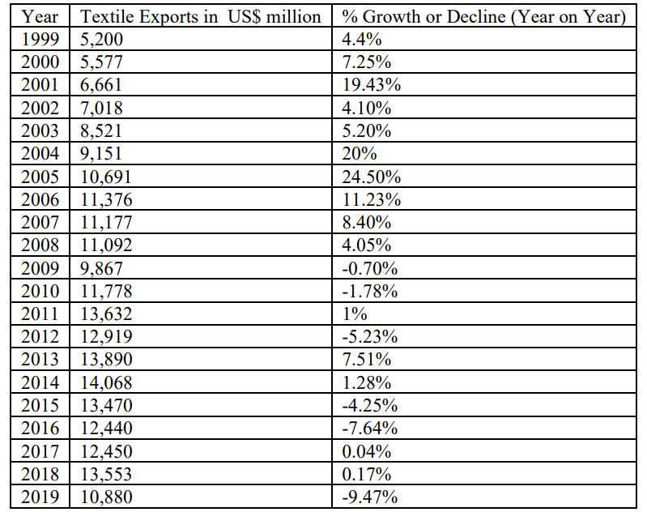

Above Statistics show that Pakistan textile sector was one of the automated industries of the subcontinent in 1990. But afterward sector’s downfall started. (J. Memon 2020). Out of 20 trade partners of Pakistan, the trade ratio enhanced of only 9 countries in 2013-2015. This fall in global commerce in the last 10 years was due to careless strategies, degrading standards and poor export targets. (Iqbal, M. 2017). Pakistan exports revenue is heavily dependent on textile, it represents about 6% of Pakistan total Imports. Over the period of FY13-FY17 decrease trend in states export has been observed and Textile exports are in-line with the decrease trend of total exports and shows a negative compound growth of 1% over the period (FY13-17).

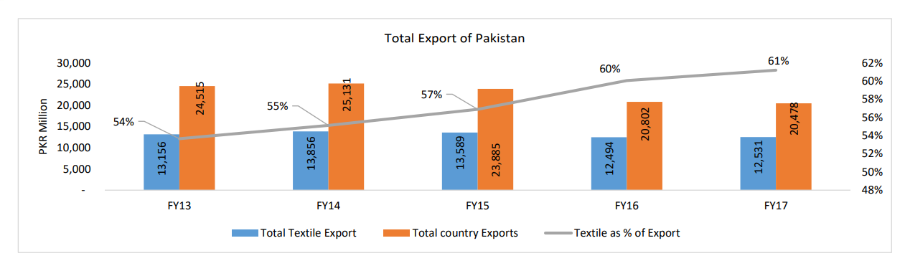

*Figure 1 total export of the country*

Pakistan has a favorable geographical location, fertile land and many resources available therefore she must be doing much more. But with the passing days we are lagging behind. The reason is that Pakistan textile industry is currently facing a lot of massive challenges. All Pakistan Textile Mills Association (APTMA) needs to enhance the quality of its products, But the argument it put forward is that the economic and administrative challenges are obstructing their pathways.

## Purpose of report

The aim of this document is to;

* Identify the challenges and difficulties faced by the textile industry of Pakistan
* Highlight the reasons why the producers and exporters of Pakistan are lagging behind in global markets.
* And based on the analysis also suggest some solutions which can help our textile industry to restart its journey towards the development process of the economy of the country.

## Significance of report

Pakistan is a developing country, whose economy mainly relies on textile and agro-industry. As world is progressing, developing countries like Pakistan are becoming more dependent on developed country, dept. on the state is increasing day-by-day. Moreover COVID situation has struck a huge blow to Pakistan economy. Hence for the substance, stability of economy state need to strength its textile industry and overcome the challenges faced by textile industry.

## Limitation of study

Due to limited time frame for the semester project widespread data has not been used in the study to make this report most relevant and authentic. This study is of descriptive nature because all the information is taken from others research work. This study focus on only economic and administrative challenges faced by textile industry, it does not cover the political and social challenges in the textile industry.

# CHAPTER 2: LITERATURE REVIEW

Most important part of Pakistan economy is textile industry. But over the year this industry has undergone an ups and down due to various reasons. The main contributor of this sector are readymade fabrics, garments and clothing, chemical processing sector and twisting sector. The sector still today is struggling and unable to perform to its full potential. Global tension, worldwide recession and market competence are also threats to the sector. (J. Memon 2020)

China, USA and India is day-by-day improving in textile industry and Pakistan textile industry has not yet fallen into pit and can rise again. It can Bounce Back Vigorously and it can be done by following the strategies and key success factors of the world textiles market leaders. (Ali, 2020)

Pakistan major share of export is based on textile industry. But this share is marginal in international market. Textile sector in west is becoming intensive, massive reconstruction is being done. To survive in progressing market Pakistan need to change its internal environment, more importance should be given to modern technology and more emphasis should be on cotton and textile quality. (Malik, A 2000).

Case Study on the Economic Impact of Energy Crisis on the Textile Sector show that load-shedding after 2007 has greatly impacted Pakistan textile industry. Software E-views 07 was used for the study. By analyzing the Return on Assets and Return on Equity of companies, inverse relation between industry performance and economic performance was found. Study emphasize that if we improve our energy resources then our textile sector could improve too. (Iqbal, M. 2017)

The results of cross reference comparison of the Pakistani Private Sector with the global Textile Manufacturing players reveal that the quality is the most important priority and it gives competitive advantages in prospector group. However for Pakistani Private Sector considerable amount of time will be taken to regain its old global recognition and improve their operational competitiveness. Faulty organizational management structure and practices, nation’s political, economic crisis, energy and security situation are the reasons that can delay the improvement process. (Kazmi, S. A., & Takala, J. 2014)

# CHAPTER 3: METHODOLOGY

The data used for the study is secondary data. The method used for analyzing the economic and administrative challenges of Pakistan textile industry involve the review of various literature on the topic. As there is no specific method of analyzing qualitative data, all the information, statistical values and graphs are taken from other researchers work, explanation and interpretation and situations is analyzed and has been put in to meaningful paragraphs.

And then based on the above process the data is used to explain the challenges and to suggest the solution for these presented challenges.

# CHAPTER 4: FINDING AND DISCUSSION

For Pakistan textile sector is the export cash cow but the national share in the global textile trade has experienced a continuous contraction. In an article by Pakistan and gulf economists it is mentioned that textile sector in Pakistan has both challenges and opportunities. (Kazmi 2018). Based on the study we will point out and discuss the main economic and administrative reasons of crisis in textile industry.



*Figure 2 Economic and Administrative challenges in Pakistan textile industry*

## 4.1 Electricity Crisis

Electricity is the basic component of nature and one of the most commonly and vastly used energy form. Previously economists described labor and capital as important element of every industry. But now scenario is different modern economists along with previous factor consider electrical energy as important determinant of every industry around the globe.

It is the fundamental element in growth of textile sector as well. The textile industry of Pakistan uses the 38 % of electricity in chemical processing, 23 %in weaving, 34 %in spinning and 5 % for other miscellaneous purposes. (H Afzal 2012). Punjab is the center of this industry but has very poor electricity situation. 8 to 10 hours of load shedding has negatively impacted the textile sector. Due to that the production process stops on a large scale, production of the textile industry is decreasing and fixed cost of the industry remains the same. The factories operate for less time due to electricity shortage and outcome or production is not rising as it should.

A journal by ISRA University Hyderabad, Pakistan conducted a study to determine the impact of energy crises on textile sector between 2005- 2010 and the results show that due to electricity load shedding return on assets in textile sector has fallen after 2007 and the fall was drastic in 2009. (Beenish Shah 2013).

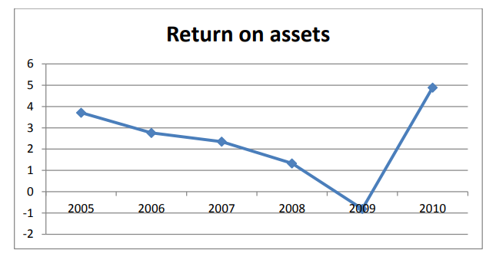

*Figure 3 return on assets of textile sector*

This study was up to 2010 and in current scenario electricity situation has worsened and Pakistan export orders has decreased because our country cannot fulfill order in time. Solution of this energy crises for textile sector is that industry go for private electricity production that though can increase costs but it can be a solution. Moreover government should provide this sector with proper electricity supply to get up our textile sector.

## 4.2 Gas Shortage

Gas is the second form of energy that is required in production and manufacturing sector. Gas load-shedding is common in central hub of textile sector. Spokesman of All Pakistan Textile Mills Association explained that 60 to 70 % of textile had been affected and was unable to accept export orders coming in from around the globe due to gas shortage. In Punjab due to energy supply disruption loss of Rs1 billion per day has been estimates.

Industrial forum to prove the importance of gas supply to industries for the growth of country has put forward a proposal to divert CNG stations in the country to LPG and suggested that the gas be transferred to large scale industries like textile industry of Pakistan and the Fertilizer industry. Government of Pakistan should develop some strategy to solve this energy crisis faced by the textile industry of Pakistan (Walayat Shah 2012)

## 4.3 Increasing Raw Material Prices

Cotton is an ideal clothing material and Pakistan cotton production is very good. But due to declining international cotton prices Pakistan local market has faced problem and Prices of cotton & other raw material used in textile industry has fluctuated in Pakistan. Rapid increase in the prices of these raw material has increased the cost of production and consequently the demand for export & home as well has decreased. The collective impact of this whole scenario is downsizing of textile firm.

Administration should take serious step to sustain the textile industry. To decrease the prices of raw material, production capability of state should be increased. Moreover to enhance quality and value of Pakistan cotton government should introduce international system of Cotton Standardization. (Aftab A. Khan 2010)

**4.4 Lack of Research & Development (R&D) in Cotton Sector**

Pakistan is an agricultural country but we are very much lagging in crop research and development area. Rest of Asia is focusing on plant biotechnology, using various technique to raise its cotton standard and in comparison Pakistan has quality of cotton. As there is low Pakistan cotton demand in international market, lower profit is gained by farmers therefor e they are shifting to other sector such as sugar sector.

It is the lack of research in cotton sector that has led to such a state. Other challenge is the use of pesticide that greatly damage the quality of cotton. Pakistan need to introduce research program in agriculture field to produce pest resistant crops and also improve cotton quality.

**4.5 Lack of Modern Equipment and Machinery**

Another major economic challenge faced by textile industry is the lack of working equipment and modernized machinery. This deficiency has declined the Pakistani textile competitiveness. Report of Punjab board of investment and trade shows that power output Raw & complete fabric/cotton has evolved mainly due to the poor technology and scarcity of quality yarn. Total Looms installed in Cotton Textile Mills are 9,084 but only 6,384 Looms are in working state.

Rotors are very important equipment in textile as it give to good orientation of the fibers. Until Jul-Mar, 2017 as per record of Textile Commissioner’s Organization there are only total 185 thousand Rotors installed in Pakistan out of which 140 thousands rotors in operation with a 84 percent and 76 percent capacity utilization respectively.

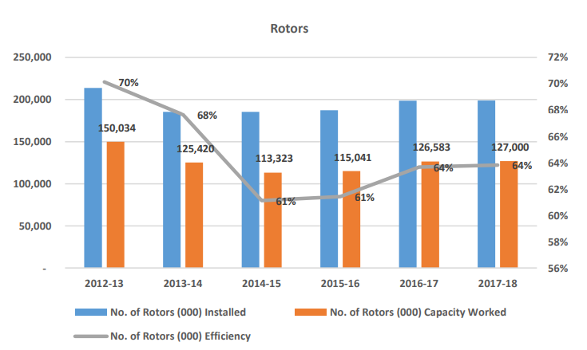

*Figure 4 Number of total installed and working rotors in Pakistan*

Above statistics clearly depict that Pakistan has obsolete technology that is the cause of higher cost of production in Pakistan compared to other countries in Asia.

So it is necessary that Pakistani textile industry be equipped with the modernized machinery to develop quality product, for the innovation of existing products and to establish a place new markets all over the globe.

**4.6 Depreciating rupee and Inflation**

Pakistan currency could not sustain its rupee value due to which cost of imported product increases. Here the cost of electricity is elevated. For example the local textile players consume electricity at 11.5 cents per kWh at the start of the year and in comparison same electricity is available to china industry at cost of 7.5 cents and in India 8 cents. This made it strenuous for Pakistan textile sector to compete for market share against these counterparts. (**Jawaid** 2020)

Solution of this inflation challenge for textile can be that government give them some relief package. And these packages must reduce the burden of cost of energy on manufacturing units of the country’s prime export, textile. Taxes on the textile products must be reduced and government should also control interest rate.

**4.7 Lack of New Investments**

The textile industry of Pakistan is facing enormous challenges of stunted growth and slowed production due to its inefficient textile equipment and machines. Pakistan’s textile sector needs a helping hand to raise again and stand in the competition. Economic Review of NBP in 2009 highlighted that around US$32 billion of investment was required till 2010 in order to achieve the government's export target.

But unfortunately Pakistan social situation around 2015 has greatly impacted the investors and there is very limited international investment. Moreover beside the external problem there is lack of internal investments. Higher class people for the fear of taxes and other interests on assets do not invest in such sector.

**4.8 Tight Monetary Policy**

One of the main problems faced by the textile industry is the misuse of authority by tax officials and implementation of heavy taxes. The continuity of tight monetary policy is a serious administrative challenge. Such policies causes an intensive increase in cost of production due to increasing interest rate.

In 2019, 4.0 percent withholding tax was imposed on textile that was very high compared to past and has badly affected the production. Pakistan Yarn Merchants Association has clarified to FBR that imposition of 4.0 percent withholding tax instead of 1.0 percent is not acceptable at any cost. (Custom news 2019)

The effect of these High marginal tax rates are reduced investment, saving and innovation and in long-run it slows the economic growth by increasing deficits.

# CHAPTER 5: RECOMMENDATION

The textile industry of Pakistan is suffering a lot because of the lack of seriousness of concerned authorities in government. Demotivated entrepreneurs have stopped further investment in excelling quality standards. Country fails to complete foreign demands due to energy breakdown, inflation and inefficient machineries. Proper planning and strategies need to be put in place by the present government and relevant textile governing institutions.

A lot of rectifications and improvements is required in the textile sector of Pakistan. Based on the review of the literature and personal observation following are some suggestions and solutions to current economic and administrative challenges faced by textile industry.

* Electricity and gas must be provided to textile organization at low rate for specific period of time which helps to establish the industry.
* For continuous supply of energy textile industries can go for private electricity production that can increase cost of production but in long-run there can be beneficial results.
* Research institutes must be established in affiliation with various agriculture universities, so that we can improve the quality of cotton, produce pest and herbicide resistant plants. Administration should fund the research initiatives and also recover the already established institution.
* To boost financing in the technology and infrastructure micro corporations be introduced, necessary unprocessed materials be supplied in uninterruptable
* Technology Up-gradation & Capacity Building is very significant for textile sector. To overcome the shortcomings of equipment, apparatus should be manufactured in house with guidance and partnership with friendly countries like China which can result in cheaper manufacturing.
* Pakistan can utilize CPEC and good relations with China by investing and partnering with them to advance our textile technology
* To Attract Foreign Direct Investment government Pakistan foreign ministry should establish good relation with other countries. Pakistan through international media needs to clear the point that there is a good social environment in Pakistan so that we can gain confidence of foreign investors.
* For a short span, for the revival and recovery of the sector subsidies should be given to the textile industry.
* Cost of production should be reduced by providing Subsidy removal, decreasing Interest rate, and by continuous supply of Electricity and gas without load shedding and also at lower cost.
* Transportation and packaging systems arrangements should be set in house to reduce the production cost accordingly.
* Administrative problem can be solved by Introducing efficient management techniques.
* Pakistani Textile Sector should change its current strategy of Playing safe to Innovative and radical strategy to make a stronger appearance in the global scene.
* Easy access loans should be given to farmers and small textile industry to develop their confidence.

# CHAPTER 6: CONCLUSION

Pakistan textile industry along with agro-industry is backbone of Pakistan economy. There is no doubt textile industry in current time contributes more than 60% in states export but still we are not as competitive as other Asian countries. Limited resources, inflation, under-developed equipment’s and management and poor Government policies of taxes and interest rate has forced slowed the pace growth the Pakistani textile sector. If this situation continued than not only Pakistan will always remain a developing country, unemployment will prevail, economy will fall and then Pakistan will always have to depend on external loans and dept.

It is important that Pakistan carefully evaluate current scenario develop strategies to rectify all challenges. Administration should provide subsidy to the textile industry, withholding tax on imported essential raw material should be withdraw, sales taxes should be withdrawn, industrial machineries should be upgraded and above all continuous supply of energy to industrial sector must be ensured.

# REFERENCES

Aftab A. Khan, Mehreen Khan, Pakistan Textile Industry Facing New Challenges Research Journal of Internatıonal Studıes - Issue 14 (May, 2010)

Aslam. (2019, August 27). Yarn merchants reject 4.0pc WHT on textile value chain. PAKISTAN CUSTOMS, SHIPPING & BUSINESS NEWS RESOURCE. Retrieved from [https://customnews.pk/2019/08/27/yarn-merchants-reject-4-0pc-wht-on-textile-value- chain/](https://customnews.pk/2019/08/27/yarn-merchants-reject-4-0pc-wht-on-textile-value-%09chain/)

Ali, A., Khan, M., Ishaq, A., Hussain, A., Rehman, S. U., Khan, I. A., & Shah, S. F. (2020). Pakistan textiles can bounce back vigorously. International Review of Management and Marketing, 10(2), 30-40. doi:10.32479/irmm.9377

H Afzal 2012. Impact of Electricity Crisis and Interest Rate on Textile Industry of Pakistan. Academy of Contemporary Research Journal Volume 1, Issue 1 (September 2012)

Iqbal, M. S., Shaikh, F. M., Mahmood, B., & Shafiq, K. (2010). Development of textile Industrial clusters in Pakistan. Asian Social Science, 6(11). doi:10.5539/ass.v6n11p123

Iqbal, M., Dr. Mahmood, Iqbal, Akhtar, M. (2017), Economic Impact of Energy Crisis on the Textile Sector: A Case Study of Pakistan, J. Appl. Environ. Biol. Sci., 7(9)39-46, 2017, TextRoad Publication.

J. Memon, Abdul Aziz, Muhammad Qayyum. (2020). The rise and fall of Pakistan’s textile Industry: An analytical view. European Journal of Business and Management. doi:10.7176/ejbm/12-12-12

Kazmi, S. A., & Takala, J. (2014). An overview of Pakistan’s textile sector from operational Competitive perspective—A suggestive analysis! World Journal of Engineering and Technology, 02(02), 124- 130. doi:10.4236/wjet.2014.22014

Malik, A. (2000). Demand for textile and clothing exports of Pakistan. Retrieved from <https://www.researchgate.net/publication/242117239>

Jawaid. (2020, November 25). Why Pakistan’s textile sector needs a helping hand. The Express Tribune. Retrieved from [https://tribune.com.pk/article/97229/why-pakistans-textile- sector-needs-a-helping-hand](https://tribune.com.pk/article/97229/why-pakistans-textile-%09sector-needs-a-helping-hand)

Khan, A. A. and Khan, M. (2010). Pakistan Textile Industry Facing New Challenges. Research Journal of International Studies - Issue 14 (May, 2010)

S. Kazmi. (2018, October 22). Pakistan textile industry: challenges and opportunities. PAKISTAN AND GULF economist.

Shah, Essrani, N Shah, Rahat (2013), the Impact of Energy Crises on the Textile Sector of Pakistan (2005-2010), Journal of Emerging Issues in Economics, Finance and Banking (JEIEFB)

W. Shah, U. A. Warraich and K. Kabeer(2012). Challenges Faced by Textile Industry of Pakistan: Suggested Solutions, KASBIT Business Journal, 5:33-39(2012) <http://ideas.repec.org/s/ksb/journl.html>

# APPENDIX-I (Tables)

*Table 2 Sector wise share of Textiles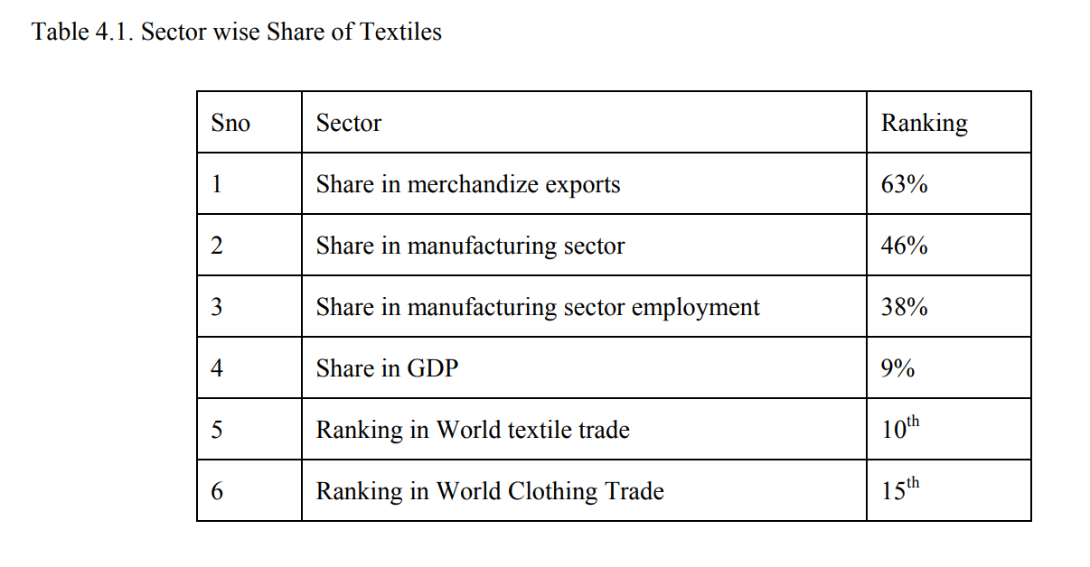*

Source *(Iqbal, M.2010)*

*Table 3 Comparison of key factor of other countries with Pakistan*

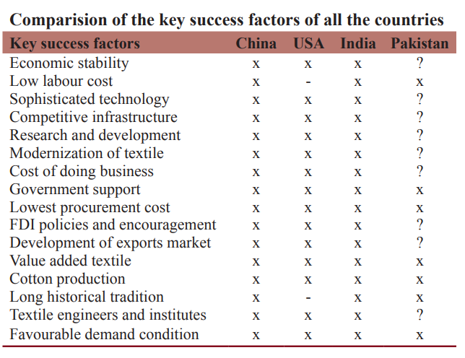

Source (Ali 2020)

In the above table (x) means presence of success factor, question mark (?) means improvement required and the areas with (--) are of no importance in this research study.

# APPENDIX-I (Figures)

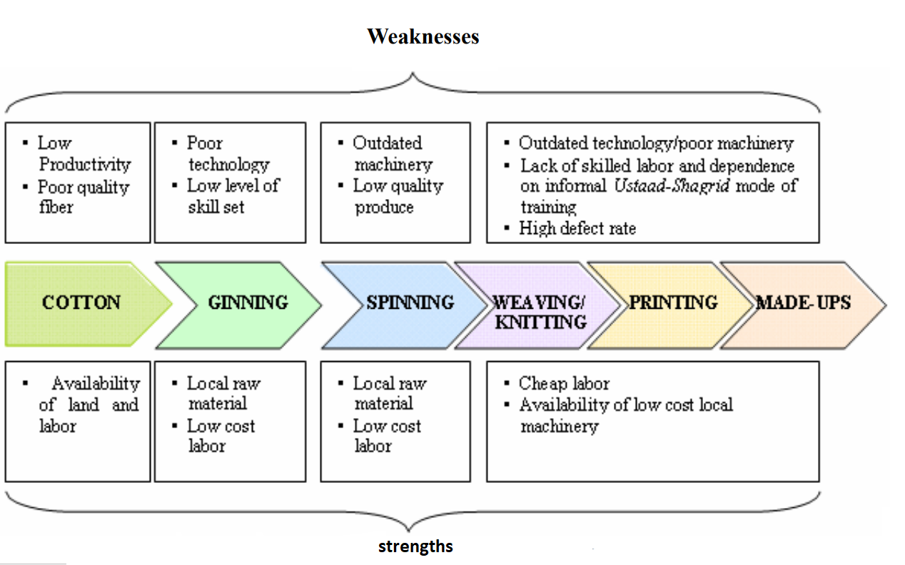

Source *(Iqbal, M.2010)*

*Figure 5 strength and weakness of Pakistan textile sector*