**COMSATS University Islamabad,**

**Abbottabad Campus**

**Attendance Using AI Face Recognition**

**for**

**AI-Assisted Learning Management System**  
Version 0.1

***By***

**Hanzla Nouman CIIT/FA21-BSE-015/ATD**

**Laiba Binta Tahir CIIT/FA21-BSE-019/ATD**

**Arfah Ali CIIT/FA21-BSE-080/ATD**

***Supervisor*Mr. Mukhtiar Zamin**

***Bachelor of Science in Computer Science (2021-2025)***

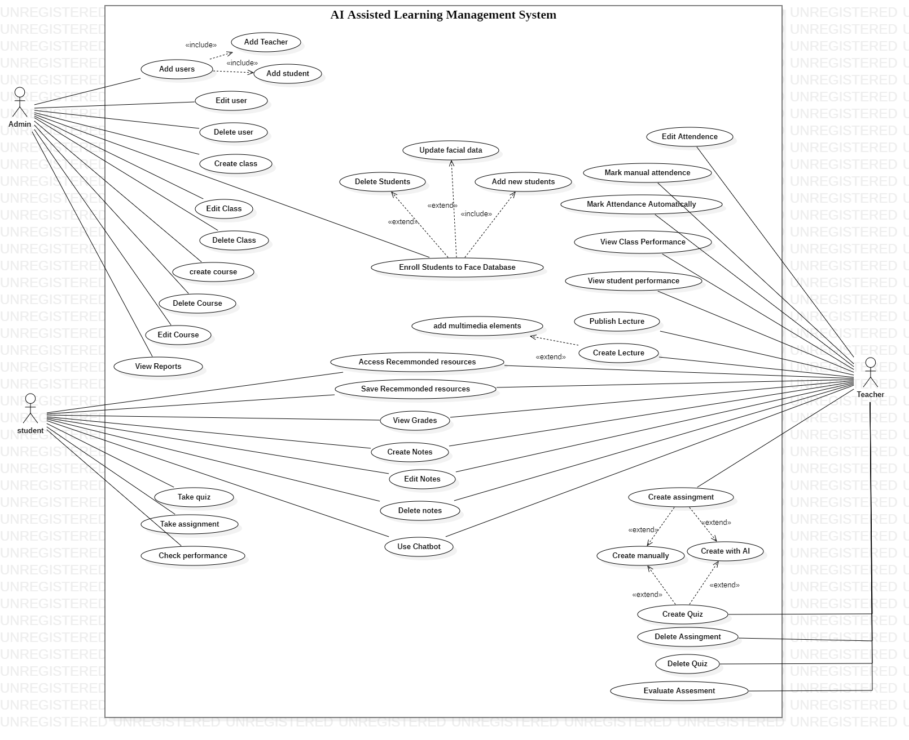**Use case diagram**

*Figure 1 Use case diagram*

**Use case description**

**Use Case 3: Mark Attendance**

|  |  |
| --- | --- |
| **Use Case ID** | **UC-3** |
| **Use Case Name** | Mark Attendance by Teacher |
| **Actors** | **Primary Actor**: Teacher **Secondary Actor**: Face Recognition System (System) |
| **Description** | The teacher uses the mobile app to mark attendance by taking a photo of the class, utilizing face recognition technology to match students' faces to the database and automatically mark their attendance. |
| **Trigger** | The teacher opens the attendance marking feature on the mobile app and clicks on the "Capture Attendance" button. |
| **Preconditions** | 1. The teacher must be logged into the system. 2. The class roster must be populated in the system. 3. The students' faces must be registered in the system's database. |
| **Postconditions** | 1. Attendance is automatically marked for students whose faces are recognized. 2. A confirmation message is displayed to the teacher indicating the attendance status. |
| **Normal Flow** | **1.0 Mark Attendance by Teacher** 1. The teacher selects the "Mark Attendance" option. 2. The teacher clicks on the "Capture Attendance" button to open the phone's camera. 3. The system detects students' faces and matches them with the stored data. 4. The system marks attendance automatically for recognized students. 5. The system displays a confirmation message: "Attendance successfully recorded for X students." |
| **Alternative Flows** | **1.1 Face Not Recognized** 1. If the system fails to recognize a student's face, it flags the student for manual verification. 2. The teacher manually marks attendance for the flagged student. **1.2 Poor Photo Quality** 1. If the teacher cannot take a clear photo due to low lighting or obstructions, the system prompts them to retake the picture. |
| **Exceptions** | **1.0.E1 Face Recognition Failure** 1. If the system cannot match a student's face, an error message is displayed: "Unable to recognize face. Please try again." **1.0.E2 Camera Error** 1. If the phone camera cannot be accessed, the system prompts the teacher to check the camera. |
| **Business Rules** | **BR-1**: Students must be enrolled in the system with their face data registered beforehand. **BR-2**: The system must provide an option for manual attendance adjustment in case of face recognition failure. |
| **Assumptions** | 1. The face recognition database is regularly updated to reflect new student enrollments or changes. 2. Students must be in view of the camera for proper recognition. |

**Use Case 4: Enroll Students in Database**

|  |  |
| --- | --- |
| **Use Case ID** | **UC-4** |
| **Use Case Name** | Enroll Students in Database by Admin |
| **Actors** | **Primary Actor**: Admin **Secondary Actor**: Student Database (System) |
| **Description** | The admin enrolls students into the system by entering their information and uploading face images for future face recognition-based attendance. |
| **Trigger** | The admin logs into the admin panel and selects the "Enroll Student" option. |
| **Preconditions** | 1. The admin must be logged into the system with appropriate permissions. 2. The student data (name, email, course, etc.) and face images are available for enrollment. |
| **Postconditions** | 1. The student’s information is added to the system. 2. The student’s face image is stored in the database for future face recognition. |
| **Normal Flow** | **1.0 Enroll Students** 1. The admin logs into the system. 2. The admin selects the "Enroll Student" option. 3. The admin enters the student’s personal details (e.g., name, email, course). 4. The admin uploads a photo of the student’s face for future attendance marking. 5. The system confirms that the student has been successfully enrolled. 6. The system stores the student’s face data and personal information. |
| **Alternative Flows** | **1.1 Missing Photo** 1. If the admin fails to upload the face photo, the system prompts the admin to upload a clear image. |
| **Exceptions** | **1.0.E1 Incomplete Data** 1. If the admin fails to provide required information, the system displays: "Please provide all required details." **1.0.E2 Image Upload Error** 1. If the image upload fails, the system prompts the admin to retry. |
| **Business Rules** | **BR-1**: The admin must have sufficient privileges to enroll students. **BR-2**: The student’s face image should meet quality standards (e.g., clear and frontal view). |
| **Assumptions** | 1. The student’s face image is used only for attendance purposes and is stored securely. 2. Students will be enrolled at the beginning of each academic term or course. |

**Functional Requirements**

**Feature 4: Attendance Management**

**Table: Functional Requirement 4.1**

|  |  |
| --- | --- |
| **Field** | **Details** |
| **Identifier** | FR-AM-001 |
| **Title** | Automated Attendance Tracking |
| **Requirement** | The system shall track student attendance using AI-powered facial recognition during in-person sessions. |
| **Source** | Institutional Requirements Document |
| **Rationale** | To reduce manual errors and save time. |
| **Business Rule** | Facial recognition data must be encrypted and comply with privacy regulations. |
| **Dependencies** | External AI API Server Integration |

## **Deployment diagram**

Figure 2 Deployment diagram

System sequence diagram

Mark attendance

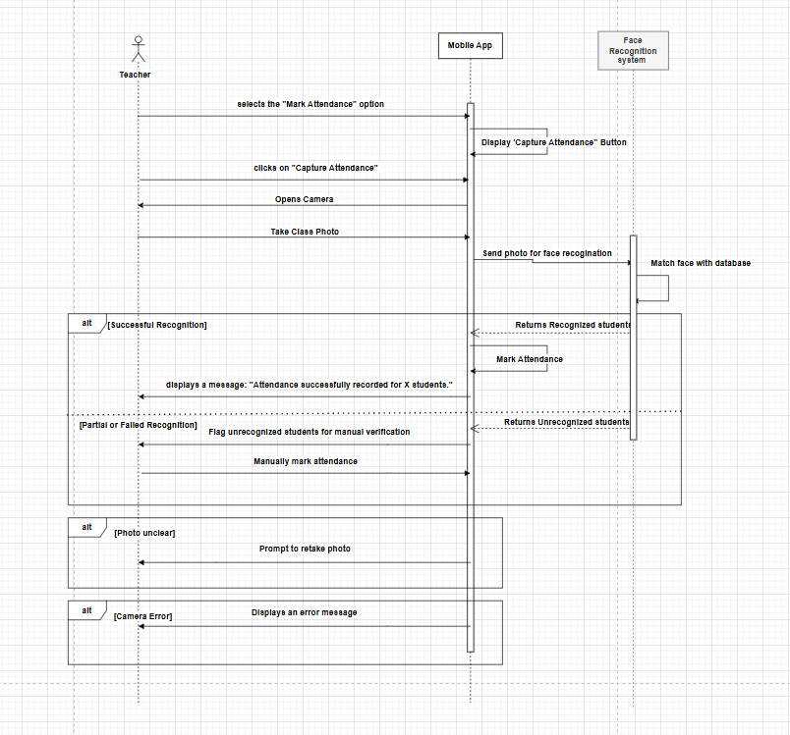

Figure 3 System sequence diagram for mark attendance

**Activity Diagram**

**Mark attendance**

Figure 4 Activity diagram fr Mark attendance

## **Decision tables**

### Table 1: Mark attendance

|  |  |  |  |  |  |  |  |  |
| --- | --- | --- | --- | --- | --- | --- | --- | --- |
| **CONDITIONS** | **Rule 1** | **Rule 2** | **Rule 3** | **Rule 4** | **Rule 5** | **Rule 6** | **Rule 7** | **Rule 8** |
| Teacher logged in | T | T | T | T | F | F | F | F |
| Roster populated | T | T | F | F | T | T | F | F |
| Student faces in database | T | F | T | F | T | F | T | F |
| Camera accessible | T | T | T | T | T | T | T | T |
| Photo quality sufficient | T | T | T | T | F | F | F | F |
| **ACTIONS** | **Rule 1** | **Rule 2** | **Rule 3** | **Rule 4** | **Rule 5** | **Rule 6** | **Rule 7** | **Rule 8** |
| Mark attendance automatically | Yes | No | No | No | No | No | No | No |
| Prompt teacher for retake | No | No | No | No | Yes | Yes | Yes | Yes |
| Flag students for verification | No | Yes | No | Yes | No | Yes | No | Yes |
| Display error message | No | No | Yes | Yes | No | No | Yes | Yes |