Contents

**System sequence diagram** 2

Mark attendance 2

Create lecture 3

**Deployment diagram** 4

**Architecture diagram** 5

**Box line diagram** 6

**Activity diagram** 7

Create lecture 7

Create quiz 8

Mark attendence 9

Access recommended resources 10

**Decision tables** 10

Mark attendance 10

Create content 11

Access Recommended Resources: 11

**Package diagram** 12

**Sequence diagram** 13

**Class diagram** 13

**ER diagram** 13

**Pseudo code** 13

## **System sequence diagram**

### Mark attendance

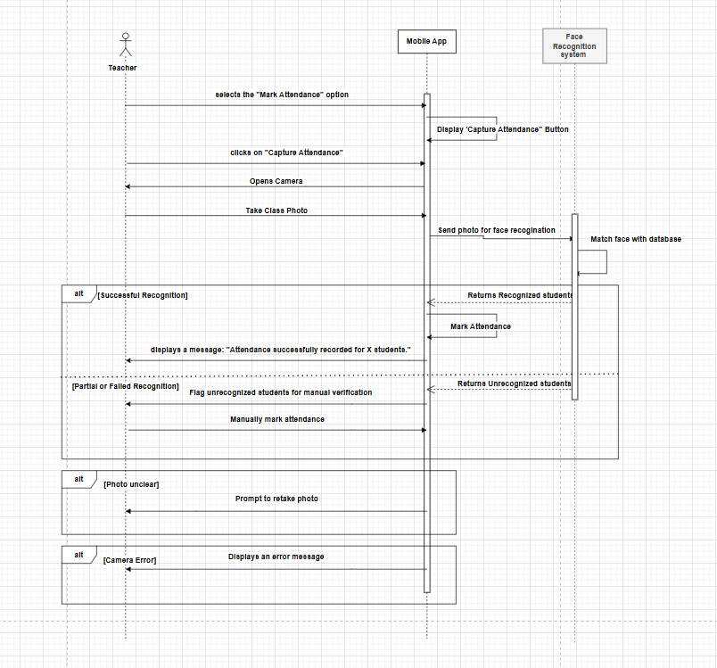

### Create lecture

## **Deployment diagram**

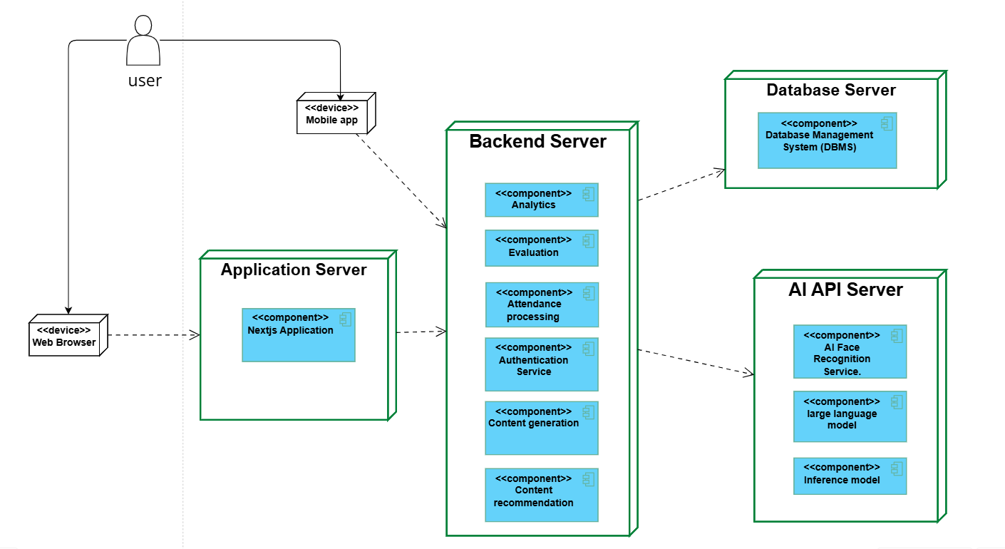

**Deployment diagram** <https://online.visual-paradigm.com/w/lcavhgiw/app/diagrams/#diagram:workspace=lcavhgiw&proj=0&id=1&type=DeploymentDiagram>

**Architecture diagram** <https://online.visual-paradigm.com/w/lcavhgiw/app/diagrams/#diagram:workspace=lcavhgiw&proj=0&id=6&type=EnterpriseArchitectureDiagram&width=11&height=8.5&unit=inch>

## **Architecture diagram**

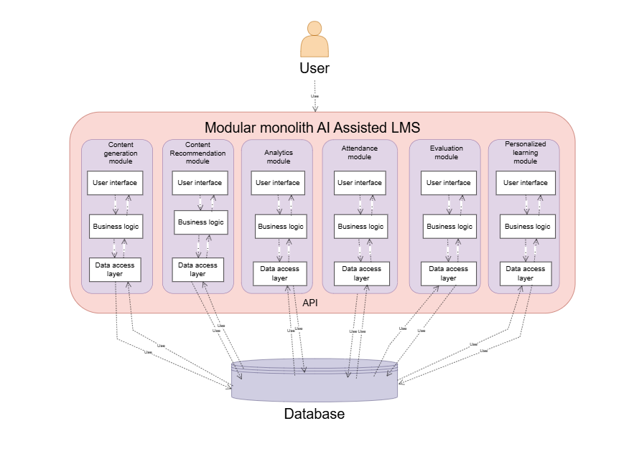

**Box line diagram**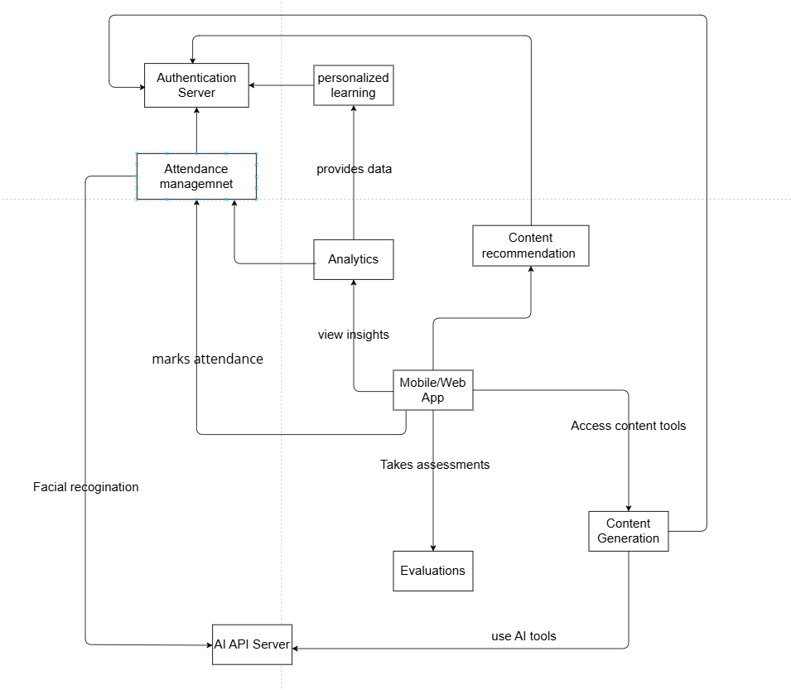

## **Activity diagram**

### Create lecture

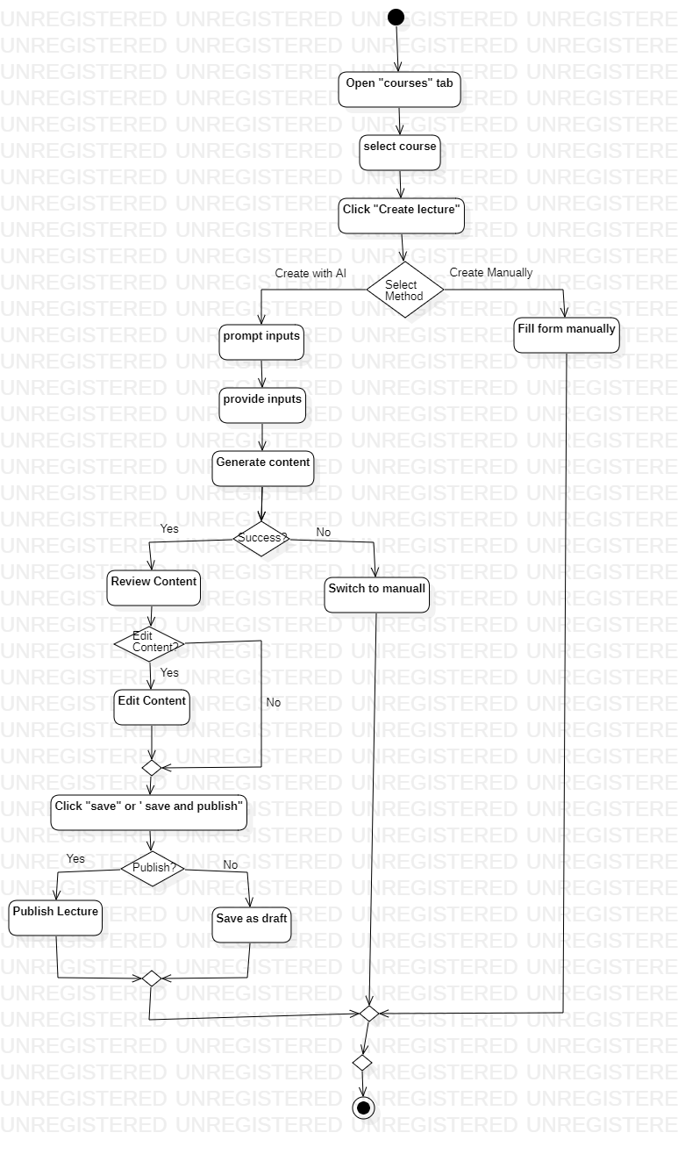

### Create quiz

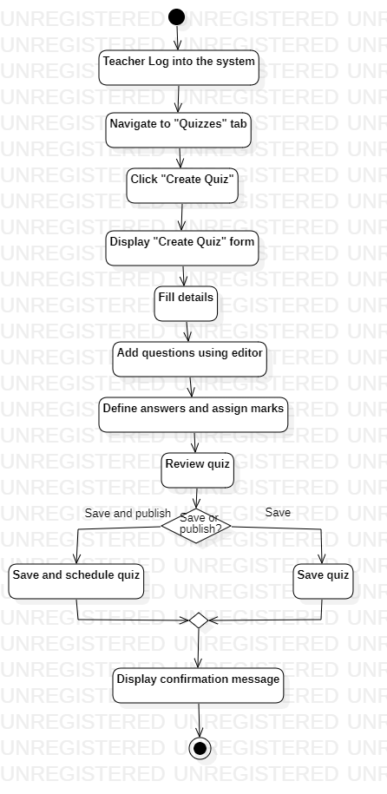

### Mark attendence

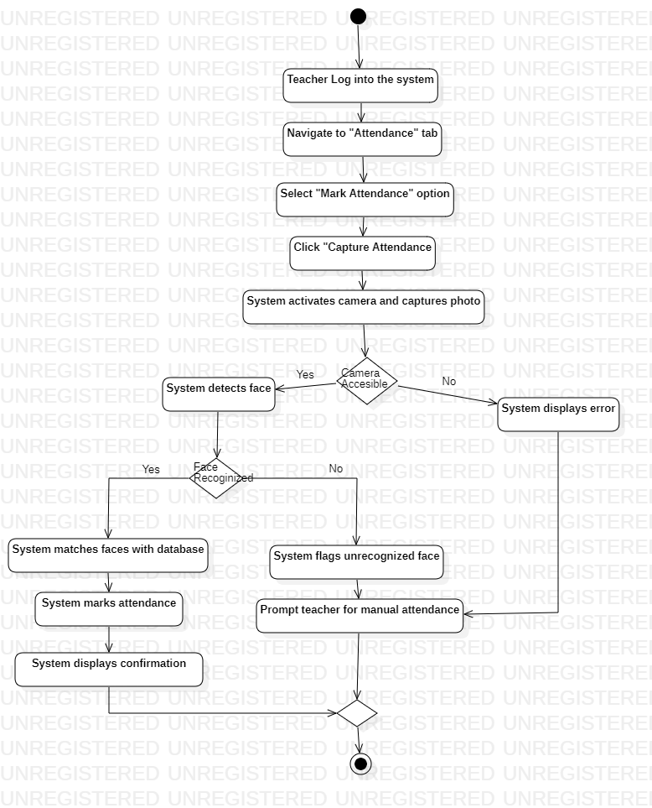

### Access recommended resources

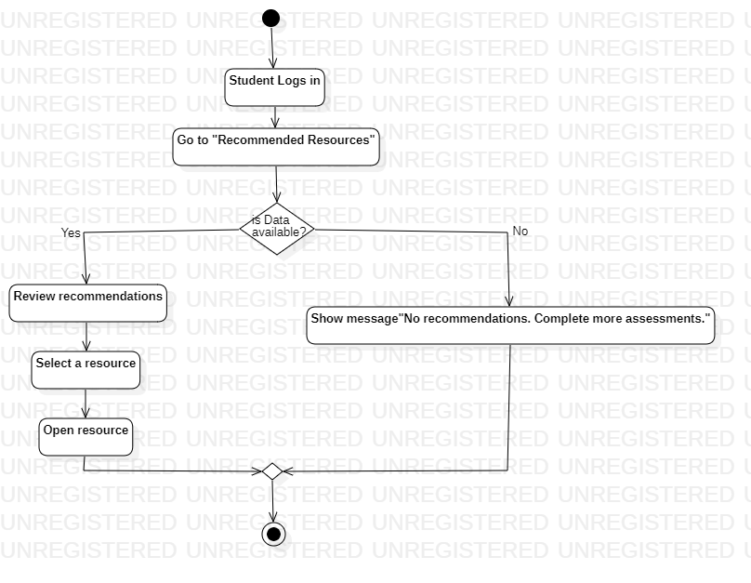

## **Decision tables**

### Mark attendance

|  |  |  |  |  |  |  |  |  |
| --- | --- | --- | --- | --- | --- | --- | --- | --- |
| **CONDITIONS** | **Rule 1** | **Rule 2** | **Rule 3** | **Rule 4** | **Rule 5** | **Rule 6** | **Rule 7** | **Rule 8** |
| Teacher logged in | T | T | T | T | F | F | F | F |
| Roster populated | T | T | F | F | T | T | F | F |
| Student faces in database | T | F | T | F | T | F | T | F |
| Camera accessible | T | T | T | T | T | T | T | T |
| Photo quality sufficient | T | T | T | T | F | F | F | F |
| **ACTIONS** | **Rule 1** | **Rule 2** | **Rule 3** | **Rule 4** | **Rule 5** | **Rule 6** | **Rule 7** | **Rule 8** |
| Mark attendance automatically | Yes | No | No | No | No | No | No | No |
| Prompt teacher for retake | No | No | No | No | Yes | Yes | Yes | Yes |
| Flag students for verification | No | Yes | No | Yes | No | Yes | No | Yes |
| Display error message | No | No | Yes | Yes | No | No | Yes | Yes |

### Create content

|  |  |  |  |  |  |  |  |  |
| --- | --- | --- | --- | --- | --- | --- | --- | --- |
| **CONDITIONS** | **Rule 1** | **Rule 2** | **Rule 3** | **Rule 4** | **Rule 5** | **Rule 6** | **Rule 7** | **Rule 8** |
| Teacher logged in | T | T | T | T | F | F | F | F |
| Course access available | T | T | T | F | T | F | T | F |
| AI system functional | T | F | T | T | T | T | F | F |
| Content passes validation | T | T | F | F | T | F | T | F |
| **ACTIONS** | **Rule 1** | **Rule 2** | **Rule 3** | **Rule 4** | **Rule 5** | **Rule 6** | **Rule 7** | **Rule 8** |
| Generate content with AI | Yes | No | Yes | No | No | No | No | No |
| Prompt teacher to retry AI | No | Yes | No | No | No | No | Yes | Yes |
| Switch to manual creation | No | Yes | Yes | Yes | No | No | Yes | Yes |
| Save as draft | Yes | No | No | No | No | No | No | No |
| Save and publish successfully | Yes | No | No | No | No | No | No | No |
| Display error message | No | Yes | Yes | Yes | Yes | Yes | Yes | Yes |

### Access Recommended Resources:

|  |  |  |  |  |  |  |  |  |
| --- | --- | --- | --- | --- | --- | --- | --- | --- |
| **CONDITIONS** | **Rule 1** | **Rule 2** | **Rule 3** | **Rule 4** | **Rule 5** | **Rule 6** | **Rule 7** | **Rule 8** |
| Student logged in | T | T | T | T | F | F | F | F |
| Assessment/progress data available | T | T | F | F | T | T | F | F |
| Internet connection available | T | F | T | F | T | F | T | F |
| System functional (no errors) | T | T | T | T | F | F | F | F |

|  |  |  |  |  |  |  |  |  |
| --- | --- | --- | --- | --- | --- | --- | --- | --- |
| **ACTIONS** | **Rule 1** | **Rule 2** | **Rule 3** | **Rule 4** | **Rule 5** | **Rule 6** | **Rule 7** | **Rule 8** |
| Generate and display recommendations | Yes | No | No | No | No | No | No | No |
| Display "No recommendations" message | No | No | Yes | Yes | No | No | Yes | Yes |
| Prompt for internet connection | No | Yes | No | Yes | No | Yes | No | Yes |
| Display system error message | No | No | No | No | Yes | Yes | Yes | Yes |

## **Package diagram**

## **Sequence diagram**

## **Class diagram**

## **ER diagram**

## **Pseudo code**