**COMSATS UNIVERSITY ISLAMABAD, ABBOTTABAD**

Software testing Lab final

***Submitted by:***

Laiba Binte tahir

Table of Contents

Question 1 1

Bubble Sort Implementation 1

Equivalence Partitioning and Boundary Value Analysis 1

Test Cases 2

JUnit Testing Result 3

Question 02 3

Exam Module 3

Test cases 3

UX automation 4

# Question 1

## Bubble Sort Implementation

package org.example;  
//ReverseArray-Column(01)  
public class Main {  
 public static void main(String[] args) {  
 int[] array = {1, 2, 3, 4, 5};  
 *reverseArray*(array);  
 for (int num : array) {  
 System.*out*.print(num + " ");  
 }  
 }  
 public static void reverseArray(int[] array) {  
 int left = 0, right = array.length - 1;  
 while (left < right) {  
 int temp = array[left];  
 array[left] = array[right];  
 array[right] = temp;  
 left++;  
 right--;  
 }  
 }  
}

## Equivalence Partitioning and Boundary Value Analysis

**Equivalence Partitioning**

***Valid Partitions:***

Array with no elements (empty array)

Array with one element

Array with two elements

Array with multiple elements

***Invalid Partitions:***

Null array: null

**Boundary Value Analysis**

Boundary values for array lengths:

0 elements (empty array)

1 element

## Test Cases

#### Equivalence Partitioning Test Cases

|  |  |  |  |  |  |
| --- | --- | --- | --- | --- | --- |
| **Test Case ID** | **Description** | **Input Data** | **Expected Result** | **Actual Result** | **Verdict** |
| TC1 | Reverse empty array | [] | [] | [] | Pass |
| TC2 | Reverse array with one element | [1] | [1] | [1] | Pass |
| TC3 | Reverse array with two elements | [1, 2] | [2, 1] | [2, 1] | Pass |
| TC4 | Reverse array with multiple elements | [1, 2, 3, 4, 5] | [5, 4, 3, 2, 1] | [5, 4, 3, 2, 1] | Pass |
| TC5 | Reverse array with an even number of elements | [1, 2, 3, 4] | [4, 3, 2, 1] | [4, 3, 2, 1] | Pass |
| TC6 | Handle null array | null | No operation or exception | No operation | Fail |

#### Boundary Value Analysis Test Cases

|  |  |  |  |  |  |
| --- | --- | --- | --- | --- | --- |
| **Test Case ID** | **Description** | **Input Data** | **Expected Result** | **Actual Result** | **Verdict** |
| TC7 | Boundary value test: empty array | [] | [] | [] | Pass |
| TC8 | Boundary value test: single element array | [1] | [1] | [1] | Pass |

## JUnit Testing Result

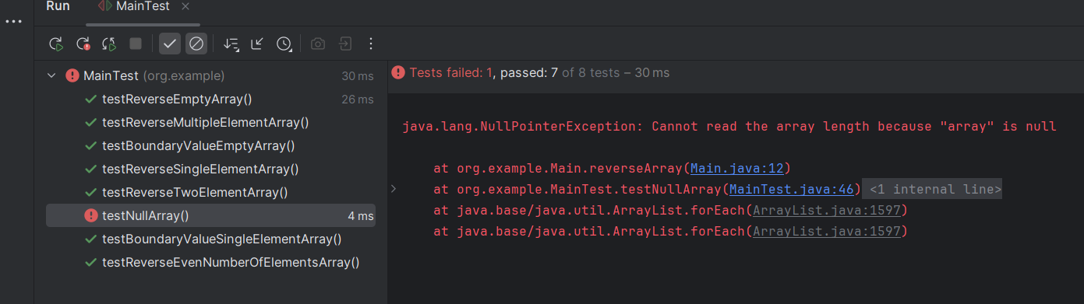

# Question 02

## Exam Module

## Test cases

Here is the table converted to text:

|  |  |  |  |  |
| --- | --- | --- | --- | --- |
| **Test ID** | **Description** | **Preconditions** | **Steps** | **Expected Result** |
| TC_SA_001 | Verify Exam Details Display | User is logged in and on the Exams page. | 1. Navigate to the Exams page. 2. Verify the display of exam details: title, duration, examiner, course, start time. | All exam details are displayed correctly. |
| TC_SA_002 | Verify Question Types and Marks Distribution | User is logged in and on the Exam Summary page. | 1. Navigate to the Exam Summary page. 2. Verify the display of number of MCQs, true/false questions, marks per question, total marks. | Question types and marks distribution are displayed correctly. |

## UX automation

Video: