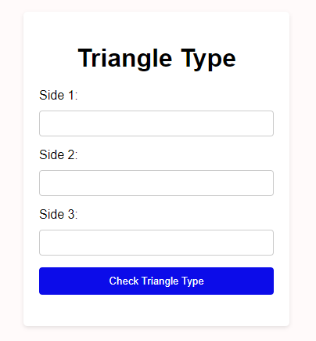

1.5 Exercises: Make test cases for a triangle that can differentiate between isosceles, equilateral, and scalene types based on side length as input and state if their verdict is true/false. Make assumptions for the actual outcome.

|  |  |  |  |  |  |
| --- | --- | --- | --- | --- | --- |
| **Test Case** | Description | Input Data | Expected Result | Actual | Status |
| 1 | Equilateral Triangle Test | (5, 5, 5) | Equilateral triangle | Equilateral triangle | pass |
| 2 | Isosceles Triangle Test | (5, 5, 6) | Isosceles triangle | Isosceles triangle | pass |
| 3 | Scalene Triangle Test | (3, 4, 5) | Scalene triangle | It's a scalene triangle. | pass |
| 4 | Invalid Triangle Test | (1, 2, 4) | Not a triangle | Not a valid triangle | pass |
| 5 | Invalid Side Lengths Test | (0, 5, 6) | Invalid side lengths | Not a valid triangle | pass |
| 7 | Boundary Test | (1, 1, 2) | Not a triangle | Not a valid triangle | pass |

Examples

Login Page: We can assume a login application like Gmail. Test Case 1: Verify that the application allows users to input their username and password. Test Case 2: Verify that the application correctly validates the correct credentials. Test Case 3: Verify that the application displays an error message when the incorrect credentials are entered.

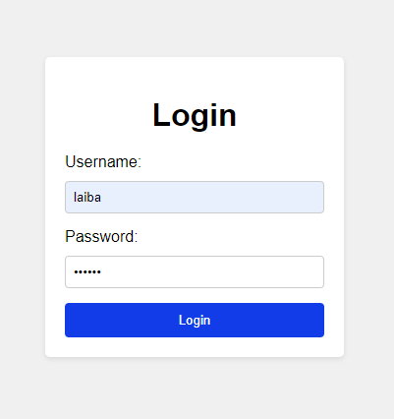 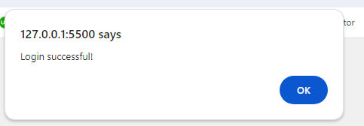

|  |  |  |  |  |  |
| --- | --- | --- | --- | --- | --- |
| **Test Case** | Description | Input Data | Expected Result | Actual | Status |
| Tc_1 | Allowing input of username and password | Username: user1, Password: 123456 | Username and password fields are present and editable | Username and password fields are present and editable | pass |
| Tc_2 | Correct validation of credentials | Username: laiba, Password: 123456, | Redirects to user's account page | Login successful | pass |
| Tc_3 | Displaying error message for incorrect credentials | Username: invalid_user, Password: invalid_password | Displays an error message indicating invalid credentials | Incorrect username or password. | pass |