**Contents**

5.4 Exercises for lab 2

**Version 1: Improved Error Handling** 2

**Test Cases for Version 1: Improved Error Handling** 2

**Code:** 3

**Version 2: Using Data Validation** 4

**Test Cases for Version 2: Using Data Validation** 4

**Code:** 4

# 5.4 Exercises for lab

Students are provided the Checklist and they must identify and explore each type of general errors that may arise during inspection session. Inspection Checklist of Errors: Data Reference

**Computational error Checklist**

|  |  |
| --- | --- |
| **Checklist Item** | **Error Found** |
| 1. Computations on nonarithmetic variables | Mixing arithmetic with non-arithmetic |
| 2. Mixed-mode computations | Mixing integer with double |
| 3. Computations on variables of different lengths | Mixing short with int |
| 4. Target size less than size of assigned value | Target size is less than assigned value |
| 5. Intermediate result overflow or underflow | Overflow |
| 6. Division by zero | Division by zero |

# **Version 1: Improved Error Handling**

* Version 1 directly handles division by zero using try-catch

## **Test Cases for Version 1: Improved Error Handling**

|  |  |  |  |  |  |
| --- | --- | --- | --- | --- | --- |
| **Test ID** | **Test Case Description** | **Input Data** | **Actual** | **Expected** | **Verdict** |
| 1 | Computations on nonarithmetic variables | "Hello" | 10 | 10 | Passed |
| 2 | Mixed-mode computations |  | 15.5 | 15.5 | Passed |
| 3 | Computations on variables of different lengths |  | 1100 | 1100 | Passed |
| 4 | Target size less than size of assigned value |  | 10 | 10 | Passed |
| 5 | Intermediate result overflow or underflow |  | 2147483648 | 2147483648 | Passed |
| 6 | Division by zero |  | Error: Division by zero | Error: Division by zero | Passed |

## **Code:**

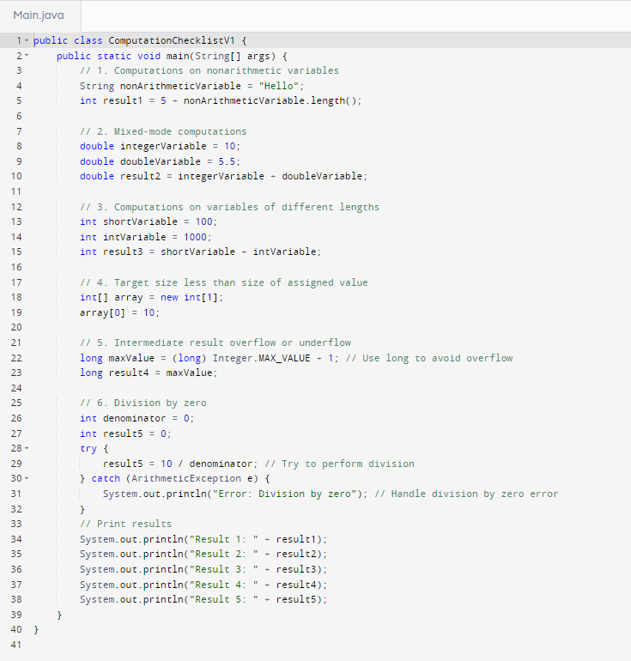

# **Version 2: Using Data Validation**

* Version 2 uses a separate method to perform division safely by validating the denominator.

## **Test Cases for Version 2: Using Data Validation**

|  |  |  |  |  |  |
| --- | --- | --- | --- | --- | --- |
| **Test ID** | **Test Case Description** | **Input Data** | **Actual** | **Expected** | **Verdict** |
| 1 | Computations on nonarithmetic variables | "Hello" | 10 | 10 | Passed |
| 2 | Mixed-mode computations |  | 15.5 | 15.5 | Passed |
| 3 | Computations on variables of different lengths |  | 1100 | 1100 | Passed |
| 4 | Target size less than size of assigned value |  | 10 | 10 | Passed |
| 5 | Intermediate result overflow or underflow |  | 2147483648 | 2147483648 | Passed |
| 6 | Division by zero |  | Error: Division by zero | Error: Division by zero | Passed |

## **Code:**

