Assignment 01 Solution
Git, Gitea, GitHub, Git LFS, and GitHub Pages
Student | Laibah Bakhtawar
Registration number | FA24B1-SE-031
Course | Cloud Computing (Fall 2026)
GitHub username | laibah-bakhtawar
Gitea server | http://192.168.39.129:3000/ (Ubuntu VM)
Gitea repository | http://192.168.39.129:3000/laibah/Assignment01
GitHub repository | https://github.com/laibah-bakhtawar/Assignment01
Portfolio (GitHub Pages) | https://laibah-bakhtawar.github.io/

Task 1: Install Gitea and Push a Repository from the Ubuntu Server

Step 1.1: Install and run Gitea
I installed Docker and the Docker Compose plug-in on the Ubuntu server, cloned the instructor-provided Gitea setup repository, and started Gitea and PostgreSQL with the supplied compose.yaml, without changing it.
sudo apt update -y
sudo apt install -y docker.io curl
sudo systemctl start docker
sudo usermod -aG docker $USER
git clone https://github.com/WaqasSaleem97/Gitea.git
cd Gitea
docker compose up -d
docker compose ps
curl -sS -o /dev/null -w "Gitea HTTP status: %{http_code}\n" http://127.0.0.1:3000/
Both containers (gitea and gitea_db) are running and Gitea answers with HTTP status 200.
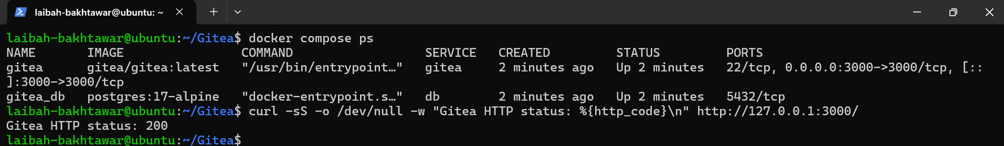
Screenshot 1: task1_gitea_running.png (docker compose ps and Gitea HTTP status 200)

Step 1.2: Create and push the initial repository
I created an empty public repository named Assignment01 in Gitea, then created a separate local repository on the Ubuntu server with a README containing my full name and registration number, committed it, and pushed it to the gitea remote over the local loopback address.
mkdir Assignment01 && cd Assignment01
git init
git branch -M main
echo "Full Name: Laibah Bakhtawar" > README.md
echo "Registration Number: FA24B1-SE-031" >> README.md
git add README.md
git commit -m "Add student information"
git remote add gitea http://laibah@127.0.0.1:3000/laibah/Assignment01.git
git remote -v
git push -u gitea main
The remote URL contains only my Gitea username; no token or password is stored in it. The first attempt below was rejected with an authentication error; I re-entered the credentials and the second attempt succeeded.
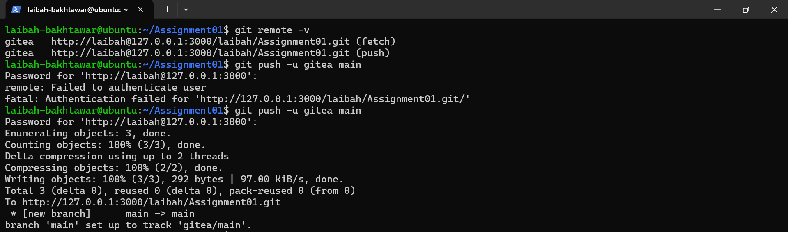
Screenshot 2: task1_gitea_push.png (gitea remote and successful push)

Step 1.3: Verify the Gitea repository
The Assignment01 repository is visible in Gitea under the owner laibah, and the README shows my full name and registration number.
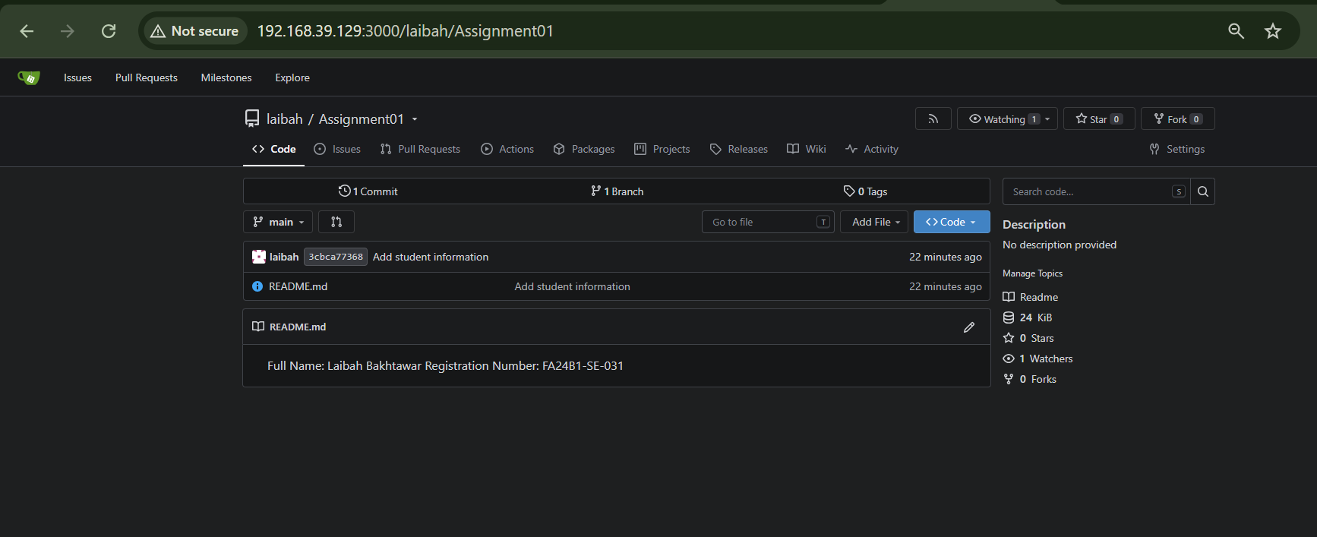
Screenshot 3: task1_gitea_repository.png (Gitea repository page)

Task 2: Push the Same Repository to GitHub

Step 2.1: Add the GitHub remote and verify both remotes
I created an empty public repository named Assignment01 on GitHub and added it as a second remote called github.
cd ~/Assignment01
git remote add github https://github.com/laibah-bakhtawar/Assignment01.git
git remote -v
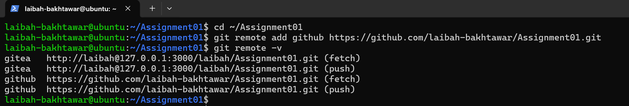
Screenshot 4: task2_remotes.png (gitea and github remotes, no credentials in URLs)

Step 2.2: Push to GitHub
git push -u github main
GitHub first rejected the push because my commit used a private email address (error GH007). I turned off "Block command line pushes that expose my email" in my GitHub email settings and pushed again successfully.
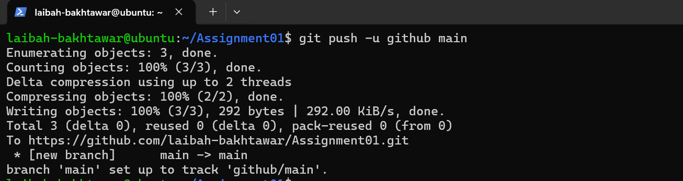
Screenshot 5: task2_github_push.png (successful push to GitHub)

Step 2.3: Verify the GitHub repository
The repository belongs to laibah-bakhtawar, is named Assignment01, is public, and the rendered README shows my full name and registration number.
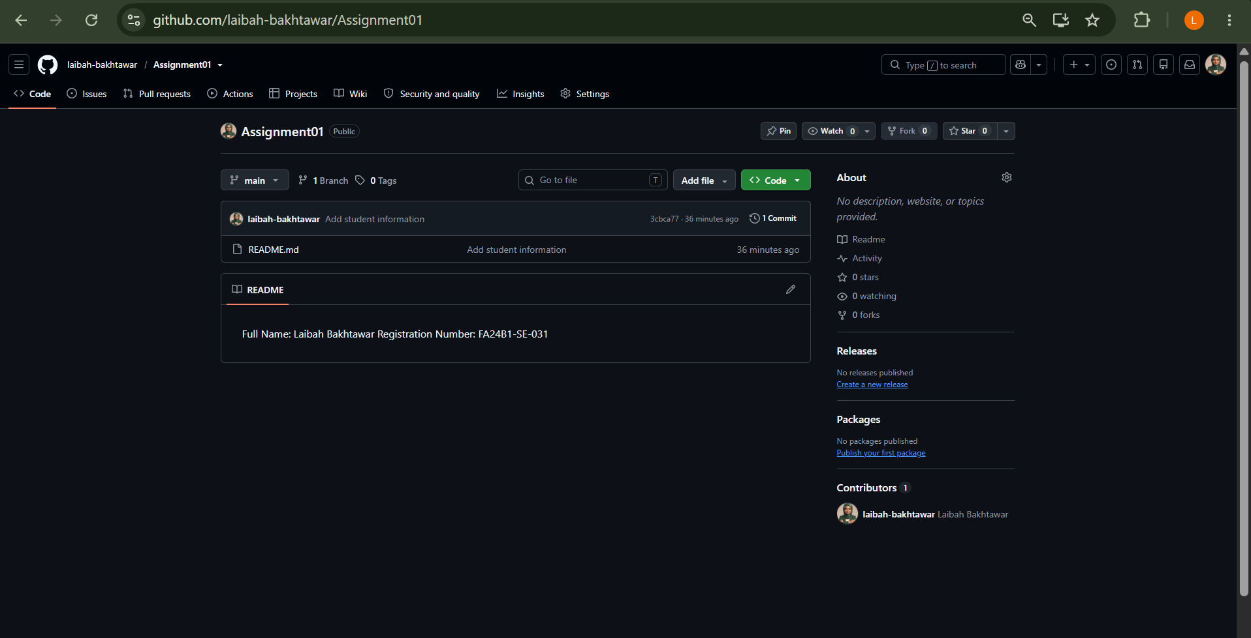
Screenshot 6: task2_github_repository.png (GitHub repository page)

Task 3: Track Three Large Files with Git LFS

Step 3.1: Configure Git LFS
cd ~/Assignment01
git lfs install
git lfs version
git lfs track "*.bin"
cat .gitattributes
Git LFS is initialised (version 3.7.1) and .gitattributes contains the *.bin rule.
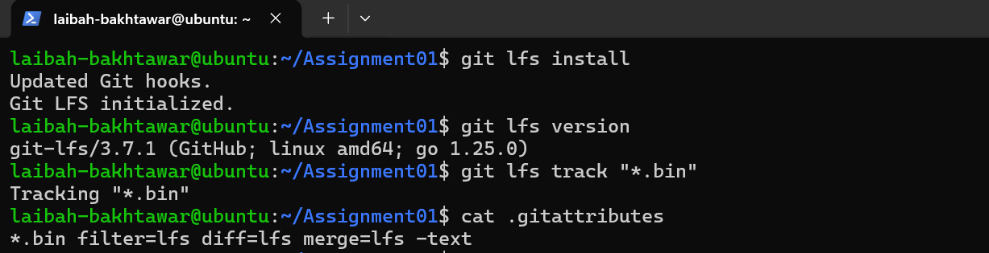
Screenshot 7: task3_lfs_setup.png (Git LFS setup and .gitattributes rule)

Step 3.2: Create and verify three LFS files
truncate -s 101M large-file-1.bin
truncate -s 102M large-file-2.bin
truncate -s 103M large-file-3.bin
git add .gitattributes large-file-1.bin large-file-2.bin large-file-3.bin
git lfs ls-files --size
All three files (101, 102 and 103 MiB) are tracked by Git LFS; each is larger than 100 MiB.
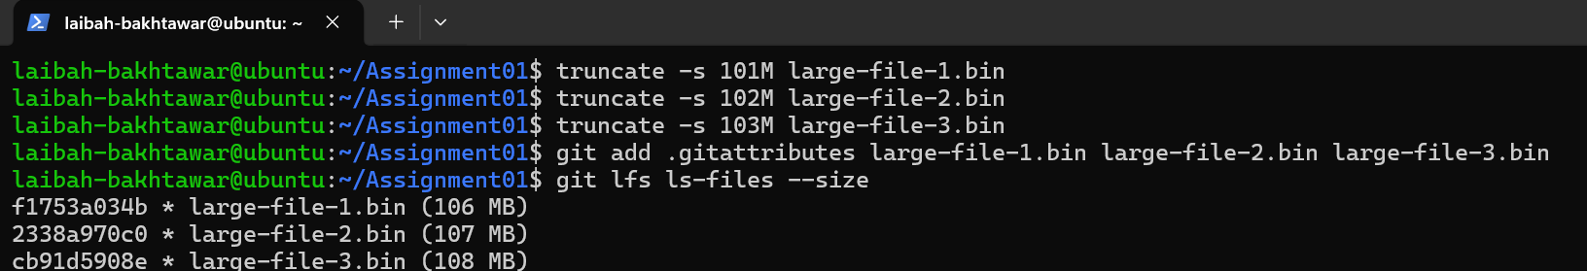
Screenshot 8: task3_lfs_files.png (git lfs ls-files --size)

Step 3.3: Commit and push the LFS files
git commit -m "Add three files using Git LFS"
git push github main
The first push uploaded all three LFS objects (100%, 3/3, 321 MB) and then pushed the commit to GitHub.
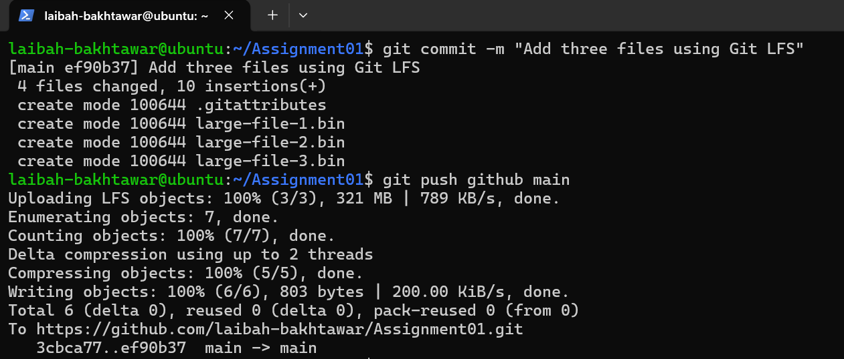
Screenshot 9: task3_lfs_push.png (LFS upload 100% (3/3) and push to GitHub)

Task 4: Create a Portfolio or CV with GitHub Pages

Step 4.1: Portfolio repository
My public repository is named laibah-bakhtawar.github.io. It contains index.html and styles.css (HTML and CSS only). The page has the required About Me, Education, Skills and Projects sections. The Projects section links to three of my GitHub repositories: little-lemon, laibah-ToDoList and car-rental-management-system-dsa. I pushed the source files to the main branch.
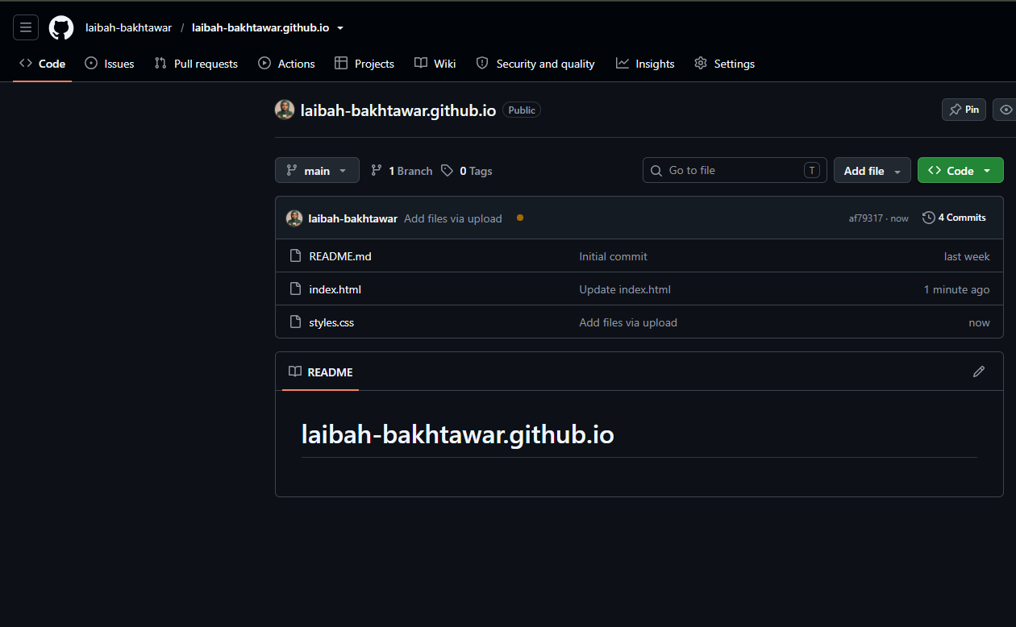
Screenshot 10: task4_pages_repository.png (portfolio repository with index.html and styles.css)

Step 4.2: Publish with GitHub Pages
In Settings > Pages, the source is set to Deploy from a branch, using the main branch and the / (root) folder. GitHub reports that the site is live at https://laibah-bakhtawar.github.io/.
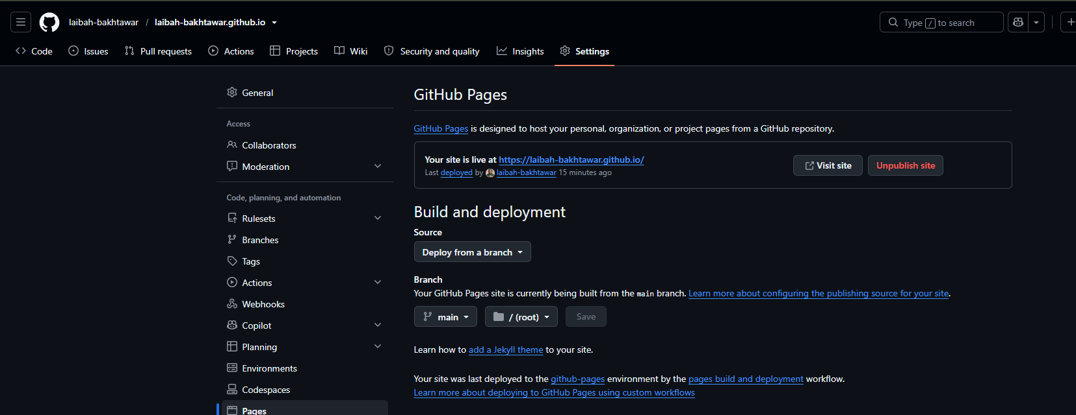
Screenshot 11: task4_pages_deployment.png (GitHub Pages settings showing the site is live)

Step 4.3: Verify the live portfolio
The site loads at https://laibah-bakhtawar.github.io/ and shows the portfolio sections, including About Me and Education.
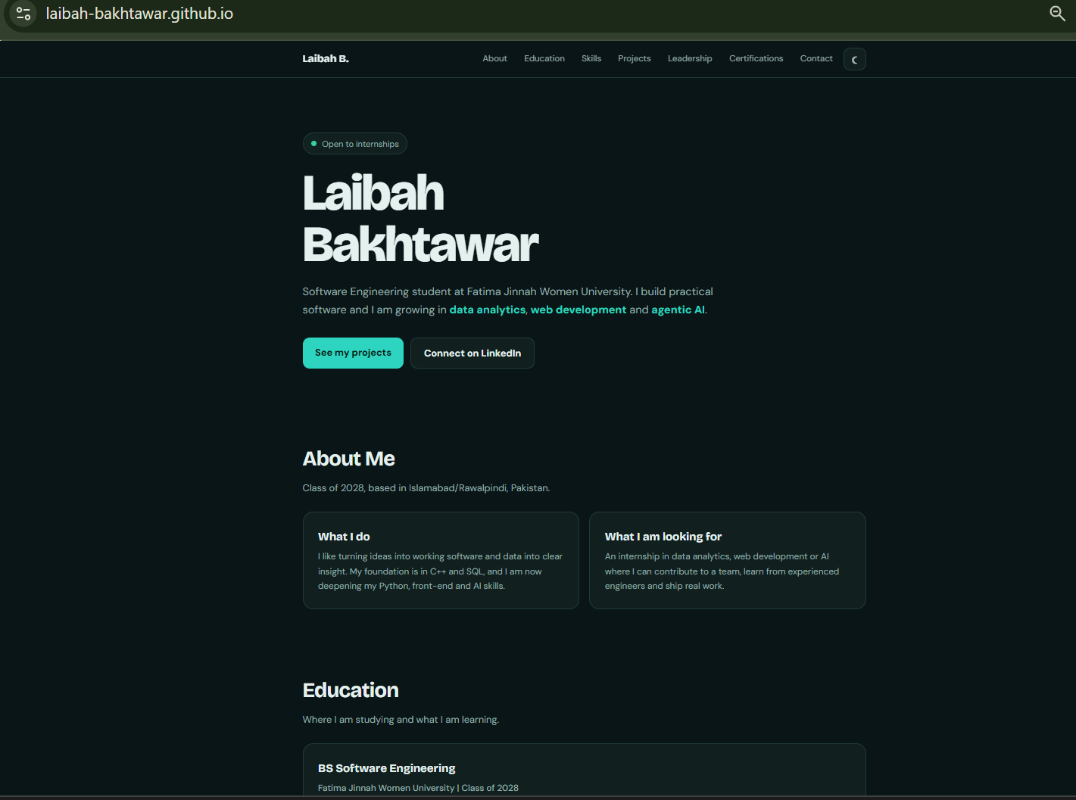
Screenshot 12: task4_portfolio_live.png (live portfolio site)

