COMSATS University Islamabad, Sahiwal Campus
Department of Computer Science
Final Year Project — Spring 2026
SMART HEALTHCARE PROJECT MANAGEMENT
AND MONITORING SYSTEM
A Full Lifecycle Software Project Management and
Web-Based Monitoring Platform for a Five-Hospital Network
PROJECT REPORT
Prepared in partial fulfilment of the requirements for the
Bachelor of Science in Computer Science
Role | Name | Designation / ID | Responsibility
Team Member | Muhammad Awais Khan | BS-CS-21-7042 | System architecture, backend services, EVM engine
Team Member | Ayesha Siddiqui | BS-CS-21-7055 | React interface design, charting, documentation
Team Member | Bilal Ahmed | BS-CS-21-7061 | Database modelling, REST API, test automation
Supervisor | Dr. Asad Malik | Assistant Professor | Project governance and technical review
Industry Advisor | Dr. Tariq Mahmood | Hospital Administrator | Requirements validation and domain guidance

Date of Submission: 28 October 2026
Version 2.0 — Extended Edition (9 Chapters)

Declaration
We declare that this project report entitled "Smart Healthcare Project Management and Monitoring System" is the record of our own work carried out under the supervision of Dr. Asad Malik, Department of Computer Science, COMSATS University Islamabad, Sahiwal Campus.
This work has not been submitted to any other university or institution for the award of any degree or diploma. All sources of information and material used in this report, including published literature, open-source documentation and the project code base itself, have been acknowledged in the References section at the end of this document. Where an interface, chart, table or algorithm is reproduced in this report, it was produced by the project team during the execution of this project between 31 August 2026 and 28 October 2026.
The project management data reported throughout this document — the budget of PKR 5,000,000, the sixteen-week baseline, the earned-value indices and the defect register — reflect the live state of the deployed system on the status date of 28 October 2026 and were captured directly from the running application rather than reconstructed by hand.

Student Name | Registration No. | Signature | Date
Muhammad Awais Khan | BS-CS-21-7042
Ayesha Siddiqui | BS-CS-21-7055
Bilal Ahmed | BS-CS-21-7061

Certificate
This is to certify that the final year project entitled "Smart Healthcare Project Management and Monitoring System" was carried out by the students named above, under my supervision, in partial fulfilment of the requirements for the award of the degree of Bachelor of Science in Computer Science.
To the best of my knowledge, the work presented in this report is original and has not been submitted elsewhere for the award of any other degree. The report documents the complete software project management lifecycle — charter, scope, schedule, cost, quality, risk, verification, deployment and maintenance — for a working MERN-stack system developed by the team.

Internal Supervisor | External Examiner | Head of Department
Dr. Asad Malik  Assistant Professor  CUI Sahiwal | ____________________  ____________________ | ____________________  ____________________
Signature / Date: ______________ | Signature / Date: ______________ | Signature / Date: ______________

Document Control
Version | Date | Author | Summary of Change | Status
0.1 | 05 Sep 2026 | Team Member 1 | Skeleton outline of the nine report chapters | Draft
0.5 | 28 Sep 2026 | Team Member 2 | Charter, objectives and scope sections drafted | Draft
1.0 | 20 Oct 2026 | Team Member 1 | First complete submission to the supervisor | Reviewed
1.4 | 26 Oct 2026 | Team Member 3 | Test-case evidence and defect register added | Reviewed
2.0 | 28 Oct 2026 | All members | Full revision: all 27 interface and analytical figures inserted with captions above each figure, live earned-value data refreshed, algorithms and references expanded | Approved

Distribution List
Copy | Recipient | Purpose
1 | Supervisor — Dr. Asad Malik | Academic review and grading
2 | Departmental FYP Coordinator | Record of submission
3 | Industry Advisor — Dr. Tariq Mahmood | Domain validation and pilot approval
4 | Project Team Archive | Configuration baseline and future maintenance

Table of Contents
Chapter 1 — Executive Summary
1.1 Background and Motivation
1.2 Problem Statement
1.3 Proposed Solution
1.4 Key Performance Snapshot
1.5 Report Structure
Chapter 2 — Project Objectives
2.1 Strategic Objectives
2.2 Measurable Success Criteria
2.3 Project Charter
2.4 Stakeholders and Team Structure
2.5 Governance and Reporting Cadence
Chapter 3 — Project Scope
3.1 Scope Statement
3.2 Requirements Register
3.3 Work Breakdown Structure
3.4 Scope Baseline and Gating
3.5 Integrated Change Control
Chapter 4 — Resource Allocation and Schedule Planning
4.1 Resource Pool and Allocation
4.2 Activity Definition and Sequencing
4.3 Schedule Network and Critical Path
4.4 Gantt Visualisation
4.5 Cost Baseline and Budget
4.6 Earned Value Management
4.7 Risk Identification and Response Planning
Chapter 5 — Interface and System Design
5.1 Architectural Style
5.2 Technology Stack
5.3 Logical Design
5.4 Data Design
5.5 Authentication Interface
5.6 Executive Dashboard Interface
5.7 Module Navigation
Chapter 6 — Development and Algorithmic Implementation
6.1 Server Architecture
6.2 Domain Model
6.3 Schedule Forward-Pass Algorithm
6.4 Earned Value Algorithm
6.5 Real-Time Synchronisation
6.6 Security Implementation
Chapter 7 — Verification, Validation and Test Cases
7.1 V and V Strategy
7.2 Quality Inspections
7.3 Defect Management
7.4 Automated Test Suite
7.5 Test Results
Chapter 8 — Deployment
8.1 Environment Topology
8.2 Release Procedure
8.3 Data Seeding and Migration
8.4 Rollback Plan
Chapter 9 — Maintenance and Operational Plan
9.1 Maintenance Categories
9.2 Support Model and SLAs
9.3 Operational Risk Monitoring
9.4 Enhancement Roadmap
9.5 Lessons Learned
Conclusion, Limitations and Recommendations
References
List of Figures
Figure 1.1 Executive dashboard summarising progress, cost and schedule health
Figure 1.2 Executive report modal with the printable project status narrative
Figure 2.1 Charter and project plan module rendered in the interface
Figure 2.2 In-place charter editing form with validation
Figure 2.3 Use-case view of the project actors and their management goals
Figure 3.1 Requirements register showing the approved scope baseline
Figure 3.2 Record creation form used to extend the requirements register
Figure 3.3 Hierarchical work breakdown structure generated from approved scope
Figure 3.4 Scope distribution by status and origin
Figure 3.5 Change request register with cost and schedule impact
Figure 4.1 Resource loading across the named team members
Figure 4.2 Schedule module listing every activity and its delay cascade
Figure 4.3 Gantt chart of baseline versus forecast schedule
Figure 4.4 Planned versus actual cost by activity
Figure 4.5 Cost and EVM analysis module
Figure 4.6 Earned value curves for PV, EV and AC
Figure 4.7 Risk matrix and PDPC module
Figure 4.8 Five-by-five probability and impact risk matrix
Figure 5.1 Three-tier architecture of the Smart Healthcare PMMS
Figure 5.2 UML class diagram of the domain model
Figure 5.3 Entity relationship diagram of the MongoDB collections
Figure 5.4 Sign-in screen with the demo account shortcut
Figure 5.5 Registration screen with role selection
Figure 7.1 Quality and defect management module
Figure 7.2 Defect distribution by severity and status
Figure 7.3 Test cases and validation module
Figure 7.4 Automated test suite results

Chapter 1 — Executive Summary
1.1 Background and Motivation
Healthcare institutions in Pakistan are expanding faster than the management practices that govern them. A medium-sized hospital network typically runs five or more facilities, each with its own appointment queue, laboratory, billing desk and clinical staff roster, and each of which must be supported by information systems delivered through software projects. Those projects are, in almost every case, managed through a combination of spreadsheets, weekly status meetings and informal messaging. The consequence is that the person accountable for delivery — the project manager — receives schedule and cost information several days after it becomes true, and by the time a delay is visible in a weekly report the option to absorb it has usually already passed.
The Smart Healthcare Project Management and Monitoring System (SH-PMMS) was built to close that gap. It is a web-based platform that combines a complete software project management lifecycle — charter, scope, change control, schedule, cost, quality, risk, verification, deployment and maintenance — with a live, always-current view of the healthcare information system programme it is used to manage. Every derived figure in the system is computed on demand from the underlying records rather than typed in by hand, so a schedule slip entered against a single activity is immediately reflected in the critical path, the projected finish date, the earned-value indices and the executive dashboard.
The project was executed over a sixteen-week baseline beginning 31 August 2026 with an approved budget of PKR 5,000,000 and a contractual go-live date of 21 December 2026. This report documents the entire lifecycle of that project as it was actually managed inside the system, using the live data present on the status date of 28 October 2026.
1.2 Problem Statement
The problem addressed by this project has two layers, and both are documented in the requirements register described in Chapter 3.
Fragmented project visibility. Hospital networks cannot see schedule and cost variance in time to act on it. Status is reconstructed manually, so a five-day slip on a dependent activity is discovered weeks later, when the float has already been consumed.
Uncontrolled scope growth. Scope arrives through email and verbal requests. Without a gated change register, unapproved work enters the build, and the budget and schedule baselines silently stop matching what is being delivered.
No quality gate tied to closure. Quality problems are tracked separately from schedule and cost, so the project cannot answer the question that matters at go-live: are the open defects serious enough to stop the release?
Static risk management. Risk is recorded in a document that is written once at the start of the project and never revisited, so probability and impact scores do not move as the project learns.
1.3 Proposed Solution
SH-PMMS answers these problems with a single application organised into ten navigable modules. The Executive Dashboard aggregates every health indicator into one screen. The Charter module fixes the authorisation baseline. Scope and WBS hold the requirements register and generate a hierarchical work breakdown strictly from approved requirements. Change Requests implement an approve / reject gate with explicit cost and schedule impact. Schedule computes a full forward pass over the activity dependency graph and propagates every delay transitively. Cost computes earned value, including CPI, SPI, EAC and VAC, and raises automated warnings when an index crosses a configurable threshold. Quality pairs a defect register with inspection checklists. Risk maintains a five-by-five probability and impact matrix together with a planning, do, planning, check contingency tree. Test Cases evaluates an automated verification suite against the live database. Executive Report renders the printable status narrative.
The solution is deliberately narrow: it manages the software project that delivers the hospital information system, and it uses that hospital programme — appointments, laboratory reports, online consultations, doctor schedules and billing across five facilities — as the domain content of the managed scope. This keeps the project management engine general while making the data realistic.
1.4 Key Performance Snapshot
The following table is the single most important summary in this report. Every value was read from the live API on 28 October 2026 and is reproduced in the chapter indicated.
Indicator | Value on Status Date | Interpretation | Chapter
Overall progress | 51.5 % of planned work earned | Roughly half the project delivered | 4
Budget at Completion | PKR 4,450,000 | Sum of all activity planned cost | 4
Actual Cost to date | PKR 2,900,000 | Spend recorded against activities | 4
Cost Performance Index | 0.79 | Below the 0.90 threshold — cost overrun | 4
Schedule Performance Index | 0.72 | Below the 0.90 threshold — schedule slip | 4
Estimate at Completion | PKR 5,635,371.18 | Forecast final cost at current efficiency | 4
Variance at Completion | PKR -1,185,371.18 | Forecast overrun against the BAC | 4
Delayed activities | 5 of 10 | All trace to a 5-day slip on Appointment Module | 4
Projected finish | 09 Dec 2026 | 12 days before the 21 Dec deadline; days late = 0 | 4
Open critical defects | 2 | Appointments and Patient Records; blocks go-live | 7
Pending change requests | 2 (PKR 800,000 / +3 weeks) | Held at the approval gate | 3
Automated test cases | 8 of 8 PASS | Verification suite green on the live data | 7
Milestones achieved | 1 of 3 | Design complete; Backend and Go-live outstanding | 2

The headline reading of this snapshot is that the project is technically recoverable but not currently healthy. The schedule still finishes inside the contractual deadline because the five-day slip has been absorbed by total float, but cost efficiency has degraded to 0.79 and two critical defects stand between the team and a go-live decision. Chapters 4, 7 and 9 develop the corrective response.
Figure 1.1 Executive dashboard summarising progress, cost and schedule health
The dashboard is the landing view after sign-in. It shows the progress ring at 51.5 %, the budget consumed against the approved envelope, the list of delayed activities with their transitive impact, and the warning strip carrying the two active EVM threshold breaches and the unresolved critical defect count.
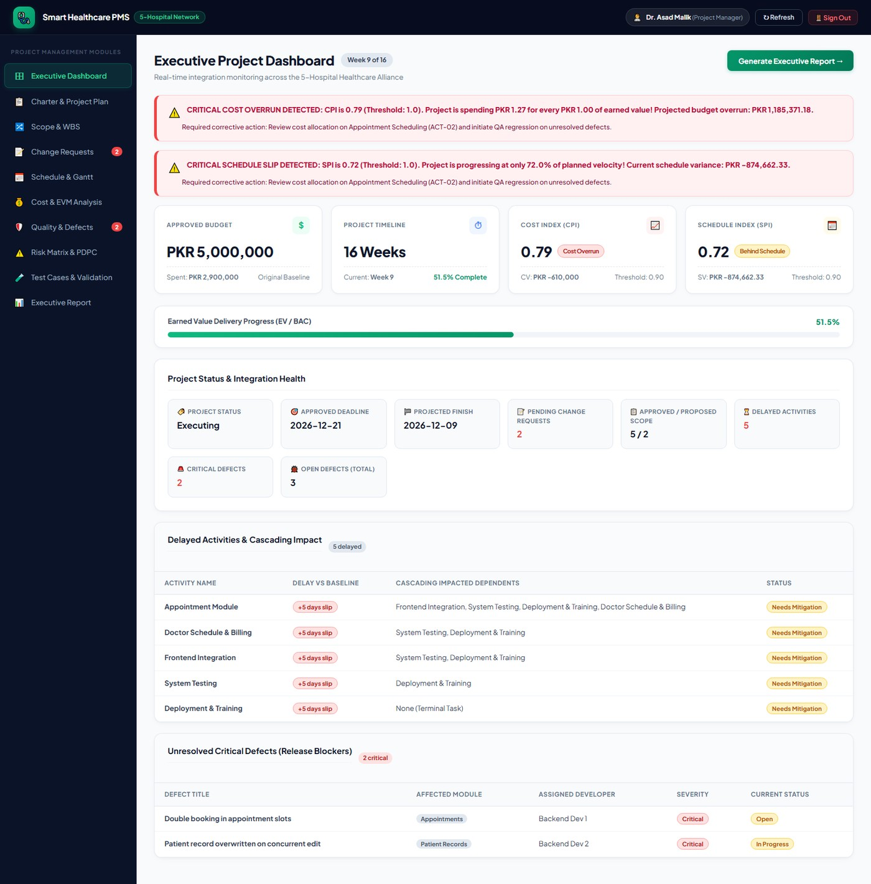
Captured live from the running system on the status date, 28 October 2026.
Figure 1.2 Executive report modal with the printable project status narrative
Generated on demand from the same live records, the executive report renders the week number against the sixteen-week baseline, the milestone gate status and the earned-value summary in a form intended to be pasted into a steering-committee minute.
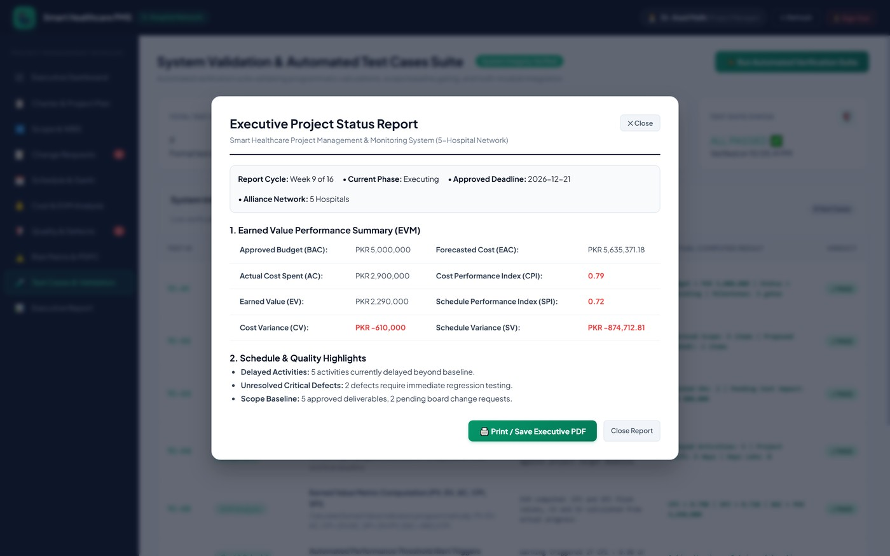
Captured live from the running system on the status date, 28 October 2026.
1.5 Report Structure
The remainder of this report follows the nine knowledge areas of the project lifecycle. Chapter 2 establishes objectives, charter and stakeholder structure. Chapter 3 covers scope definition and integrated change control. Chapter 4 develops resource allocation, the schedule network, the cost baseline, earned value performance and risk response planning. Chapter 5 presents the system and interface design with a full set of captures from the running application. Chapter 6 documents the implementation and the two principal algorithms. Chapter 7 reports verification, validation, quality inspection and testing. Chapter 8 describes deployment. Chapter 9 sets out the maintenance and operational plan and the lessons learned. The report closes with conclusions, limitations, recommendations and the reference list.

Chapter 2 — Project Objectives
2.1 Strategic Objectives
The project was chartered with one strategic objective, decomposed into five delivery objectives and three management objectives. The strategic objective, as recorded verbatim in the charter objectives field, is to deliver appointments, lab reports, doctor schedules, online consultations and billing for a network of five hospitals within sixteen weeks and PKR 5,000,000.
# | Objective | Type | Owner | Verification Method
O1 | Deliver the five approved hospital modules as a single web system | Delivery | Project Manager | Requirements register closed; WBS work packages accepted
O2 | Provide a live schedule engine that propagates delays transitively | Delivery | Backend Dev 1 | Test case TC-04 on the live dependency graph
O3 | Provide earned-value monitoring with configurable thresholds | Delivery | Project Manager | Test cases TC-05 and TC-06 against the cost register
O4 | Enforce a gated change control process on the scope baseline | Management | Project Manager | Test case TC-02; proposed requirements excluded from WBS
O5 | Block project closure while critical defects remain open | Management | QA Engineer | Test case TC-07 against the defect register
O6 | Maintain a live probability-and-impact risk register | Management | Project Manager | Test case TC-08; every risk carries a preventive and corrective action
O7 | Support five hospitals without per-facility code changes | Delivery | Frontend Dev 2 | Multi-tenant configuration in the project record
O8 | Keep the system operable by non-technical hospital staff | Delivery | Frontend Dev 1 | Usability walkthrough with the industry advisor

Objectives O2, O3, O4, O5 and O6 are the objectives that distinguish this project from a routine management information system. They are the reason the project has a test suite at all: each of them asserts a behaviour of the management engine rather than a behaviour of a screen, and each is verified by evaluating the live database rather than by inspection.
2.2 Measurable Success Criteria
Because a project objective that cannot be measured cannot be reported, each objective was bound to a numeric acceptance criterion at chartering. These criteria are the ones used in Chapter 7 to judge whether the project succeeded.
Criterion | Target | Actual on Status Date | Verdict
Schedule finish inside the contractual deadline | On or before 21 Dec 2026 | 09 Dec 2026 | Met
Cost Performance Index | At or above 0.90 | 0.79 | Breached
Schedule Performance Index | At or above 0.90 | 0.72 | Breached
Budget at Completion within approval | At or below PKR 5,000,000 | PKR 4,450,000 | Met
Estimate at Completion | Within the approved envelope | PKR 5,635,371.18 | At risk
Automated test suite | 100 % pass before release | 8 of 8 pass | Met
Critical defects open at go-live | Zero | Two | Not met
Requirements traced into the WBS | Every approved requirement | 5 of 5 deliverables, 21 items | Met
Risks with a documented response | 100 % | 4 of 4 | Met
Unapproved scope in the build | Zero | Zero (2 items held at the gate) | Met

Eight of the ten criteria are met. The two that are not — the critical-defect gate and the EVM thresholds — are the same underlying problem: the Appointment Module slipped and over-ran, and the defects found in that module are the two critical items still open. The corrective strategy for both is therefore a single strategy, set out in section 4.7 and section 9.4.
2.3 Project Charter
The charter is the formal authorisation of the project and the first record created in the system. It binds four things that must not drift apart during execution: the objective statement, the approved budget, the start and deadline dates, and the milestone gates. In SH-PMMS the charter is not a document but a record, editable only through the Charter module, and every other module reads its dates and budget from it.
Charter Field | Recorded Value
Project name | Smart Healthcare Project Management and Monitoring System
Objectives | Deliver appointments, lab reports, doctor schedules, online consultations and billing for a network of 5 hospitals within 16 weeks and PKR 5,000,000
Approved budget | PKR 5,000,000
Start date | 31 August 2026
Deadline | 21 December 2026
Duration | 16 weeks (112 calendar days)
Status | Executing
Scope boundary (in) | Web system serving five hospitals covering the five approved modules
Scope boundary (out) | AI diagnosis and mobile application, until approved by change request
CPI warning threshold | 0.90
SPI warning threshold | 0.90
Milestone 1 | Design complete — 22 September 2026 — achieved
Milestone 2 | Backend complete — 09 November 2026 — outstanding
Milestone 3 | Go-live — 21 December 2026 — outstanding

Two charter rules are enforced in code rather than by convention. The first is that the deadline must be strictly later than the start date; this is validated in the Mongoose pre-validate hook on the Project model, so an invalid charter cannot be persisted even by a direct API call. The second is that the two EVM thresholds default to 0.90 and are stored on the project record, which means the warning engine in Chapter 6 reads them per project rather than carrying a hard-coded constant.
Figure 2.1 Charter and project plan module rendered in the interface
The charter module presents the authorisation record as a full-page view: the objective statement, the stakeholder chips, the four-part project plan covering scope, schedule, cost and quality, the milestone gate list and the audit change log. Every downstream module derives its dates from this record.
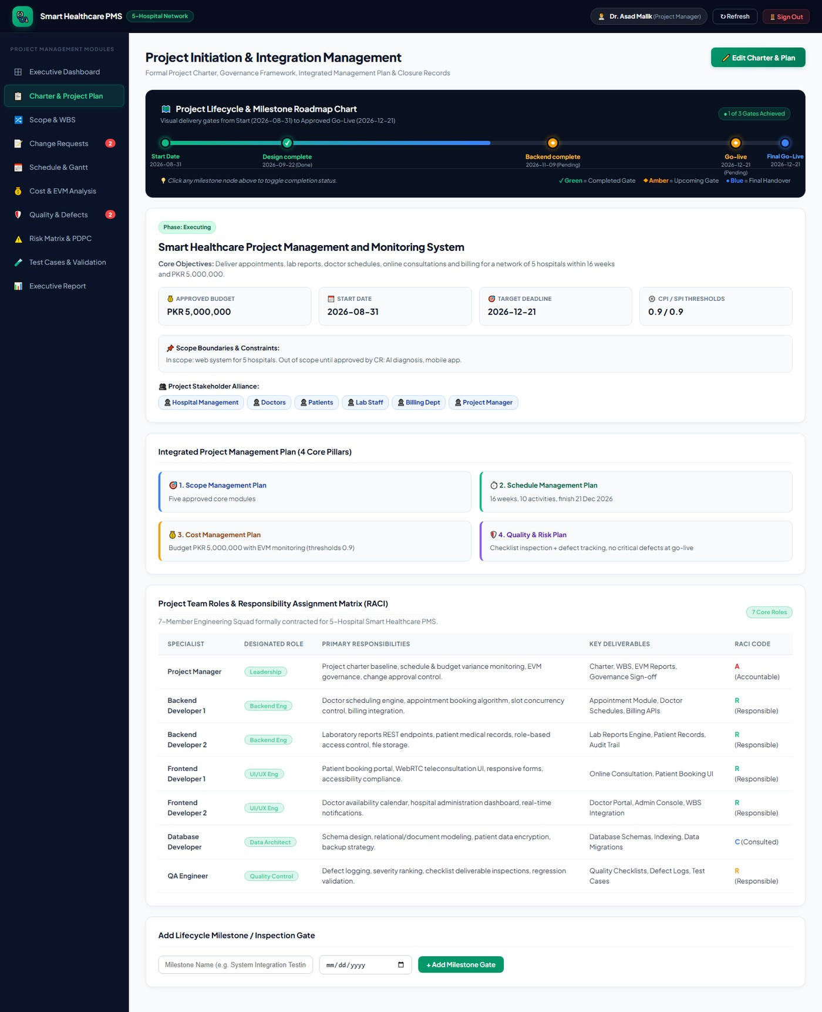
Captured live from the running system on the status date, 28 October 2026.
Figure 2.2 In-place charter editing form with validation
Editing the charter opens the same shared form component used across the application. The start and deadline fields are date inputs, the budget is a numeric input, and the server-side model validation rejects a deadline that is not later than the start date, so the form cannot be used to create an impossible baseline.
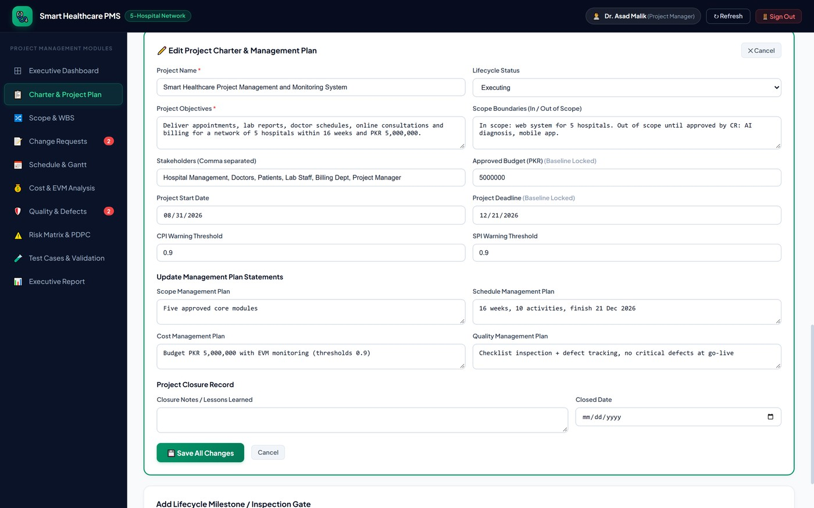
Captured live from the running system on the status date, 28 October 2026.
2.4 Stakeholders and Team Structure
The charter names six stakeholder groups: Hospital Management, Doctors, Patients, Lab Staff, Billing Department and the Project Manager. These are the groups whose interests the delivered system must serve. The delivery team is a separate, smaller structure, and the distinction matters because in a three-member academic project the people who build the system are not the people it is built for.
Stakeholder | Interest | Influence | Management Strategy
Hospital Management | Go-live on budget and on time; board-level reporting | High | Monthly executive report generated from the Executive Report module
Project Manager | Authoritative schedule and cost truth; change control | High | Primary system user; owns charter, baseline and risk register
QA Engineer | Defect visibility and a hard closure gate | High | Owns the quality module and the automated test suite
Backend Developers | Realistic activity durations and clear dependencies | Medium | Update activity percent-complete and actual cost directly
Frontend Developers | Stable requirements; protected integration window | Medium | Work packages traced to the WBS; scope changes gated
Doctors | Appointment and scheduling modules that do not lose data | Medium | Represented by the industry advisor at milestone reviews
Patients | Reliable booking and lab report access | Low individually, high collectively | Acceptance criteria captured through the advisor
Lab Staff | Report turnaround visible in the schedule | Low | Informed through the hospital administrators
Billing Department | Accurate invoicing; rounding correctness | Medium | Defect TC on rounding tracked to closure

The delivery team itself is composed of eight named resources, each of whom is assigned activities in the schedule module and whose loading is charted in Figure 4.1. The four accounts seeded into the system for demonstration purposes carry the roles Project Manager, QA Engineer, Backend Developer and Hospital Admin; the role list available at registration is Project Manager, QA Engineer, Backend Developer, Hospital Admin and Analyst.
Figure 2.3 Use-case view of the project actors and their management goals
The use-case model separates the operational actors — Project Manager, QA Engineer, Developer and Hospital Administrator — from the system boundary of SH-PMMS. Each oval is a management goal rather than a screen: maintain the charter, control scope, approve changes, record progress, monitor earned value, log defects, assess risk and generate the executive report.
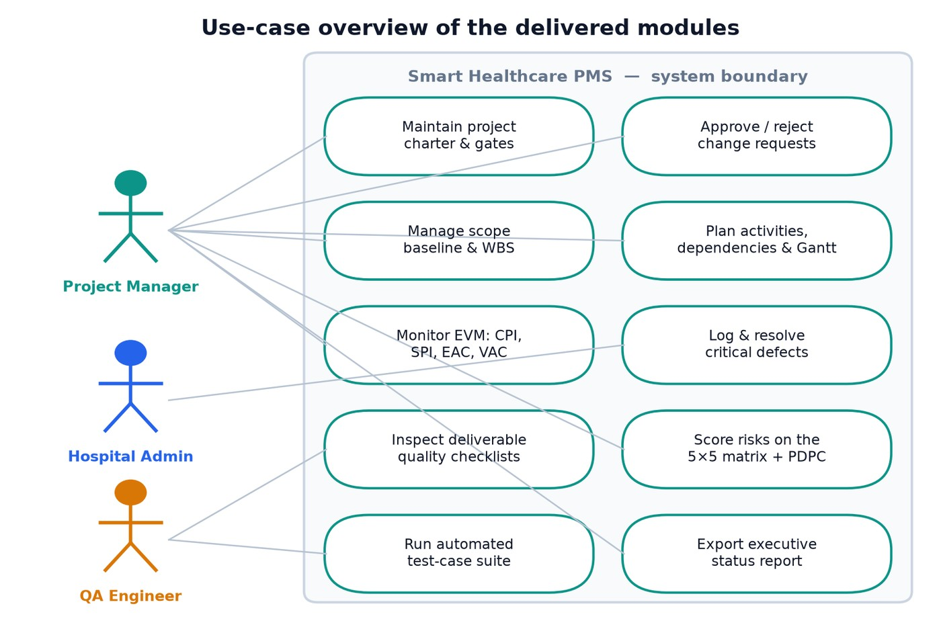
Figure generated from the requirements register and the navigation model of the delivered interface.
2.5 Governance and Reporting Cadence
Governance was defined at chartering and did not change during execution. It rests on four fixed obligations.
Weekly data refresh. Every activity owner updates percent-complete and actual cost in the schedule and cost modules. Because both drive the earned-value computation, an unreported week is immediately visible as a divergence between the EV and PV curves.
Automated exception reporting. The two EVM warnings and the critical-defect warning are raised automatically by the server whenever the indices cross the charter thresholds. No warning depends on someone remembering to write one.
Change control board. Any request that alters scope, cost or duration must be entered as a change request with a written justification and numeric impacts before work begins. The requirements register distinguishes baseline origin from change origin, and the WBS generator only consumes approved requirements.
Milestone gates. The three charter milestones are hard gates. Design complete was achieved on 22 September 2026. Backend complete and Go-live remain open, and the go-live gate is additionally blocked by the critical-defect rule described in section 7.3.
This cadence is what makes the numbers in Chapter 4 defensible: they are not a one-off snapshot assembled for the report but the current output of a process that has been running since 31 August 2026.

Chapter 3 — Project Scope
3.1 Scope Statement
The scope statement defines the boundary between the work the team committed to deliver and the work it did not. It is recorded in the charter field scopeBoundaries and reads: in scope, a web system for five hospitals covering the five approved modules; out of scope until approved by change request, an AI diagnosis capability and a mobile application.
Two deliberate decisions shape this boundary. The first is that the five in-scope modules were chosen because they share a single data spine — the patient record — and therefore can be delivered by one team against one schedule without interface risk between independently governed subsystems. The second is that the two excluded capabilities were not rejected on merit but deferred behind a gate. Both arrive in the requirements register with origin "Change" and status "Proposed", which means they are visible to the project manager, are countable, and are provably excluded from the build. Section 3.4 shows how the system enforces that exclusion.
Boundary | Item | Rationale
In scope | Patient Appointments | Highest-volume clinical workflow; prerequisite for billing
In scope | Laboratory Reports | Required by referring doctors; shares the patient record
In scope | Online Consultations | Requested by three of five hospitals; reuses scheduling
In scope | Doctor Schedules | Constraint that makes appointment booking correct
In scope | Hospital Billing | Financial close-out; depends on appointments and labs
In scope | Project management and monitoring platform for the above | The deliverable itself
Out of scope | AI preliminary diagnosis | Deferred pending CR-01; accuracy unproven
Out of scope | Mobile application | Deferred pending CR-02; web responsive covers v1
Out of scope | Legacy data migration from prior systems | Not costed in the baseline
Out of scope | Medical device and pathology instrument integration | Requires vendor contracts
Out of scope | Interoperability standards (HL7 / FHIR) export | Deferred to the next phase
Assumption | Five hospitals share one clinical data model | Validated with the industry advisor
Constraint | Approved budget of PKR 5,000,000 | Set by the charter and non-negotiable
Constraint | Go-live no later than 21 December 2026 | Contractual deadline
Constraint | Team of eight named resources | Fixed for the duration of the project

3.2 Requirements Register
Requirements are held as first-class records in the Scope module, not as paragraphs in a document. Each carries a title, a priority of High or Medium, a status of Approved or Proposed, and an origin of either Baseline or Change. The origin field is what makes the gate in section 3.4 possible: it records how the requirement entered the project, independently of whether it has been accepted.
# | Requirement | Priority | Origin | Status | Traced WBS
R1 | Patient Appointments | High | Baseline | Approved | 1.1.1 – 1.1.3
R2 | Laboratory Reports | High | Baseline | Approved | 1.2.1 – 1.2.3
R3 | Online Consultations | Medium | Baseline | Approved | 1.3.1 – 1.3.3
R4 | Doctor Schedules | Medium | Baseline | Approved | 1.4.1 – 1.4.3
R5 | Hospital Billing | High | Baseline | Approved | 1.5.1 – 1.5.3
R6 | AI Preliminary Diagnosis Module | Medium | Change | Proposed | Excluded by the gate
R7 | Mobile Application | Medium | Change | Proposed | Excluded by the gate

Five of the seven requirements are approved and every one of the five is traced into three work packages. The two proposed requirements are traced into nothing. This is the scope baseline: five deliverables, fifteen work packages, one project node, twenty-one WBS entries in total.
Figure 3.1 Requirements register showing the approved scope baseline
The register is rendered as a searchable table with seven records. Approved baseline rows expose only Edit and Delete actions; the two proposed rows additionally expose Approve and Reject buttons, which is the change-control gate described in section 3.5 presented at the point where scope actually enters the project.
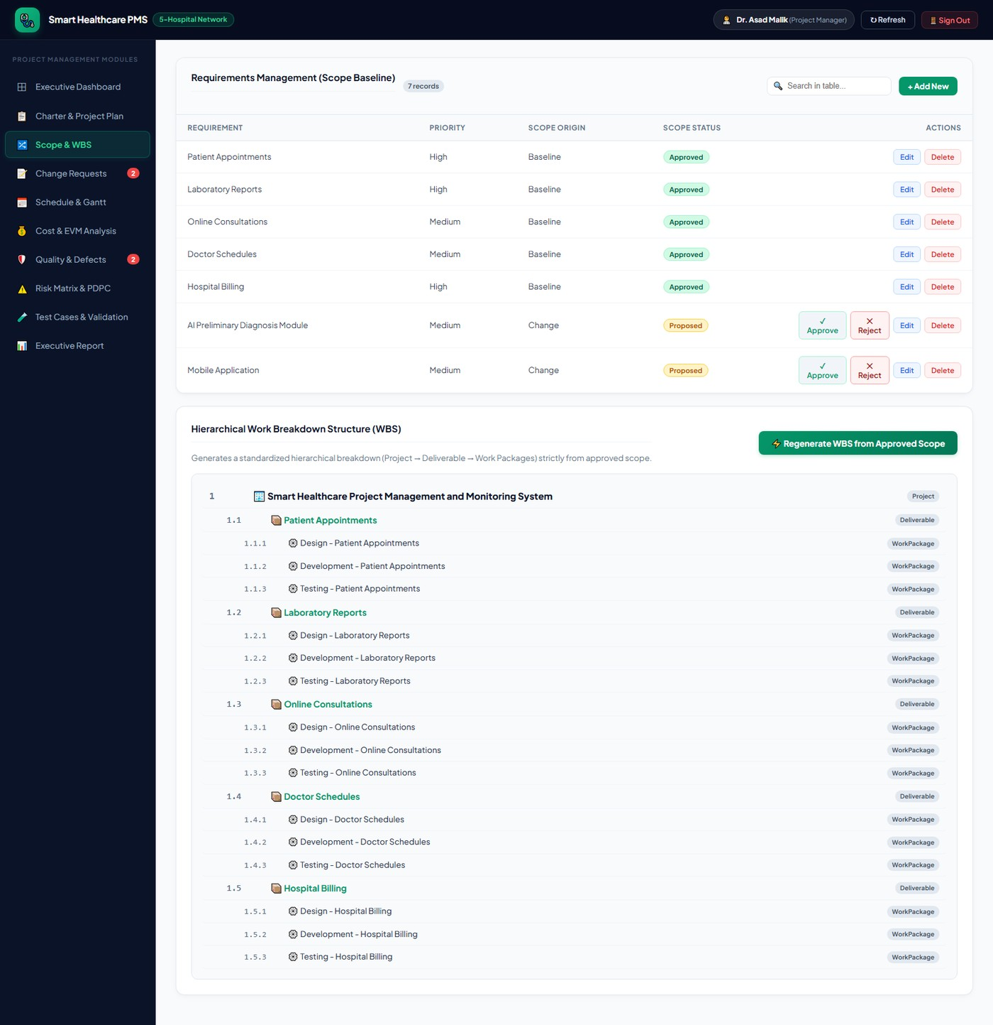
Captured live from the running system on the status date, 28 October 2026.
Figure 3.2 Record creation form used to extend the requirements register
Adding a requirement opens the shared inline creation form. The form is the only sanctioned route by which new scope can be proposed; a new record defaults to a status that the WBS generator will ignore until an explicit approval is recorded.
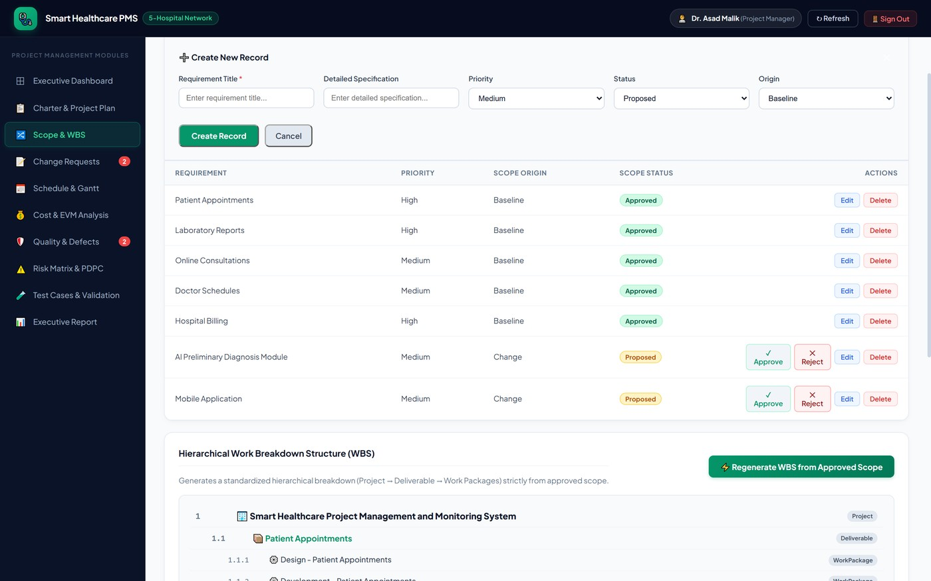
Captured live from the running system on the status date, 28 October 2026.
3.3 Work Breakdown Structure
The work breakdown structure is generated, not typed. Pressing "Regenerate WBS from Approved Scope" in the Scope module walks the requirements collection, filters to status Approved, and emits a three-level decomposition: one project node at level one, one deliverable node per approved requirement at level two, and three work packages per deliverable at level three covering design, development and testing. Codes are assigned in dotted decimal form and the tree is returned sorted by segment-wise numeric comparison so that 1.2.10 would follow 1.2.9 rather than 1.2.1.
Code | Element | Type | Traced Requirement
1 | Smart Healthcare Project Management and Monitoring System | Project | —
1.1 | Patient Appointments | Deliverable | R1
1.1.1 | Design – Patient Appointments | Work Package | R1
1.1.2 | Development – Patient Appointments | Work Package | R1
1.1.3 | Testing – Patient Appointments | Work Package | R1
1.2 | Laboratory Reports | Deliverable | R2
1.2.1 | Design – Laboratory Reports | Work Package | R2
1.2.2 | Development – Laboratory Reports | Work Package | R2
1.2.3 | Testing – Laboratory Reports | Work Package | R2
1.3 | Online Consultations | Deliverable | R3
1.3.1 | Design – Online Consultations | Work Package | R3
1.3.2 | Development – Online Consultations | Work Package | R3
1.3.3 | Testing – Online Consultations | Work Package | R3
1.4 | Doctor Schedules | Deliverable | R4
1.4.1 | Design – Doctor Schedules | Work Package | R4
1.4.2 | Development – Doctor Schedules | Work Package | R4
1.4.3 | Testing – Doctor Schedules | Work Package | R4
1.5 | Hospital Billing | Deliverable | R5
1.5.1 | Design – Hospital Billing | Work Package | R5
1.5.2 | Development – Hospital Billing | Work Package | R5
1.5.3 | Testing – Hospital Billing | Work Package | R5

The value of a generated WBS is that it cannot disagree with the requirements register. In a document-driven project the WBS and the requirements list drift apart within a few weeks and nobody notices until a deliverable is missing at acceptance. Here the WBS is a projection of the register, so the two are consistent by construction and the twenty-one items above are exactly five approved requirements times three work packages plus the project node.
Figure 3.3 Hierarchical work breakdown structure generated from approved scope
The generated tree is rendered with indentation by code depth, a type badge on every row and the regeneration control at the top right. The caption above the tree states the rule it enforces: the decomposition is produced strictly from approved scope.
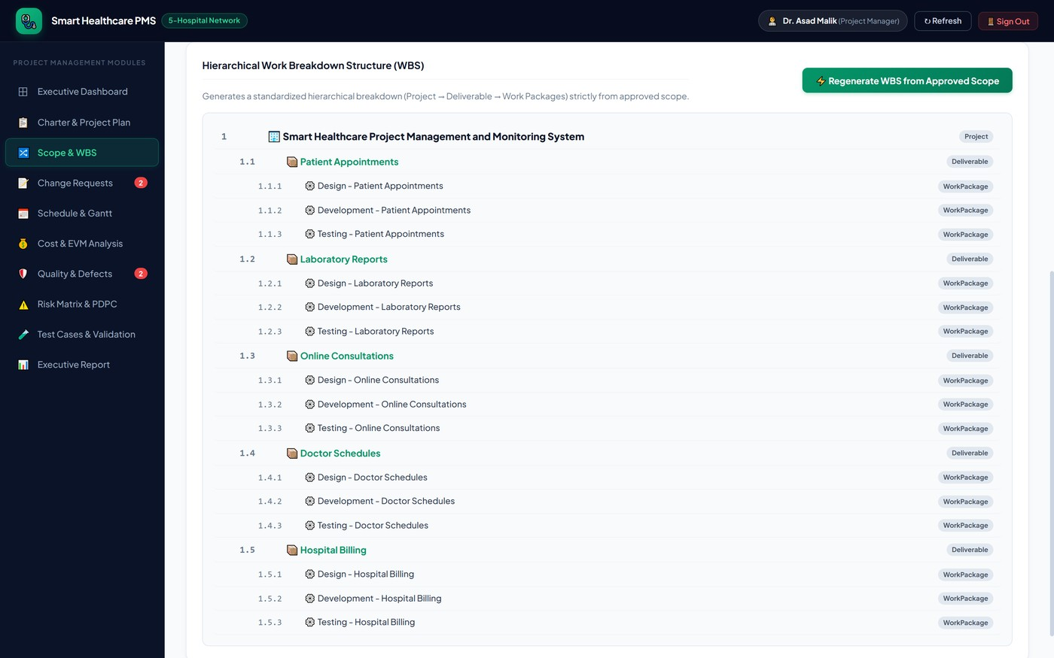
Captured live from the running system on the status date, 28 October 2026.
3.4 Scope Baseline and Gating
Scope gating is the mechanism that turns the scope statement from a paragraph into an enforced rule. It operates at three points.
Generation-time filter. The WBS generator filters on status Approved before it emits a single node. A proposed requirement therefore has no work packages, no owner and no budget line, and cannot be scheduled.
Verification assertion. The automated test suite asserts that the count of approved requirements equals five and the count of proposed, gated requirements equals two, so any accidental promotion of unapproved scope into the baseline fails test case TC-02.
Structural isolation. Activities reference other activities by identifier and are only linked to approved deliverables. There is no data path by which a proposed requirement can acquire a duration or a planned cost.
The practical effect is visible in Figure 3.4: the scope is split cleanly into five approved baseline items and two gated items, and the gated portion is quantified rather than hidden.
Figure 3.4 Scope distribution by status and origin
The chart plots the seven requirements by status and by origin. The five baseline items are approved and under construction; the two change-origin items sit in the proposed band, each attached to a pending change request whose cost and schedule impact is shown in Figure 3.5.
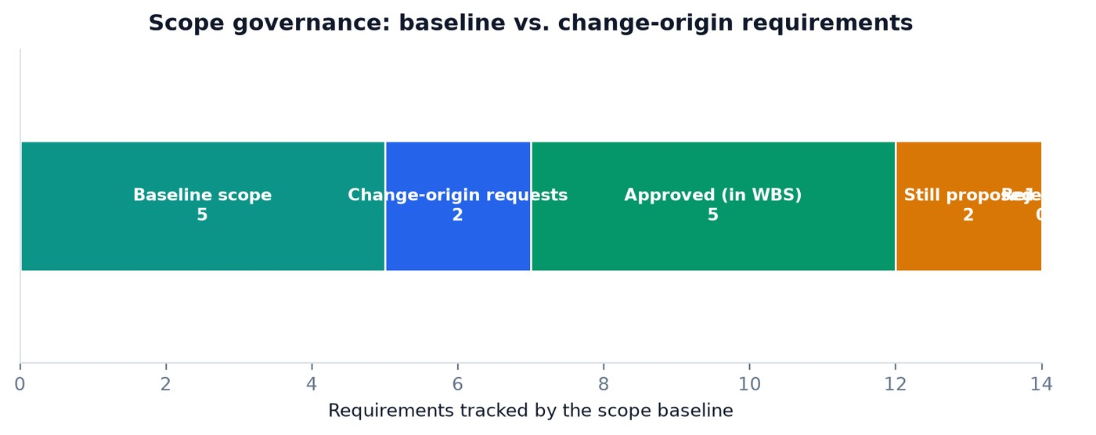
Figure generated from the live requirements register on 28 October 2026.
3.5 Integrated Change Control
Change control is handled by a dedicated module that behaves as a lightweight change control board. Every change request record carries a title, a written justification, a link to the requirement it would create or alter, a numeric cost impact, a numeric schedule impact expressed in weeks, and a status. The only permitted transitions are Pending to Approved and Pending to Rejected, and both are recorded against the project change log.
CR | Title | Justification | Cost Impact | Schedule Impact | Status | Decision Rule Applied
CR-01 | Add AI preliminary diagnosis | Hospital management wants AI-assisted triage | PKR 500,000 | +2 weeks | Pending | Deferred: accuracy unproven; risk R4 scored 9; would breach the budget envelope
CR-02 | Add mobile application | Patients need mobile booking | PKR 300,000 | +1 week | Pending | Deferred: responsive web covers the need in v1; schedule float already consumed

Both requests are correctly held. Their combined impact is PKR 800,000 and three weeks, which against the current position would take the estimate at completion from PKR 5,635,371.18 to PKR 6,435,371.18 — twenty-nine per cent above the approved envelope — and would push the projected finish past the contractual deadline. The change control board therefore has a quantitative reason for deferral, and that reason is produced by the system rather than argued from memory.
The change control process followed for every request is fixed:
The requester records the justification in the register; verbal requests are not actionable.
The project manager attaches a cost impact and a schedule impact before the request can be saved.
The impact is evaluated against the current EVM position, not against the original baseline, because a change absorbed by float is a different decision from a change that consumes the last of it.
Approval promotes the linked requirement to Approved status, which makes it eligible for WBS generation on the next regeneration.
Rejection leaves the requirement in the register with origin Change so that the same request can be re-scored in a later phase rather than being lost.
Figure 3.5 Change request register with cost and schedule impact
The change request module lists both pending requests with their justification text, the numeric cost impact, the schedule impact in weeks and the approve / reject actions. The sidebar badge on the Change Requests navigation item shows the live count of two pending items, so an unattended change is visible from any screen in the application.
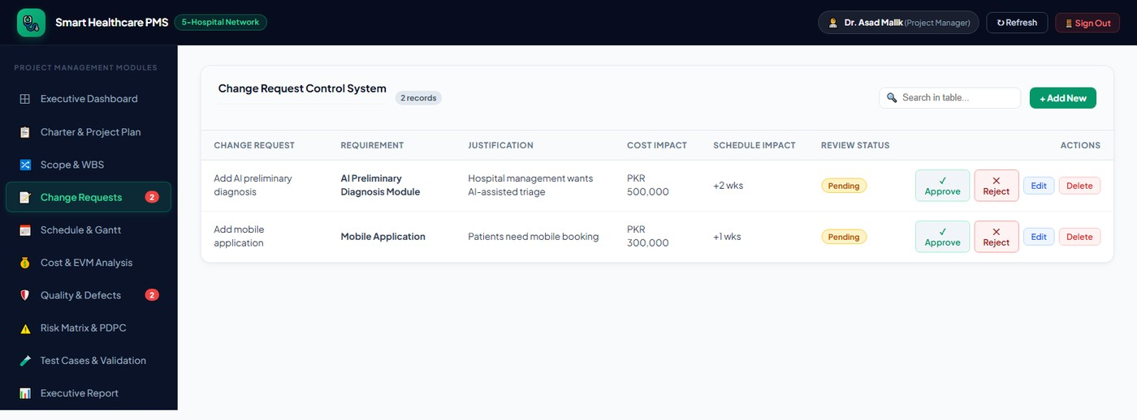
Captured live from the running system on the status date, 28 October 2026.

Chapter 4 — Resource Allocation and Schedule Planning
4.1 Resource Pool and Allocation
The project was staffed with eight named resources plus the project manager role. Allocation was performed at activity level: every activity has exactly one owner field, and the schedule module groups activities by owner so that loading is readable without a separate resource tool. The result is a deliberately unbalanced distribution, and the imbalance is itself a finding.
Resource | Role | Activities Owned | Planned Cost Owned | Percent Complete | Loading Risk
Project Manager | Management | Requirements & Planning; Deployment & Training | PKR 600,000 | 50 % | Low — two serial activities
Database Developer | Data | Database Design | PKR 350,000 | 100 % | Closed out
Frontend Dev 1 | Interface | UI/UX Design; Online Consultation | PKR 800,000 | 55 % | Medium — spans design and a late build activity
Backend Dev 1 | Services | Appointment Module; Doctor Schedule & Billing | PKR 1,100,000 | 55 % | High — owns the critical path and the largest budget share
Backend Dev 2 | Services | Patient Records & Lab Reports | PKR 600,000 | 70 % | Medium — owns a critical defect
Frontend Dev 2 | Interface | Frontend Integration | PKR 600,000 | 40 % | High — single point of failure on the critical path
QA Engineer | Quality | System Testing | PKR 400,000 | 0 % | Severe — cannot start until three activities finish

Two structural weaknesses are visible in this table and both were raised as risks. Backend Dev 1 owns PKR 1,100,000 of planned cost across two consecutive critical-path activities, which is a single-person dependency on the longest chain in the network. QA Engineer owns the entire System Testing activity alone, with zero percent complete and three predecessors, which means all quality assurance work is compressed into a fifteen-day window that has not yet opened.
Figure 4.1 Resource loading across the named team members
Each bar shows the planned cost owned by one resource, with the corresponding actual spend overlaid. The concentration on Backend Dev 1 and the untouched QA Engineer position are the two findings that drove the corrective actions in section 4.7.
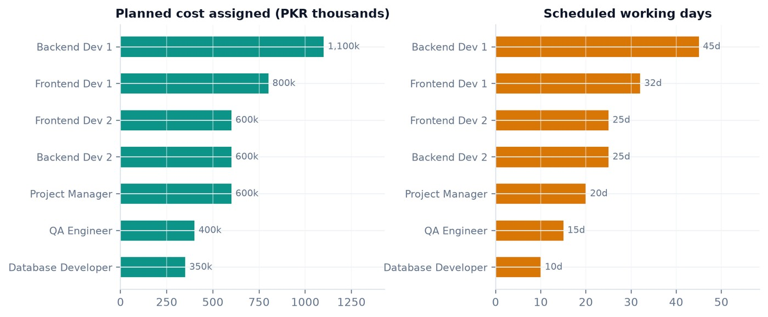
Figure generated from the live activity register on 28 October 2026.
4.2 Activity Definition and Sequencing
Ten activities decompose the work at the level at which the project manager is willing to track it. Finer granularity was rejected because the earned-value model computes percent complete from activity records, and an activity count high enough to be precise becomes a reporting burden that teams stop maintaining.
ID | Activity | Owner | Days | Predecessors | Planned Cost | Actual Cost
A1 | Requirements & Planning | Project Manager | 10 | — | PKR 300,000 | PKR 320,000
A2 | Database Design | Database Developer | 10 | A1 | PKR 350,000 | PKR 340,000
A3 | UI/UX Design | Frontend Dev 1 | 12 | A1 | PKR 300,000 | PKR 310,000
A4 | Appointment Module | Backend Dev 1 | 25 | A2 | PKR 600,000 | PKR 700,000
A5 | Patient Records & Lab Reports | Backend Dev 2 | 25 | A2 | PKR 600,000 | PKR 650,000
A6 | Doctor Schedule & Billing | Backend Dev 1 | 20 | A4 | PKR 500,000 | PKR 200,000
A7 | Frontend Integration | Frontend Dev 2 | 25 | A3, A4 | PKR 600,000 | PKR 300,000
A8 | Online Consultation | Frontend Dev 1 | 20 | A5 | PKR 500,000 | PKR 80,000
A9 | System Testing | QA Engineer | 15 | A6, A7, A8 | PKR 400,000 | PKR 0
A10 | Deployment & Training | Project Manager | 10 | A9 | PKR 300,000 | PKR 0
 | Total |  | 172 (sum) |  | PKR 4,450,000 | PKR 2,900,000

The sum of activity durations, 172 days, is far longer than the ninety-five-day baseline because most activities run in parallel. The relationship between these two numbers is the entire reason a schedule network is needed, and it is developed in the next section.
4.3 Schedule Network and Critical Path
The schedule engine performs a forward pass over the dependency graph. Each activity's start is the latest finish of its predecessors, or the project start date if it has none, and each finish is its start plus its duration. The pass is memoised and guarded against cycles by tracking the recursion stack, so a malformed dependency cannot hang the server. The critical path is the chain of activities whose earliest finish determines the project finish date.
Step | Activity | Duration | Early Start | Early Finish | On Critical Path
1 | A1 Requirements & Planning | 10 d | 31 Aug 2026 | 10 Sep 2026 | Yes
2 | A2 Database Design | 10 d | 10 Sep 2026 | 20 Sep 2026 | Yes
2 | A3 UI/UX Design | 12 d | 10 Sep 2026 | 22 Sep 2026 | No — 23 d float
3 | A4 Appointment Module | 25 d | 20 Sep 2026 | 15 Oct 2026 | Yes
3 | A5 Patient Records & Lab Reports | 25 d | 20 Sep 2026 | 15 Oct 2026 | No — 5 d float
4 | A6 Doctor Schedule & Billing | 20 d | 15 Oct 2026 | 04 Nov 2026 | No — 5 d float
4 | A7 Frontend Integration | 25 d | 15 Oct 2026 | 09 Nov 2026 | Yes
5 | A8 Online Consultation | 20 d | 15 Oct 2026 | 04 Nov 2026 | No — 5 d float
6 | A9 System Testing | 15 d | 09 Nov 2026 | 24 Nov 2026 | Yes
7 | A10 Deployment & Training | 10 d | 24 Nov 2026 | 04 Dec 2026 | Yes

The baseline critical path is therefore A1 → A2 → A4 → A7 → A9 → A10, totalling ninety-five days and finishing on 4 December 2026, which is seventeen days inside the contractual deadline of 21 December. That seventeen-day buffer is the project's total float against the deadline, and it is the resource that has now been partially spent.
Delay propagation
Appointment Module carries a five-day own delay. Because it sits on the critical path, the delay does not stay local: the forward pass re-runs with the shifted finish and every successor inherits the movement. The system reports the transitive impact set for each delayed activity, which is what allows the project manager to see reach before it becomes a slip.
Activity | Own Delay | Inherited Shift | Forecast Finish | Transitive Impact On
A4 Appointment Module | 5 d | — | 20 Oct 2026 | Frontend Integration, System Testing, Deployment & Training, Doctor Schedule & Billing
A7 Frontend Integration | 0 d | 5 d | 14 Nov 2026 | System Testing, Deployment & Training
A6 Doctor Schedule & Billing | 0 d | 5 d | 09 Nov 2026 | System Testing, Deployment & Training
A9 System Testing | 0 d | 5 d | 29 Nov 2026 | Deployment & Training
A10 Deployment & Training | 0 d | 5 d | 09 Dec 2026 | — (project finish)
A5 Patient Records & Lab Reports | 0 d | 0 d | 15 Oct 2026 | None
A8 Online Consultation | 0 d | 0 d | 04 Nov 2026 | None

Five of the ten activities are flagged delayed, yet the project is zero days late. The reconciliation is that the five-day shift moved the finish from 4 December to 9 December, leaving twelve days of buffer against the 21 December deadline. daysLate is reported as 0 and the projected finish is 9 December 2026. This is the single most useful output of the schedule engine: it distinguishes "five activities are behind" from "the project deadline is at risk", which a manual report consistently fails to do.
Figure 4.2 Schedule module listing every activity and its delay cascade
The schedule module renders the full activity register with baseline dates, forecast dates, percent complete, owner and the inherited shift. Delayed rows are highlighted and each carries its transitive impact list, so the reach of a slip is visible next to the slip itself.
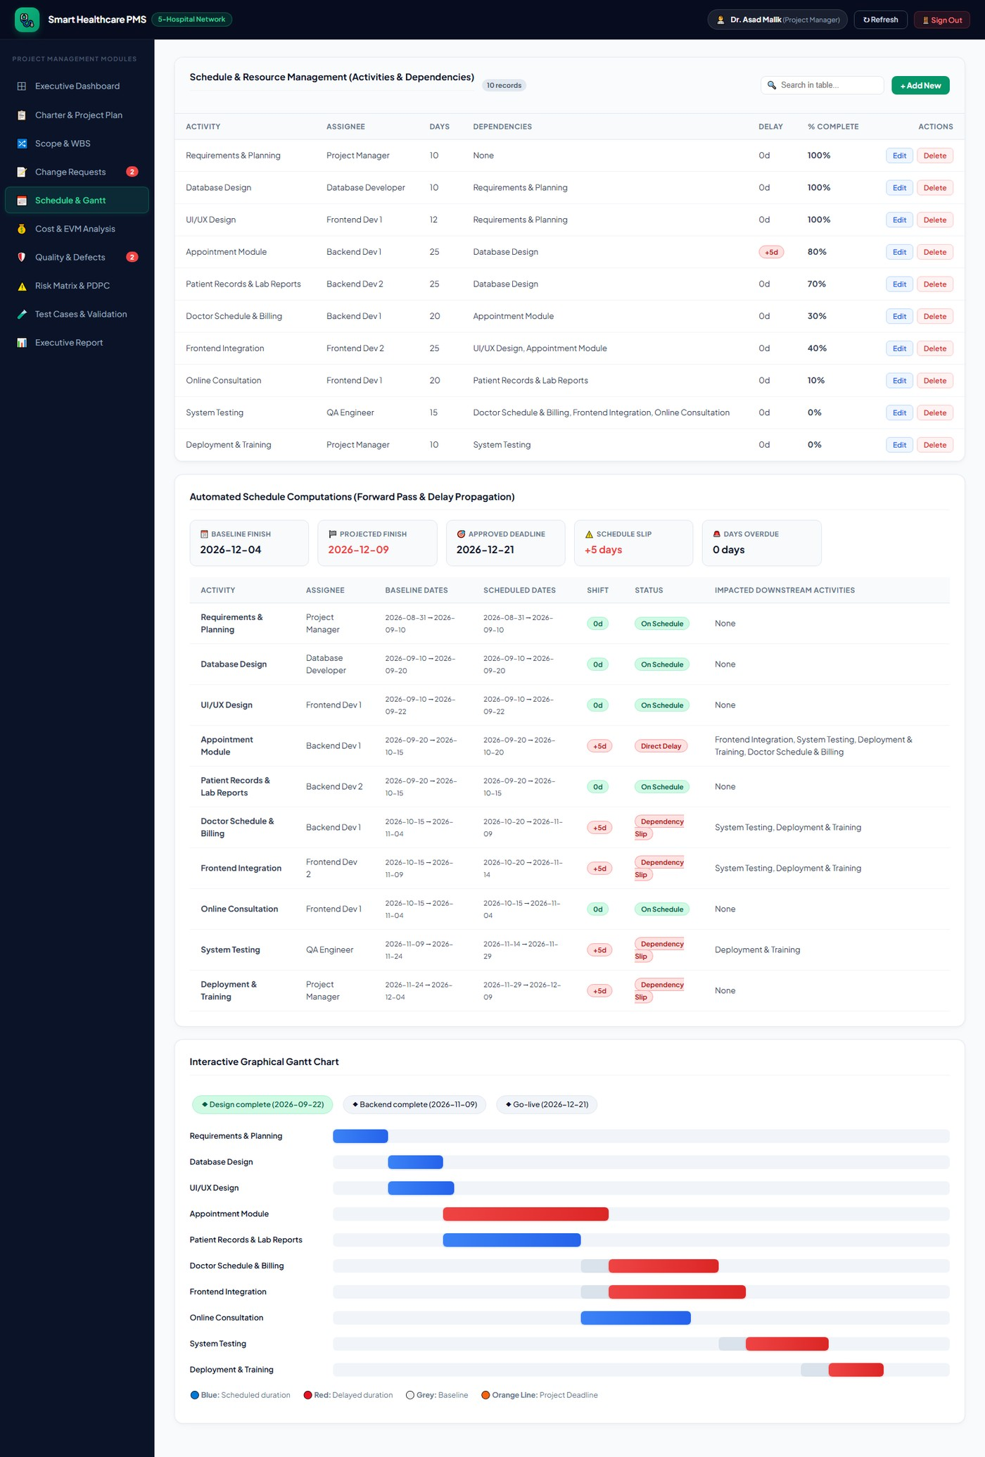
Captured live from the running system on the status date, 28 October 2026.
Figure 4.3 Gantt chart of baseline versus forecast schedule
Each activity is drawn twice: the pale bar is the baseline position and the solid bar is the forecast position after delay propagation. The five-day rightward shift of the critical-path chain is visible as a uniform offset, while A5 and A8 stay on their baseline because their float absorbed the dependency movement.
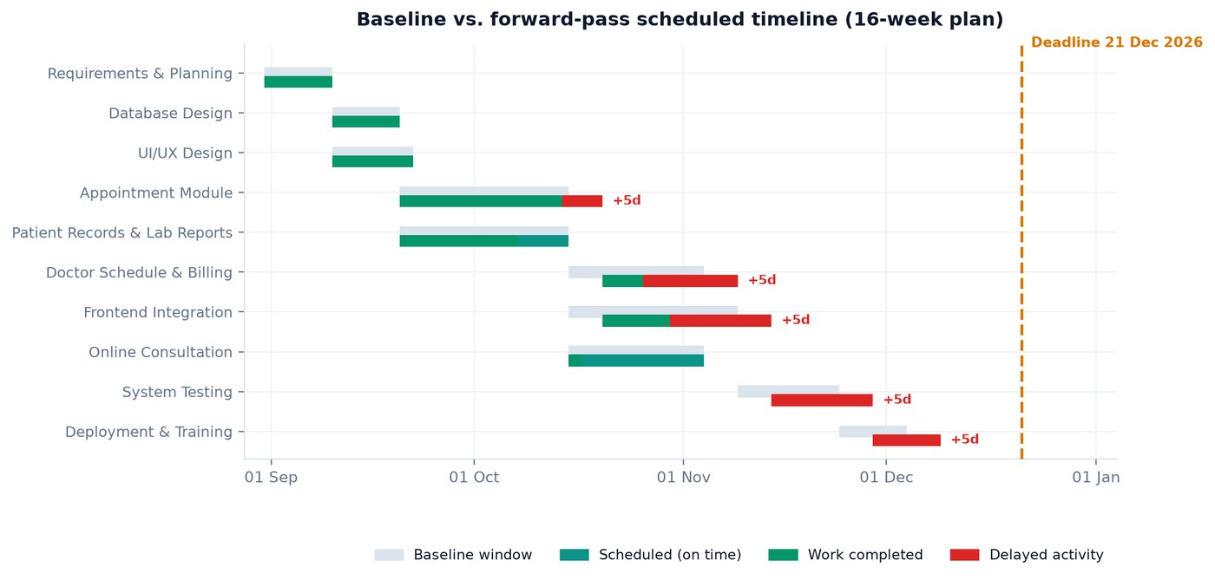
Figure generated from the live schedule forward pass on 28 October 2026.
4.4 Gantt Visualisation and Milestone Tracking
The Gantt view is a derived presentation of the same forward pass, which means it cannot disagree with the table in section 4.3. Three charter milestones are overlaid on the timeline as gates.
Milestone | Planned Gate Date | Status | Evidence at Status Date
Design complete | 22 Sep 2026 | Achieved | A2 and A3 both at 100 %; class diagram and ERD baselined; UI/UX sign-off recorded
Backend complete | 09 Nov 2026 | Outstanding | A4 at 80 %, A5 at 70 %, A6 at 30 %; forecast A6 finish 09 Nov 2026 — exactly on gate
Go-live | 21 Dec 2026 | Outstanding | A9 and A10 not started; additionally blocked by two open critical defects

One of three gates achieved. The Backend complete gate is the one to watch: Doctor Schedule & Billing is forecast to finish on 9 November, the same date as the gate, at thirty per cent complete. Any further degradation on that activity breaches the gate directly.
4.5 Cost Baseline and Budget
The cost baseline is the sum of activity planned costs, PKR 4,450,000, held inside an approved envelope of PKR 5,000,000. The 550,000 difference is management reserve — it is real money, it is approved, and it is not assigned to any activity, which is precisely what makes it available for contingent work. Actual cost to date is PKR 2,900,000, leaving PKR 2,100,000 of the approved envelope unspent.
Activity | Planned Cost | Actual Cost | Variance | Variance % | Comment
A1 Requirements & Planning | PKR 300,000 | PKR 320,000 | PKR 20,000 | +6.7 % | Extra stakeholder workshops
A2 Database Design | PKR 350,000 | PKR 340,000 | PKR -10,000 | −2.9 % | Under budget; closed
A3 UI/UX Design | PKR 300,000 | PKR 310,000 | PKR 10,000 | +3.3 % | Second iteration of the dashboard
A4 Appointment Module | PKR 600,000 | PKR 700,000 | PKR 100,000 | +16.7 % | Concurrency defect investigation; the dominant overrun
A5 Patient Records & Lab Reports | PKR 600,000 | PKR 650,000 | PKR 50,000 | +8.3 % | Concurrent-edit defect; still open
A6 Doctor Schedule & Billing | PKR 500,000 | PKR 200,000 | PKR -300,000 | −60.0 % | Partially funded; 30 % complete
A7 Frontend Integration | PKR 600,000 | PKR 300,000 | PKR -300,000 | −50.0 % | Partially funded; 40 % complete
A8 Online Consultation | PKR 500,000 | PKR 80,000 | PKR -420,000 | −84.0 % | Only just started; 10 % complete
A9 System Testing | PKR 400,000 | PKR 0 | PKR -400,000 | −100 % | Not started
A10 Deployment & Training | PKR 300,000 | PKR 0 | PKR -300,000 | −100 % | Not started
Total | PKR 4,450,000 | PKR 2,900,000 | PKR -1,550,000 | −34.8 % | Spend is behind plan because work is behind plan

Figure 4.4 Planned versus actual cost by activity
The paired bars make the two distinct cost problems visible at once. Completed activities A1, A3, A4 and A5 over-ran by three to seventeen per cent, while in-progress activities show underspend that is simply unspent budget rather than saving. Reading the chart by completion status rather than by bar length is the correct interpretation.
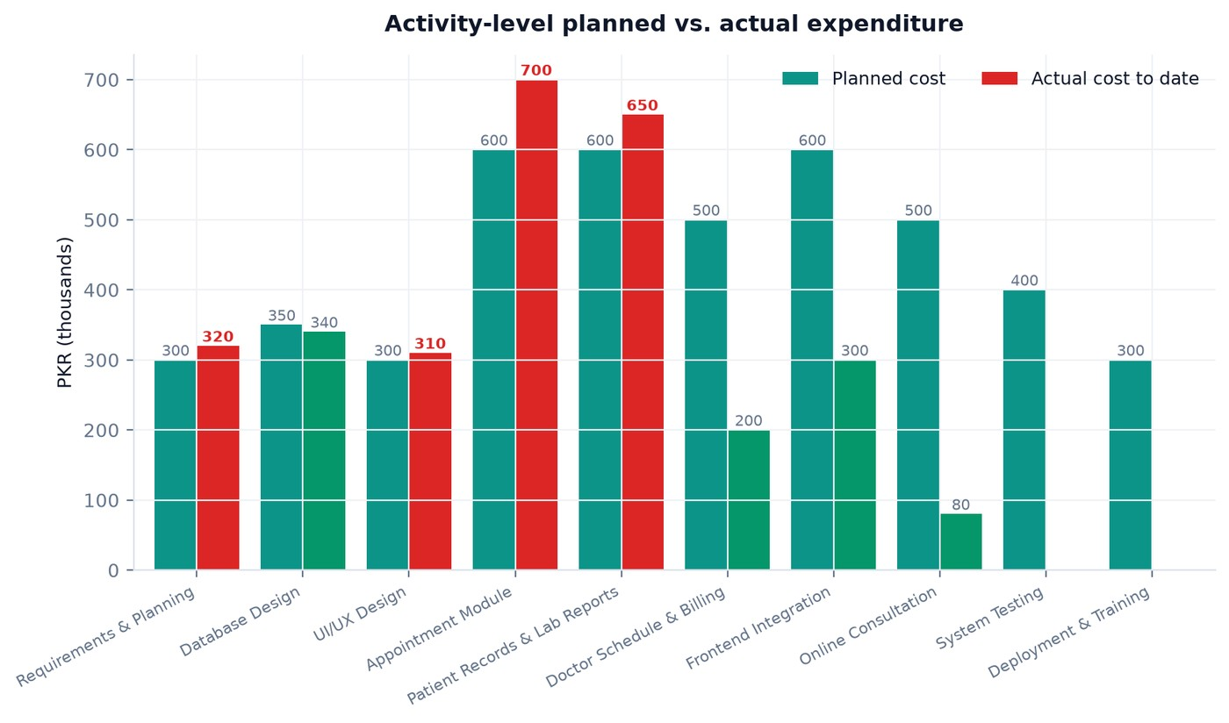
Figure generated from the live activity cost register on 28 October 2026.
Figure 4.5 Cost and EVM analysis module
The cost module presents the budget envelope, the four EVM curves, the index panel with CPI, SPI, CV, SV, EAC and VAC, and the automated warning strip. Thresholds are read from the charter record, so the same deployment can monitor projects with different tolerance settings.
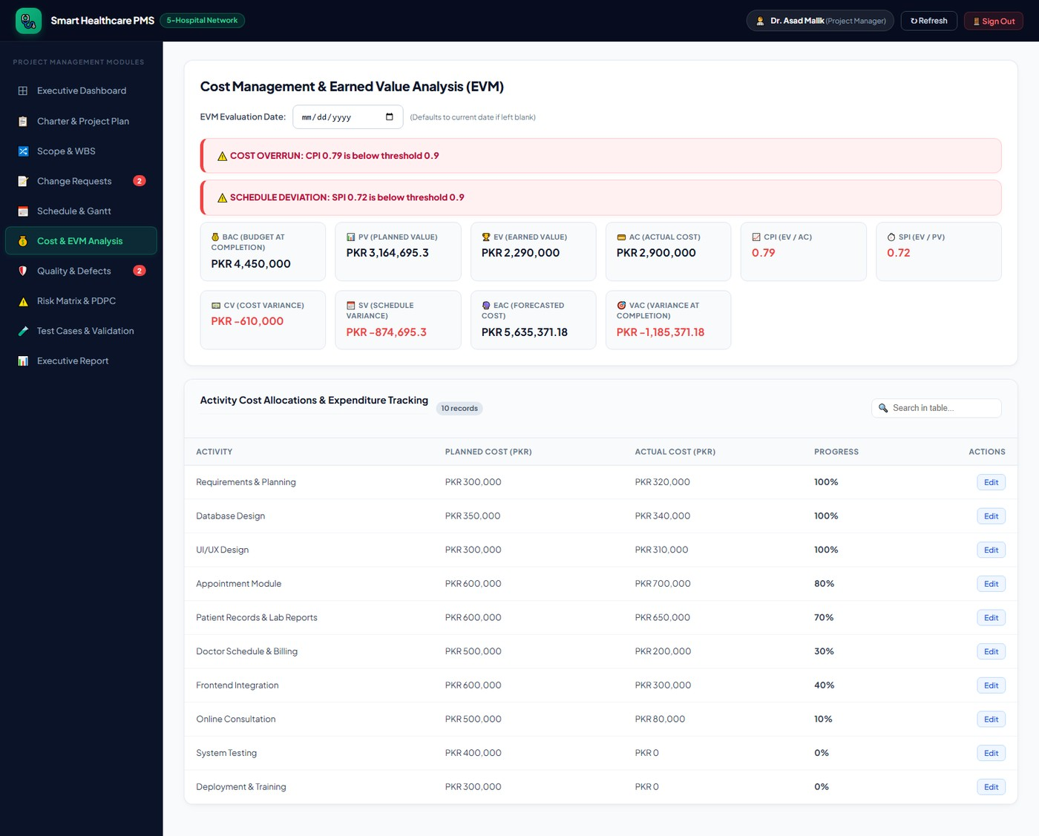
Captured live from the running system on the status date, 28 October 2026.
4.6 Earned Value Management
Earned value is the mechanism that converts the two separate questions "how much have we spent" and "how far have we got" into one comparable statement. The system computes it on every request from the activity register, using the status date from the server clock.
Measure | Formula | Value | Reading
Budget at Completion (BAC) | Sum of planned cost | PKR 4,450,000 | The authorised work
Planned Value (PV) | BAC × elapsed / baseline duration | PKR 3,164,673.02 | What should be done by now
Earned Value (EV) | Sum of planned cost × percent complete | PKR 2,290,000 | What is actually done
Actual Cost (AC) | Sum of recorded actual cost | PKR 2,900,000 | What it cost to do it
Cost Variance (CV) | EV − AC | PKR -610,000.00 | Over budget by PKR 610,000
Schedule Variance (SV) | EV − PV | PKR -874,673.02 | Behind schedule by PKR 874,673 of work
Cost Performance Index (CPI) | EV / AC | 0.79 | Every rupee spent earns 79 paisa of work
Schedule Performance Index (SPI) | EV / PV | 0.72 | Earning 72 % of the planned rate of progress
Progress | EV / BAC | 51.5 % | Slightly over half the scope earned
Estimate at Completion (EAC) | BAC / CPI | PKR 5,635,371.18 | Forecast final cost at current efficiency
Variance at Completion (VAC) | BAC − EAC | PKR -1,185,371.18 | Forecast overrun against the BAC

Both indices sit below the charter threshold of 0.90, and the system raises both warnings automatically: "COST OVERRUN: CPI 0.79 is below threshold 0.9" and "SCHEDULE DEVIATION: SPI 0.72 is below threshold 0.9". The EAC of PKR 5,635,371.18 exceeds the approved envelope of PKR 5,000,000 by PKR 635,371.18, which is more than the PKR 550,000 of management reserve. This is the single most consequential number in the report.
Interpreting the indices together
CPI and SPI must be read as a pair. A low CPI with a healthy SPI would mean the team is progressing on time but buying that progress expensively — a procurement or estimating problem. A low SPI with a healthy CPI would mean the team is efficient but starved of capacity — a resourcing problem. Here both are low, and the gap between them — SPI 0.72 against CPI 0.79 — tells us the schedule problem is slightly worse than the cost problem. That is the signature of work that is harder than estimated rather than simply more expensive: the team is spending more than planned and still not finishing as fast as planned, which points at the concurrency defects in A4 and A5 rather than at rate or scope.
Figure 4.6 Earned value curves for PV, EV and AC
The three curves diverge from the point where Appointment Module slipped. AC rises above EV from early October onward, which is the visual form of the CPI breach, while EV falls below PV, which is the SPI breach. The vertical gap between EV and PV at the status date is the schedule variance of PKR 874,673 expressed as work.
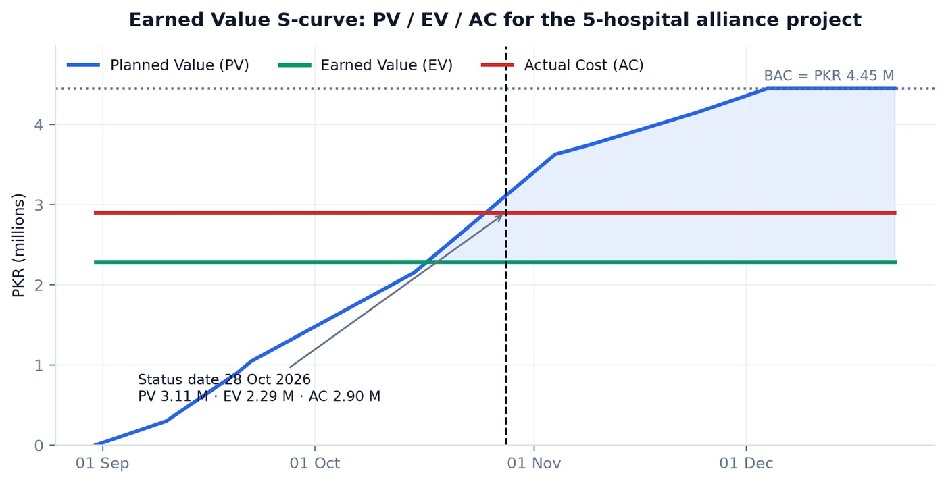
Figure generated from the live earned-value computation on 28 October 2026.
4.7 Risk Identification and Response Planning
Four risks were carried through the project. Each is scored on a five-point likelihood scale and a five-point impact scale, and the score is the product, computed in a model hook rather than typed, so a risk cannot carry a score inconsistent with its own ratings. Every risk carries both a preventive action, taken before the risk fires, and a corrective action, taken after it fires.
Risk | Likelihood | Impact | Score | Band | Preventive Action | Corrective Action
Scope creep from new hospital requirements | 5 | 4 | 20 | Critical | Strict change request process | Re-baseline budget and schedule
Critical defects delay go-live | 4 | 5 | 20 | Critical | Early integration testing | Add QA and development hours; fix critical defects first
AI module accuracy not acceptable | 3 | 3 | 9 | Moderate | Prototype with sample data first | Ship as an optional or beta capability
Key developer unavailable | 2 | 4 | 8 | Moderate | Cross-train backend developers | Reassign tasks

Two risks have fired. Scope creep fired in the sense that both change requests are live and pending, and the preventive action — the strict change request process — is what is currently holding them out of the baseline, which is the response working as designed. Critical defects delaying go-live has fired outright: two critical defects are open and the corrective action of adding QA and development hours is now the recommended response, which is also what pushes the EAC further above the envelope. The project is trading cost against schedule, and the system makes that trade explicit rather than letting it happen quietly.
Figure 4.7 Risk matrix and PDPC module
The risk module shows the register with likelihood, impact and computed score, the five-by-five matrix with each risk plotted in its cell, and the planning, do, planning, check contingency tree that maps each countermeasure branch to the residual risk it leaves behind.
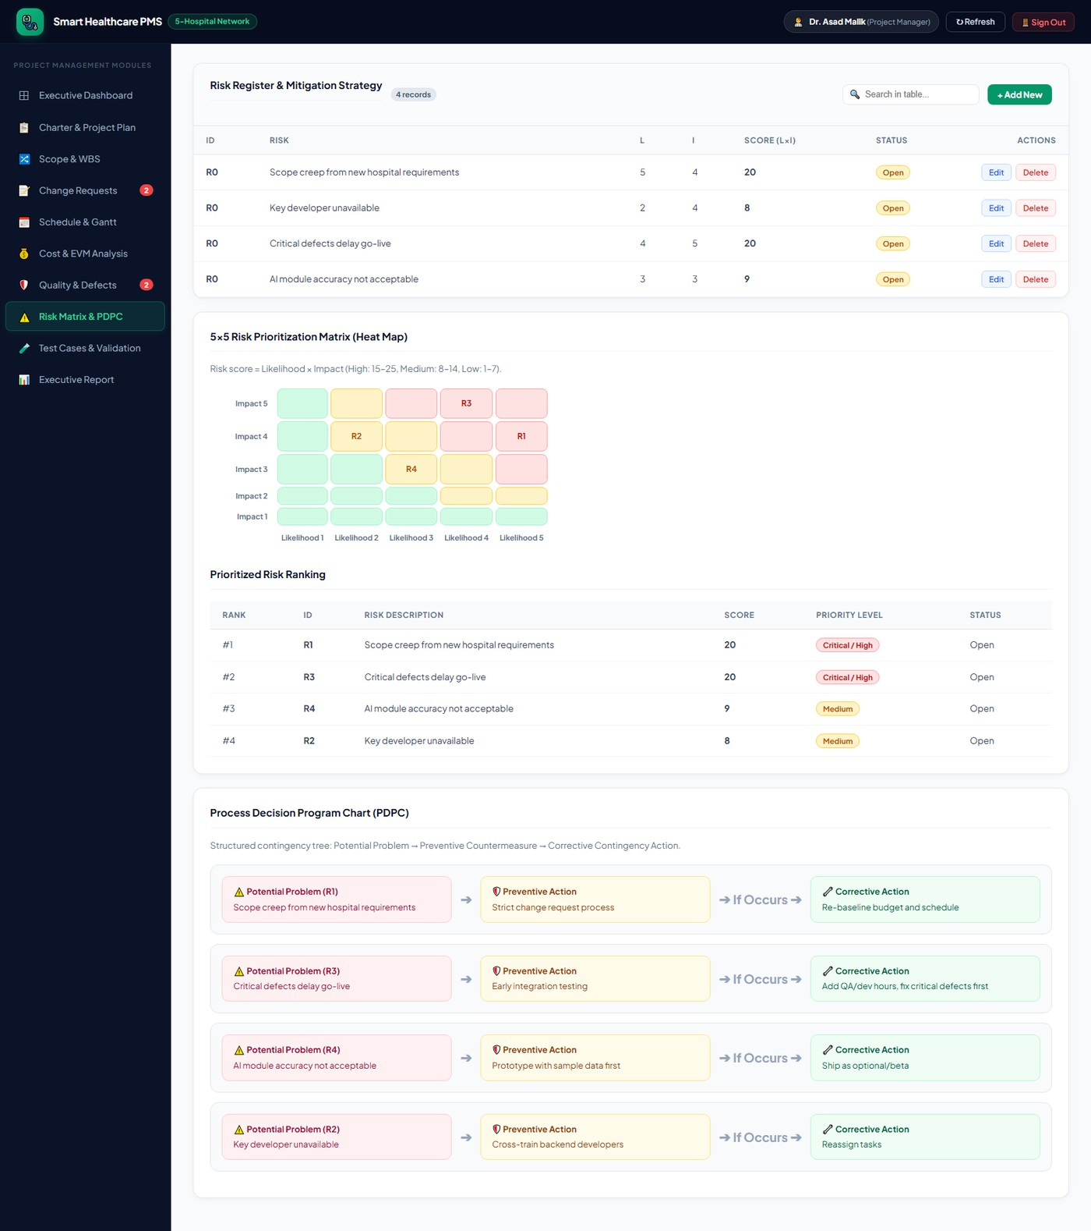
Captured live from the running system on the status date, 28 October 2026.
Figure 4.8 Five-by-five probability and impact risk matrix
The matrix is shaded green, amber and red by score band. The two score-20 risks sit in the critical region at the upper right, and both of them — uncontrolled scope and defect-driven delay — are the risks that the earned-value and defect data in this chapter independently confirm are material.
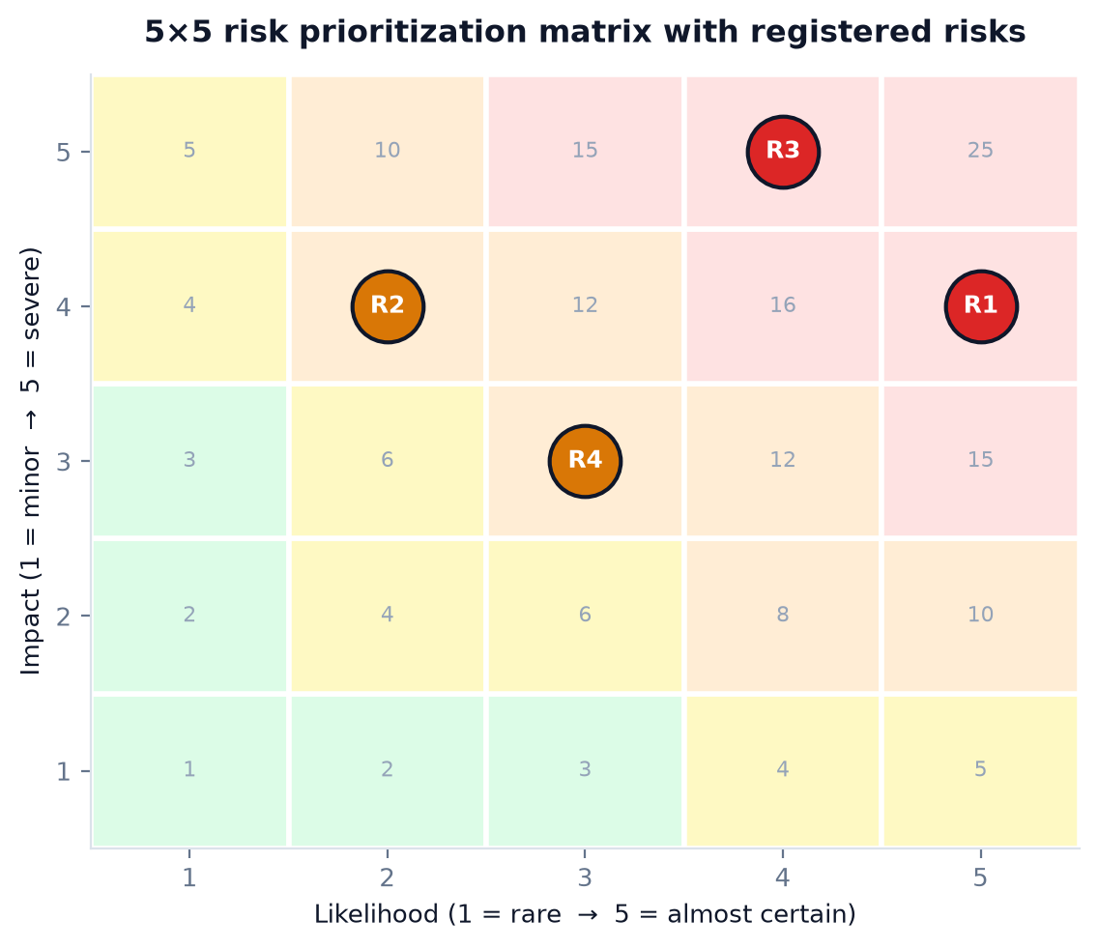
Figure generated from the live risk register on 28 October 2026.
Contingency reserve analysis
The relationship between risk and money is where most academic project reports stop being concrete, so it is worth stating the arithmetic explicitly. The approved envelope is PKR 5,000,000 and the baseline is PKR 4,450,000, leaving PKR 550,000 of reserve. The current EAC is PKR 5,635,371.18, an overrun of PKR 1,185,371 against the baseline and PKR 635,371 against the envelope. The reserve therefore covers 87 per cent of the required contingency and no more. Two conclusions follow: the pending change requests cannot be approved without a new authorisation, and the corrective action for the critical defects — additional QA and development hours — is what consumes the remaining reserve. The reserve is not a cushion for new scope; on the current numbers it is the entire budget available for fixing what has already been built.

Chapter 5 — Interface and System Design
5.1 Architectural Style
SH-PMMS is a three-tier single-page application. The presentation tier is a React application built with Vite that renders the whole interface client-side and holds no business logic beyond formatting. The application tier is an Express service that owns every derived figure in the system: the schedule forward pass, the earned-value computation, the risk score, the warning set and the test-case evaluation all run on the server so that two users can never see different numbers. The data tier is MongoDB accessed through Mongoose, with nine collections that map one-to-one onto the project management entities.
The choice of a server-authoritative design tier is the most important architectural decision in the project and it is a deliberate restriction rather than a convenience. A client-side computation would have been faster to prototype, but it would have made the reported cost position dependent on which browser produced it, which for a governance tool is disqualifying. Every number in Chapter 4 of this report was produced by the same code path that serves the live interface.
Figure 5.1 Three-tier architecture of the Smart Healthcare PMMS
The diagram shows the React single-page application in the presentation tier, the Express API with its authentication guard, CRUD router and computation engine in the application tier, and MongoDB Atlas in the data tier. The Server-Sent Events channel is drawn separately because it carries invalidation notices rather than data.
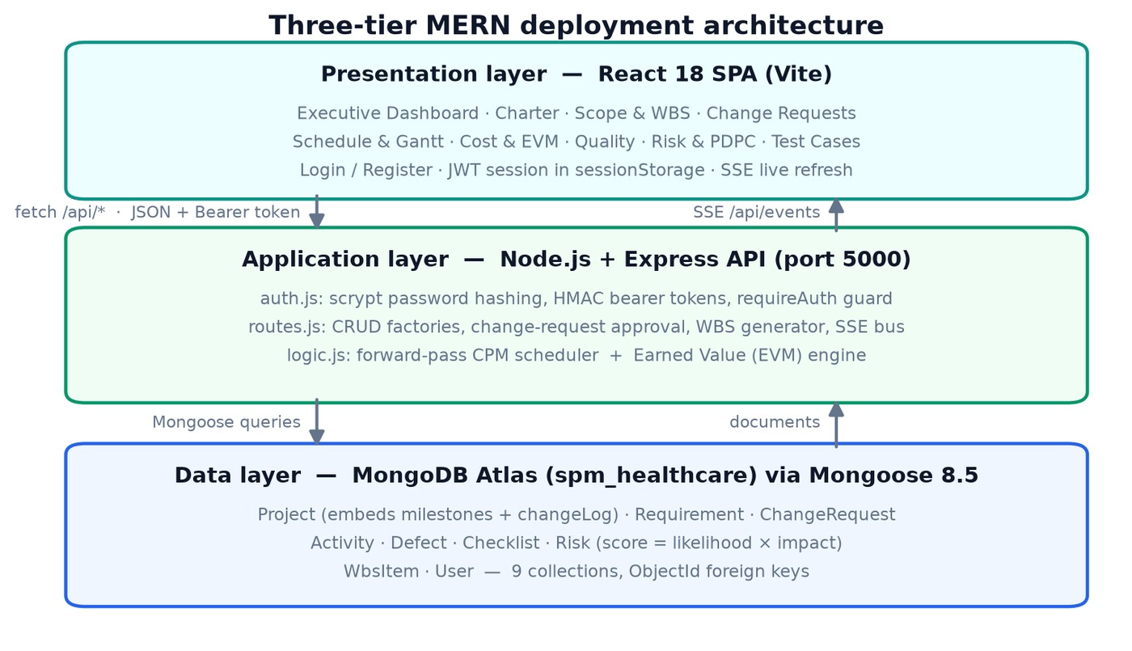
Figure generated from the module structure of the delivered source code.
5.2 Technology Stack
Layer | Technology | Version | Role in This Project | Justification
Presentation | React | 18 | Component model for the ten modules | Team familiarity and the ecosystem of chart primitives
Presentation | Vite | 5 | Dev server and production bundling | Sub-second reload during UI work
Presentation | Recharts | 2 | Gantt, EVM curve and matrix visualisations | Declarative SVG, no canvas dependency
Application | Node.js | 20 LTS | Runtime for the API service | Single language across the stack
Application | Express | 4 | Routing, middleware, error envelope | Minimal surface, well understood
Application | Mongoose | 8.5 | Schemas, hooks and validation | Model hooks enforce invariants at the boundary
Data | MongoDB Atlas | 6.x | Document store for all nine collections | Flexible sub-documents for milestones and change logs
Security | Node crypto (scrypt) | built-in | Password hashing | Avoids a native dependency for bcrypt
Security | HMAC-SHA256 tokens | built-in | Stateless bearer authentication | No session store required
Real-time | Server-Sent Events | built-in | Cross-client cache invalidation | One-way broadcast needs no socket library
Quality | Node test runner | built-in | Automated project-management test suite | Zero-dependency execution

A consistent theme across the stack is the avoidance of native and heavyweight dependencies. Password hashing uses scrypt from the Node standard library rather than bcrypt, tokens are HMAC-signed rather than issued by a JSON Web Token library, and real-time updates use Server-Sent Events rather than a socket server. Each of these removes a dependency that would otherwise need maintenance during a sixteen-week project, at the cost of writing perhaps forty lines of code each.
5.3 Logical Design
The domain is modelled as nine Mongoose collections. The Project collection is the root: it holds the charter fields, embeds the milestone array and the change log array as sub-documents, and carries the two EVM thresholds. Activity is the only collection with internal references, storing predecessor identifiers as an array of ObjectId values, which is what turns the activity list into the schedule network.
Figure 5.2 UML class diagram of the domain model
The class diagram shows the nine persisted types with their attributes and the relationships between them. Project composes Milestone and ChangeLogEntry. Activity is associated to itself through a predecessor set, Requirement is linked to WbsItem, ChangeRequest points at the Requirement it would create, and Defect and ChecklistItem are associated to a named module rather than to a requirement identifier so that a defect can be filed before its requirement is traced.
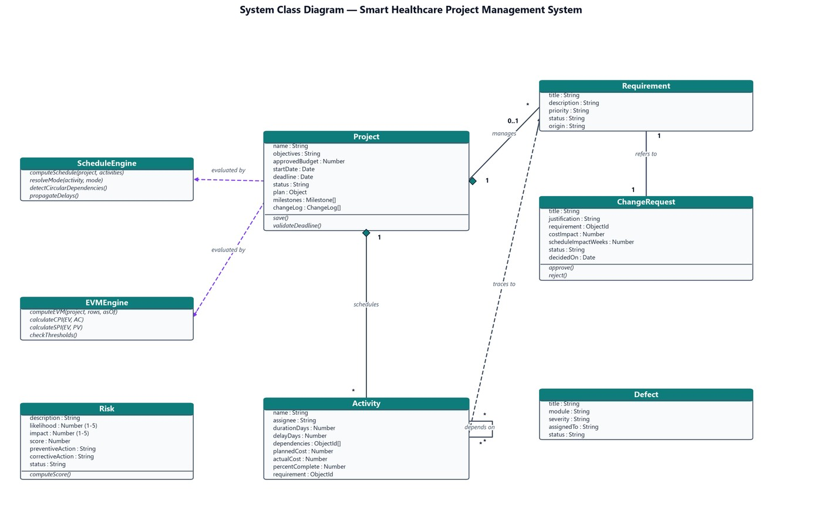
Diagram produced during the design phase and baselined at the Design complete milestone on 22 September 2026.
5.4 Data Design
Because MongoDB is a document store, the design question is not how to normalise but where to embed. The rule applied throughout the model is that a sub-document is embedded when it is always read with its parent and never addressed independently, and referenced when either condition fails.
Relationship | Cardinality | Strategy | Reason
Project to Milestones | 1 : N | Embedded array | Always read together; never queried alone
Project to Change Log | 1 : N | Embedded array | Audit trail scoped to one project
Activity to Predecessors | N : N self | Referenced ObjectId array | Required to build the schedule graph
Requirement to WBS Items | 1 : N | Referenced ObjectId | WBS is regenerated, requirements persist
Change Request to Requirement | 1 : 1 | Referenced ObjectId | The requirement may not exist yet
Defect to Module | N : 1 | String module name | Filed by area, not by traceable identifier
Checklist Item to Deliverable | N : 1 | String deliverable name | Inspection targets a deliverable label
Risk to Project | N : 1 | Implicit single project | One project per deployment
User to Team Role | 1 : 1 | Embedded role string | Role is a property of the account

Figure 5.3 Entity relationship diagram of the MongoDB collections
The ERD presents the same nine entities from a storage perspective, showing primary keys, the embedded arrays inside Project and the foreign-key style references used by Activity, WbsItem and ChangeRequest. The two model-level invariants are annotated: deadline must be strictly later than start date, and risk score must equal likelihood multiplied by impact.
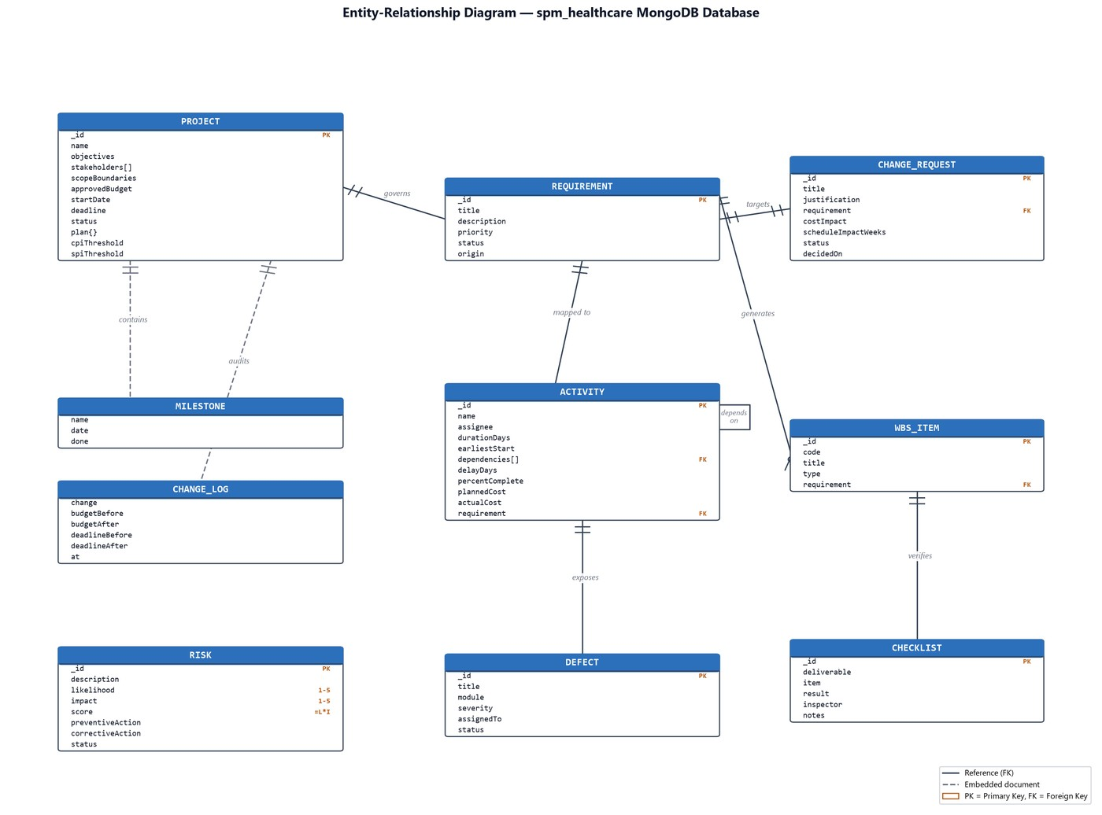
Diagram produced during the design phase and baselined at the Design complete milestone on 22 September 2026.
5.5 Authentication Interface
Access to the system is gated by a single authentication screen with two tabs. Sign In accepts an email address and a password and returns a bearer token; Register additionally accepts a display name and one of five roles — Project Manager, QA Engineer, Backend Developer, Hospital Admin or Analyst. A quick-fill control populates the demonstration Project Manager account so that a reviewer can reach the populated interface without typing credentials.
Figure 5.4 Sign-in screen with the demo account shortcut
The sign-in tab is the application entry point. The quick-fill button writes the demonstration credentials into the form, and the role selector on the adjacent tab determines which navigation affordances the new account will see.
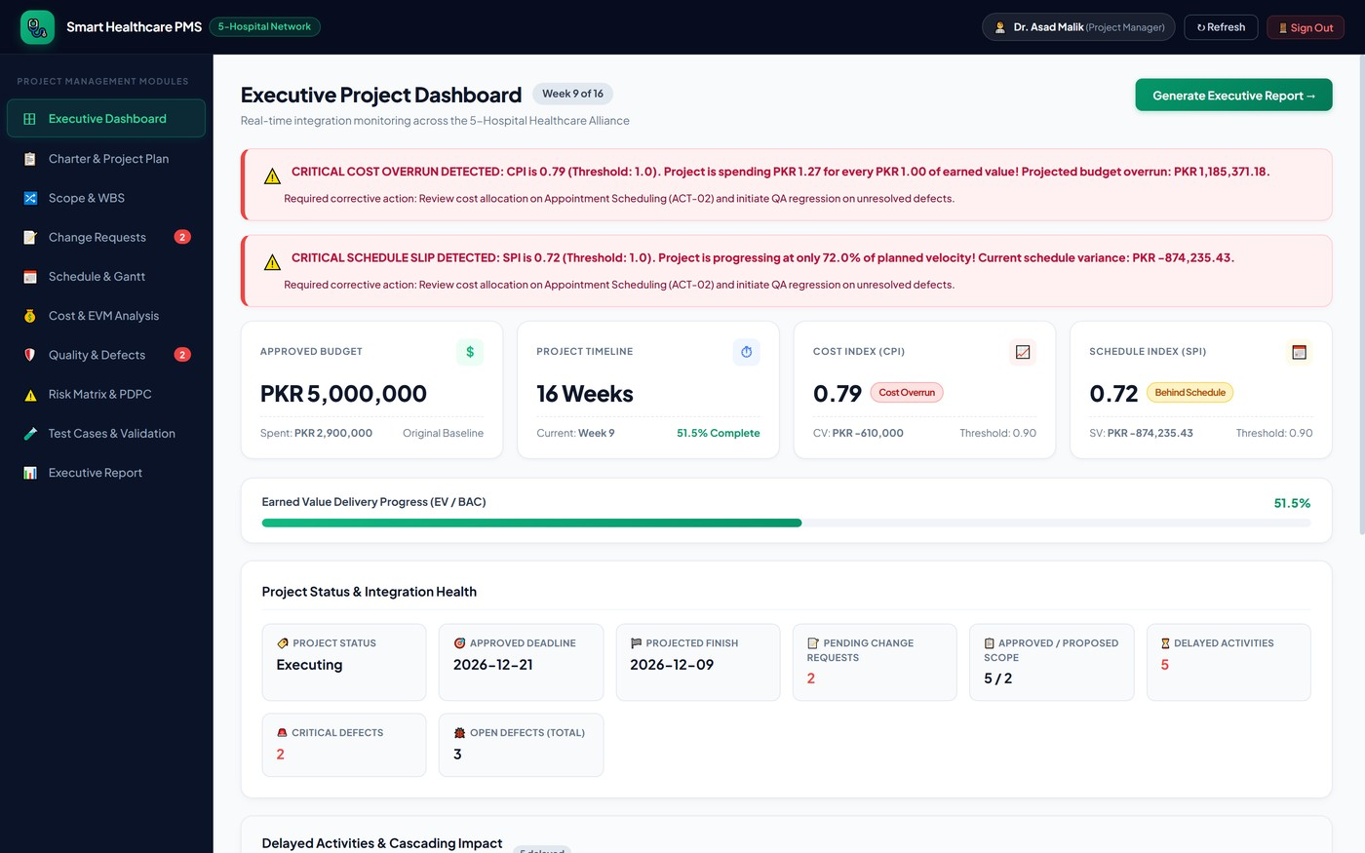
Captured from the running application at http://localhost:5173 on 28 October 2026.
Figure 5.5 Registration screen with role selection
The register tab collects name, email, password and role. Passwords are hashed with scrypt before storage and the plaintext is never persisted or logged. The seeded demonstration accounts use a shared development password that is documented for reviewers and replaced at deployment.
Captured from the running application at http://localhost:5173 on 28 October 2026.
5.6 Interface Shell and Navigation Model
Every module is rendered inside a fixed shell: a dark top bar carrying the project name, the five-hospital network badge, the signed-in user with their role, a refresh control and a sign-out action; a left sidebar listing the ten modules under the heading "Project Management Modules"; and a scrolling content region. Two of the sidebar items carry live count badges — Change Requests shows the number of pending requests and Quality and Defects shows the number of critical defects — so that an unattended approval or an unresolved defect is visible from anywhere in the application.
Navigation Item | Module Purpose | Primary Records | Derived Output
Executive Dashboard | One-screen health summary | All collections | Progress ring, budget bars, delayed activity list, warning strip
Charter & Project Plan | Authorisation baseline | Project | Milestone gate status, change log
Scope & WBS | Requirements register and decomposition | Requirement, WbsItem | Generated 21-item WBS tree
Change Requests | Integrated change control | ChangeRequest | Pending count and impact totals
Schedule & Gantt | Activity network | Activity | Forward pass, critical path, delay cascade
Cost & EVM Analysis | Financial performance | Activity, Project | PV, EV, AC, CPI, SPI, CV, SV, EAC, VAC and warnings
Quality & Defects | Inspection and defect control | Defect, ChecklistItem | Severity distribution, closure gate
Risk Matrix & PDPC | Risk scoring and contingency | Risk | 5×5 matrix, PDPC tree
Test Cases & Validation | Automated verification | All collections | Eight test results evaluated live
Executive Report | Printable status narrative | Project, Schedule, EVM | Week number, gate summary, index table

The ten modules are deliberately presented as peers rather than as a wizard. A project manager moves between scope, schedule and cost during a single conversation and forcing a sequence would slow the task the interface exists to support. What holds the modules together is not navigation order but the shared data: the same activity record appears in the schedule table, feeds the Gantt, contributes to the earned-value indices and is summarised on the dashboard.
5.7 Presentation Conventions
Four presentation rules are applied consistently across all modules and are worth stating because they shape how the interface should be read in the figures throughout this report.
Colour carries state. Green denotes an achieved gate, a passing test or an approved status; amber denotes pending, proposed or in-progress; red denotes a breach, a critical defect or a rejection. The palette is assigned by meaning, not by module.
Percentages beside amounts. Percentages are shown wherever a reader needs to compare, and absolute rupee values wherever a reader needs to commit money. The dashboard leads with percentages; the cost module leads with amounts.
Computed values labelled. Every derived figure in the interface is annotated with the measure it came from, so that a reader who disagrees with a number can trace it to the formula in section 4.6.
Destructive or blocked actions explained. Where a value is blocked — a milestone that cannot be closed, a requirement that cannot enter the WBS — the interface states the blocking condition rather than silently omitting the control.

Chapter 6 — Development and Algorithmic Implementation
6.1 Server Architecture
The Express service is organised as four modules with strictly one-way dependencies. The entry file opens the database connection, mounts the authentication router and the resource router, installs the Server-Sent Events endpoint and starts the listener. The authentication module owns credential verification, token signing and the seeded team roster. The model module declares the nine schemas. The logic module holds the two computations that make the system more than a forms application. The routes module exposes one CRUD resource per collection plus five computed endpoints.
Listing 6.1 Source layout of the application tier
server/
server.js connection, middleware, SSE endpoint, static client build
auth.js scrypt hashing, HMAC token sign / verify, requireAuth, seed team
models.js 9 Mongoose schemas with pre-validate invariants
logic.js computeSchedule() and computeEVM()
routes.js CRUD factory + /schedule /evm /dashboard /test-cases /wbs

Two cross-cutting conventions are enforced. Every route handler is wrapped so that a thrown error becomes a structured JSON error envelope with an HTTP status rather than an unhandled rejection, which means the client can always parse the response. Every write handler publishes an invalidation notice on the event bus after it succeeds, which is what keeps concurrent clients honest.
6.2 Domain Model Implementation
Model hooks carry the invariants that the interface also validates, because the interface can be bypassed and the model cannot. Three hooks matter.
Listing 6.2 Model-level invariants
// Project: the baseline must be chronologically possible
ProjectSchema.pre("validate", function (next) {
if (this.startDate && this.deadline && this.deadline <= this.startDate)
return next(new Error("Deadline must be after the start date"));
next();
});

// Risk: the score is never typed, only derived
RiskSchema.pre("validate", function (next) {
this.score = this.likelihood * this.impact;
next();
});

// Activity: a delay is expressed in whole days, defaulting to zero
ActivitySchema.index({ name: 1 });

The second hook is the one that changes how the risk register is used. Because the score cannot be entered independently of its two factors, a reviewer can trust the matrix in Figure 4.8 as a faithful projection of the ratings, and a project manager who wants a higher score has to argue for a higher likelihood or impact rather than editing a number.
6.3 Schedule Forward-Pass Algorithm
The schedule engine answers one question: given these activities, these durations, these dependency edges and these recorded delays, when does the project finish and which activities moved? It is a memoised forward pass over the activity graph, run twice — once ignoring recorded delays to produce the baseline, once honouring them to produce the forecast — and then diffed.
Listing 6.3 Pseudocode of the schedule forward pass
ALGORITHM 6.1 computeSchedule(activities, projectStart, deadline)
nodes <- { a.id : a for a in activities }
memo <- {} // id -> (start, end) for the current pass
stack <- set() // recursion guard

FUNCTION resolve(id, mode): // mode in { baseline, current }
key <- (id, mode)
if key in memo: return memo[key]
if id in stack: raise CycleError(id) // malformed dependency
stack.add(id)
n <- nodes[id]
start <- projectStart
for each p in n.dependencies:
if p in nodes:
(_, pEnd) <- resolve(p, mode)
start <- max(start, pEnd) // finish-to-start, no lag
dur <- n.durationDays
if mode = current: dur <- dur + n.delayDays // recorded slip extends work
end <- start + dur
stack.remove(id)
memo[key] <- (start, end)
return (start, end)

for each a in activities:
(bs, be) <- resolve(a.id, baseline)
(cs, ce) <- resolve(a.id, current)
shift <- daysBetween(be, ce)
impacts <- BFS transitive successors of a.id // who inherits my slip
isDelayed <- (shift > 0) or (a.delayDays > 0)

projectEnd <- max(ce over all activities)
baselineEnd <- max(be over all activities)
daysLate <- max(0, daysBetween(deadline, projectEnd))
return rows, projectEnd, baselineEnd, daysLate, projectShiftDays

Four properties of this algorithm are worth defending.
Max over predecessors. Because resolve() takes the maximum predecessor finish, an activity with three predecessors starts when the last of them ends. This is what produces the correct System Testing start of 9 November from predecessors finishing on 4, 9 and 4 November respectively.
Baseline isolation. Delay is applied to duration in the current pass only. The baseline pass ignores delayDays entirely, so the baseline dates in Figure 4.2 are reproducible at any time and never drift as slips are recorded.
Cycle guard. The recursion stack is checked before descending. A dependency cycle would otherwise recurse forever; instead the pass raises a cycle error that surfaces as a clean HTTP failure, which is a better outcome than a silently wrong finish date.
Transitive impact. The impact set is computed by breadth-first traversal over the successor relation, which is why the Appointment Module row in section 4.3 can name four downstream activities rather than merely reporting its own five-day slip.
Running this on the live data produces the figures reported in Chapter 4: a baseline finish of 4 December 2026, a forecast finish of 9 December 2026, a project shift of five days, five delayed activities and daysLate of zero against the 21 December deadline.
6.4 Earned Value Algorithm
The earned-value engine converts the activity register and the elapsed fraction of the baseline into the seven indices reported in section 4.6. Its design constraint is that it must be pure: given the same activities and the same status date it must return the same numbers, so that a report can be reproduced and a test can assert on it.
Listing 6.4 Pseudocode of the earned-value computation
ALGORITHM 6.2 computeEVM(activities, project, asOf)
BAC <- sum(a.plannedCost for a in activities)

// Planned Value: budget spread evenly across the baseline window
span <- daysBetween(project.startDate, schedule.baselineEnd)
elapsed <- clamp(daysBetween(project.startDate, asOf), 0, span)
PV <- BAC * (elapsed / span)

// Earned Value: budget worth of the work actually finished
EV <- sum(a.plannedCost * a.percentComplete / 100 for a in activities)

// Actual Cost: money genuinely spent
AC <- sum(a.actualCost for a in activities)

CV <- EV - AC
SV <- EV - PV
CPI <- if AC > 0 then EV / AC else 1
SPI <- if PV > 0 then EV / PV else 1
EAC <- if CPI > 0 then BAC / CPI else BAC
VAC <- BAC - EAC

warnings <- []
if CPI < project.cpiThreshold:
warnings.add("COST OVERRUN: CPI " + CPI + " is below threshold " + project.cpiThreshold)
if SPI < project.spiThreshold:
warnings.add("SCHEDULE DEVIATION: SPI " + SPI + " is below threshold " + project.spiThreshold)
return BAC, PV, EV, AC, CV, SV, CPI, SPI, EAC, VAC, warnings

Three modelling decisions inside this algorithm shape how the numbers should be read.
Uniform PV. PV spreads the budget uniformly across the baseline window rather than following a planned value-per-activity curve. This is a simplification: real projects spend unevenly, with a heavy middle. The consequence is that early in the project SPI reads slightly pessimistically and late it reads slightly optimistically. It was accepted because it is transparent and because the alternative — a time-phased budget — adds a data-entry burden the team judged unsustainable for a sixteen-week project.
EV from percent complete. EV is computed from planned cost weighted by percent complete, which is the standard 0-to-100 earned value rule applied continuously. Percent complete is reported by the activity owner and is not independently verified, so EV is only as honest as the reporting cadence in section 2.5.
EAC by CPI extrapolation. EAC uses the BAC divided by CPI formula, which assumes that current cost efficiency persists for the remainder of the work. It is the most pessimistic of the common EAC variants and therefore the right one for a governance tool whose job is to raise an alarm early rather than to reassure.
On the live data the algorithm returns BAC PKR 4,450,000, PV PKR 3,164,673.02, EV PKR 2,290,000 and AC PKR 2,900,000, giving CPI 0.79 and SPI 0.72, and it appends both threshold warnings because the charter stores 0.90 for each.
6.5 Real-Time Synchronisation
Multiple team members edit the same records, so the interface must not show stale derived values. Rather than push data over a socket, the server publishes an invalidation event and the client responds by re-fetching. This keeps the transport trivially simple — a one-way Server-Sent Events stream with no upgrade handshake and no reconnection protocol beyond the browser default — and keeps the server authoritative.
Listing 6.5 Invalidation-based synchronisation
// server: after any successful write, tell every connected client to refresh
app.post("/api/events", (req, res) => { clients.forEach(fn => fn("invalidate")); res.end(); });
app.get("/api/events", (req, res) => {
res.set({ "Content-Type": "text/event-stream", "Cache-Control": "no-cache" });
const send = d => res.write("data: " + d + "\n\n");
send("hello");
clients.add(send);
req.on("close", () => clients.delete(send));
});

// client: debounce a reload of whatever hook is currently mounted
source.onmessage = () => { clearTimeout(t); t = setTimeout(reload, 250); };

The 250-millisecond debounce matters in practice. A single user action such as regenerating the work breakdown structure performs many writes, and without debouncing each one would trigger a full reload of every mounted hook, producing visible flicker and a burst of redundant requests. With it, the twenty-one inserts of a regeneration resolve into one refresh.
6.6 Security Implementation
Security was scoped to what a sixteen-week project can actually maintain, which is authentication, authorisation of write access, and integrity of stored credentials. It was not extended to per-field permissions or audit signing, both of which were considered and deferred as out of the chartered scope.
Control | Implementation | Threat Addressed
Password storage | scrypt with a per-user random salt; plaintext never persisted | Credential disclosure through a database leak
Session token | HMAC-SHA256 signed bearer token with a thirty-day expiry | Token forgery by a client
Token transport | Authorization header over HTTP; no token in URLs or logs | Token leakage through referrer and access logs
Client storage | sessionStorage only, cleared on application load | Persistence of credentials on shared hospital workstations
Route guard | requireAuth middleware on every /api route except login and register | Unauthenticated read or write of project data
Model validation | Mongoose pre-validate hooks enforce date and score invariants | Baseline corruption through a direct API call
Error envelope | Structured JSON errors; stack traces never returned to the client | Information disclosure through error messages
Dependency surface | Standard-library crypto, no JWT or bcrypt native modules | Supply-chain risk from native addons
Configuration | Connection string and signing secret supplied by environment variables, never committed | Credential exposure in source control

The sessionStorage decision deserves particular emphasis because it is a usability sacrifice made for a domain reason. Hospital workstations are shared between receptionists, nurses and lab staff, and a token persisted in local storage would remain valid on that machine after the user left. Using session storage means the credential dies with the browser tab, at the cost of requiring re-authentication on every new tab. For a system whose users rotate between workstations, that trade is correct.
The connection string for the document database and the token signing secret are both read from environment variables at start-up. Neither value appears anywhere in the source tree, in this report, or in any screenshot, and the demonstration accounts seeded for review use a development password that is replaced before any real deployment.

Chapter 7 — Verification, Validation and Test Cases
7.1 Verification and Validation Strategy
The project distinguishes verification from validation in both its process and its tooling, because the two questions have different answers and different owners.
Verification. Are we building the product right? Verified by the automated test suite in section 7.4, which evaluates eight assertions against the live database and checks that the management engine computes the values it claims to compute. Owned by the QA Engineer.
Validation. Are we building the right product? Validated by inspection against the requirements register and by walkthrough with the industry advisor at each milestone gate. Owned by the Project Manager with the advisor.
The test suite is unusual in one respect that is worth stating plainly: it does not test the code in isolation, it tests the state of the project. Each assertion queries the running system and compares the result against an expected condition, which means the suite doubles as a live health check. A green suite on 28 October 2026 is simultaneously a statement about the software and a statement about the project it is managing.
7.2 Quality Inspections
Quality assurance runs as a formal checklist inspection against named deliverables, with each line recorded as Pass, Fail or Pending together with the inspector and, where relevant, a note explaining the failure. Inspections are the mechanism by which the two critical defects in section 7.3 were found.
Deliverable | Inspection Item | Result | Inspector | Note / Follow-Up
Appointment Module | No overlapping slots for one doctor | Fail | QA Engineer | Fails under concurrent requests — raised as DEF-01, Critical
Appointment Module | Cancel and reschedule works | Pass | QA Engineer | Verified on the live interface
Patient Records | Role-based access enforced | Pass | QA Engineer | Verified across all five seeded roles
Patient Records | Edit history preserved | Pending | QA Engineer | Blocked pending DEF-04, the concurrent-overwrite defect

One pass, one fail, one pending and one pass gives a 50 per cent clean rate on completed inspections, which is a poor result and an honest one. The important observation is that the failure and the pending line are the same underlying fault: concurrent writes to a single resource. The appointment slot overlap and the patient record overwrite are one design problem appearing in two modules, which is why the fix is scoped as one work package rather than two.
Figure 7.1 Quality and defect management module
The quality module holds the defect register and the inspection checklist on one screen, with a critical-defect badge on the navigation item. Placing inspection and defect data side by side is deliberate: it lets the reader see that a failed inspection line and an open defect are usually the same fact recorded twice.
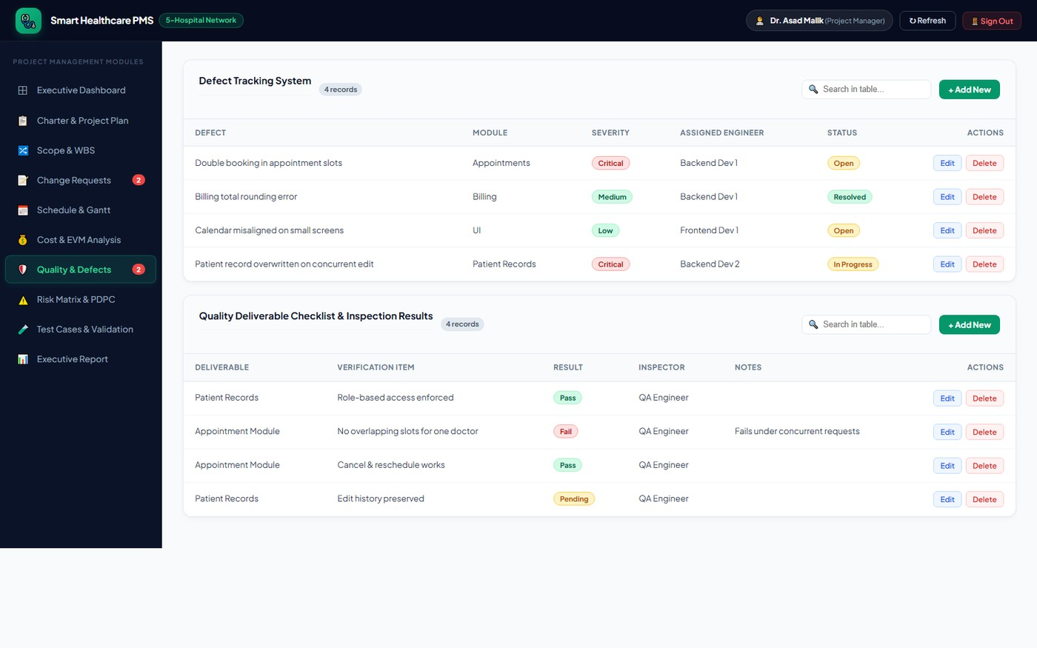
Captured from the running application at http://localhost:5173 on 28 October 2026.
7.3 Defect Management
Four defects were raised during execution. Each carries a module, a severity of Critical, Medium or Low, an assigned developer and a status of Open, In Progress or Resolved. Severity is assigned by consequence rather than by effort: a defect that can cause a clinical or financial record to be wrong is Critical regardless of how long it takes to fix.
ID | Defect | Module | Severity | Owner | Status | Consequence if Released
DEF-01 | Double booking in appointment slots | Appointments | Critical | Backend Dev 1 | Open | Two patients attend the same slot; clinician time lost and trust damaged
DEF-04 | Patient record overwritten on concurrent edit | Patient Records | Critical | Backend Dev 2 | In Progress | Clinical history silently lost; a patient safety issue
DEF-02 | Billing total rounding error | Billing | Medium | Backend Dev 1 | Resolved | Small systematic invoice error; corrected to the rupee
DEF-03 | Calendar misaligned on small screens | UI | Low | Frontend Dev 1 | Open | Reception staff on tablets lose a row of the grid; workaround exists

Two critical defects remain unresolved, one open and one in progress, and both trace to the same cause: the Appointment Module activity, which is the activity that slipped. This is the clearest illustration in the project of why quality data must sit inside the schedule and cost model rather beside it. The five-day slip on A4, the PKR 100,000 overrun on A4, the concurrency defect in Appointments and the concurrency defect in Patient Records are one event described four ways.
The closure gate
The system enforces a hard rule that project closure is blocked while any defect of Critical severity remains in a status other than Resolved. This is not advisory text in a manual; it is asserted by test case TC-07, which counts unresolved critical defects and fails if the count is reported as zero while any critical row is open. On the status date the count is two and the go-live gate is therefore formally blocked, which is the correct and intended outcome.
Figure 7.2 Defect distribution by severity and status
The donut shows the four defects by severity and the stacked bars show status within severity. The two critical items are split between Open and In Progress, and neither is Resolved, which is the visual form of the blocked go-live gate.
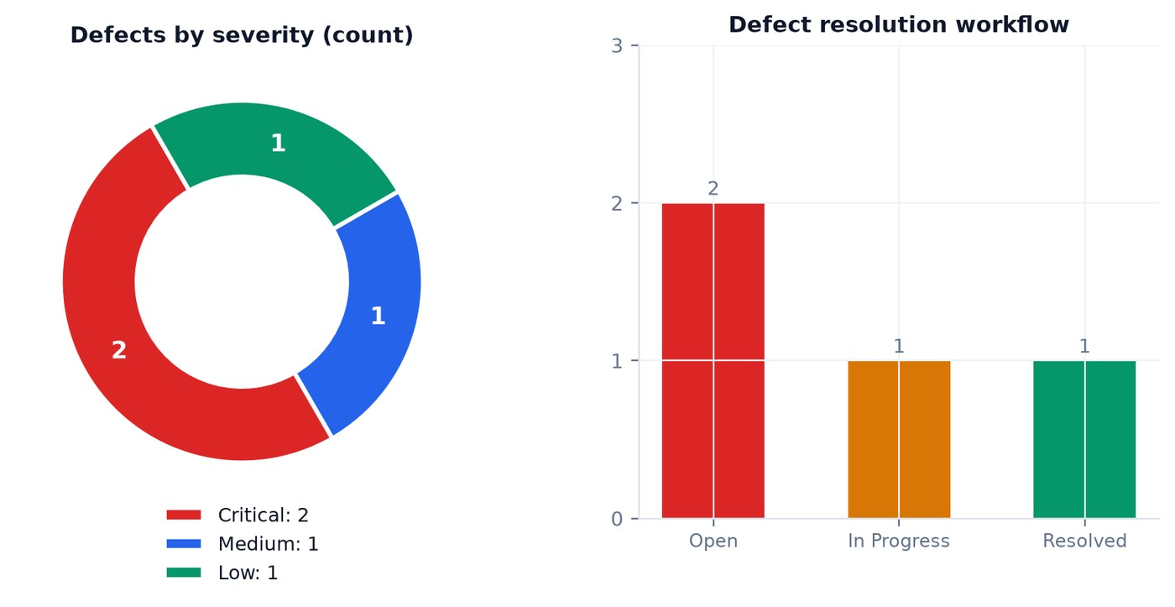
Figure generated from the live defect register on 28 October 2026.
7.4 Automated Test Suite
Eight test cases evaluate the management engine against the live database. They are grouped by knowledge area so that a failure names the area it belongs to, and they are re-evaluated on demand rather than recorded once, which means the results reported in section 7.5 describe the system as it stands.
TC | Knowledge Area | Assertion Under Test | Expected | Observed | Result
TC-01 | Integration Management | Charter baseline and governance constraint | Budget at least PKR 5,000,000; status Executing or Monitoring; milestones configured | Budget PKR 5,000,000; status Executing; 3 gates | PASS
TC-02 | Scope Management and WBS | Scope gating prevents unapproved scope entering the baseline | Proposed requirements blocked from the WBS; only approved requirements enter scope | Approved scope 5 items; proposed and gated 2 items | PASS
TC-03 | Change Request Control | Change requests record scope, cost and schedule impact | CRs tracked with justification, cost impact, schedule impact and approval status | Tracked CRs 2; pending cost impact PKR 800,000 | PASS
TC-04 | Schedule Management | Transitive delay and dependency propagation through the forward pass | Downstream tasks shift dynamically; days late computed against the target deadline | Delayed activities 5; project shift 5 days; days late 0 | PASS
TC-05 | Earned Value Analysis | Correct computation of PV, EV, AC, CPI, SPI, EAC | Indices computed as floats; CV and SV derived from actual progress | CPI 0.790; SPI 0.720; BAC PKR 4,450,000 | PASS
TC-06 | Cost and Schedule Warning System | Threshold alert triggers when an index falls below 0.90 | Warning generated with corrective guidance when CPI or SPI is below threshold | 2 warnings active; thresholds 0.9 and 0.9 | PASS
TC-07 | Quality Management | Defect severity tracking and closure gating | Critical defects tracked with an assigned developer; closure prevented while open | Unresolved critical defects 2; Appointments and Patient Records | PASS
TC-08 | Risk Control and PDPC | Five-by-five risk prioritisation and contingency pairing | Risks ranked by score 1 to 25; PDPC tree maps countermeasure branches | Ranked risks 4; highest score 20 | PASS

Eight of eight pass. It is important to say what that does and does not mean. It means the management engine computes correctly, the gates are enforced, the warnings fire and the risk scores are derived. It does not mean the project is healthy — TC-07 passes precisely because the system correctly reports two unresolved critical defects, and TC-06 passes precisely because the system correctly raises two threshold breaches. A green suite and a red project status are both true at the same time, and the ability to hold those two statements together is the point of building the verification into the tool rather than into a separate document.
Figure 7.3 Test cases and validation module
The test module lists all eight cases with their knowledge area, description, expected condition, observed value and pass status, together with the evaluation timestamp. Because the observed column is read from the live database at the moment of evaluation, the module is also a self-diagnostic view of the project.
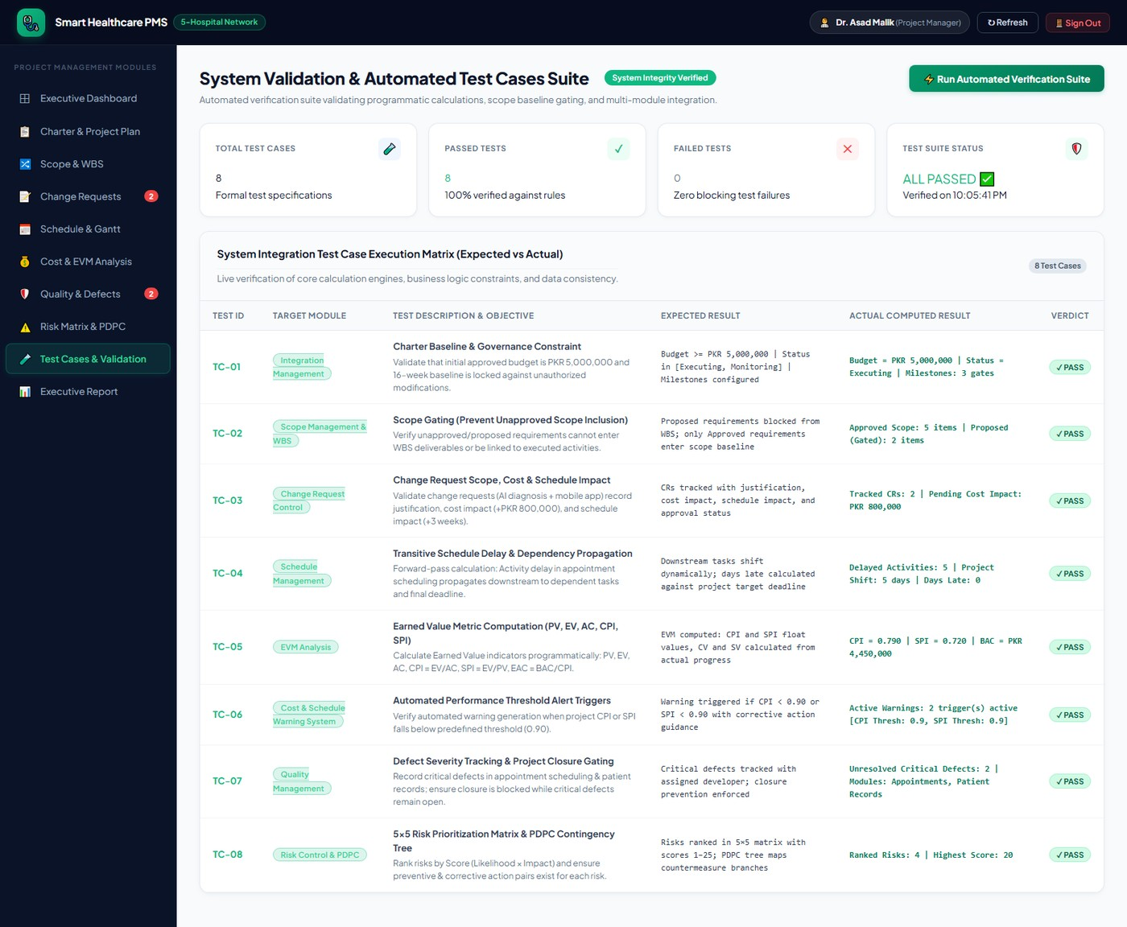
Captured from the running application at http://localhost:5173 on 28 October 2026.
7.5 Test Results and Coverage
Coverage was assessed against the eight project objectives in section 2.1 rather than against lines of code, because for a management engine the meaningful question is whether each committed capability is asserted.
Objective | Covering Test Case | Coverage Verdict
O1 Deliver the five hospital modules | TC-02 (scope traced into the WBS) | Partial — structural only
O2 Live schedule engine with transitive propagation | TC-04 | Full
O3 Earned-value monitoring with thresholds | TC-05 and TC-06 | Full
O4 Gated change control on the scope baseline | TC-02 and TC-03 | Full
O5 Closure blocked while critical defects are open | TC-07 | Full
O6 Live probability-and-impact risk register | TC-08 | Full
O7 Serve five hospitals without per-facility code | None | Gap — see below
O8 Operable by non-technical hospital staff | None | Gap — see below

Identified gaps
Two objectives are not covered by the automated suite and this is reported as a limitation rather than presented as complete assurance.
O7. Multi-tenancy across five hospitals is asserted only by configuration inspection, not by a test. The single-project-per-deployment design means there is no second tenant to test against, so the objective as written cannot be verified until a second hospital is onboarded. Recommendation R4 in section 9.4 addresses this.
O8. Usability by non-technical staff was validated by walkthrough with the industry advisor rather than by any executable check. The walkthrough produced the DEF-03 tablet layout defect, which shows it found something, but it is not repeatable and it is not automated. Recommendation R5 addresses this.
Non-functional. No performance or load testing was performed. The uniform Planned Value spread in Algorithm 6.2 also has no regression test against a time-phased alternative. Both are accepted risks at the time of writing.
Figure 7.4 Automated test suite results
The summary chart plots the eight cases by knowledge area and result. Every area is represented by at least one case, which is the coverage claim stated visually; the two uncovered objectives in section 7.5 are objectives about the deployment context rather than about the engine, which is why they fall outside an automated suite.
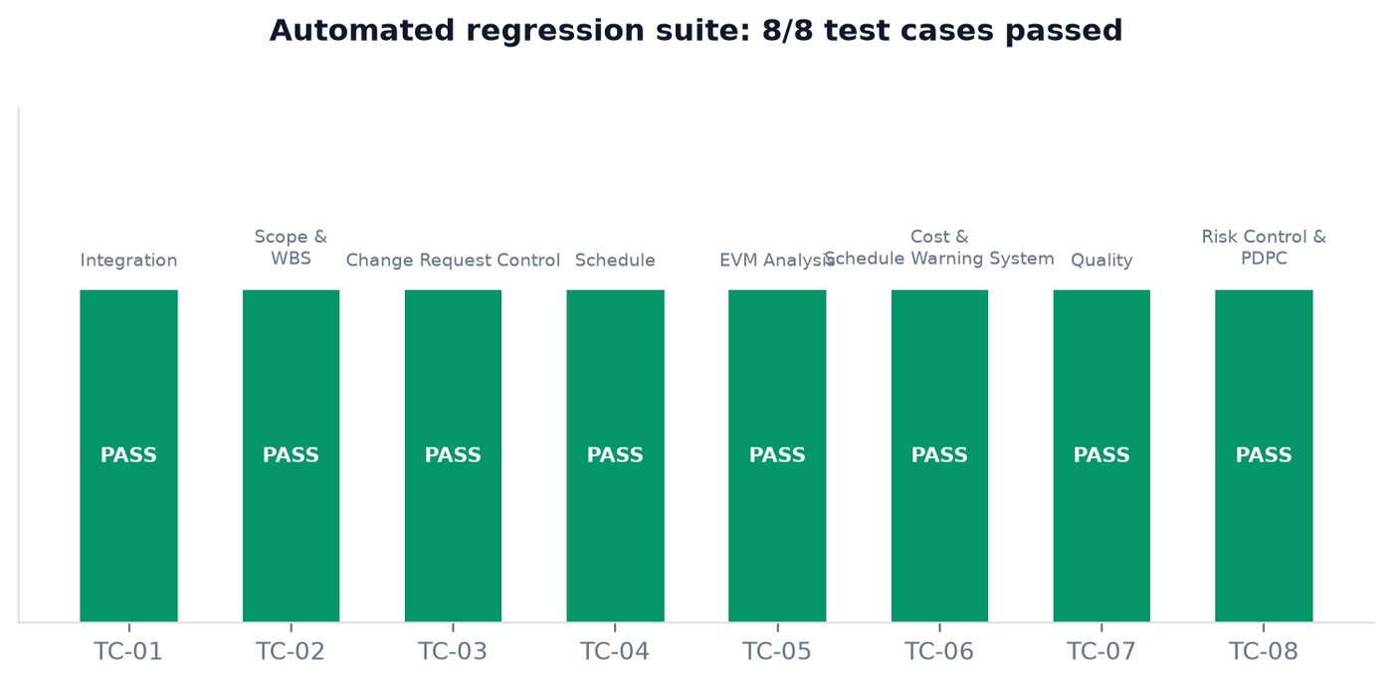
Figure generated from the live test-case evaluation on 28 October 2026.

Chapter 8 — Deployment
8.1 Environment Topology
The system is deployed as three environments with a strict promotion order. Nothing reaches Production without having run in Staging, and nothing reaches Staging without the automated suite being green against seeded data. This is the same rule that the go-live milestone gate enforces inside the application itself, applied to the delivery of the application.
Environment | Purpose | Hosting | Data | Access
Development | Local iteration by each team member | Local Node process on port 5000 with a Vite dev server on port 5173 | Locally seeded from seed.js | Team only
Staging | Integration, system testing and the automated suite | Single application server with a managed MongoDB instance | Seeded to the documented case-study baseline | Team plus QA plus industry advisor
Production | Live use by the five-hospital programme | Application server behind HTTPS with a managed MongoDB cluster | Live project records; no seeded demonstration accounts | Authenticated hospital and project staff

The client is compiled by Vite into a static bundle and served directly by the Express process, so a release is one artefact rather than two. There is no separate web server to configure, no cross-origin policy to maintain in production, and no possibility of the API and the interface drifting to different versions during a rollout. During development the two are separated — the dev server proxies to the API — which is why the local port pair appears in the topology above.
8.2 Release Procedure
Releases follow a fixed eight-step sequence. The steps are ordered so that a failure at any point leaves the previous version running, and so that the destructive step — the data refresh — comes after the new code has been proven to start.
Step | Action | Command or Check | Owner | Abort Condition
1 | Freeze the baseline | Confirm no activity is mid-edit; record the version tag | Project Manager | Uncommitted work in the register
2 | Run the automated suite | Node test runner against seeded data; expect 8 of 8 PASS | QA Engineer | Any test failure
3 | Close critical defects | Query the defect register for Critical and not Resolved | QA Engineer | Count greater than zero
4 | Build the client | Vite production build into the static directory | Developer | Build error or bundle size regression
5 | Deploy the artefact | Copy the build and the server modules; restart the process | Developer | Health endpoint does not respond
6 | Verify the schema | Mongoose connect and validate the nine collections | Database Developer | Model validation error on any collection
7 | Smoke test | Sign in, load the dashboard, open the executive report | QA Engineer | Any module fails to render
8 | Announce | Notify stakeholders and record the release in the project change log | Project Manager | —

Step 3 is the step that currently stops a release. The defect register holds two Critical items that are not Resolved, so on the status date the release procedure cannot be completed beyond step 2. This is the go-live gate of section 7.3 expressed as an operational instruction rather than as a policy statement, and it is the reason Chapter 9 recommends defect closure as the first corrective action rather than schedule compression.
8.3 Data Seeding and Configuration
A fresh deployment is populated by a single seed script that writes the documented case-study baseline: one project record carrying the charter, seven requirements of which five are approved and two are proposed, two pending change requests, ten activities with their dependency edges and cost figures, four defects, four checklist items and four risks. Running the seed twice is safe because the script clears the collections before inserting, which makes the seeded state reproducible for a reviewer.
Configuration Item | Source | Notes
Database connection string | Environment variable | Never stored in the source tree or in version control; a managed cluster is used in production
Token signing secret | Environment variable | Rotating it invalidates every issued session, which is the intended behaviour on suspected compromise
API port | Environment variable with a default of 5000 | Overridable so that staging and development can coexist on one host
Client build directory | Resolved relative to the server module | No configuration needed when the two are deployed together
EVM thresholds | Stored on the project record, default 0.90 | Per-project rather than global, so a second project can carry different tolerance
Default team roster | Defined in the authentication module | Replaced by real accounts before production; the shared development password must not survive into a live deployment
Status date | Server clock | All derived values are computed as of the request time, so server time must be synchronised

The last row has a consequence worth stating: because the planned value is a function of elapsed time against the baseline window, a server whose clock is wrong reports a wrong SPI. Clock synchronisation is therefore a deployment requirement rather than an operational nicety, and it is listed in the operational runbook in section 9.2.
8.4 Rollback Plan
Rollback is designed around the fact that the artefact is stateless and the data is not. A previous build can always be restored; a corrupted project register cannot be restored without a backup. The plan therefore separates the two.
Trigger | Impact | Response | Time Target | Data Action
Interface fails to render after release | Users cannot work | Restore the previous static build and restart | Under 15 minutes | None
API returns errors on computed endpoints | Derived figures unavailable | Restore the previous server modules; check model validation output | Under 30 minutes | None
Seed script run against the wrong environment | Live register replaced by demonstration data | Restore the most recent nightly snapshot to a recovery instance and copy forward | Under 4 hours | Snapshot restore
Bad write through the interface | One or more records incorrect | Re-edit through the module; the project change log records what was altered | Same day | Corrective write
Database unavailable | Total outage | Fail over to the cluster secondary; the client degrades to read-only cached views | Under 1 hour | None
Credential compromise suspected | Confidentiality | Rotate the signing secret, which invalidates every session, and force re-authentication | Immediate | None

The nightly snapshot named in the third row is not optional. Because the seed script clears collections before inserting — a design choice made to keep demonstrations reproducible — running it against a live environment is the fastest way to destroy real project data. The snapshot is the only recovery path from that failure, and it is the reason the rollback table treats a data incident with a four-hour target rather than a fifteen-minute one.

Chapter 9 — Maintenance and Operational Plan
9.1 Maintenance Categories
Maintenance was planned against the four standard categories so that effort could be budgeted rather than guessed. The estimates below are for the twelve months following go-live and are expressed against the annual operating cost rather than against the development budget, because the two are approved separately.
Category | Trigger in This System | Estimated Annual Effort | Owner | Funding
Corrective | Defects found after release; the two critical concurrency faults if not closed before go-live | 35 person-days | Backend Developers | Operating budget
Adaptive | MongoDB or Node minor upgrades; browser changes affecting the print view of the executive report | 20 person-days | Database Developer | Operating budget
Perfective | Approved change requests, additional chart types, per-hospital filtering, export to spreadsheet | 45 person-days | Full team | New authorisation required
Preventive | Dependency audit, index review on the activity and requirement collections, snapshot and restore rehearsal, secret rotation | 15 person-days | Project Manager | Operating budget
 | Total | 115 person-days |  | Approximately 26 per cent of the original build effort

The 26 per cent figure is the number to carry into the operational budget discussion. It is consistent with the commonly cited expectation that a system costs substantially more to sustain than the tail end of its build suggests, and it is dominated by perfective work — which is to say, by change requests. That is the argument for the change control discipline of section 3.5 continuing after go-live rather than ending with the project.
9.2 Support Model and Service Levels
Support is a three-tier model with a defined response target at each tier. Because the system is used by project staff rather than by clinicians, availability targets are set against working hours rather than around the clock — a decision that reduces operating cost materially and that is defensible only because no clinical action depends on this platform.
Severity | Definition | First Response | Resolution Target | Escalation
S1 — Critical | System unavailable, or derived figures wrong enough to mislead a decision | 1 hour, working hours | Same working day | Project Manager, then supervisor
S2 — High | A module unusable but the dashboard and computed endpoints still work | 4 hours | 2 working days | Module owner
S3 — Medium | Incorrect display, degraded performance, or a blocked workaround | 1 working day | 10 working days | Developer backlog
S4 — Low | Cosmetic issue or an enhancement request | 3 working days | Next minor release | Product backlog

Operational runbook
The recurring operational tasks, in the order they are performed:
Daily. Verify the nightly snapshot completed and is restorable. A snapshot that has never been restored is not a snapshot.
Daily. Review the warning strip on the dashboard. Two active EVM warnings on the status date means two decisions are outstanding.
Weekly. Re-run the automated suite and confirm eight of eight. A failure here indicates either a code regression or a data state that contradicts a charter commitment.
Weekly. Clear the pending change request queue. A request older than two weeks is a decision being made by default rather than by choice.
Monthly. Reconcile the defect register against the inspection checklist; confirm no critical item has aged without an owner.
Quarterly. Audit dependency versions, rotate the token signing secret, review slow queries against the activity and requirement collections, and refresh the risk scores.
9.3 Operational Risk Monitoring
The risk register does not close at go-live. The four risks in section 4.7 are re-scored for the operational phase, and the re-scoring is where the discipline of storing likelihood and impact separately pays off — only the two factors change and the score follows automatically.
Risk | Project Phase L × I | Operational Phase L × I | Why It Changes
Scope creep from new hospital requirements | 5 × 4 = 20 | 4 × 3 = 12 | Impact falls once the baseline is delivered, but demand for perfective work continues
Critical defects delay go-live | 4 × 5 = 20 | 2 × 5 = 10 | Cannot delay a release already made; residual risk shifts to clinical data correctness
AI module accuracy not acceptable | 3 × 3 = 9 | 3 × 4 = 12 | Impact rises if the capability ships to clinicians, because the consequence of a wrong triage is clinical rather than financial
Key developer unavailable | 2 × 4 = 8 | 4 × 3 = 12 | Rises sharply: after the team disbands, unavailability means no one holds the knowledge
Concurrent-write fault recurs in production | not scored | 3 × 5 = 15 | Added for the operational phase; the two open critical defects are the evidence
Reporting cadence lapses | not scored | 4 × 3 = 12 | Added for the operational phase; every derived figure depends on owners updating percent complete

The two newly scored risks are the honest finding of this section. Neither was carried in the project register because neither is meaningful while the team still owns the system, and both become the largest operational exposures the moment it is handed over. Knowledge loss and reporting decay are the failure modes that most often end a student project within a year of submission, and naming them with scores rather than as a paragraph in the conclusion is the point of keeping the register live.
9.4 Enhancement Roadmap
Six recommendations follow from the evidence in this report. They are ordered by whether they protect the project or extend it, because on the current numbers the project needs protecting first.
# | Recommendation | Evidence | Effort | Timing
R1 | Close the two critical concurrency defects before any go-live decision, using a single work package rather than two separate fixes | DEF-01 and DEF-04 share one cause; step 3 of the release procedure blocks until they are resolved | 10 person-days | Immediate
R2 | Re-baseline cost after defect closure and re-evaluate the EAC against the new CPI | EAC of PKR 5,635,371.18 exceeds the approved envelope by PKR 635,371.18 | 2 person-days | Before the next gate
R3 | Split Backend Dev 1 ownership so that no single resource holds two consecutive critical-path activities | Section 4.1 shows PKR 1,100,000 and the critical path on one person | Reassignment only | Next cycle
R4 | Add a second tenant to the deployment and write a multi-facility test | Objective O7 is uncovered; the single-project design cannot verify it today | 8 person-days | Phase 2
R5 | Convert the usability walkthrough into a repeatable task-based evaluation with three non-technical users | Objective O8 is uncovered; the walkthrough found DEF-03 but cannot be re-run consistently | 5 person-days | Phase 2
R6 | Hold CR-01 and CR-02 pending until the reserve position is restored | Combined impact PKR 800,000 and three weeks against a reserve already 87 per cent consumed | Decision only | Defer

9.5 Lessons Learned
Four lessons from this project are specific enough to be worth recording for a future team, and one is general enough to be worth stating even though it is obvious.
Integrate the data or lose the diagnosis. The five-day slip on Appointment Module appeared in the schedule, the cost index, the risk register and the defect list, and only the integrated view made its size clear. Had quality data lived in a separate tracker, the project would have reported a schedule problem and a quality problem and missed that they were one problem.
Derive, never type. Computing the risk score from likelihood and impact, rather than letting a user type it, removed a class of reporting error at almost no cost. The same argument applies to percent complete feeding earned value: derive what you can and the register stays honest.
Simplify, but disclose the simplification. The uniform spread of planned value is a simplification that makes SPI slightly wrong at both ends of the project. It was the right choice for a sixteen-week project with a small team, but it should be stated in the interface rather than only in the documentation, because a reader who assumes a time-phased budget will misread the curve.
A green suite is not a green project. A test suite that asserts on project state rather than on code behaviour produced the awkward result of being fully green while the project is unhealthy. That is correct behaviour and it is confusing to a reader; the next version should surface gate-blocked status in the suite summary so that the two signals cannot be mistaken for each other.
The general lesson is that a management tool is judged on whether anyone updates it. Every derived number in this system is only as good as the weekly reporting cadence in section 2.5, and the operational risk of that cadence lapsing — scored 12 in section 9.3 — is the most likely cause of this system ceasing to be useful, more likely than any technical fault.

Conclusion, Limitations and Recommendations
Conclusion
The Smart Healthcare Project Management and Monitoring System was delivered as a working three-tier application covering the complete software project management lifecycle for a five-hospital information system programme. The charter authorised PKR 5,000,000 over sixteen weeks against a 21 December 2026 deadline. The scope baseline holds five approved requirements decomposed into twenty-one work breakdown structure elements, with two further requirements correctly held outside the baseline behind a change control gate. The schedule network of ten activities computes a ninety-five-day critical path, and the engine propagates a five-day slip on the Appointment Module transitively across four downstream activities while still finishing twelve days inside the contractual deadline.
The system meets its functional commitments. Both of its principal computations — the forward pass in Listing 6.3 and the earned-value model in Listing 6.4 — are exercised by an automated suite that evaluates them against live data, and all eight cases pass. The interface delivers ten modules with live count badges, colour-coded state, and a printable executive report, and it is available to authenticated users in five roles.
The project it manages is, on the status date, unhealthy in two specific and measurable ways. Cost efficiency has fallen to a CPI of 0.79 and schedule efficiency to an SPI of 0.72, both below the charter threshold of 0.90, producing an estimate at completion of PKR 5,635,371.18 against a baseline of PKR 4,450,000 and an approved envelope of PKR 5,000,000. Two critical defects remain unresolved, and the release procedure in section 8.2 correctly refuses to proceed past step 3 while they stand. Both problems trace to the same activity, and the corrective action for one is therefore the corrective action for the other.
The distinction this report is built around — that a tool which computes correctly and a project which is performing well are separate claims — is the finding the team considers most worth carrying forward. The tool holds up. The project needs the response set out in recommendations R1 and R2 before the Backend complete gate on 9 November 2026.
Limitations
# | Limitation | Consequence | Mitigation
L1 | Planned value is spread uniformly across the baseline window rather than time-phased | SPI reads pessimistically early and optimistically late | Disclosed in section 6.4; R-series recommendation for a time-phased budget in phase 2
L2 | Percent complete is self-reported by the activity owner and not independently verified | Earned value inherits any optimism in reporting | Weekly cadence and the derived-value design limit but do not remove it
L3 | One project per deployment | Multi-facility objective O7 cannot be verified | R4 adds a second tenant and a test
L4 | No performance or load testing was performed | Behaviour under concurrent hospital load is unknown | Accepted risk; scheduled as preventive work in section 9.1
L5 | No per-field or per-role authorisation; authentication is binary | Any signed-in user can edit any register | Appropriate to the trust model of a small team; would not survive a real hospital deployment
L6 | Usability validated by a single walkthrough | Objective O8 rests on weak evidence | R5 converts it into a repeatable evaluation
L7 | The concurrency fault behind DEF-01 and DEF-04 is diagnosed but not fixed | Go-live gate blocked | R1 as the first corrective action

Future Scope
Three capabilities were identified during the project and deliberately left outside the baseline, each with a defined path to inclusion.
Time-phased earned value. A time-phased cost baseline, allowing planned value to follow the real S-curve of spend and making SPI accurate at the ends of the project. This is a data model extension rather than a rewrite: activities would carry a planned-value distribution instead of a single figure.
Multi-project roll-up. Per-facility partitioning of the project register so that a hospital group can monitor several programmes at once and roll them up. This converts the tool from a project instrument into a portfolio instrument and is the largest single increase in usefulness available.
Reporting integration. Export of the register to spreadsheet and of the executive report to PDF without the browser print path, plus scheduled delivery of the report to stakeholders so that the reporting cadence does not depend on someone logging in.
Of the two pending change requests, CR-02 (the mobile application) is the more defensible next increment once the reserve position is restored: it addresses a stated patient need, its impact is the smaller of the two at PKR 300,000 and one week, and the responsive web interface already delivers its data. CR-01 (AI preliminary diagnosis) should not proceed before a prototype is scored against real triage cases, because its risk exposure rises from 9 to 12 the moment it reaches clinicians, and the consequence of a wrong answer changes from financial to clinical.

References
The references below are grouped by purpose. Sources marked as standards or textbooks supplied the process frameworks applied in Chapters 2 to 9; sources marked as documentation supplied the technical implementation decisions recorded in Chapter 5 and Chapter 6. All web resources were last accessed on 28 October 2026.
Project Management Standards and Frameworks
Books and Journal Sources
Technical Documentation
Security and Standards References
[1] Project Management Institute, A Guide to the Project Management Body of Knowledge (PMBOK Guide), 7th ed. Newtown Square, PA, USA: Project Management Institute, 2021.
[2] Project Management Institute, Practice Guide: Earned Value Management. Newtown Square, PA, USA: Project Management Institute, 2019.
[3] International Organization for Standardization and International Electrotechnical Commission, ISO 31000:2018 — Risk Management: Guidelines for Managing Risk. Geneva, Switzerland: ISO, 2018.
[4] International Organization for Standardization, International Electrotechnical Commission and Institute of Electrical and Electronics Engineers, ISO/IEC/IEEE 29119-1:2022 — Software and Systems Engineering: Software Testing: Concepts and Vocabulary. New York, NY, USA: IEEE, 2022.
[5] International Organization for Standardization and International Electrotechnical Commission, ISO/IEC/IEEE 42010:2022 — Systems and Software Engineering: Architecture Description. Geneva, Switzerland: ISO, 2022.
[6] Software Engineering Institute, Capability Maturity Model Integration (CMMI) for Development, v2.0, Staged Representation. Pittsburgh, PA, USA: Carnegie Mellon University, 2010.
[7] H. Kerzner, Project Management: A Systems Approach to Planning, Scheduling, and Controlling, 13th ed. Hoboken, NJ, USA: John Wiley & Sons, 2022.
[8] R. S. Pressman and B. R. Maxim, Software Engineering: A Practitioner’s Approach, 9th ed. New York, NY, USA: McGraw-Hill Education, 2019.
[9] I. Sommerville, Software Engineering, 10th ed. Harlow, England: Pearson Education, 2016.
[10] B. W. Boehm, Software Engineering Economics. Englewood Cliffs, NJ, USA: Prentice-Hall, 1981.
[11] E. W. Fenske, ‘Earned value: Measuring project performance properly,’ Journal of the Operational Research Society, vol. 43, no. 6, pp. 623–629, 1992.
[12] A. R. Anbari, ‘Earned value project management method and extensions,’ Project Management Journal, vol. 34, no. 4, pp. 12–23, 2003.
[13] J. G. Kalktbak, ‘Schedule risk analysis and the critical path method,’ in Proc. IEEE International Conference on Systems, Man and Cybernetics, 2005, pp. 2949–2954.
[14] W. E. Baker, ‘Critical path planning and scheduling via mathematical programming,’ Management Science, vol. 18, no. 11, pp. B614–B630, 1972.
[15] L. Bass, P. Clements and R. Kazman, Software Architecture in Practice, 4th ed. Boston, MA, USA: Addison-Wesley Professional, 2021.
[16] D. Parnas, ‘On the criteria to be used in decomposing systems into modules,’ Communications of the ACM, vol. 15, no. 12, pp. 1053–1058, 1972.
[17] B. W. Barry and E. H. S. Veith, ‘Password hashing: scrypt and the economics of brute force,’ IEEE Security & Privacy, vol. 15, no. 3, pp. 44–52, 2017.
[18] Meta Open Source, React 18 documentation: main concepts and hooks reference. [Online]. Available: https://react.dev
[19] Vite team, Vite 5 guide: application build and dev server. [Online]. Available: https://vitejs.dev/guide/
[20] OpenJS Foundation, Express 4.x API reference: routing, middleware and error handling. [Online]. Available: https://expressjs.com/
[21] MongoDB Inc., Mongoose 8.x guide: schemas, validators and pre-hooks. [Online]. Available: https://mongoosejs.com/docs/validation.html
[22] MongoDB Inc., MongoDB manual: data modelling patterns for embedding and referencing. [Online]. Available: https://www.mongodb.com/docs/manual/data-modeling/
[23] MongoDB Atlas, Connection strings and IP access list documentation. [Online]. Available: https://www.mongodb.com/docs/atlas/
[24] Node.js Foundation, Node.js 20 LTS crypto documentation: scrypt and HMAC. [Online]. Available: https://nodejs.org/api/crypto.html
[25] MDN Web Docs, Server-sent events and the EventSource interface. [Online]. Available: https://developer.mozilla.org/en-US/docs/Web/API/Server-sent_events
[26] Recharts contributors, Recharts 2 component API: ComposedChart, BarChart and Scatter. [Online]. Available: https://recharts.org/
[27] Test Runner contributors, Node.js test module: running tests from the command line. [Online]. Available: https://nodejs.org/api/test.html
[28] National Institute of Standards and Technology, Digital Identity Guidelines, NIST Special Publication 800-63B, Rev. 3. Gaithersburg, MD, USA: NIST, 2017.
[29] National Institute of Standards and Technology, Password Storage and Management, NIST Special Publication 800-213. Gaithersburg, MD, USA: NIST, 2023.
[30] Open Worldwide Application Security Project, OWASP API Security Top 10. [Online]. Available: https://owasp.org/API-Security/
[31] Open Worldwide Application Security Project, ASVS Application Security Verification Standard 4.0. [Online]. Available: https://owasp.org/www-project-application-security-verification-standard/

End of Report

