E-Commerce Product Catalog System
ER Diagram and Database Design

1. Entity Relationship Diagram
The database has 16 entities. PK marks a primary key and FK a foreign key. A double bar marks the “one” side of a relationship; a crow’s foot with a circle marks “zero or many”.
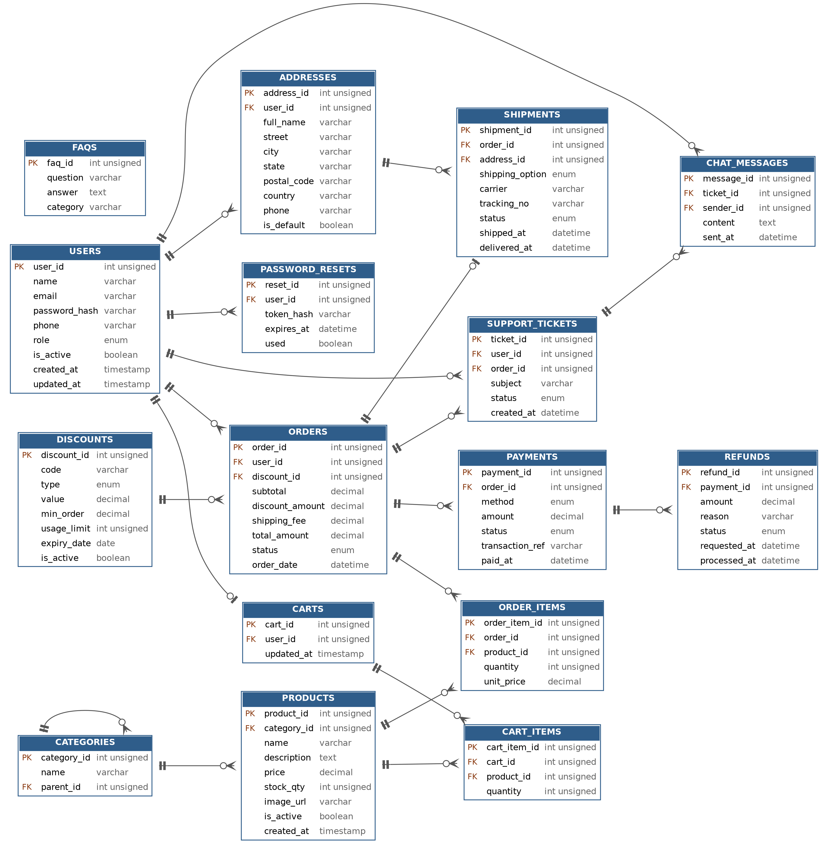

2. Database Design Table definitions

2.1 users
Registered customers and administrators.
Column | Type | Constraints | Description
user_id | INT UNSIGNED | PK, AI | Unique user identifier
name | VARCHAR(100) | NOT NULL | Full name
email | VARCHAR(150) | UNIQUE, NOT NULL | Login email
password_hash | VARCHAR(255) | NOT NULL | Hashed password
phone | VARCHAR(20) |  | Contact number
role | ENUM | NOT NULL, default customer | customer or admin
is_active | BOOLEAN | NOT NULL, default TRUE | Account enabled flag
created_at | TIMESTAMP | NOT NULL | Registration time
updated_at | TIMESTAMP | NOT NULL | Last profile update

2.2 password_resets
Tokens for the reset-password flow.
Column | Type | Constraints | Description
reset_id | INT UNSIGNED | PK, AI | Unique identifier
user_id | INT UNSIGNED | FK, NOT NULL | References users
token_hash | VARCHAR(255) | NOT NULL | Hashed reset token
expires_at | DATETIME | NOT NULL | Token expiry
used | BOOLEAN | NOT NULL, default FALSE | Whether token was used

2.3 addresses
Saved delivery addresses per user.
Column | Type | Constraints | Description
address_id | INT UNSIGNED | PK, AI | Unique identifier
user_id | INT UNSIGNED | FK, NOT NULL | Owner (users)
full_name | VARCHAR(100) | NOT NULL | Recipient name
street | VARCHAR(200) | NOT NULL | Street address
city | VARCHAR(100) | NOT NULL | City
state | VARCHAR(100) |  | State or region
postal_code | VARCHAR(20) | NOT NULL | Postal code
country | VARCHAR(100) | NOT NULL | Country
phone | VARCHAR(20) |  | Recipient phone
is_default | BOOLEAN | NOT NULL, default FALSE | Default address flag

2.4 categories
Product categories, optionally nested.
Column | Type | Constraints | Description
category_id | INT UNSIGNED | PK, AI | Unique identifier
name | VARCHAR(100) | UNIQUE, NOT NULL | Category name
parent_id | INT UNSIGNED | FK, NULL | Parent category (self-reference)

2. 5 products
Product listings and inventory.
Column | Type | Constraints | Description
product_id | INT UNSIGNED | PK, AI | Unique identifier
category_id | INT UNSIGNED | FK, NOT NULL | References categories
name | VARCHAR(200) | NOT NULL, indexed | Product name
description | TEXT |  | Product details
price | DECIMAL(10,2) | NOT NULL, >= 0, indexed | Current unit price
stock_qty | INT UNSIGNED | NOT NULL, default 0 | Inventory on hand
image_url | VARCHAR(255) |  | Product image
is_active | BOOLEAN | NOT NULL, default TRUE | Listed or hidden
created_at | TIMESTAMP | NOT NULL | Creation time

2.6 discounts
Discount and coupon codes.
Column | Type | Constraints | Description
discount_id | INT UNSIGNED | PK, AI | Unique identifier
code | VARCHAR(50) | UNIQUE, NOT NULL | Coupon code
type | ENUM | NOT NULL | percent or fixed
value | DECIMAL(10,2) | NOT NULL, > 0 | Discount amount or percentage
min_order | DECIMAL(10,2) | NOT NULL, default 0 | Minimum order value
usage_limit | INT UNSIGNED | NULL | Maximum redemptions
expiry_date | DATE | NOT NULL | Last valid day
is_active | BOOLEAN | NOT NULL, default TRUE | Code enabled flag

2. 7 carts
One active cart per user.
Column | Type | Constraints | Description
cart_id | INT UNSIGNED | PK, AI | Unique identifier
user_id | INT UNSIGNED | FK, UNIQUE, NOT NULL | Cart owner
updated_at | TIMESTAMP | NOT NULL | Last change

2.8 cart_items
Products inside a cart.
Column | Type | Constraints | Description
cart_item_id | INT UNSIGNED | PK, AI | Unique identifier
cart_id | INT UNSIGNED | FK, NOT NULL | References carts
product_id | INT UNSIGNED | FK, NOT NULL | References products
quantity | INT UNSIGNED | NOT NULL, > 0 | Quantity (unique per cart and product)

2.9 orders
Customer orders and their status.
Column | Type | Constraints | Description
order_id | INT UNSIGNED | PK, AI | Unique identifier
user_id | INT UNSIGNED | FK, NOT NULL | Customer
discount_id | INT UNSIGNED | FK, NULL | Applied discount
subtotal | DECIMAL(10,2) | NOT NULL | Items total
discount_amount | DECIMAL(10,2) | NOT NULL, default 0 | Discount applied
shipping_fee | DECIMAL(10,2) | NOT NULL, default 0 | Shipping cost
total_amount | DECIMAL(10,2) | NOT NULL | Final amount payable
status | ENUM | NOT NULL, default pending | pending, paid, processing, shipped, delivered, cancelled, refunded
order_date | DATETIME | NOT NULL | Order placement time

2.10 order_items
Line items of an order.
Column | Type | Constraints | Description
order_item_id | INT UNSIGNED | PK, AI | Unique identifier
order_id | INT UNSIGNED | FK, NOT NULL | References orders
product_id | INT UNSIGNED | FK, NOT NULL | References products
quantity | INT UNSIGNED | NOT NULL, > 0 | Quantity ordered
unit_price | DECIMAL(10,2) | NOT NULL | Price at time of purchase

2.11 payments
Payment attempts for orders.
Column | Type | Constraints | Description
payment_id | INT UNSIGNED | PK, AI | Unique identifier
order_id | INT UNSIGNED | FK, NOT NULL | References orders
method | ENUM | NOT NULL | card, paypal, bank_transfer, wallet, cod
amount | DECIMAL(10,2) | NOT NULL | Amount paid
status | ENUM | NOT NULL, default pending | pending, success, failed, refunded
transaction_ref | VARCHAR(100) | UNIQUE | Gateway reference (no card data stored)
paid_at | DATETIME | NULL | Payment confirmation time

2.12 refunds
Refund requests against payments.
Column | Type | Constraints | Description
refund_id | INT UNSIGNED | PK, AI | Unique identifier
payment_id | INT UNSIGNED | FK, NOT NULL | References payments
amount | DECIMAL(10,2) | NOT NULL | Refund amount
reason | VARCHAR(255) |  | Customer reason
status | ENUM | NOT NULL, default requested | requested, approved, rejected, completed
requested_at | DATETIME | NOT NULL | Request time
processed_at | DATETIME | NULL | Processing time

2.13 shipments
Delivery details and tracking.
Column | Type | Constraints | Description
shipment_id | INT UNSIGNED | PK, AI | Unique identifier
order_id | INT UNSIGNED | FK, UNIQUE, NOT NULL | References orders
address_id | INT UNSIGNED | FK, NOT NULL | Delivery address
shipping_option | ENUM | NOT NULL, default standard | standard, express, overnight
carrier | VARCHAR(100) |  | Courier
tracking_no | VARCHAR(100) |  | Tracking number
status | ENUM | NOT NULL, default preparing | preparing, shipped, in_transit, delivered, returned
shipped_at | DATETIME | NULL | Dispatch time
delivered_at | DATETIME | NULL | Delivery time

2.14 support_tickets
Support requests raised by users.
Column | Type | Constraints | Description
ticket_id | INT UNSIGNED | PK, AI | Unique identifier
user_id | INT UNSIGNED | FK, NOT NULL | Ticket creator
order_id | INT UNSIGNED | FK, NULL | Related order
subject | VARCHAR(200) | NOT NULL | Issue summary
status | ENUM | NOT NULL, default open | open, in_progress, resolved, closed
created_at | DATETIME | NOT NULL | Creation time

2.15 chat_messages
Live chat and ticket replies.
Column | Type | Constraints | Description
message_id | INT UNSIGNED | PK, AI | Unique identifier
ticket_id | INT UNSIGNED | FK, NOT NULL | References support_tickets
sender_id | INT UNSIGNED | FK, NOT NULL | Customer or admin (users)
content | TEXT | NOT NULL | Message text
sent_at | DATETIME | NOT NULL | Sent time

2.16 faqs
Frequently asked questions.
Column | Type | Constraints | Description
faq_id | INT UNSIGNED | PK, AI | Unique identifier
question | VARCHAR(255) | NOT NULL | Question
answer | TEXT | NOT NULL | Answer
category | VARCHAR(100) |  | Topic group

