**Analysis of Results and Findings**

In the analysis of the Logistic Regression models developed for predicting responses in the given dataset, both a custom-developed model and a built-in logistic regression model were employed. The features utilized for prediction were Time Delay, Common Keyword Count, and Has Questions. The performance of the models was evaluated based on their accuracy and learning curves.

**1. Built-in Logistic Regression Model:**

- Accuracy: The accuracy of the built-in logistic regression model was found to be 1.0, indicating perfect classification on the test set. This implies that the model was able to accurately predict whether a message receives a response or not for the given features.

- Learning Curve: The learning curve for the built-in logistic regression model displayed a constant log loss across iterations. This consistency in log loss indicates a stable and well-trained model, with minimal fluctuations in prediction performance.

**2. Developed Logistic Regression Model:**

- Accuracy: In contrast, the accuracy of the custom-developed logistic regression model was found to be 0.53. This suggests that the model's predictive performance, while above chance, is not as robust as the built-in logistic regression model. There is room for improvement in terms of feature selection, model architecture, or hyperparameter tuning.

- Learning Curve: The learning curve for the developed logistic regression model revealed an increasing log loss over iterations. This trend indicates that the model's performance did not improve with additional iterations, suggesting potential issues in the training process or model complexity.

- Complexity and Time Consumption: It's important to note that the code for the self-developed logistic regression model was longer and more complex. Calculating weights manually added an extra layer of complexity, making the model less straightforward to implement. Moreover, the training process took more time due to the intricacies involved in managing the weight updates.

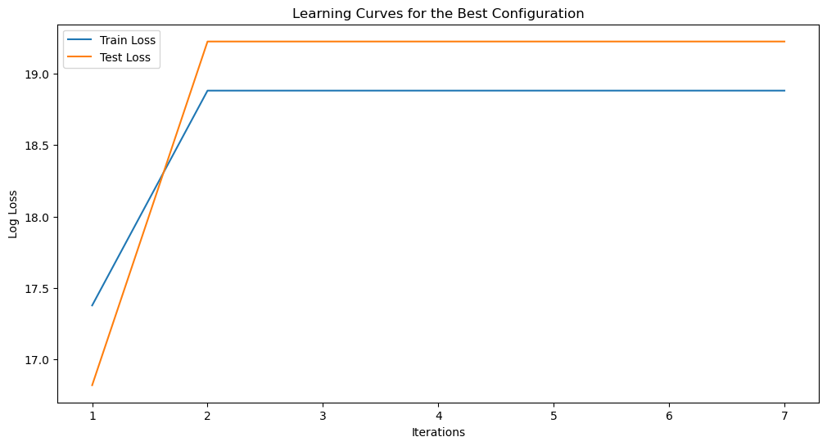

**Conclusion:**

While the built-in logistic regression model demonstrated exceptional accuracy, the custom-developed model fell short in predictive performance. Further exploration and refinement of the custom model are recommended, such as fine-tuning hyperparameters or exploring additional features.