LAIBA BATOOL  BS Computer Science Graduate | Junior Web Developer (Laravel / PHP)  Mansehra, Pakistan | +92 317 1595545 | laibashah399@gmail.com | [LinkedIn] | [GitHub] | 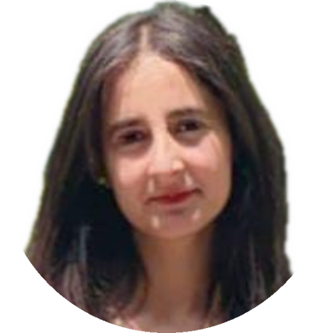
PROFESSIONAL SUMMARY
BS Computer Science graduate from Hazara University Mansehra (CGPA 3.56/4.00) with a six-month development internship at PSEB, IT Park Kawish. I have hands-on experience building web applications with Laravel, PHP and SQL, including an online quiz system, and I contributed to an AI-based e-commerce assistant in a team. I am looking for a [junior web developer / Laravel developer] role where I can build reliable applications and keep improving my skills.
TECHNICAL SKILLS
Web HTML, CSS, PHP, Laravel
Database SQL [add MySQL if you used it]
Core knowledge Data Structures, Web Engineering, Software Engineering, Artificial Intelligence basics
Tools [add only tools you can truly use, e.g. Git/GitHub, JavaScript, Python, REST APIs]
EXPERIENCE
Development Intern PSEB, IT Park Kawish [Month Year] – [Month Year] (6 months)
- [Describe one real task, e.g. what you developed and the tools you used.]
- [Describe a second task, e.g. bugs you fixed or features you tested.]
- [Describe teamwork, e.g. who you worked with and what you delivered.]
PROJECTS
Quiz System Laravel · PHP · SQL · self-initiated [Year]
- Built an online quiz application where [describe features, e.g. users log in, take timed quizzes and see results].
- Designed the SQL database to store [questions, users, results].
- [Add one problem you solved or one result.]
AI E-commerce Assistant University group project, Hazara University Mansehra Jan 2025 – Jul 2025
- Worked in a team of [number] to build an AI-based assistant for an online shopping setting.
- My part: [describe exactly what you built or wrote].
- [Add the outcome, e.g. what the assistant could do in the demonstration.]
EDUCATION
BS Computer Science Hazara University Mansehra Oct 2021 – [Jul/Aug] 2025
CGPA: 3.56 / 4.00
Relevant courses: Data Structures · Web Engineering · Software Engineering · Artificial Intelligence · Parallel and Distributed Computing · Information Security and Computer Networks
FSc IIUI College Mansehra [group, marks] 2019 – 2021
Matric Al Quran Beacon School and College Mansehra [marks] 2017 – 2019
CERTIFICATION
PSEB Soft Skill Program – Career Development
LANGUAGES
Urdu Native
English [name of your certificate, score or level]
Korean Beginner, self-study [optional]

