Final Year Project Documentation

Medicare : Smart Healthcare Reminder


By

Laiba Shamim 087251
Amna Amjad 087269
Javeria Batool 087272

Under the Supervision of
Mam Tayyaba

Bachelor of Science in Information Technology,

FG Post Graduate College ,
Kashmir road Rawalpindi.

Medicare: Smart Healthcare Reminder

A project represented to
University of the Punjab, Lahore.
In partial fulfilment
of the requirement for the degree of
Bachelor of Science in Information Technology,
Session (2022-2026)

Department of Information Technology,
FG Post Graduate College,
kashmir Road Rawalpindi

DECLARATION

We hereby declare that this software , neither the whole nor a part ,was copied from any source .It is further declared that we have developed this software and accompanying report based on our effort . If any part of this project is proven to be copied from any source or found to be a reproduction of some other, we will stand by the consequences. No portion of the work presented has been submitted for any application for any other degree or qualification of this or any other university or institute of learning .

Laiba Shamim [ 087251] Javeria Batool [087272]
Signature : Signature:

Amna Amjad [087269]
Signature:

CERTIFICATE OF APPROVAL

It is to certify that the final year project (FYP) of BSIT, session (2022-2026),the project Smart HealthCare Reminder and Notification App was developed by laiba Shamim(087251) ,Amna Amjad(087269) Javeria Batool (087272) under the supervision of Mam Tayyaba , in my opinion ,it is fully appropriate ,in scope and quality for the degree of Bachelors of science in Information Technology.

FYP Advisor : Mam Tayyaba .
Advisor Signature:

Signature (Faculty Advisory Committee (FAC))

 | FAC1 | FAC2
NAME | Mam Tayyiba
Signature

Head of FYP Coordination office : Mam Tayyiba Naeem
Signature:

Head of Department, Information Technology : Mam Lubna Zakia

Signature: Dated :

Executive Summary

Smart HealthCare Reminder is an Android-based mobile application developed to assist patients in managing their medications, health measurements, appointments, and daily activities efficiently. The application aims to reduce missed doses, forgotten appointments, and poor medication compliance by providing timely reminders and health tracking features. The application offers a comprehensive health management system that allows users to add and manage medications, track daily intake, record important health measurements such as blood pressure and sugar levels, schedule doctor appointments, and receive refill alerts when medicines are running low. Through automated notifications and an organized dashboard, the system ensures that users stay consistent with their healthcare routines.One of the primary goals of Smart Health Care Reminder is to provide an easy-to-use and accessible healthcare solution for individuals who may struggle with remembering complex medication schedules. The application is particularly helpful for elderly patients, individuals with chronic illnesses, and users managing multiple prescriptions. The system is developed using Android Studio with modern development practices. In conclusion, Smart Health Care Reminder provides a smart, reliable, and user-friendly healthcare assistance platform that promotes medication adherence, improves health tracking, and enhances overall patient self-management.

Acknowledgement

We express our gratitude to our Allah Almighty and after that, we are thankful to our families who allowed us to get higher education, and we become capable of creating Something productive. We’re also thankful to our advisor and department faculty for their support

Laiba Shamim : Signature
Amna Amjad : Signature
Javeria Batool : Signature

Abbreviation

Table of all abbreviation and acronyms used in your FYP, along with their respective brief description. The abbreviation list must be ordered alphabetically .

IT | Information Technology
LLM | Large Language Model
DB | Database
PU | Punjab University
RAM | Random Access Memory

Contents
1.Introduction 9
1.1 Problem statement 9
1.2 Problem Solution 10
1.3 Objectives of Proposed System 10
1.4 Scope 10
1.5 System Components 11
1.5.1 Module 1: User Authentication (End User Mobile App) 11
1.5.2 Module 2 : Medication ( End User Mobile App) 11
1.5.3 Module 3: Measurement (End User Mobile App) 12
1.5.4 Module 4: Measurement tracker ( End User Mobile App) 12
1.5.5 Module 5 : Activity (End User Mobile App ) 12
1.5.6 Module 6 : Appointment ( End User Mobile App ) 12
1.5.7 Module 7 : Chatbot Assistance (End User Mobile App) 12
1.5.8 Module 8: Refill medicines (End User Mobile App) 13
1.5.9 Module 9 : Track Intake (End User Mobile App) 13
1.5.10 Module 10 : Notification and Reminder 13
1.5.11 Module 11 : Profile section ( End User Mobile App ) 13
1.6 Related System Analysis /Literature Review 13
1.7 Vision statement 14
1.8 System Limitations and Constraint 14
1.9 Tools and Technologies 15
1.10 Project Deliverables 15
1.11 Project Planning 16
Gantt Chart 16
1.12 Summary 16
2.Analysis 18
2.1 User Classes and Characterization 18
2.2 Requirement Identifying Techniques 19
2.2.1 Interview 19
2.2.2 Ethnography or observation 19
2.3 Use Case model 19
2.4 Use Case Description 20
2.5 Functional Requirements 36
2.6 Non-Functional Requirements 44
2.7 External interface Analysis: 44
2.7.1User Interface Requirements 44
2.7.2 Software Interfaces 45
2.7.3 Hardware Interfaces 45
2.7.4 Communication Interfaces 45
2.7.5 Error handling and Reporting 45
2.8 Summary 45
3.System Design 47
3.1 Design Considerations 47
Assumptions and Dependencies: 47
Limitations 47
3.2 Design Models 48
1: Class Diagram 48
2:Sequence Diagram 49
3: State Diagram 49
4 :Activity Diagram 50
3.3 Architectural Design 50
3.3.1 Component structure: 52
3.3.2 Component Diagram 53
3.3.3 Architecture Pattern Diagram 54
54
3.4 Data Design 54
3.4.1 Data Dictionary 56
3.5 :User Interface Design 58
3.5.1Screen Images 58
3.5.2 Screen Objects and Actions 59
3.6 Design Decisions 60
3.7 :Summary 61

Chapter 1
Introduction

1.Introduction
In today’s digital world maintaining a healthy lifestyle has become increasingly challenging. Many users rely on paper notes or memory which can lead to missed medications or appointments. Health information is usually kept in different places and not saved in one organized system. In many cases people’s memory becomes weaker as they get older. In earlier times, people only arranged their pills physically in boxes. There were no automatic reminders no data storage no tracking system and no proper way to manage overall health information. Many Applications are already available but most of them are not user-friendly, for example: Pill reminder, Dosecast, Medisafe. These Applications provide only medicine reminder, user cannot track their full health routine at one platform. We are motivated to search for an easy, user-friendly and effective approach. This Application brings forth the emerging trend of mobile based health management systems along with the problem to patients who missed their medicine dose and other regular routines. The purpose of this application is to manage health through technology and make a person’s medical life easier. As healthcare needs became more complex, users required a system that could integrate multiple types of reminders in one application. Application Smart Healthcare Reminder allow users to maintain medication schedule, record health measurement, manage daily activities, manage appointments and receive timely refill reminder. The system will send notification at schedule time. The system is designed to be flexible and scalable which means it can be used by different users with different needs. By providing timely reminders and healthcare information the system aim to improve medication adherence. The application aims to fulfill these needs with interacting features with the help of several tools and technologies along with constraints, limitations and enhancement.

1.1 Problem statement
In today ’s era people has shortage of time ,busy routine or due to multiple health issues they cannot manage their medical routine. According to studies, between 40% and 75% of adults fail to take their prescribed medication on time each day. As a result , individuals fail to take the right dosage at the right time which may result in additional patient suffering and put their lives in danger. Many patients cannot manage their daily routine which is essential for managing their health. This application Smart Healthcare Reminder Will work as intelligent mobile-based health assistant which help patients to manage their daily health routine.

1.2 Problem Solution
Many reminder Applications are available in market but they allow user to enter the medicine name, time or quantity or give notification at that time but this application fulfill this gap and provides all-in-one solutions and not only provide medicine reminder but also manages patients daily routine such as Measurement(Bp ,sugar, Weight ),Activity( Meal, water Intake, Walking),Appointment (Medical tests, hospital visits)and Refill. Appointment module will help user to remind their medical checkup and lab tests. Refill module will help to restoke their medicine when stock will be limited. Chatbot will guide user and provide answer of simple health related questions and allow users to give feedback on the quality of its responses.

1.3 Objectives of Proposed System
- The user will authenticate system with name, age, and gender.
2. To never miss a dose, allow application “Medicare” to send you notification.
  - Medication section add medication to your treatment plan to get reminders and track your intakes.
  - Measurement section help to measure health data like blood pressure , weight and sugar.
  - Setup reminders for daily habits such as walking, drinking water, or meal.
  - Appointment module will help user to remind their medical checkup.
  - Chatbot will guide users and give basic health tips and allow user to give feedback on the quality of its responce .
  - Refill module will help to restoke their medicine.
  - Intake module allow the user to update the intake status of scheduled reminder as taken or missed to maintain daily health progress record.
  - Notification will be send based on the reminder time set by the user in different module.
  - Profile section to view intake progress.

1.4 Scope
The scope of the Smart Healthcare Reminder system is to develop a mobile application that helps users manage their daily health activities in an organized and simple way. The application will allow user to set reminders for medicines ,health measurement tracker(blood pressure, sugar level, weight),physical activities(walking, drinking water, eating meal),medical appointments(medical tests , hospital visits) , medicine refill and includes chatbot that guide users, answer simple health questions and allow users to give feedback on the quality of its responses. It will send notification at scheduled time and allow users to mark tasks as taken or missed. The system will also store daily records so user can track their health progress over time. This application is mainly develop for individuals who want to manage their daily health routine and avoid forgetting important health tasks. The Application allows users to create account ,login, set reminder for medicine and health activities, receive notification and track their daily progress. All information is stored safely in the database. The application only helps with reminders and tracking. It does not provide medical advice, diagnosis or treatment. The main goal of the project is to offer a simple, easy to use and reliable health reminder application where users can manage their health activities at one place.

1.5 System Components
The Application is divided into two main parts
1: End user
2: Caregiver
The Application will work in online mode. When the user has an active internet connection, it will allow users to manage medication, measurement, appointments, activities, refill and profile information. All updates, notifications, and data backup are handled online.

1.5.1 Module 1: User Authentication (End User Mobile App)
The list of features this module will have and how it will be used are the following.
1) A splash screen to initialize or load user specific data if authenticated, else redirected to authorization screen. The splash screen will check if there’s a user logged in or not using Firebase Authentication. If User is logged in then user will be redirected to home screen.
2)The authorization page will have the following option log In and Sign UP.
3)The Sign-Up screen will ask the user to enter his personal details like email, full name, date of birth, gender, and password.
4)The Log In screen will ask the user to enter the registered email and password. After validation, the user will be redirected to the home screen. Login screen will also have options for forgotten password with email verification.

1.5.2 Module 2 : Medication ( End User Mobile App)
The user can add a new medication by entering details such as medicine name, dosage , frequency ,start date, end date and reminder time. After saving the information, the medication is added to history. Once a medication is added, the system automatically gives reminders based on the specified time. Upon receiving a reminder, the user can mark the medication status as taken or missed. The user can update medication details such as dosage and reminder time. Changes are applied immediately, and reminders are updated automatically. The user can remove a medication from the list when it is no longer required. Deleting a medication cancels its reminders.

1.5.3 Module 3: Measurement (End User Mobile App)
The user can set reminder for health measurements such as blood pressure, blood sugar, body weight by selecting the measurement type and preferred reminder time. At the predefined time, the system sends a notification reminding the user to take the selected health measurement. The user can view a list of all active measurement reminders. The user can update reminder details such as the measurement type or reminder time. The user can delete a measurement reminder when it is no longer needed.

1.5.4 Module 4: Measurement tracker ( End User Mobile App)
The user can record and track their health measurements such as blood pressure, blood sugar, and body weight. The user can enter measurement values like systolic and diastolic for blood pressure, sugar level for blood sugar, and weight value for body weight. The system saves the recorded measurements so the user can view them later. The user can see a list of all previous measurement records to monitor their health condition. The user can also update or delete a measurement record if it was entered incorrectly.

1.5.5 Module 5 : Activity (End User Mobile App )
The user can set reminders for daily activities such as drinking water, eating meals by selecting an activity type, and preferred reminder time. The user can choose the frequency of reminders, including daily or multiple times per day, based on their routine and health goals. At the scheduled time, the system sends notification reminding the user to perform the selected Activity. The user can view a list of all active Activity reminders from the Activity section. The user can update Activity reminder details such as Activity type, reminder, or frequency. The user can delete an activity reminder when it is no longer needed.

1.5.6 Module 6 : Appointment ( End User Mobile App )
The appointment module allows the user to schedule doctor Appointments by entering details such as Appointment date, time, doctor or clinic name. Once the appointment is scheduled, the system sets a reminder notification to ensure user do not miss the appointment. The user can view a list of all upcoming and scheduled appointments within an application. The user can update appointment details such as Appointment date, time or doctor/clinic information. The user can delete an Appointment reminder when it is no longer needed.

1.5.7 Module 7 : Chatbot Assistance (End User Mobile App)
The chatbot works as a virtual assistant that helps users with basic health-related questions. The user can ask questions about reminders or general health tips. The chatbot provides simple responses and guidance to help users manage their health tasks in the application and allow users to give feedback on the quality of its responses. It can also suggest actions such as checking blood pressure, drinking water, or doing light exercise when health values are high or low. This feature helps users quickly get helpful information.

1.5.8 Module 8: Refill medicines (End User Mobile App)
The user can set refill reminders for their medicines by entering details such as refill date or remaining quantity. The system monitors the refill schedule and sends notifications to remind the user to refill their medicines on time. The user can view a list of all active refill reminders. The user can update refill details such as date or quantity and can delete a refill reminder when it is no longer needed. This feature helps users avoid running out of essential medicines.

1.5.9 Module 9 : Track Intake (End User Mobile App)
The track intake module tracks the medicine intake also measurement (BP, Sugar, weight),Daily activities ,Appointment and Refill status . The purpose of this module is to ensure that the user can confirm and review everything related to their health routine in one place .When a reminder notification appear the user can update its status by selecting options such as taken or missed.

1.5.10 Module 10 : Notification and Reminder
The system automatically generates and schedules notification based on the reminder time set by the user in different modules. At the scheduled time, the user receives a notification reminding them of specific task .

1.5.11 Module 11 : Profile section ( End User Mobile App )
The profile section allows users to view the summary of health-related progress .All profile data is stored securely and synchronized using Firebase Firestore.

1.6 Related System Analysis /Literature Review
With the increased use of smartphones and mobile-health technology, many reminder applications have entered the market. Most of the applications currently available primarily focus only on medicine reminders. This proposed application aims to fill this gap by providing an all-in –one solution. The proposed application not only provide medicine reminders but also helps manage patients daily routine such as meal schedule, water intake and walking routine. It also includes doctor appointment reminder and medicine refill reminder. All these features in the application are free, the user interface is easy to use and users can navigate through app with ease . Most existing applications such as Medisafe and Dosecast provide only medicine reminders and do not offer integrated options to manage other aspects of health such as diet planning or regular health checkups.

Application Name | Weakness | Proposed Project Solution
Medisafe | Provide only medicine reminders. user cannot track their full health routine at one platform | App manage complete health routine, user will not miss the important health task.
Dose cast | Dose cast give basic refill reminders does not give smart options like medicine quantity tracking or low-stock alert. | Medicare track medicine and send automatic refill reminder when stock is low.
Pill Reminder | Pill reminder offers simple alarm based reminder with no intake tracking or health summary. | Application provides intelligent reminders intake tracking (taken, missed) and a detail health progress summary.

1.7 Vision statement
To create an intelligent mobile application that help individuals manage their daily health task by providing smart reminder for medicine, measurement, activities, appointments and refill. The application also includes measurement tracker to record and monitor blood pressure, blood sugar, weight and Chatbot that provide guidance, answers basic health question and help user manage reminders and allow users to give feedback on the quality of its responses. Encourage user to stay consistent with their health routine and minimizing the chances of missed or late care. The application aims to stay simple and smart so people of all ages can manage their health easily without any confusion.

1.8 System Limitations and Constraint
Limitation:
Internet dependency: The application needs compatible smartphones and stable internet which may limit some users.
User dependency: Reminder effectiveness depends on user interaction correctly setting reminders and responding to notification.
Notification delays: System or device restrictions can delay notifications.
Constraints:
The system constraints will be:
- The application is designed only for android devices.
- The application reminder functionality depends on user allow notification permission.

1.9 Tools and Technologies
Our system use these tools and technologies for complete implementation of goals / objectives :
Tools /Technology | Version | Rational
Android studio | Narwhal | Official IDE for android app development.
Firebase | Latest | For authentication, and Data storage.
Draw.io | 24.x | For creating Diagrams
Flutter | 3.38.6 | Familiarity with Flutter due to Mobile Application development course. Now Application are developed in flutter.
Dart | 3.10.7 | The programming language used with Flutter.
GitHub | Build-in Android studio | To save a common storage for project submission.

1.10 Project Deliverables
Our system will have following deliverables by the end of 7th semester:
1. Project Proposal
2. Final Year Project Registration Form
3. Software Requirement Specification (SRS)
4. Software Design Specification (SDS)
5. Prototype
6. Comprehensive Evaluation Document (Proposal, SRS, SDS)
Our system will have the following deliverables by the end of 8th semester:
1. Coding/Implementation
2. Testing
3. Deployment
4. Final
5. Presentation & Final Evaluation

1.11 Project Planning
 | Task name | Duration | Start | Finish | predecessor
1 | Planning | 18 days | 01/12/25 | 12/12/25 | 1
2 | Requirement gathering | 14 days | 19/12/25 | 1/1/26 | 2
3 | Analysis | 30 days | 1/1/26 | 1/22/26 | 2
4 | Design | 32 days | 1/1/26 | 3/7/26 | 2
5 | Coding | 30 days | 6/3/26 | 4/12/26 | 2,5
6 | Testing | 25 days | 13/4/26 | 5/18/26 | 5
7 | Implementation | 18 days | 7/6/26 | 5/6/26 | 6
8 | Documentation | 130 days | 1/12/25 | 5/1/26 | 2

Gantt Chart
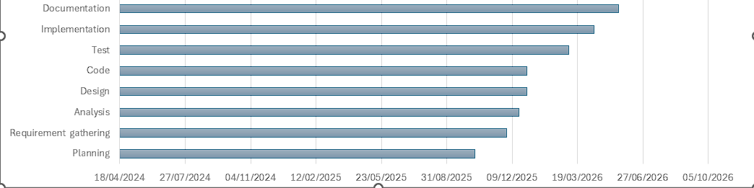

1.12 Summary
To get together with emerging trend of mobile-health management system and solve patient’s problem who forget about their dose and regular routine, our project will deliver its modules and fulfill its goals and objectives within the planned timeframe while maintaining the scope of project to deliver a quality product.

Chapter 2
Requirements Analysis

2.Analysis
This chapter focuses on requirement identification, elicitation and analysis. The users categorized into two classes. For requirement identification and elicitation open interviews, ethnography, and use case analysis are used. The identified requirements are categorized into functional and non-functional requirements, along with their use case description and diagram.

2.1 User Classes and Characterization
Table 2-1 User classes and characteristics
User class | characterization
End User | The end user is the patient who logs into the application to manage medications, health measurements, appointments, and reminders.
Caregiver | The caregiver is an authorized person who can log in as an end user to manage reminders and health activities on behalf of the patient when the patient is unavailable.

2.2 Requirement Identifying Techniques
There are fundamental approaches used to identify requirements. As elicitation of requirements requires meeting with stakeholders so following are the approaches used:

2.2.1 Interview
Open interviews were conducted with individuals from different age groups to understand the difficulty they face in managing medicines, appointments and daily health activities. The application helps to identify common problems such as forgetting doses and missing appointments which helps in defining the system requirement.

2.2.2 Ethnography or observation
Software systems are not used alone they work in social and organizational environments. User needs are often affected by their daily routines and surroundings. Ethnography is an observational technique that can be used to understand operational processes and help derive requirements for software to support these processes. It was noticed that many people rely on memory or simple alarms and often forget important health tasks. This observation helped in identifying the need for a structured and organized healthcare reminder system.

2.3 Use Case model
Use Case Diagram 1:
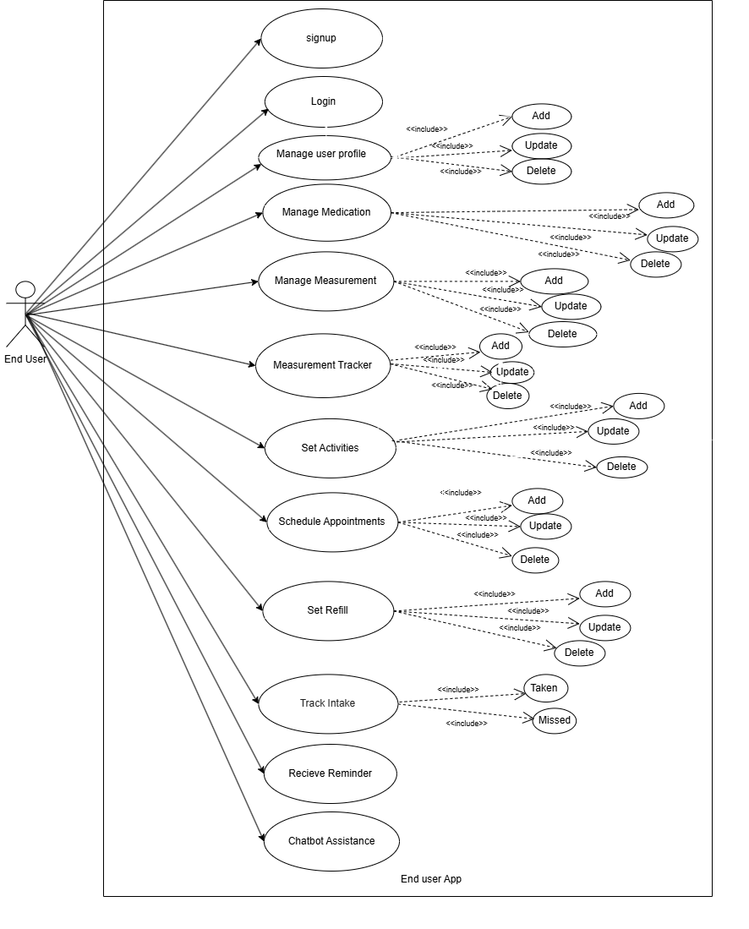
Figure 2-2 Use case diagram for user

2.4 Use Case Description
Use Case 1
Use Case ID | UC-1
Use Case Name | Sign Up with Email and password
Actors | New user
Description | This use case allows a new user to register by providing their personal details and credentials.
Trigger | User selects the “sign up” option from the authorization screen.
Preconditions | User must not already be registered.
Postconditions | A new user account is created in firebase, and the user is redirected to the profile completion screen.
Normal Flow | User opens the application.  Authorization screen appears.  User selects “sign up”.  User enters email, name, DOB ,gender, password.  Form is validated.  Firebase authentication creates user.
Alternative Flows | Email Already Exists: if the email is already registered, an error message is shown.  Weak password: if password does not meet criteria, the user is prompted to correct it.
Business Rules | Email must be unique and valid.  Password must be at least 8 characters.  Required fields cannot be empty.
Assumptions | Firebase authentication is active and integrated.  User devices has internet access.

Use Case 2
Use Case ID | UC-2
Use Case Name | Login with email and password
Actors | End User
Description | This use case allows registered users to login into the application using their email and password.
Trigger | The user opens the application and selects the “login” option on the authorization screen.
Preconditions | The user must already register with a valid email and password.
Postconditions | If the login is successful, the user is redirected to the home screen. If not, an error message is shown.
Normal Flow | 1. The user opens the application.  2. Splash screen checks the login status.  3. User is not authenticated and is taken to the authorization screen.  4.Users select login with email.  5. Users enter email and password.  6.App validates credentials with Firebase authentication.  7. If valid, the user is redirected to the home screen.
Alternative Flows | Invalid Credentials: if the entered email or password is incorrect, the user is shown an error message and remains on the login screen.
Business Rules | Email and password fields must be filled and validated.  Email must be registered.  Password must meet firebase authentication requirements.
Assumptions | The user has a stable internet connection.  Firebase services are available.  The app is correctly configured to use firebase authentication.

Use case 3
Use Case ID | UC-3
Use Case Name | Add medication
Actors | End user
Description | This use case allows the user to add a new medicine to their medication list by entering details such as medicine name, dosage, frequency and timing
Trigger | Users select the “medication” option from the home screen.
Preconditions | Users must be logged in.  Medication details must be available to enter.
Postconditions | A new medication entry is entered into the database.  Medication appears in the user medication list, and reminders are scheduled.
Normal Flow | Users open the app and navigate to the medication screen.  User taps on “Add medication”  Users enter medicine's name, dosage, start date, end date, and reminder timings.  System validates the input.  System saves medication details to the database.  System schedules medication reminders.  User is redirected to the medication screen.
Alternative Flows | System shows an error message and highlights missing fields.  The user is not prompted to enter valid dates
Business Rules | Medication names and dosage fields are mandatory.  Reminder time must be valid
Assumptions | User has enabled notification permission.  Internet is available if saving to firebase.

Use Case 4
Use Case ID | UC-4
Use Case Name | View medication list
Actors | End user
Description | This use case allows the user to view all their medications, along with timing and status
Trigger | User navigates to the medication screen.
Preconditions | Users must be logged in.
Postconditions | The system displays all active medications from the list.
Normal Flow | Users open the app and navigate to the medication screen.  System retrieves medication data from the database.  System displays the list with fields (name, dosage, time)
Alternative Flows | System displays no medication added message.
Business Rules | Medication should be listed frequently
Assumptions | User has enabled notification permission.  Internet is available if saving to firebase.

Use Case 5
Use Case ID | UC-5
Use Case Name | Edit health activities reminder time
Actors | End user
Description | Allows to edit health activities reminder time from the list.
Trigger | User select on existing health activities reminder time from the list and select “Edit”.
Preconditions | Users must be logged in.  The health activities reminder entry must already exist.
Postconditions | Health activities reminder time detail are updated in the database.  Updated reminder times are rescheduled.
Normal Flow | User navigates to the health activities list screen.  User selects a module and tap “Edits”.  User updates fields (name, dosage, timing, dates)  System validates updated inputs.  System applies updates to the database.  System reschedules reminders according to new timings.
Alternative Flows | System displays validation errors.  If the user makes no changes, the system keeps previous data.
Business Rules | Edited data must follow the same constraint as adding health activities reminder time.
Assumptions | User has enabled notification permission.  Internet is available if saving to firebase.

Use case 6
Use Case ID | UC-6
Use Case Name | Delete health activities reminder time
Actors | End User
Description | Allows to delete health activities reminder time from the list.
Trigger | User select on existing health activities reminder time from the list and select “Delete”.
Preconditions | Users must be logged in.  The health activities reminder time must already exist.
Postconditions | Health activities reminder time are removed from the database.  Scheduled reminders for the health activities are cancelled.
Normal Flow | Users navigates to the health activities list screen.  Users select module.  Users tap the “delete” button.  The system asks for confirmation.  User confirms.  System deletes the entry and cancels reminders.
Alternative Flows | If user cancel deletion ,System keeps reminder timing unchanged.
Business Rules | Deleted activities cannot be recovered unless it is backed up.
Assumptions | User has enabled notification permission.  Internet is available if saving to firebase.

Use case 7
Use Case ID | UC-7
Use Case Name | Track intake
Actors | End User
Description | This use case allow user to update the intake status of scheduled reminder as taken or missed to maintain daily health progress record.
Trigger | User receive a reminder notification and select taken or missed.
Preconditions | User must be logged in to the application.  Reminder time must active for the current day.
Postconditions | Intake status is stored for daily progress tracking.  Reminder history is updated in the database.
Normal Flow | The system sends a scheduled reminder notification.  The user selects an intake status(taken, missed).  The system saves the selected status in firebase.  The daily progress dashboard is updated.
Alternative Flows | If the user ignores the reminder, the system automatically marked it as missed after a defined time period.  If internet is unavailable the intake status is saved locally and synchronized once the connection is restored.
Business Rules | Each reminder have only one intake status per scheduled time.  Intake status must be recorded within the same day.
Assumptions | User has enabled notification permission.  Internet is available if saving to firebase.

Use case 8
Use Case ID | UC-8
Use Case Name | Set Measurement Reminder
Actors | End User
Description | Allows the user to set a reminder to check their health measurement (blood pressure, weight, or blood sugar).
Trigger | Users select the measurement option from the measurement screen.
Preconditions | Users must be logged in.
Postconditions | A reminder is saved and scheduled for notification.
Normal Flow | Users navigate to “ Measurement Reminder "section.  Users select measurement type(BP, weight, sugar).  Users selects reminder time.  User optionally sets repeat option (daily, weekly).  System saves reminder.  System schedules notification for the selected time.
Alternative Flows | System prompts users to select time.  User tries to save without selecting measurement type.
Business Rules | Each reminder must have a type and time.
Assumptions | User has enabled notification permission.  Internet is available if saving to firebase.

Use case 9
Use Case ID | UC-9
Use Case Name | Measurement tracker
Actors | End user
Description | Allow users to record and track their health measurement such as blood pressure, sugar level and body weight.
Trigger | User select the measurement tracker option from measurement screen.
Preconditions | User must be logged in.  Measurement type must be selected.
Postconditions | The entered measurement data is saved in the database.  The record becomes available in the user’s profile history for tracking.
Normal Flow | User navigates to the Measurement Tracker section.  User selects measurement type (BP, weight, sugar).  User enters the measurement values (e.g., systolic/diastolic for blood pressure, sugar level , or weight).  System validates the entered data.  System saves the measurement record.  The record appears in the profile history list.
Alternative Flows | System prompts user if measurement values are missing.  System displays validation error if entered values are invalid.
Business Rules | Measurement values must be entered in valid numeric format.
Assumptions | User has enabled notification permission.  Internet is available if saving details to Firebase.

Use case 10
Use Case ID | UC-10
Use Case Name | Set Activity reminder
Actors | End User
Description | This use case allows the user to set reminders for daily activities (walking, drinking water, eating).
Trigger | Users select activity section.
Preconditions | Users must be logged in.
Postconditions | A new activity reminder is created and scheduled for notification.
Normal Flow | Users open the activity section.  Users select the activity type(walk ,water ,meal).  Users select reminder type.  Users select Frequency (daily, multiple times a day).  System saves the activity reminder.  System schedules the notification.
Alternative Flows | No time selected: System prompt user to select time.  No activity type selected :System shows warning message.
Business Rules | Each reminder must include a selected Activity type and time.  Multiple reminders for the same activity type must have different time slots.
Assumptions | Notifications are enabled on the user’s device.  Users have stable internet if data is stored in cloud.

Use case 11
Use Case ID | UC-11
Use Case Name | Set Appointment reminder
Actors | End user
Description | Allows the user to schedule appointments by entering appointment details(date, time, doctor/clinic name). This use case allow user to set reminder for appointment(Medical test, Hospital visits).
Trigger | User selects “Add appointment”
Preconditions | Users must be logged in.
Postconditions | A new appointment is saved, and a reminder notification is scheduled.
Normal Flow | Users open the appointment section.  Users select Add appointments.  Users enter the appointment date and time.  Users enter a doctor/clinic name.  System saves appointments.  System schedules a reminder notification.
Alternative Flows | If date or time is missed, the system shows error and asks the user to fill required fields.  If past date is entered System prompt user to select future valid date.
Business Rules | Appointments must have a valid date and time.  Appointment reminder must trigger at least once before  The appointment (e.g.1 hour before)
Assumptions | User has enabled notification permission.  Internet is available if saving to firebase.

Use case 12
Use Case ID | UC-12
Use Case Name | Set medicine refill reminder
Actors | End user
Description | This use case allows the user to set refill reminder by entering refill-related details for a medicine.
Trigger | User select “Refill Reminder "from the medication section.
Preconditions | The medicine must already exist in the medication list.
Postconditions | A refill reminder is scheduled based on the refill date or remaining quantity.
Normal Flow | User open medication section.  Users select medicine.  User taps “Set Refill reminder”  Users enter refill date or remaining quantity.  System validates the input.  System saves the refill reminder.  System schedules notifications accordingly.
Alternative Flows | If refill date or quantity is missed system prompt the user to enter required fields
Business Rules | Refill Reminders must be set at least 1 day before the refill date or when quantity reaches the low stock.
Assumptions | User has enabled app notification.  Internet available if saving details to Firebase.

Use case 13
Use Case ID | UC-13
Use Case Name | Chatbot Assistance
Actors | End user
Description | This use case allows the user to interact with the chatbot to get guidance on health reminders or general health tips and allow users to give feedback on the quality of its responses.
Trigger | User taps the Chatbot icon from the dashboard
Preconditions | User must be logged in.  Chatbot service must be active.
Postconditions | User receives guidance from the chatbot.  Relevant instructions are provided to help manage reminders or health tracking.
Normal Flow | User opens the chatbot from the application.  User types a question.  System processes the request using chatbot logic.  Chatbot provides answers, health tips or guidance on setting reminders and allow users to give feedback on the quality of its responses.  User follows instructions or navigates to the appropriate module if needed.
Alternative Flows | If the question is unclear the chatbot asks for clarification.
Business Rules | Chatbot responses must be general health guidance only and not provide professional medical advice.  Chatbot should respond within a few seconds to maintain user connection.
Assumptions | User has enabled internet access for chatbot interaction.

Use case 14
Use Case ID | UC-14
Use Case Name | Receive low stock alert
Actors | End user
Description | The System alerts the user when medicine stock is running low.
Trigger | System detects remaining quantity has reached low- stock  Limit (e.g. 3 doses left)
Preconditions | Refill quantity tracking must be enabled for that medicine.
Postconditions | A low-stock notification is sent to the user.
Normal Flow | User marks a dose as “Taken”.  System updates the remaining quantity.
Alternative Flows | If stock level is sufficient, no alert is generated.
Business Rules | Default low- stock threshold may be set (e.g. 3 units left).
Assumptions | Notifications are enabled on the device.

Use case 15
Use case Id | UC-15
Use Case Name | View user profile
Actors | End User
Description | Allows users to view their health related summary.
Trigger | User taps the “Profile” section from the menu.
Preconditions | Users must be logged in.  Profile data must exist in the database.
Postconditions | Profile details are displayed on screen.
Normal Flow | User opens the app and selects “profile”. In profile user’s health reminders are shown which are taken or missed their history is made in it.
Alternative Flows | If the user is not logged in the system redirects to the login/signup screen.
Business Rules | Only authenticated user can access their own profile.  Health summary must accurately reflect the recorded intake status and history.
Assumptions | User has enabled internet connection.  Firebase services are available and correctly configured.

Use case 16
Use case Id | UC-16
Use Case Name | Receive notification for reminders
Actors | End user
Description | System send notification to remind user about medication, Measurements, Activities, Appointments and refills.
Trigger | A reminder time which is scheduled is reached.
Preconditions | Notification permission must be granted.
Postconditions | Users receive notification at the correct time.
Normal Flow | User sets a reminder(medicine, Activity, Appointment).  System schedules notifications.  When time arrives, system sends a notification.  Users view the notification.
Alternative Flows | If notification permission is off Systems prompt user to enable notification.
Business Rules | Notification must be sent at the reminder time.  Each reminder must give only one notification.  Notification will clearly tell the type of reminder.
Assumptions | Internet connection is available when cloud based notification are used.  The user device is powered on at reminder time.

2.5 Functional Requirements
This section describes the functional requirements of the system expressed in natural language style. This section is organized by features as a system feature name and specific functional requirements associated with this feature. So for each module and it’s features the functional requirements are itemized below:
Functional Requirement 1
Identifier | FR-1
Title | User profile management
Requirement | The end user shall be able to create and manage their profile by entering personal information such as full name, email, Date of Birth, gender and password. The end user shall be able to login by entering email and password, then tapping login.
Source | Business Requirement
Rationale | Provides a secure environment and collects essential profile data for personalization.
Business Rule | User Date of Birth must follow a correct format (DD/MM/YY), Gender selection must be from predefined options (Male, Female, others).
Dependencies | Internet connection, Firebase authentication
Priority | High

Functional Requirement 2
Identifier | FR-2
Title | Password Reset
Requirement | The end user shall be able to reset the password by entering a registered email and receiving a reset link.
Source | Business Requirement
Rationale | Reduce support costs by enabling self-service password recovery
Business Rule | Password reset link must be expired after one hour.
Dependencies | FR-1
Priority | Medium

Functional Requirement 3
Identifier | FR-3
Title | Add medication
Requirement | The end user will be able to add medication to their treatment plan by entering the medicine name, dosage, frequency, start date, end date, and reminder time.
Source | Business requirement
Rationale | Users can properly manage their prescribed medicines and take them on time.
Business Rule | Medicine name cannot be empty, start date cannot be later than end date, frequency must be selected from predefined options (e.g. once daily, twice daily), Reminder time must be a valid time format.
Dependencies | Notification manager, User profile, Firebase Fire store
Priority | High

Functional Requirement 4
Identifier | FR-4
Title | Track intake
Requirement | The user shall be able to mark routine as “Taken" or "Missed” and the system shall update daily progress accordingly.
Source | Business Requirement
Rationale | To help users maintain consistent adherence.
Business Rule | Once marked, the intake status is saved with date and time for progress tracking.  Intake status can only be marked after the reminder is triggered.
Dependencies | FR-1, FR-3
Priority | High

Functional Requirement 5
Identifier | FR-5
Title | Edit/Delete health activities
Requirement | The user will be able to update or delete health activities reminder timing.
Source | Business requirement, interviews
Rationale | Prevents incorrect reminders for health activities. Users often change their dosage, timing, or discontinue activities.
Business Rule | A deleted activity time must remove all future reminders from the schedule.
Dependencies | FR-1, FR-3, local database
Priority | High

Functional Requirement 6
Identifier | FR-6
Title | Set measurement reminder
Requirement | The user shall be bale to set reminders for health measurement such as blood pressure, blood sugar and body weight by selecting the measurement type and preferred reminder time.
Source | Business Requirement, interviews
Rationale | Regular health measurement help user monitor their health conditions effectively and detect health issues at early stage.
Business Rule | The user must select one measurement type and valid reminder time.
Dependencies | FR-1,FR-11,FR-12
Priority | High

Functional Requirement 7
Identifier | FR-7
Title | Record measurement data (Measurement Tracker)
Requirement | The user shall be able to record and store health measurement data such as blood pressure(systolic/diastolic), blood sugar level, body weight for tracking and monitoring their health over time.
Source | Business Requirement, interview
Rationale | Recording health measurement helps users monitor their health condition and observes changes over time.
Business Rule | The user must enter valid numeric values for measurements (e.g. systolic/diastolic for BP, sugar level or weight).
Dependencies | FR-1, FR-6
Priority | High

Functional Requirement 8
Identifier | FR-8
Title | Set Activity reminder
Requirement | The user shall be able to set a daily habit reminder (such as walking, drinking water, or eating meals) by selecting a habit type and reminder time.
Source | Business Requirement, interviews
Rationale | Supports healthcare by promoting regular activity, hydration, and proper eating.
Business Rule | User can create multiple activity reminders (e.g. morning walk + water reminder)
Dependencies | FR-1,FR-11,FR-12
Priority | Medium

Functional Requirement 9
Identifier | FR-9
Title | Appointment Reminder
Requirement | The user shall be able to schedule doctor's appointments by entering the date, time, and doctor/clinic time.
Source | Business requirements, user interviews
Rationale | Helps users avoid missing doctor visits, useful for chronic ill patients who have regular checkups
Business Rule | Appointment reminders must notify the user at least once (e.g. 1 hour before),Date and time must be valid and cannot be empty.
Dependencies | FR-1
Priority | High

Functional Requirement 10
Identifier | FR-10
Title | Chatbot Assistance
Requirement | The user shall be able to interact with chatbot to ask health related question and guidance about reminders and allow users to give feedback on the quality of its responses.
Source | Business Requirements, user interviews
Rationale | Helps users quickly get health guidance and information without searching manually. It will make the application more interactive and user-friendly.
Business Rule | The chatbot must respond only to predefined health-related queries and should provide simple and clear responses.
Dependencies | FR-1, FR-3, FR-6
Priority | Medium

Functional Requirement 11
Identifier | FR-11
Title | Medicine Refill Reminder
Requirement | The system shall notify the user when medicines are about to finish, based on the refill date or remaining quantity entered by the user.
Source | Business requirements, user interviews
Rationale | Ensures user never miss important medicine
Business Rule | Notification must be sent before the medicine runs out (e.g. 2-3 days earlier).
Dependencies | FR-1,FR-5,FR-6,FR-11
Priority | High

Functional Requirement 12
Identifier | FR-12
Title | View user profile
Requirement | The user shall be able to view personal information and a summary of health reminders and intake progress.
Source | Business requirements, user interviews
Rationale | Viewing the user profile helps user review and manage their personal details and monitor their overall health reminder progress in one place.
Business Rule | Only authenticated user can access their own profile.  Health progress shown must be calculated from recorded intake data.
Dependencies | FR-1,FR-5,FR-6
Priority | High

2.6 Non-Functional Requirements
Identifier | category | Requirement description | Priority
NFR-1 | Performance | The application should load the home screen within 3 seconds after login. | High
NFR-2 | Scalability | The application must support upto 10,000 users concurrently without performance degradation. . | High
NFR-3 | Availability | System should have 99.9% uptime. | High
NFR-4 | Reliability | Saved measurements should not be lost even after application restarts. | High
NFR-5 | Usability | The user interface should be simple even for older or non-technical users. | Medium
NFR-6 | Responsiveness | App layout must adapt to all Android screen sizes of phones and tablets. | High
NFR-7 | Notification  Delivery | Notifications must be delivered to users in under 10 seconds via Firebase cloud messaging. | Medium

2.7 External interface Analysis:

2.7.1User Interface Requirements
- The app follows standard design principles for clarity and ease of use.
- It will adjust to different screen sizes and devices.
- Users will receive clear notifications for their actions.

2.7.2 Software Interfaces
- The app will run on android.
- Firebase will be used for data storage and management.

2.7.3 Hardware Interfaces
- Users will access the application mainly through smartphones and tablets.

2.7.4 Communication Interfaces
The application will use standard mobile communication methods and secure protocols for data exchange.

2.7.5 Error handling and Reporting
The smart healthcare reminder application handles errors by checking user input, login details, internet connection and notification permission. When a problem occurs, clear messages are shown to help user to fix it, which keeps the application reliable and easy to use.

2.8 Summary
Chapter 2 outlines the requirements of smart healthcare reminder application, detailing how user can register, set reminders for medication, measurement, activity, appointment and refills and track their daily intake. This chapter also outlines non-functional requirements such as reliability, usability, security along with system interfaces used for notification, data storage and user interaction.

Chapter 3
Design and Architecture

3.System Design
This chapter explains the overall system design and its detailed analysis. It includes key design consideration, System Structure, and different high level abstract models. The Design models used in this project include sequence diagrams, state diagrams, class diagrams, and component diagrams, each representing a different perspective of the system’s behavior and structure. For the application architecture, the MVVM (Model-View-View Model) pattern is adopted because it provides clear separation of responsibilities, improves modularity, and enhances testability and maintainability of code.

3.1 Design Considerations

Assumptions and Dependencies:
Following assumptions and dependencies were considered during the system design, the user will have stable internet connection for data synchronization and authentication through Firebase services. The user is also expected to use an android device running version 7 or above with google play service enabled, as notification and background reminder functionality depends on it. The system assumes that the device has at least 2GB of RAM and 1GB of free storage to install the application.
Most assumptions, dependencies, and system constraint are further discussed in chapter 1.

Limitations
- The application is designed for mobile use and may have limited functionality on desktop browser.
- The application does not provide health monitoring or emergency alerts for critical health condition.
Risks:
- There is a risk of downtime if the firebase server experience issues, which could disrupt access user the app.
- Sensitive user data could be at risk if security measures like encryption and authentication are not properly implemented.

3.2 Design Models
Design models provide structured representations of the system from multiple viewpoints. It is important to note that a design model does not attempt to fully replicate the entire system. A representation tries to capture every detail of an entity, whereas an abstraction focuses on simplifying the system to bring forward its most significant features. Such models are used to convey the bird's eyed view of application to other stakeholders. It purposely leaves out detail to make it easier to understand.

1: Class Diagram
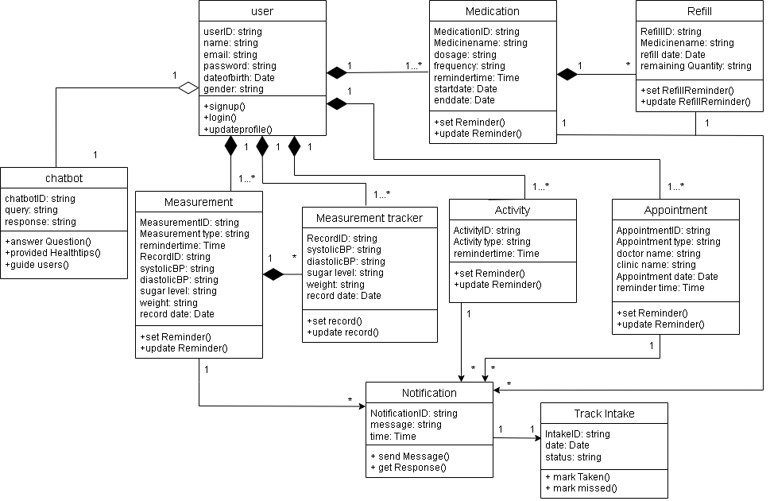Figure 3.1 Class Diagram

2:Sequence Diagram
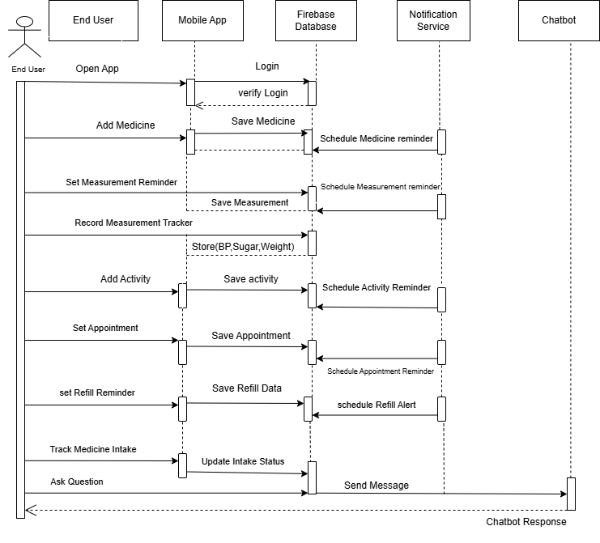
Figure 3.2 Sequence Diagram

3: State Diagram
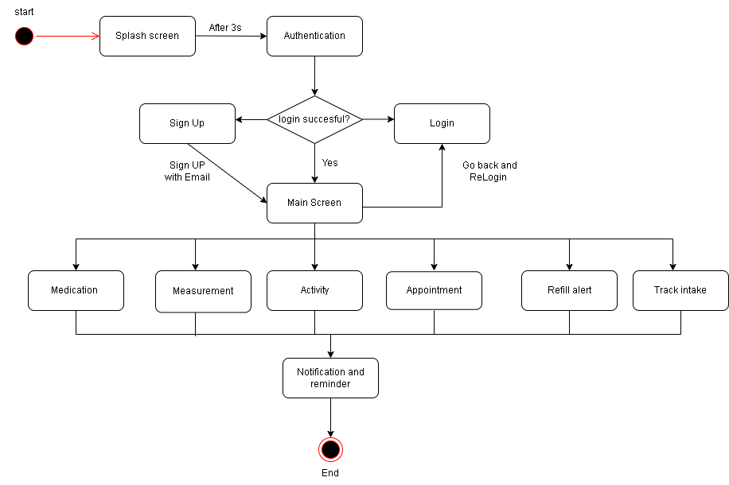
Figure 3.3 State Diagram

4 :Activity Diagram

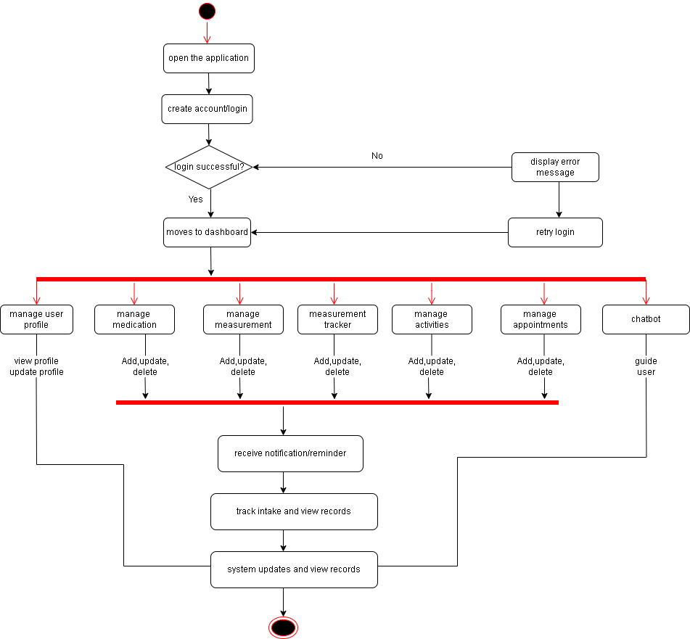
Figure 3.4 Activity Diagram

3.3 Architectural Design
Architecture Design is concerned with understanding how a software system should be organized and designing the overall structure of that system . Architectural design is the first stage in the software design process . It is the critical link between design and requirements engineering ,as it identifies the main structural components in a system and the relationships between them. The output of the architectural design process is an architectural model that describes how the system is organized as a set of communicating components .The smart Healthcare reminder application follows the Model-View-View Model(MVVM)architecture. This architecture divides the application into three main layers which help keep the code organized, makes the system easier easy to manage, and simplifies testing and maintenance.
1.Architecture Pattern: MVVM (Model-view-View Model)
Model: The model layer handles the data of the application. It stores, retrieves, and processes data from the database.
In this project, the model layer includes:
- User profile information
- Medication reminders
- Health measurement data(blood pressure, weight, blood sugar)
- Activity reminders(walking, water intake, eating meal)
- Appointment schedules
- Medicine Refill reminders
- Storing and retrieving data from Firebase Firestore
View: The view layer is the user interface of the application. It is the part that users interact with directly. It displays information and allows users to perform actions in the application.
The View layer of this project includes:
- Login and registration screens
- Dashboard/Home screen
- Medication reminder screen
- Health Measurement screen
- Activity reminder screen
- Appointment scheduling screen
- Chatbot screen
- Refill reminder screen
- Track intake screen
- Profile section screen
View Model: The View Model act as a bridge between the Model and View layers. It manages the application logic and prepare data so it can be easily displayed in the user interface.
The functionality of this layer includes:
- Managing UI related data
- Fetching reminders and health data from Firebase
- Processing user actions such as adding or editing reminders
- Handling reminder scheduling and intake tracking
- Separates business logic from view

3.3.1 Component structure
Component | Role
User Authentication module | Handles user registration, login and logout using Firebase authentication.
Medication Management module | Allows user to add, edit and manage medicine reminder and schedule.
Measurement module | Allows user to set reminder and record health measurement such as blood pressure, blood sugar, weight.
Activity Reminder module | Allows user to set reminder for daily physical activities like walking, drinking water, eating meal.
Appointment management module | Enables user to schedule and manage doctor appointment.
Refill Reminder module | Tracks medicine quantity and send notification when medicine stock is about to finish.
Intake tracking module | Allows user to mark reminders as taken or missed and stores daily health records.
Profile Management module | Allows user to view and update their personal profile and health reminder history.
Chatbot Assistance module | Helps users by answering basic health-related questions, providing simple health tips, and guiding them to manage reminders and allow users to give feedback on the quality of its responses.
Firebase Data module | Handles data storage and retrieval using Firebase Firestore and manages CRUD operation
View Model layer | Act as a bridge between the user interface and backend services

3.3.2 Component Diagram
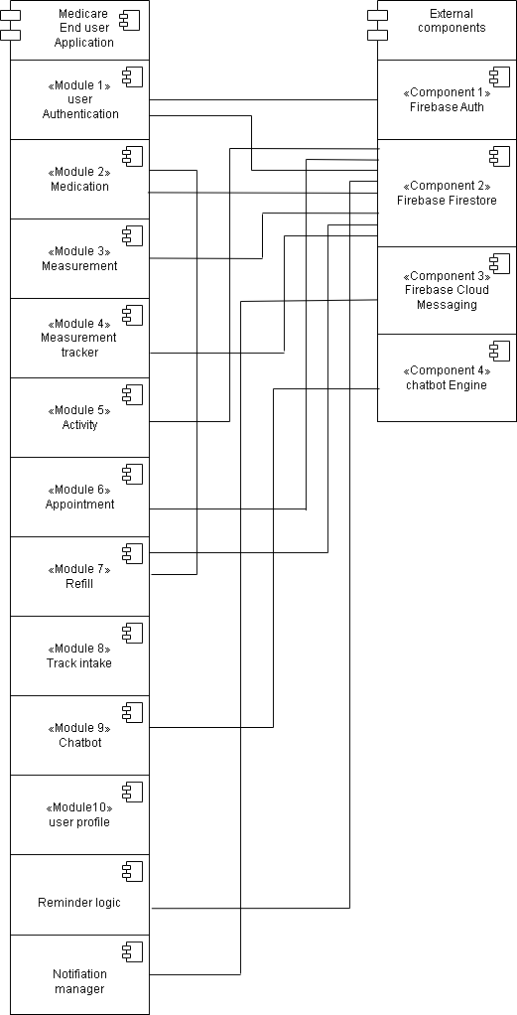
Figure 3.5 Component Diagram

3.3.3 Mapping Components to MVVM Architecture
MVVM modules | Mapped modules/components
Model | User, Medication, Measurement, Activity, Appointment, Refill, TrackIntake, Notification, UserProfile, FirebaseRepository, FirebaseAuth, Firestore Database
ViewModel | AuthViewModel, MedicationViewModel, MeasurementViewModel, ActivityViewModel, AppointmentViewModel, RefillViewModel, TrackIntakeViewModel, NotificationViewModel, UserProfileViewModel
View | XML Layout Files, Activities/Fragments such as LoginActivity, DashboardActivity, MedicationActivity, MeasurementActivity, ActivityScreen, AppointmentActivity, RefillActivity, TrackIntakeScreen, NotificationScreen, ProfileActivity

3.4 Data Design
For Database we are using Firebase Firestore is a NoSQL, cloud based backend service that stores data in a hierarchical structure of collections, documents and fields. The smart Healthcare reminder application uses firebase Firestore to store and manage data. The data is organized into collections for structured access and scalability. Medication collection stores medicine details including name, dosage, frequency, reminder times. Measurement collection stores health measurement reminders such as blood pressure, weight and blood sugar. Activity collection stores daily physical activity reminders (walking , drinking water, eating meals). Appointment collection stores doctor appointment details including date, time and clinic information. Refill collection stores medicine refill information and alerts users when medicine stock is about to finish. Intake tracking records whether reminders were marked as taken or missed for progress tracking. The Chatbot collection stores predefined questions and responses to guide users with health queries and application guidance and allow users to give feedback on the quality of its responses.

The firestore hierarchy is given below:
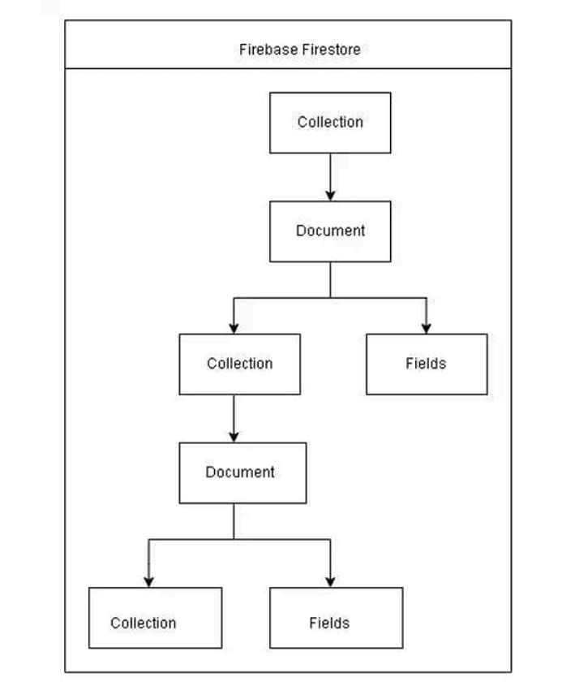

Module | Firebase Features | Data Structure
User Auth | Firebase Authentication | Hash map, model classes
Medication | Firebase Firestore | Hash map, model classes, collections, documents, fields
Measurement | Firebase Firestore | Hash map, model classes, collections, documents, fields
Activity | Firebase Firestore | Hash map, model classes, collections, documents, fields
Appointment | Firebase Firestore | Hash map, model classes, collections, documents, fields
Refill | Firebase Firestore | Hash map, model classes, collections, documents, fields
Chatbot | Firebase Firestore | Hash map, model classes, collections, documents, fields
Notification | Firebase cloud messaging | Message payload, model classes
User profile | Firebase Firestore | Hash map, model classes, collections, documents, fields

3.4.1 Data Dictionary
As we are using object-oriented approach so our data dictionary is comprised of classes, major classes are given below:
Terminology | Description
User | Class: Stores personal details such as name, age, date of birth, gender and manage medications, measurement, activities and appointments.
Medication | Class: Used to store medication details including medication name, dosage, frequency, start/end date, and reminder time.
Medication Intake | Class: Tracks medication intake status such as Taken, missed along with date and time.
Measurement | Class: Represents Reminders for health measurement such as blood pressure, weight or blood sugar. Stores  Reminder type and scheduled time.
Activity | Class: Used to store activity reminders such as walking, drinking water, or meals. Store Reminder type and schedule time.
Appointment | Class: Stores doctor appointment details such as date, time, Doctor or clinic name.
Refill | Class: Represents Medicine Refill information including refill date or remaining quantity.
Chatbot | Class: Acts as a virtual assistant that handles user queries related to health, reminders, and application usage by providing predefined responses and guidance and allow users to give feedback on the quality of its responses.
Notification | Class: Used to manage reminder notification for medication, activities, measurement, appointment and Refill
Firebase Authentication | Class: Used to interact with firebase Authentication for user login, signup.
Firebase Firestore | Class: Used to interact with firebase firestore to store and retrieve user data and reminders.
Document Snapshot | Class: Used to interact with documents retrieve from Firestore.

3.5 :User Interface Design

3.5.1Screen Images

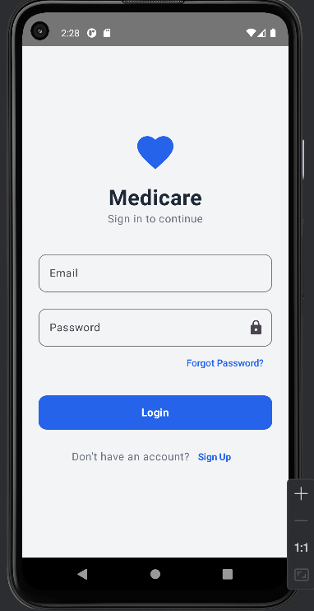
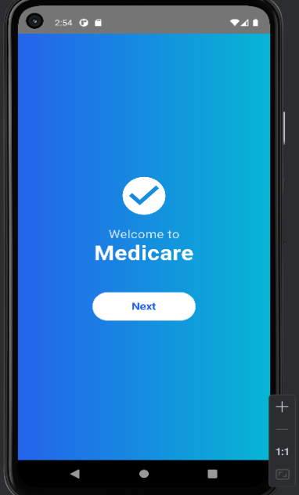

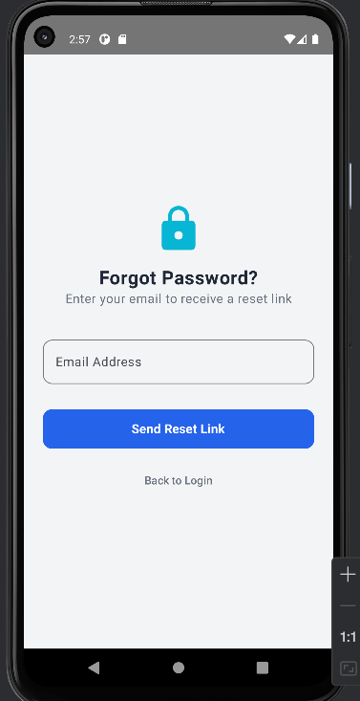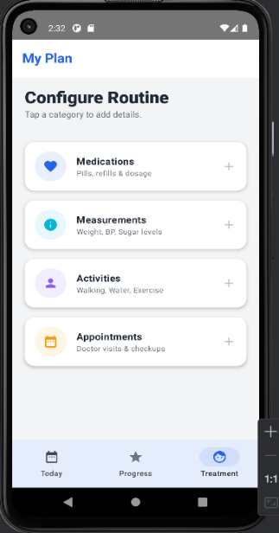

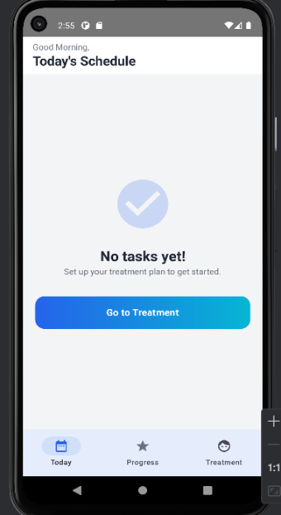

3.5.2 Screen Objects and Actions
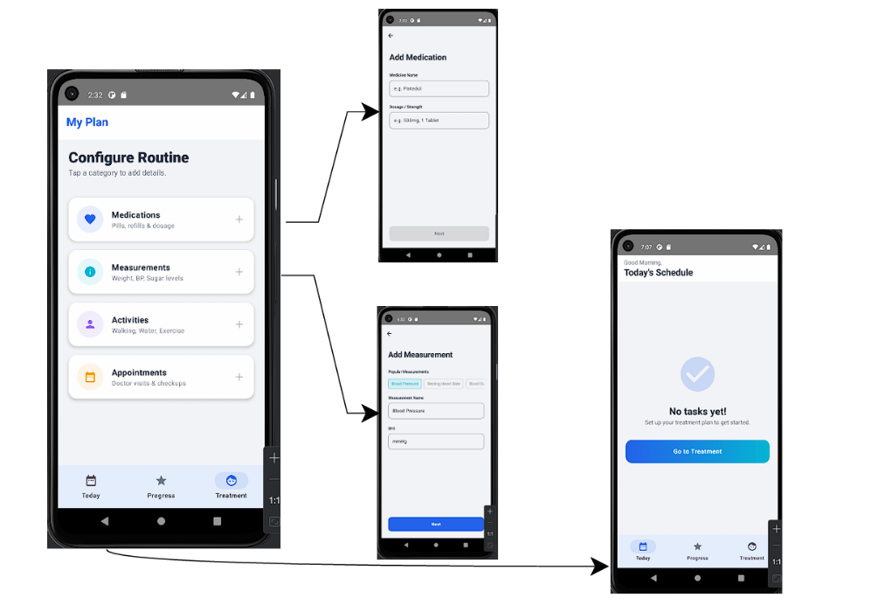
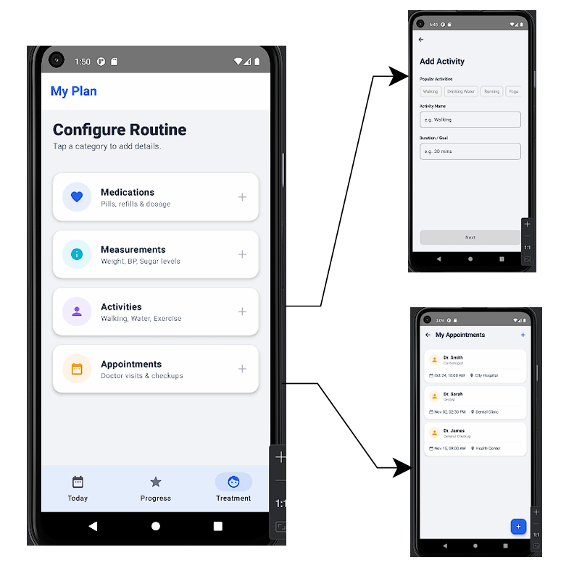

3.6 Design Decisions
In designing smart healthcare reminder mobile application, several key decision were made to ensure scalability, user-friendliness, maintainability and security while supporting healthcare-related reminders.
1.Design Methodology
Choice: Structured and modular approach
Reason: This approach divides the system into clear modules making the system easy to understand, maintain and extend in the future.
2.Architectural style
Choice: Three-Tier Architecture(Presentation, Application, Firebase Backend)
Reason: This improves maintainability and scalability, allowing independent updates to the UI, logic, and back-end.
3.Database design
Choice: Firebase FIrestore
Reason: Firestore supports hierarchical data storage which is suitable for managing dynamic data
4.Programming languages & Framework
Choice: Flutter for Android frontend and Firebase (Authentication, Firestore, Cloud Messaging) for backend services.
Frontend: Android(Flutter)
Backend: Firebase (Authentication, Firestore, cloud messaging)
Reason: Flutter provides native android experience with strong performance, while Firebase offers reliable backend services.
5.Algorithmic Approach
Choice: CRUD operation with time- based scheduling logic.
Reason: CRUD operation are essential for creating, updating and deleting reminders and user data while time based logic ensures accurate scheduling and delivery of notification.
6.Security decisions
Choice: Firebase authentication with secure login options.
Reason: This ensures sensitive data is managed securely and reduces the risk of unauthorized access.
7.Design Tools
Choice: UML modelling tools such as draw.io.
Reason: These tools help visualize system structure through use case, class, sequence, state and activity diagram improving system understanding.

3.7 :Summary
This chapter presents a detailed analysis of the system design , covering design considerations architectural structure , and high level abstract models. It includes sequence, state , class, and component diagrams. The MVVM architecture pattern is used for its simplicity and ease of testing.

