Name: Laiba Tahir
Registration no: 04072313014
Semester: BSCS-6th semester
Course Title: Advanced Database Systems
Course Instructor: Dr. Khalid Saleem
Topic: Data Marts


Donation & Funds Management System

Overview:

This project creates 5 single fact data marts based on the star schema approach.
Source Database: DonationManagementSystem
Data Mart Location: Same database
Design Explanation:
The data marts of the Donation & Funds Management System are designed using the Star Schema.

Design Structure: Star Schema
Each data mart has:
- One Fact Table in the center
- Multiple Dimension Tables around it
This creates a star-like structure. It helps users easily analyze data based on different aspects such as time, category, and donor information.

Dimension Tables:
- Surrogate Keys (SK):
Each dimension table uses a surrogate key (auto-generated ID). This makes the system independent of the source database and avoids issues if original keys change.
- Descriptive Data:
Dimension tables store descriptive information such as:
- who (donor or beneficiary)
- when (time)
- category or type
- Denormalization:
The dimension tables are slightly simplified (not fully normalized). This reduces the need for complex joins and improves query speed.

Fact Tables:
- Single Fact:
Each data mart focuses on one main measure, such as:
- donation amount
- allocated amount
- request count
- Foreign Keys:
Fact tables only store:
- foreign keys (linking to dimensions)
- Numeric values (facts)
.

Source Tables Used:
- Donor (10 records)
- Beneficiary (10 records)
- Donation (10 records)
- RequestSupport (10 records)
- FundsAllocation (10 records)

Data Mart 1: Donation Amount Mart:
Purpose:
Track donation amounts by donor, time, category, and status.

Star Schema (Created using draw.io):
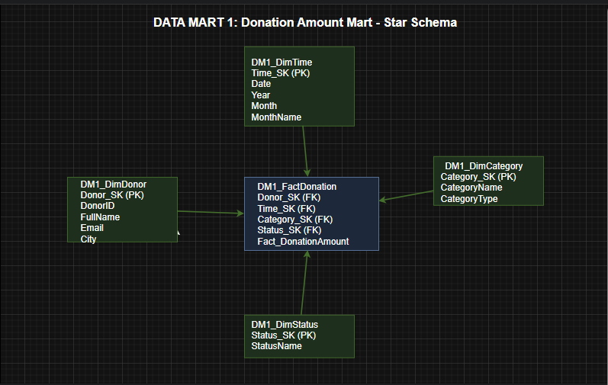

- Fact Table: DM1_FactDonation
- Dimension Tables:
- DM1_DimDonor
- DM1_DimTime
- DM1_DimCategory
- DM1_DimStatus
SQL:
SELECT d.FullName AS DonorName,t.Year, t.MonthName,c.CategoryName,s.StatusName,f.Fact_DonationAmount
FROM DM1_FactDonation f
JOIN DM1_DimDonor d ON f.Donor_SK = d.Donor_SK
JOIN DM1_DimTime t ON f.Time_SK = t.Time_SK
JOIN DM1_DimCategory c ON f.Category_SK = c.Category_SK
JOIN DM1_DimStatus s ON f.Status_SK = s.Status_SK;

Output after running the Query (also written in SQL Server DataMart1 Section):
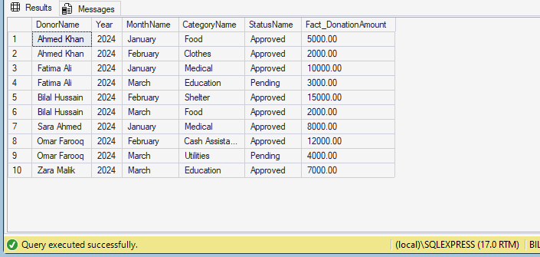

Data Mart 2: Funds Allocation Mart:
Purpose:
Track how funds are allocated from donors to beneficiaries.
Star Schema:

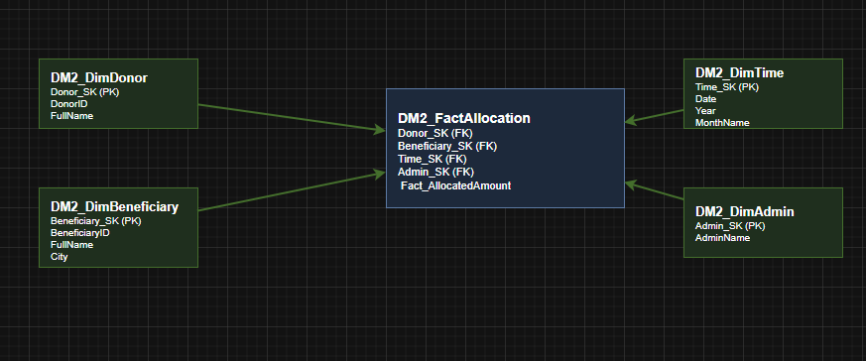

- Fact Table: DM2_FactAllocation
- Dimension Tables:
- DM2_DimDonor
- DM2_DimBeneficiary
- DM2_DimTime
- DM2_DimAdmin

SQL:
SELECT d.FullName AS DonorName,b.FullName AS BeneficiaryName,t.Year, t.MonthName,f.Fact_AllocatedAmount
FROM DM2_FactAllocation f
JOIN DM2_DimDonor d ON f.Donor_SK = d.Donor_SK
JOIN DM2_DimBeneficiary b ON f.Beneficiary_SK = b.Beneficiary_SK
JOIN DM2_DimTime t ON f.Time_SK= t.Time_SK;
GO
Output after running the Query (also written in SQL Server DataMart2 Section):

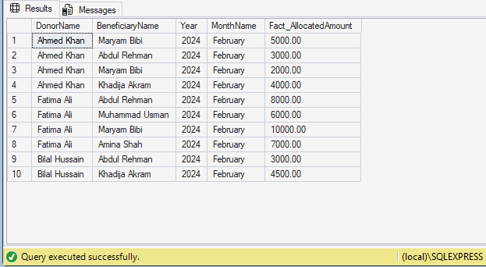

Data Mart 3: Donor Contribution Mart:
Purpose:
Show total donation per donor (aggregated).
Star Schema:
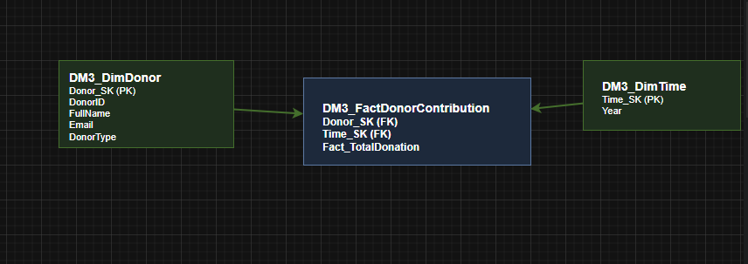
- Fact Table: DM3_FactDonorContribution
- Dimension Tables:
- DM3_DimDonor
- DM3_DimTime
SQL:
SELECT d.FullName, d.DonorType, f.Fact_TotalDonation
FROM DM3_FactDonorContribution f
JOIN DM3_DimDonor d ON f.Donor_SK=d.Donor_SK;

Output after running the Query (also written in SQL Server DataMart3 Section):
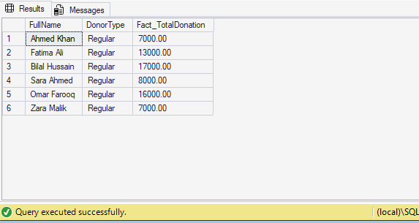

Data Mart 4: Request Analysis Mart:
Purpose:
Track beneficiary support requests.
Star Schema:

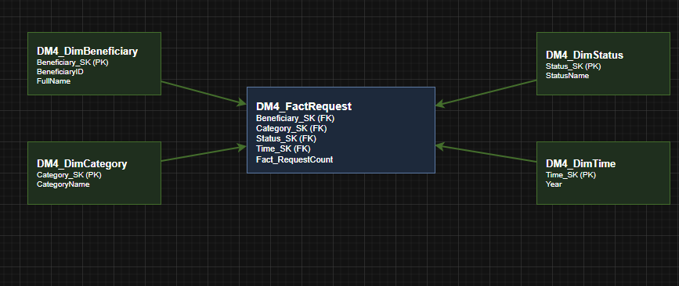

- Fact Table: DM4_FactRequest
- Dimension Tables:
    - DM4_DimBeneficiary
    - DM4_DimCategory
    - DM4_DimStatus
    - DM4_DimTime
SQL:
SELECT b.FullName, c.CategoryName, s.StatusName, f.Fact_RequestCount
FROM DM4_FactRequest f
JOIN DM4_DimBeneficiary b ON f.Beneficiary_SK= b.Beneficiary_SK
JOIN DM4_DimCategory c ON f.Category_SK= c.Category_SK
JOIN DM4_DimStatus s ON f.Status_SK= s.Status_SK;

Output after running the Query (also written in SQL Server DataMart4 Section):

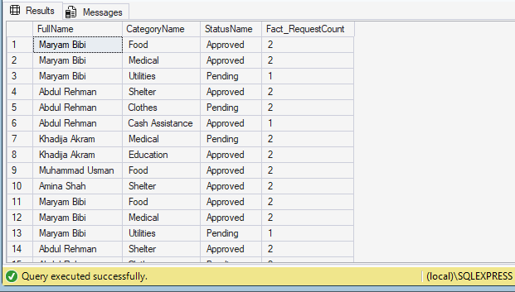

Data Mart 5: Category Performance Mart:
Purpose:
Show donation performance by category over time.
Star Schema:
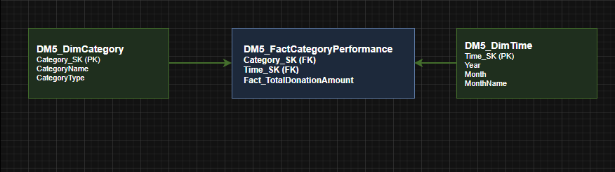

- Fact Table: DM5_FactCategoryPerformance
- Dimension Tables:
- DM5_DimCategory
- DM5_DimTime

SQL:
SELECT c.CategoryName, t.Year, t.MonthName, f.Fact_TotalDonationAmount
FROM DM5_FactCategoryPerformance f
JOIN DM5_DimCategory c ON f.Category_SK= c.Category_SK
JOIN DM5_DimTime t ON f.Time_SK= t.Time_SK
ORDER BY c.CategoryName, t.Year, t.Month;

Output after running the Query (also written in SQL Server DataMart5 Section):

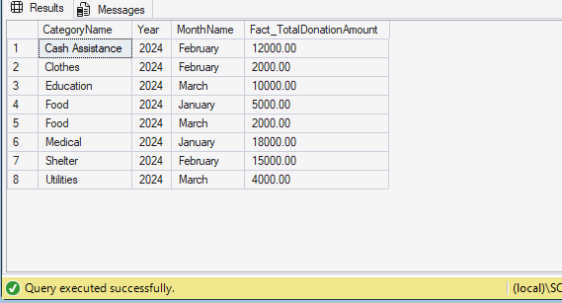

Conclusion:
Five single fact data marts were successfully designed for the Donation and Funds Management System. A source database was created with 5 tables (Donor, Beneficiary, Donation, RequestSupport, FundsAllocation), and synthetic data of 10 records each was generated.
The 5 data marts created are:
Donation Amount Mart – tracks donation amounts by donor, time, category, and status.
Funds Allocation Mart – tracks fund distribution from donors to beneficiaries.
Donor Contribution Mart – shows total donation per donor.
Request Analysis Mart – analyzes beneficiary support requests.
Category Performance Mart – shows donation trends by category over time.

All star schema rules were followed: dimension tables have surrogate keys (IDENTITY), fact tables contain only foreign keys and measurable values, and joins use surrogate keys.

