HYDROLOGICAL ANALYSIS REPORT
Pakistan Monsoon Rainfall and Flood Analysis
Using Google Earth Engine | CHIRPS & Sentinel-1 SAR | 2015–2025

160  DISTRICTS ANALYZED | 10  YEARS · 2015–2025 | 1,760  DISTRICT-YEAR RECORDS | 2026–27  RAINFALL PROJECTION

Work Done By | Laiba Zarar Noor

00 | ABSTRACT
This study presents a district-level analysis of monsoon-season rainfall and flood extent across all 160 administrative districts of Pakistan over a 10 year record (2015–2025), performed entirely within the Google Earth Engine (GEE) cloud computing platform. Monsoon rainfall totals were derived from the CHIRPS satellite precipitation dataset, and annual flood extent was detected using Sentinel-1 SAR backscatter change detection, with permanent water bodies excluded so that only new flood water was counted.
Each of the 1,760 resulting district-year records was classified by rainfall deviation (Wet, Normal, or Dry Year) and flood severity (No, Low, Moderate, or High), and a Pearson correlation between rainfall and flood extent was computed for every district. Across all 160 districts, 77 show a strong positive correlation and 39 a moderate positive correlation, confirming that flooding in most of Pakistan is well explained by local rainfall. A group of six districts breaks this pattern with a negative correlation: five (Abbottabad, Muzaffarabad, Hunza, Chakwal, Kohat) are mountainous or upstream-river districts where flooding is driven by glacial melt and upstream discharge rather than local rain, while the sixth (Central Karachi) reflects a statistically unreliable correlation caused by near-zero flood signal. Sujawal, in the lower Indus delta, emerged as the single most flood-affected district nationwide. Statistical trend projections for 2026–2027 were also generated using linear and quadratic fits.
Keywords: Monsoon Rainfall · CHIRPS · Sentinel-1 SAR · Google Earth Engine · Flood Extent · Pearson Correlation · Pakistan · District-Level Analysis

01 | INTRODUCTION

Background & Rationale
Monsoon flooding is one of Pakistan's most recurring and costly natural hazards, but the relationship between local rainfall and flood extent is not uniform across the country. Districts fed primarily by upstream river discharge and glacial melt can flood independently of local rainfall, while districts in the plains and delta regions tend to flood in direct proportion to the rain that falls on them. Distinguishing between these two behaviours at a district level is essential for designing rainfall-based early warning systems that are actually reliable for the district they are meant to protect.
This project analyzes monsoon-season rainfall and flood extent across all 160 administrative districts of Pakistan (Admin Level 2, WFP/OCHA COD-AB boundaries) over a 10-year record (2015–2025), using satellite rainfall estimates (CHIRPS) and radar-based flood detection (Sentinel-1 SAR) in Google Earth Engine. Analysis was carried out at district level rather than province level to preserve fine-grained contrasts that a provincial average would otherwise erase.

Study Area
The study covers the full territory of Pakistan, spanning the monsoon-fed plains of Punjab and Azad Kashmir, the arid southwest of Balochistan, the glacial and upstream-river districts of Khyber Pakhtunkhwa and Gilgit-Baltistan, and the coastal/delta districts of Sindh, a range of conditions wide enough that no single rainfall-flood relationship holds everywhere.
02 | OBJECTIVES

- Extract 10 years (2015 - 2025) of monsoon season (June - September) rainfall totals per district from CHIRPS
- Detect annual flood extent per district using Sentinel-1 SAR backscatter change detection
- Classify each district-year by rainfall deviation (Wet / Normal / Dry) and flood severity (No / Low / Moderate / High)
- Compute the Pearson correlation (r) between rainfall and flood area for each of the 160 districts across the 10-year record (r runs from -1 to +1: +1 means rainfall and flooding rise and fall in perfect step, -1 means one rises as the other falls, 0 means no relationship)
- Identify districts where flooding is not explained by local rainfall, and investigate the likely cause
- Generate statistical trend projections for 2026 and 2027 rainfall using linear and quadratic fits

03 | METHODOLOGY

Data Sources
DATASET | SOURCE | PURPOSE
CHIRPS Daily | UCSB Climate Hazards Group | Monsoon-season (Jun–Sep) rainfall totals, 2015 - 2025
Sentinel-1 SAR (GRD) | ESA Copernicus | Radar backscatter for flood extent detection (backscatter is the radar signal that bounces back to the satellite, open water reflects less of it, so a sharp drop in signal is how flooding is detected)
COD-AB District Boundaries | WFP / OCHA | 160 district administrative boundaries (Admin Level 2)

Analysis Workflow
The full analysis reduces to four conceptual stages, executed as a ten-script Earth Engine pipeline:


Ten-Stage Earth Engine Pipeline
Each stage runs as a discrete, sequential script centralizing shared constants once (Stage 1) so that any adjustment, such as flood sensitivity, only needs to be made in a single place:



04 | FINDINGS

Overview Statistics
Averaged across all 10 years, the wettest districts are Kotli (900.3mm), Bhimber (897.1mm), and Narowal (888.8mm), all in Azad Kashmir and Punjab, while the driest are Chagai (3.6mm), Chaman (5.3mm), and Nushki (6.7mm), all in Balochistan. This roughly 250-fold gap reflects Pakistan's transition from the monsoon-fed east to the arid southwest.
The single wettest district-year on record is Bhimber in 2025 (1,171.6mm); the single driest is Chagai in 2015 (0.12mm). Rainfall consistency also varies sharply by geography: Karachi's urban districts (Central, East, Korangi, West) show the most spatially consistent rainfall (coefficient of variation (CV) under 4%), while Chagai and Chaman in Balochistan show the most erratic (over 160%). (CV measures how much rainfall swings year to year in a district, as a percentage of its average: a high CV means unpredictable rainfall)

Classification Breakdown
Each of the 1,760 district-year records was classified using the thresholds defined in Stage 1 of the pipeline (rainfall deviation of more than 15% from a district's own average = Wet/Dry Year; flood severity by % of district area flooded). The chart below breaks this out year by year rather than as a single 11-year total, since the flat total hides how sharply the classification shifted from one monsoon season to the next:
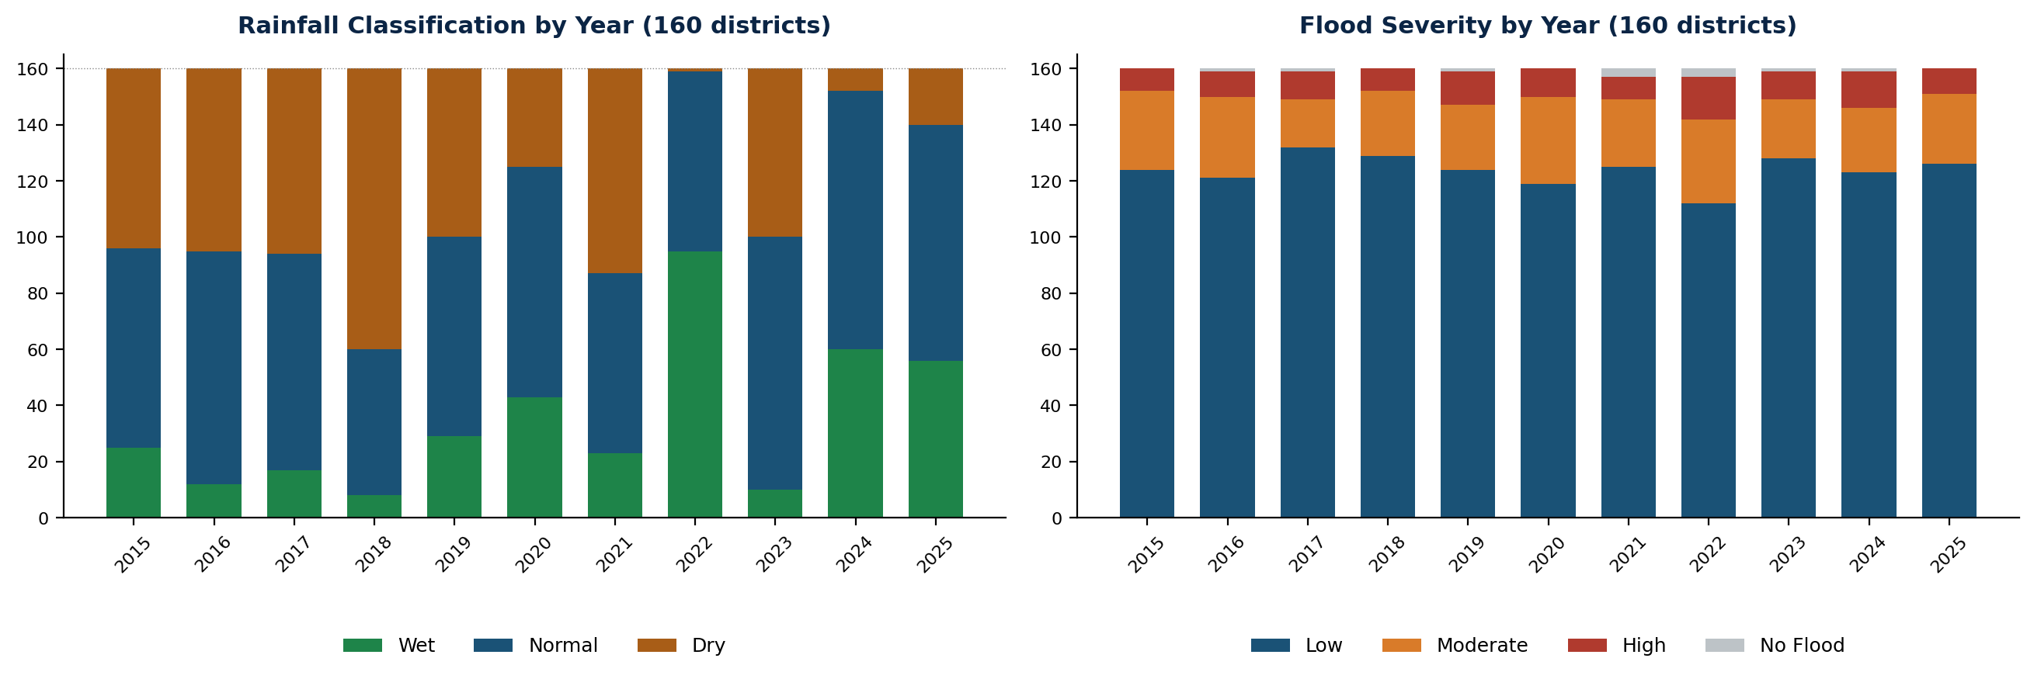
2022 stands out sharply from every other year in the record: 95 of the 160 districts were classified as a Wet Year that season, more than four times the count of any other single year with only 1 district classified Dry. 2022 also recorded the year's highest count of High-severity flood districts (15). This concentration is consistent with 2022 being Pakistan's national flood peak, and it is a pattern the old flat 11-year total did not show.
The large majority of district-years still saw only low-level flooding overall, consistent with flood damage in Pakistan being concentrated in a relatively small number of severe events rather than spread evenly across years.

Rainfall And Flood Correlation Findings
For each district, the correlation between its rainfall and flood area across the 10-year record was computed:
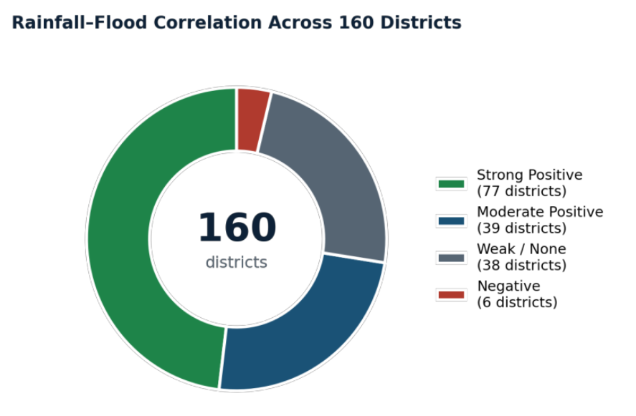
In most districts, flooding is well explained by local rainfall; the strongest examples are Shaheed Sikandarabad (r = 0.97), Chaman (r = 0.94), and Kalat (r = 0.94). A small but important group of six districts breaks this pattern, showing a negative correlation between local rainfall and flood extent:
DISTRICT | PROVINCE | r | INTERPRETATION
Abbottabad | Khyber Pakhtunkhwa | -0.31 | Upstream / glacial-driven flooding
Muzaffarabad | Azad Kashmir | -0.31 | Upstream / glacial-driven flooding
Hunza | Gilgit-Baltistan | -0.30 | Upstream / glacial-driven flooding
Chakwal | Punjab | -0.26 | Upstream / glacial-driven flooding
Kohat | Khyber Pakhtunkhwa | -0.25 | Upstream / glacial-driven flooding
Central Karachi | Sindh | -0.21 | Flood signal near-zero every year, not meaningful
The first five districts are mountainous or upstream-river districts in the north and northwest, where flooding is driven more by glacial melt and upstream discharge than by rain falling directly on the district, a genuine reportable finding, since standard rainfall-based flood warnings would likely be unreliable in these five districts specifically.
Central Karachi's case is different: its flood area values are negligible in every year of the record (never exceeding 0.006% of district area, including 2022 at the national flood peak), while neighbouring South Karachi's flood extent scales directly with rainfall. This indicates the negative correlation is a statistical artifact of near-zero flood signal rather than a genuine rainfall-flood disconnect.

NOTABLE DISTRICT-LEVEL FINDING: SUJAWAL
The single most flood-affected district in the dataset is Sujawal, Sindh, which recorded the five worst flood-extent years of any district nationwide: 19.3% of its area flooded in 2022, 18.7% in 2019, 13.0% in 2024, 12.9% in 2020, and 11.9% in 2016. No other district approaches this level of repeated, severe flooding. Given its position in the lower Indus delta, this is consistent with Sujawal being a downstream convergence point for river flow from further upstream in addition to local monsoon rainfall, and it warrants attention independent of the district-level correlation results above.

Yearly Rainfall and Flood Maps (2015 - 2025)
The maps below show classified monsoon-season rainfall intensity (No / Low / Moderate / Heavy) and detected flood extent for each of the 10 years in the study period, captured from the Earth Engine map view, alongside the districts driving each year's extremes.
2015 · National average district rainfall: 263.6mm

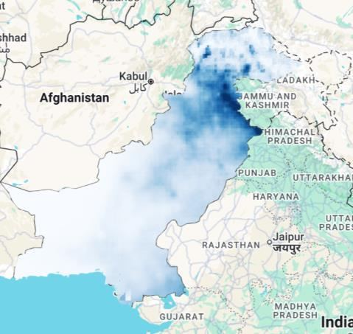  Rainfall classification | 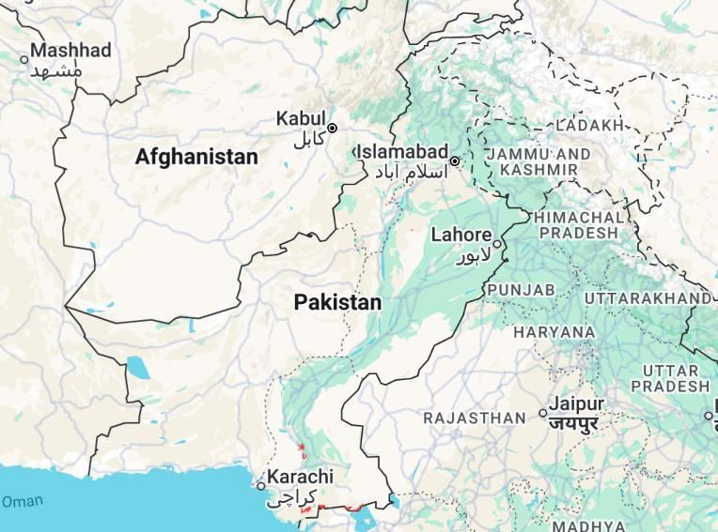  Flood extent
Heaviest rainfall: Kotli (895.9mm), Sudhnoti (859.3mm), Abbottabad (832.9mm), Narowal (822.1mm), Bhimber (809.1mm)
Driest areas: Chagai (0.1mm), Chaman (1.4mm), Nushki (1.7mm), Washuk (3.9mm), Killa Abdullah (3.9mm)
Most flood-affected: Sujawal (9.64%), Kashmore (6.68%), Badin (4.73%), Sohbatpur (3.78%), Jacobabad (2.85%)
Rain-flood disconnect: Sujawal, Kashmore, Badin flooded despite below-average rainfall that season (anomaly as low as -40%), flooding here tracks upstream/glacial discharge rather than local rain. (anomaly = how far that year's rainfall was above or below the district's own 10-year average)
2016 · National average district rainfall: 256.4mm

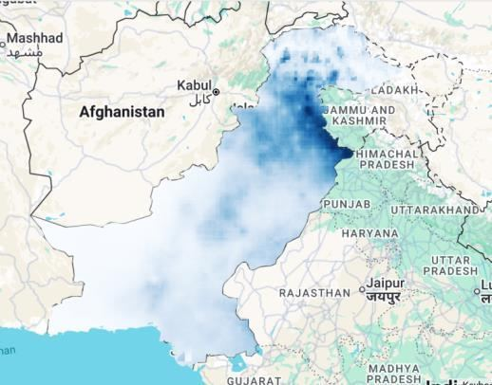  Rainfall classification | 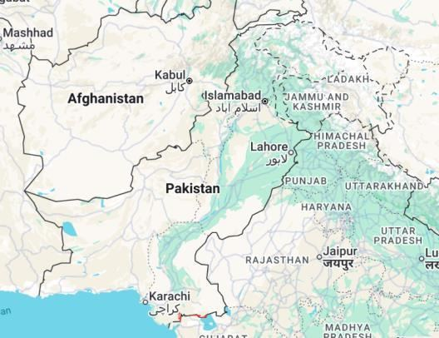  Flood extent
Heaviest rainfall: Narowal (895.5mm), Bhimber (838.0mm), Kotli (813.8mm), Sialkot (809.0mm), Mirpur (778.8mm)
Driest areas: Chaman (0.2mm), Nushki (1.1mm), Chagai (2.4mm), Killa Abdullah (2.6mm), Gwadar (4.8mm)
Most flood-affected: Sujawal (11.86%), Mirpur (9.75%), Kashmore (4.71%), Badin (3.92%), Sohbatpur (2.92%)
Rain-flood disconnect: Sujawal, Mirpur, Badin flooded despite below-average rainfall that season (anomaly as low as -49%), flooding here tracks upstream/glacial discharge rather than local rain.
2017 · National average district rainfall: 255.4mm

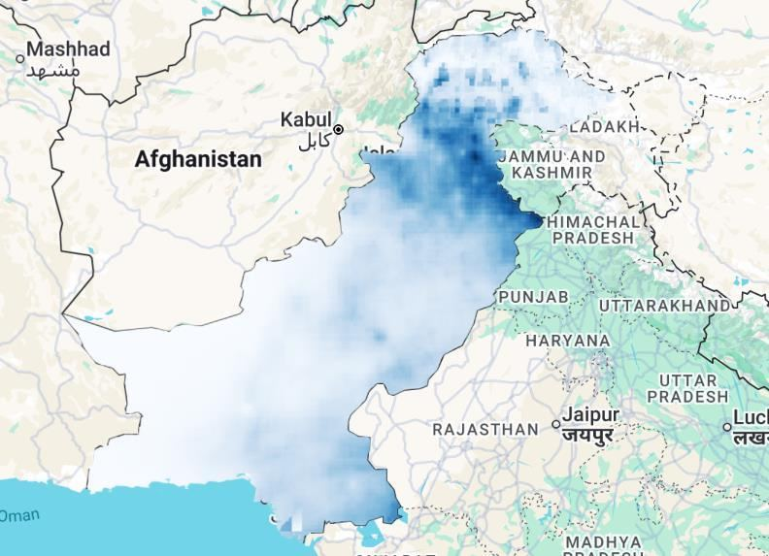  Rainfall classification | 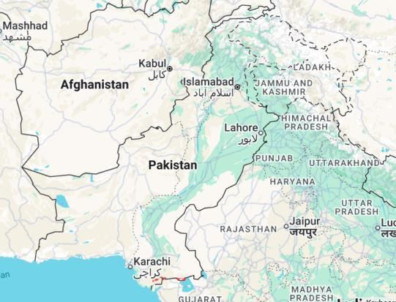  Flood extent
Heaviest rainfall: Bhimber (750.8mm), Kotli (715.9mm), Mirpur (706.4mm), Narowal (702.8mm), Islamabad (676.2mm)
Driest areas: Chagai (0.2mm), Nushki (1.5mm), Chaman (2.2mm), Killa Abdullah (4.4mm), Kharan (7.8mm)
Most flood-affected: Sujawal (10.88%), Mirpur (9.33%), Kashmore (5.32%), Haripur (3.38%), Sohbatpur (3.31%)
Rain-flood disconnect: Sujawal, Mirpur, Kashmore flooded despite below-average rainfall that season (anomaly as low as -22%), flooding here tracks upstream/glacial discharge rather than local rain.
2018 · National average district rainfall: 220.8mm

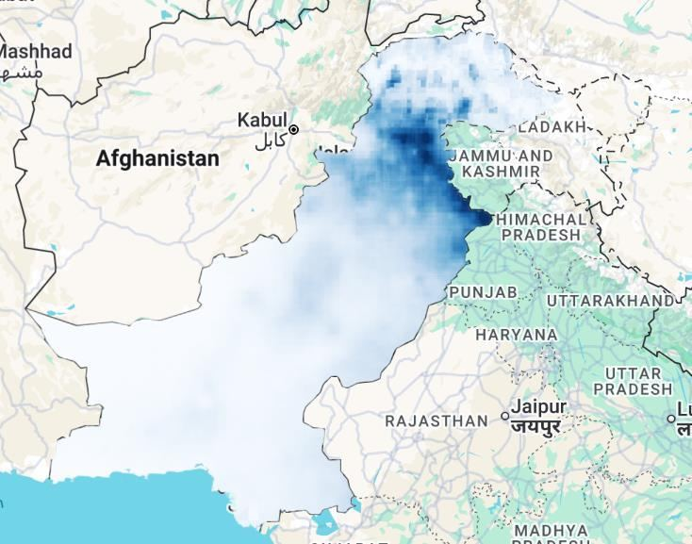  Rainfall classification | 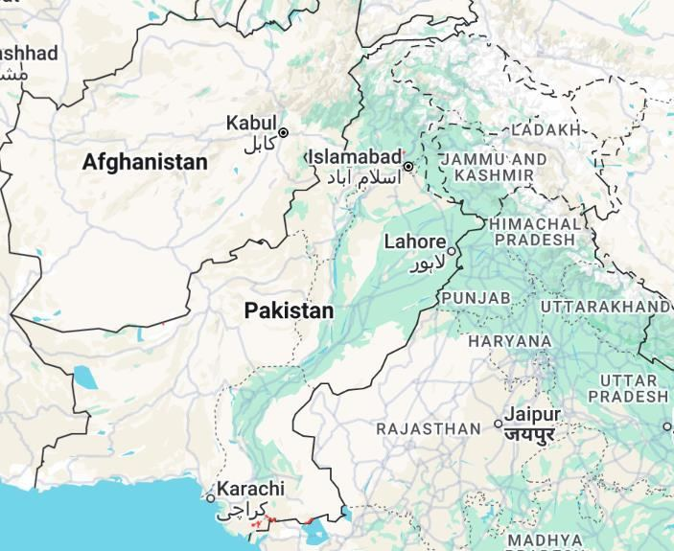  Flood extent
Heaviest rainfall: Narowal (867.4mm), Abbottabad (844.8mm), Bhimber (766.6mm), Kotli (762.2mm), Islamabad (737.4mm)
Driest areas: Nushki (0.4mm), Chagai (0.8mm), Chaman (0.9mm), Kharan (3.3mm), Killa Abdullah (3.4mm)
Most flood-affected: Sujawal (7.9%), Mirpur (7.38%), Kashmore (4.84%), Haripur (3.65%), Sohbatpur (3.11%)
Rain-flood disconnect: Sujawal, Mirpur, Kashmore flooded despite below-average rainfall that season (anomaly as low as -83%), flooding here tracks upstream/glacial discharge rather than local rain.
2019 · National average district rainfall: 264.2mm

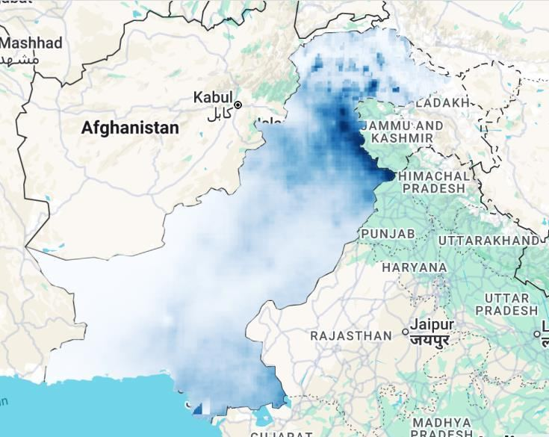  Rainfall classification | 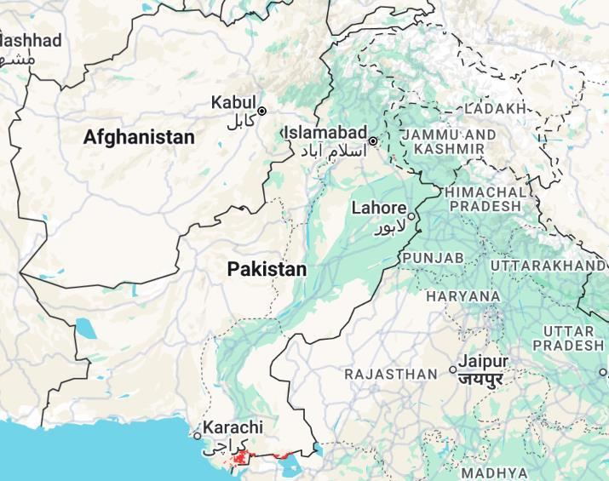  Flood extent
Heaviest rainfall: Bhimber (881.1mm), Kotli (868.9mm), Narowal (827.2mm), Abbottabad (788.8mm), Sudhnoti (779.6mm)
Driest areas: Chagai (0.7mm), Nushki (1.7mm), Chaman (2.2mm), Killa Abdullah (6.4mm), Kharan (12.7mm)
Most flood-affected: Sujawal (18.72%), Mirpur (10.03%), Kashmore (5.45%), Badin (4.54%), Sohbatpur (3.73%)
Rain-flood disconnect: Mirpur, Kashmore, Sohbatpur flooded despite below-average rainfall that season (anomaly as low as -36%), flooding here tracks upstream/glacial discharge rather than local rain.
2020 · National average district rainfall: 283.8mm

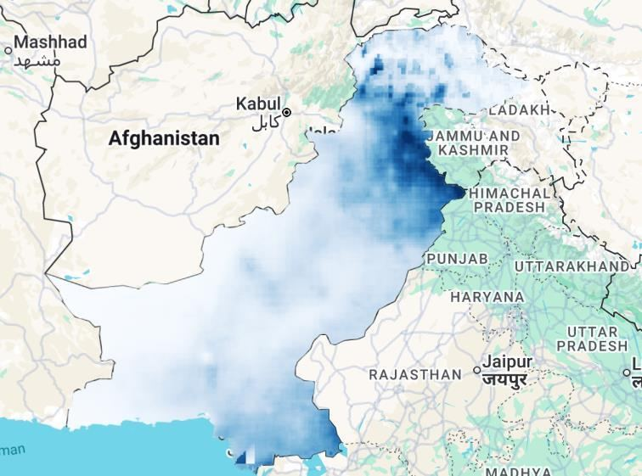  Rainfall classification | 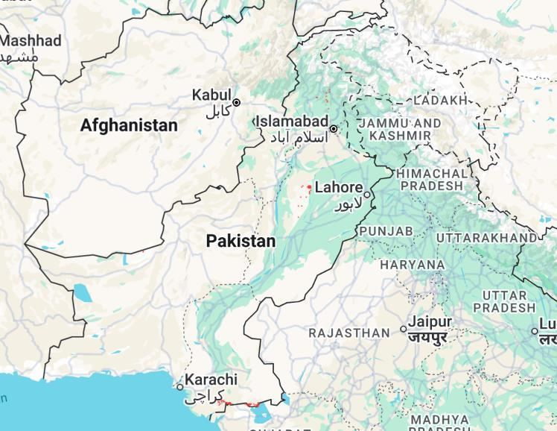  Flood extent
Heaviest rainfall: Narowal (834.9mm), Bhimber (832.8mm), Kotli (829.1mm), Sudhnoti (826.3mm), Islamabad (789.5mm)
Driest areas: Chaman (5.1mm), Chagai (5.4mm), Nushki (7.4mm), Killa Abdullah (11.8mm), Pishin (20.1mm)
Most flood-affected: Sujawal (12.92%), Kashmore (5.09%), Sohbatpur (4.07%), Jacobabad (4.05%), Badin (3.86%)
Rain-flood disconnect: Kashmore, Sohbatpur, Jacobabad flooded despite below-average rainfall that season (anomaly as low as -25%), flooding here tracks upstream/glacial discharge rather than local rain.
2021 · National average district rainfall: 275.5mm

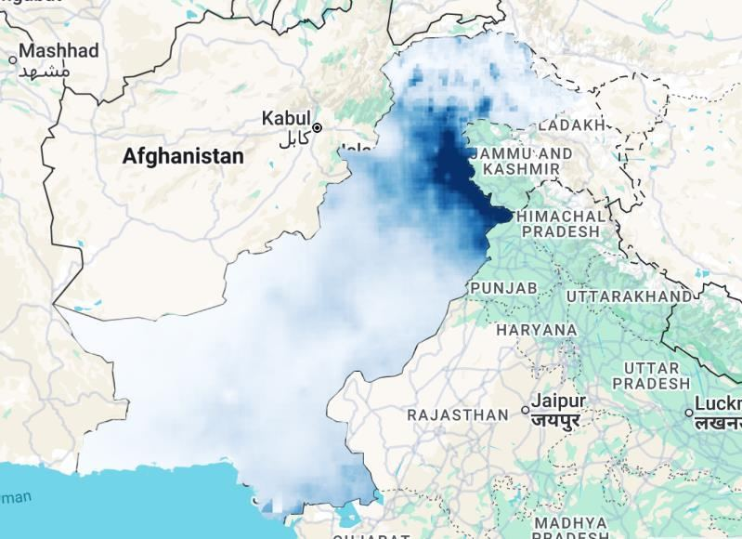  Rainfall classification | 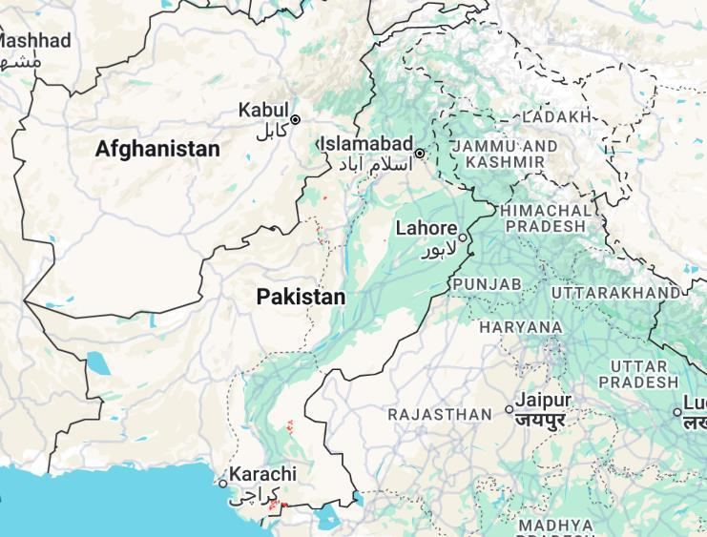  Flood extent
Heaviest rainfall: Bhimber (1151.2mm), Kotli (1113.2mm), Mirpur (1080.5mm), Narowal (1080.1mm), Sudhnoti (1008.3mm)
Driest areas: Chaman (5.0mm), Chagai (6.2mm), Nushki (8.2mm), Killa Abdullah (10.1mm), Mastung (18.9mm)
Most flood-affected: Mirpur (10.77%), Sujawal (7.4%), Kashmore (5.48%), Sohbatpur (3.94%), Haripur (3.44%)
Rain-flood disconnect: Sujawal, Kashmore, Sohbatpur flooded despite below-average rainfall that season (anomaly as low as -43%), flooding here tracks upstream/glacial discharge rather than local rain.
2022 · National average district rainfall: 356.1mm

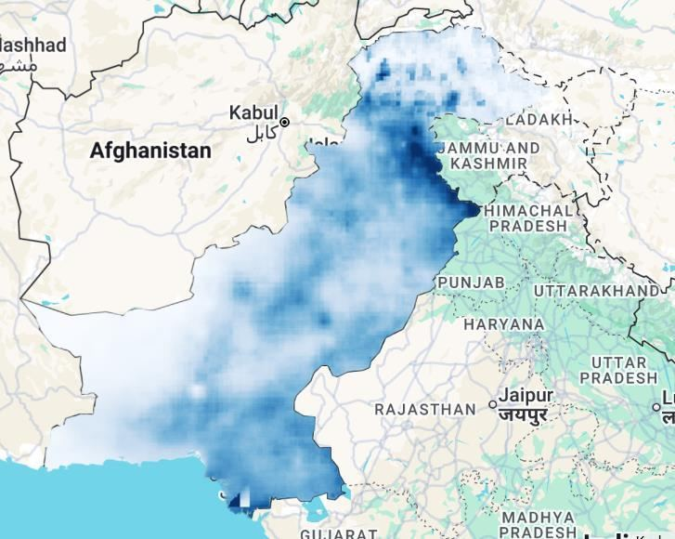  Rainfall classification | 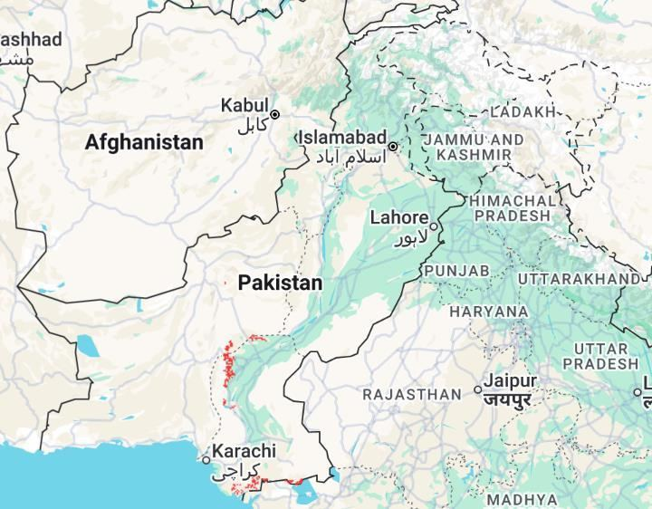  Flood extent
Heaviest rainfall: Kotli (887.0mm), Narowal (843.4mm), Sudhnoti (828.0mm), Bhimber (826.5mm), Mirpur (822.4mm)
Driest areas: Chagai (13.9mm), Chaman (21.9mm), Nushki (23.7mm), Killa Abdullah (42.3mm), Ghanche (55.1mm)
Most flood-affected: Sujawal (19.31%), Sohbatpur (10.1%), Jacobabad (9.46%), Mirpur (8.87%), Kashmore (6.64%)
Rain-flood disconnect: Mirpur, Haripur, Tor Ghar flooded despite below-average rainfall that season (anomaly as low as -8%), flooding here tracks upstream/glacial discharge rather than local rain.
2023 · National average district rainfall: 261.6mm

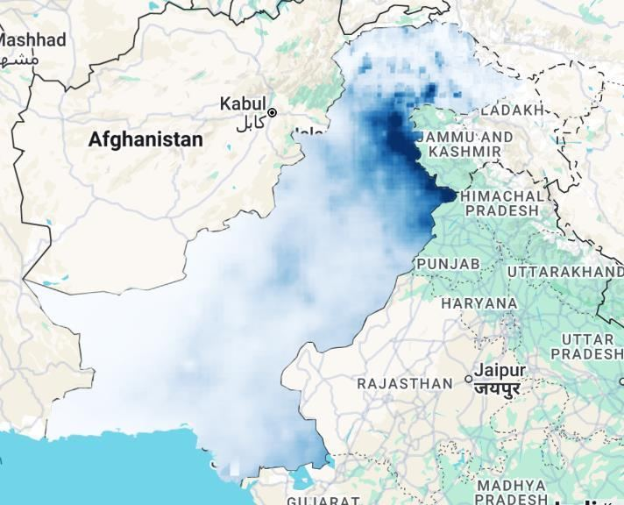  Rainfall classification | 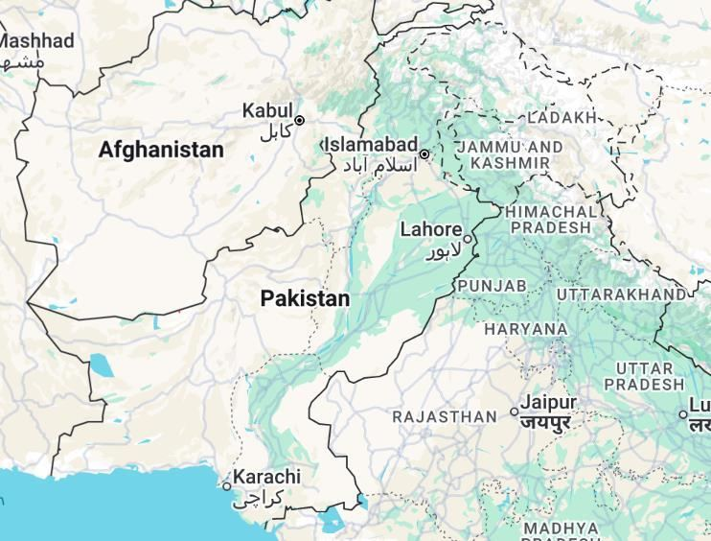  Flood extent
Heaviest rainfall: Kotli (985.5mm), Narowal (983.2mm), Sudhnoti (949.5mm), Abbottabad (933.9mm), Bhimber (886.7mm)
Driest areas: Chaman (1.3mm), Chagai (3.8mm), Killa Abdullah (6.0mm), Nushki (8.6mm), Gwadar (11.5mm)
Most flood-affected: Mirpur (11.49%), Sujawal (9.67%), Kashmore (5.18%), Sohbatpur (3.61%), Badin (3.32%)
Rain-flood disconnect: Sujawal, Badin, Matiari flooded despite below-average rainfall that season (anomaly as low as -32%), flooding here tracks upstream/glacial discharge rather than local rain.
2024 · National average district rainfall: 290.8mm

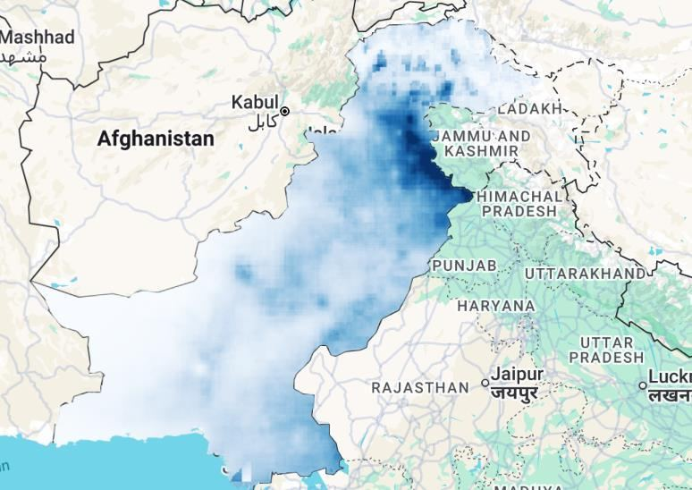  Rainfall classification | 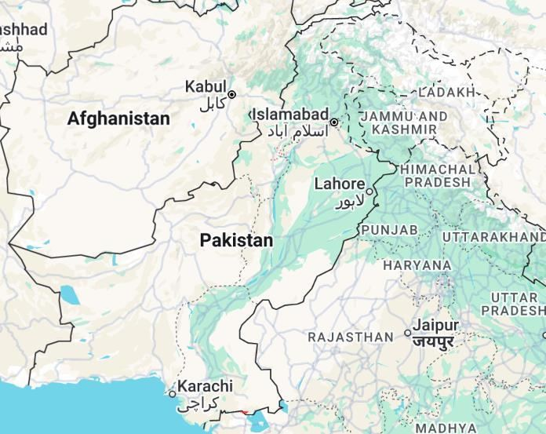  Flood extent
Heaviest rainfall: Bhimber (953.4mm), Mirpur (904.9mm), Kotli (893.3mm), Narowal (818.3mm), Gujrat (815.2mm)
Driest areas: Chagai (3.2mm), Nushki (9.1mm), Chaman (11.5mm), Gwadar (23.1mm), Killa Abdullah (23.2mm)
Most flood-affected: Sujawal (12.99%), Mirpur (8.81%), Kashmore (5.37%), Jacobabad (4.19%), Sohbatpur (3.61%)
Rain-flood disconnect: Haripur, Tor Ghar, Swabi flooded despite below-average rainfall that season (anomaly as low as -4%), flooding here tracks upstream/glacial discharge rather than local rain.
2025 · National average district rainfall: 319.3mm

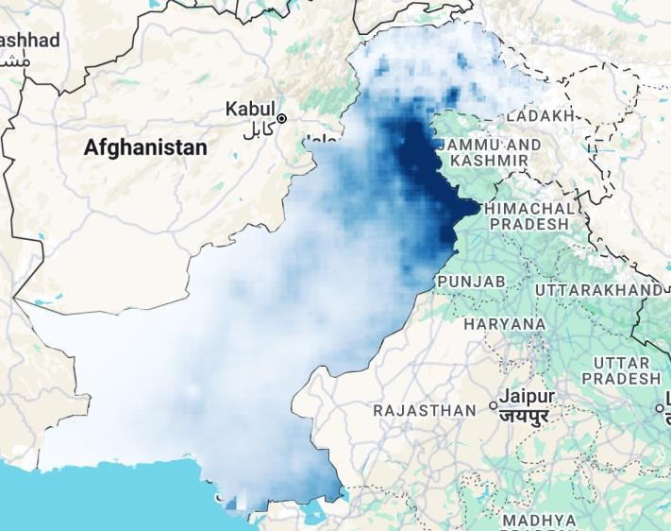  Rainfall classification | 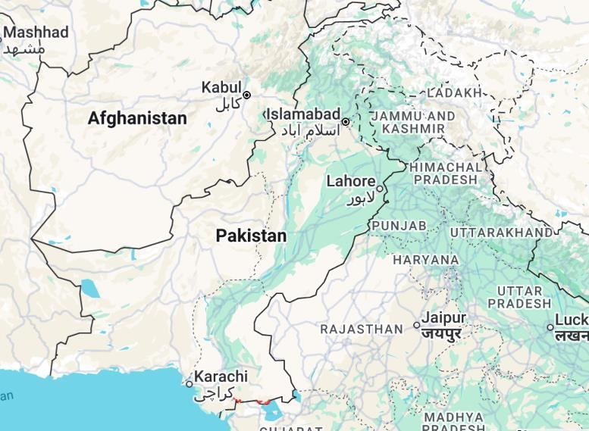  Flood extent
Heaviest rainfall: Bhimber (1171.6mm), Kotli (1138.3mm), Sudhnoti (1110.6mm), Islamabad (1109.2mm), Narowal (1102.1mm)
Driest areas: Chagai (2.2mm), Chaman (6.3mm), Nushki (10.0mm), Gwadar (13.9mm), Killa Abdullah (15.5mm)
Most flood-affected: Mirpur (10.76%), Sujawal (8.6%), Kashmore (5.3%), Haripur (3.45%), Matiari (2.82%)
Rain-flood disconnect: Sujawal, Kashmore, Matiari flooded despite below-average rainfall that season (anomaly as low as -20%), flooding here tracks upstream/glacial discharge rather than local rain.

2026-2027 Rainfall Trend Projections
Statistical trend projections were calculated for every district using linear and quadratic fits through the 10 years of historical data (a linear fit is a straight-line trend; a quadratic fit is a curved trend, used when rainfall is speeding up or slowing down over time rather than changing at a constant rate). These are extrapolations of the historical trend only, not meteorological forecasts and do not account for ENSO, IOD, or other climate drivers of a given season's actual monsoon behaviour.
Based on the linear fit R² value (R² shows how well the trend line fits the actual data, from 0 to 1 — closer to 1 means the trend is more reliable, closer to 0 means it's mostly noise), trend reliability across all 160 districts breaks down as: 7 districts show a strong rising trend, 49 a moderate rising trend, 12 a moderate falling trend, and 92 show a weak or statistically unreliable trend.
The five most reliable rising trends, all contiguous central Punjab districts gaining roughly 18–30mm of rainfall per year, form the most consistent rising-rainfall cluster in the country:
DISTRICT | R² | TREND | 2026 / 2027 PROJECTION
Nankana Sahib | 0.72 | Rising | 561.0mm / 585.0mm
Sheikhupura | 0.63 | Rising | 660.8mm / 685.8mm
Lahore | 0.61 | Rising | 792.3mm / 821.8mm
Faisalabad | 0.60 | Rising | 425.4mm / 443.1mm
Kasur | 0.57 | Rising | 554.2mm / 575.9mm
By contrast, the most reliable falling trends are concentrated in Khyber Pakhtunkhwa's northwest belt: Khyber (R²=0.48, -9.7mm/yr), Orakzai (R²=0.41, -13.1mm/yr), Charsadda (R²=0.40, -10.3mm/yr), Peshawar (R²=0.38, -8.9mm/yr), and Mohmand (R²=0.37, -6.3mm/yr).
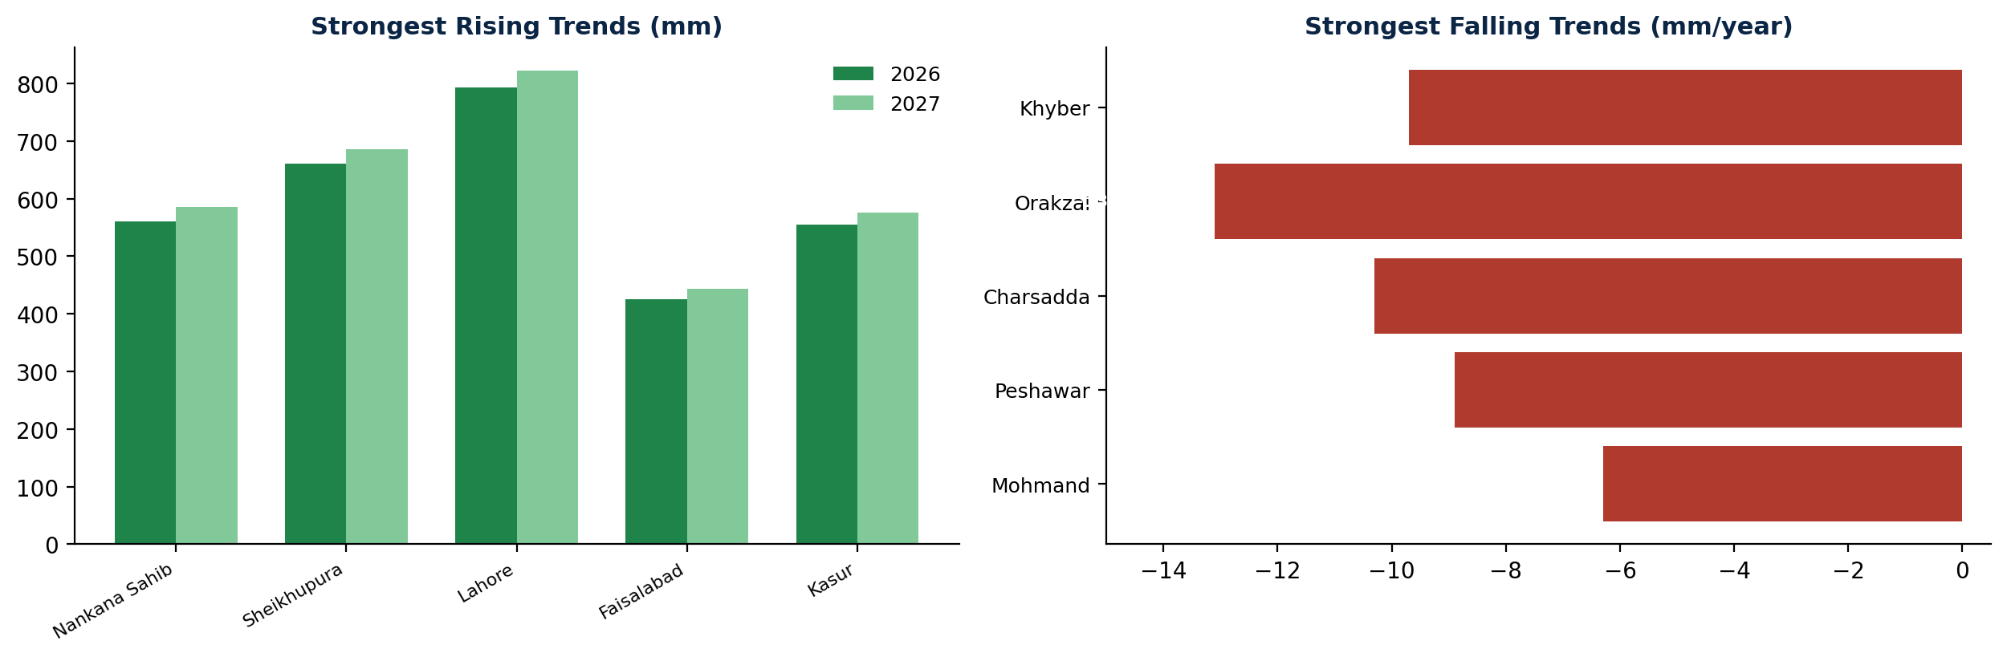

05 | LIMITATIONS

- 2026 and 2027 rainfall figures are statistical trend projections based on 10 years of historical data, not actual weather forecasts; a real seasonal outlook would require separate ENSO/IOD climate data.
- The Sentinel-1 flood detection threshold (3dB backscatter drop) is a starting point and may need adjustment after comparison against known flood extents such as the 2022 floods.
- Correlation values computed on near-zero-variance flood data (as in Central Karachi) should be treated as statistically unreliable rather than evidence of a genuine rainfall-flood disconnect.
06 | CONCLUSION
This study demonstrates a complete, reproducible district-level rainfall and flood correlation workflow for Pakistan using Google Earth Engine, covering 160 districts and 10 years of monsoon data. The analysis confirms that flooding in the large majority of Pakistani districts is well explained by local rainfall, while identifying a specific, geographically coherent set of exceptions: five glacial-fed districts where flood warnings should not rely on local rainfall alone, and Sujawal, whose position in the lower Indus delta makes it Pakistan's most consistently flood-affected district regardless of local rainfall. The GEE-based pipeline, with its centralized configuration and automated Drive export, provides a scalable methodology applicable to future multi-year flood-risk monitoring.

