r = 5;
x1 = -5;y1 = 0;
x2 = 5;y2 = 0;
x3 = 0;y3 = 5;
x4 = 10;y4 = 5;
x5 = -10;y5 = 5;
figure
rectangle('Position',[x1-r,y1-r,2*r,2*r],'Curvature',[1,1]),axis equal
rectangle('Position',[x2-r,y2-r,2*r,2*r],'Curvature',[1,1]),axis equal
rectangle('Position',[x3-r,y3-r,2*r,2*r],'Curvature',[1,1]),axis equal
rectangle('Position',[x4-r,y4-r,2*r,2*r],'Curvature',[1,1]),axis equal
rectangle('Position',[x5-r,y5-r,2*r,2*r],'Curvature',[1,1]),axis equal
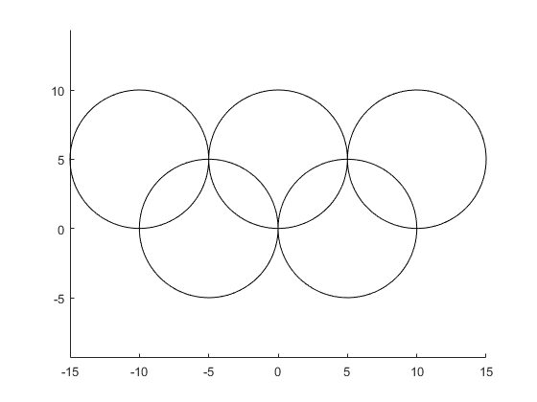
Published with MATLAB? R2016a

