%P92_2_2
clc
clear all
h = 0.1;
tao = 0.0025;
lamda = 0.25;
x = 0:h:1;
u(1:6,1) = 1;
N = 1.000/tao;
for k=1:N
u(1,2) = 0.5*(u(2,1)+0.9*u(1,1));
u(2:5,2) = 0.25*(u(1:4,1)+2*u(2:5,1)+u(3:6,1));
u(6,2) = 0.5*(u(5,1)+u(6,1));
u(1:6,1) = u(1:6,2);
end
u_out = [u(1:6,1);u(5:-1:1,1)];
plot(x,u_out(1:11,1),'LineWidth',2);
text(x(3),u_out(3,1),['u(0.2,1.000)=',num2str(u_out(3,1))]);
title('t=1.000,数值解');
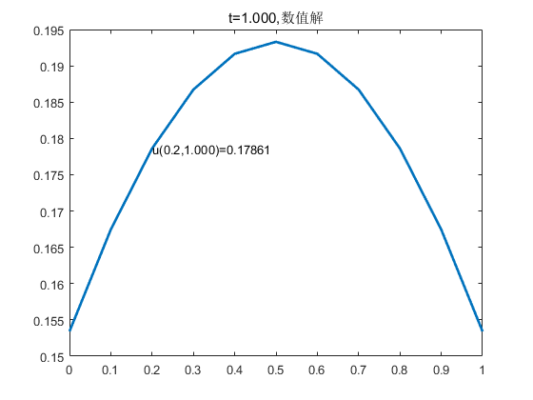
Published with MATLAB? R2016a

